Task:

How to Create SQL database in Azure portal.

1.Creating SQL database and also creating the database server.

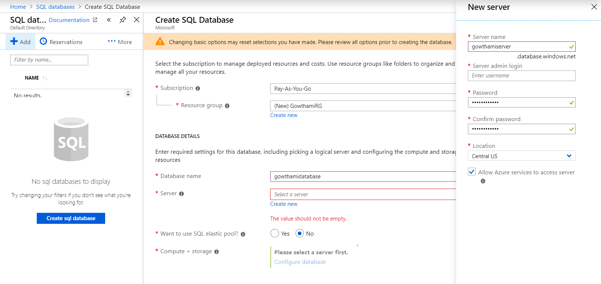

2.Configuring the EDTU AND DTU to the database.

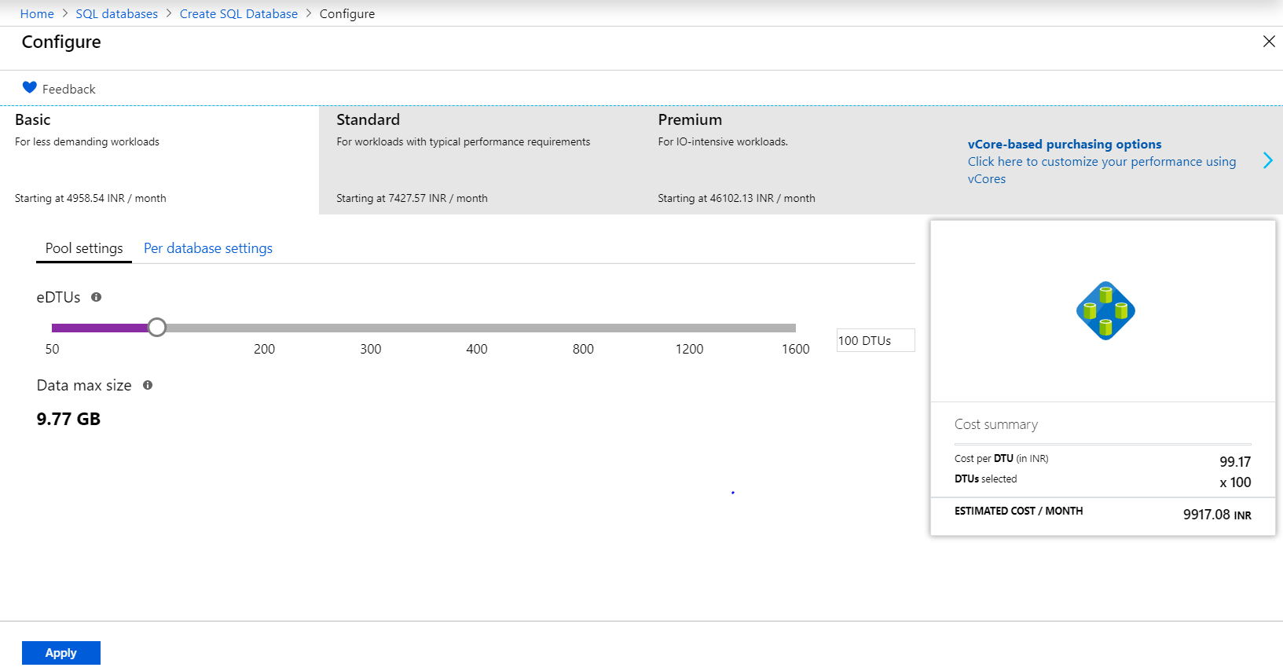

3.Configution of EDTU and DTU in the database this is the selection of the standard.

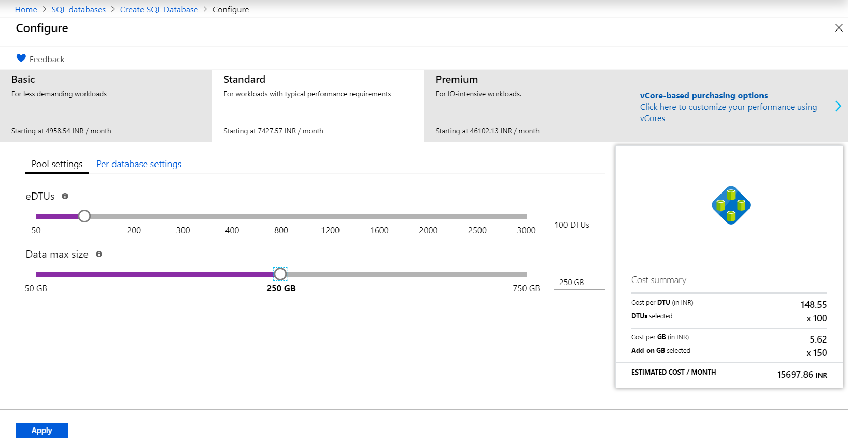

4.Configution of EDTU and DTU in the database this is the selection of the Premium.

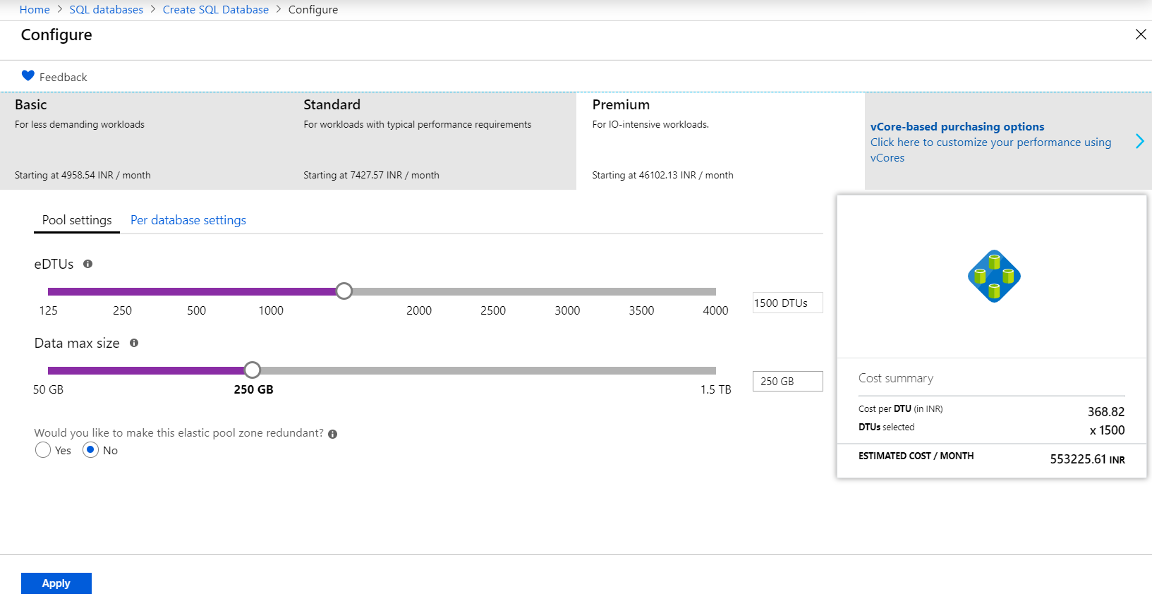

5.After Selection of the all things in SQL Database.

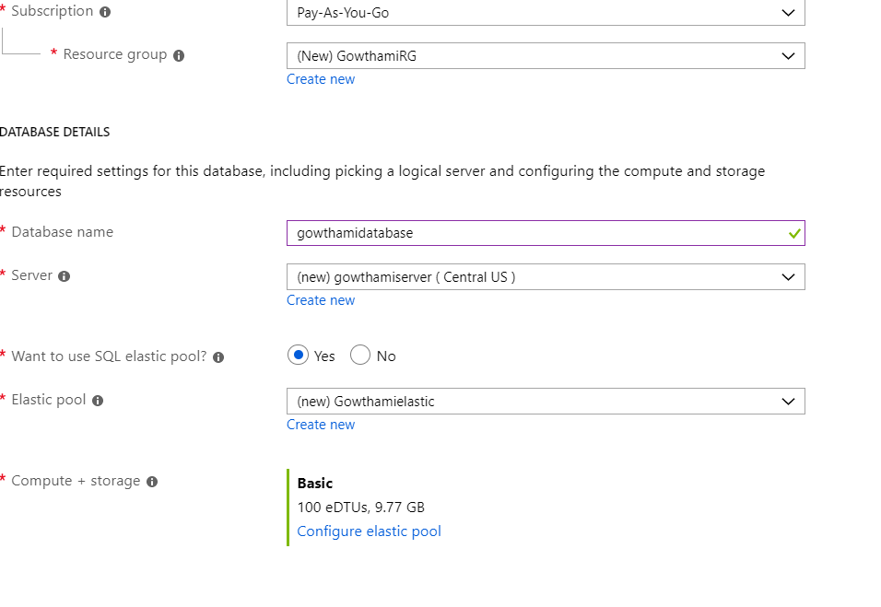

6.Creating the SQL Database.

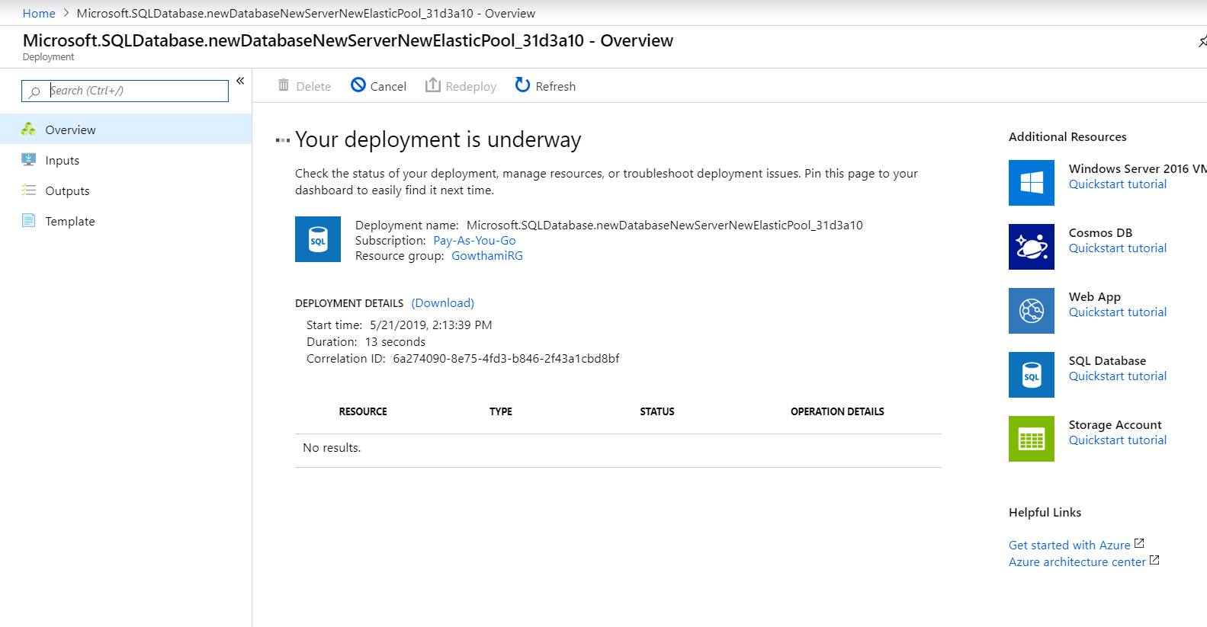

7.SQL Database Created.

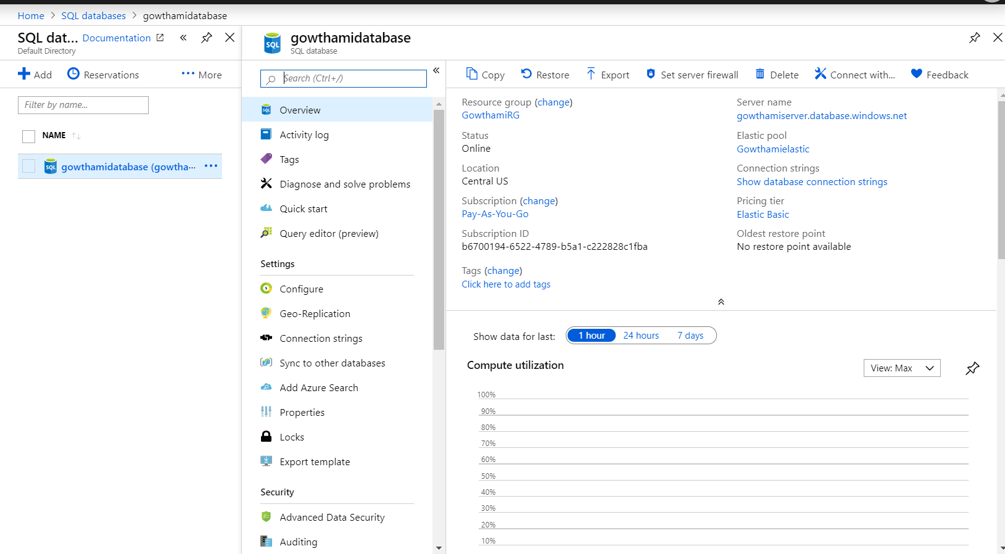

Setting Firewall Setting in SQL

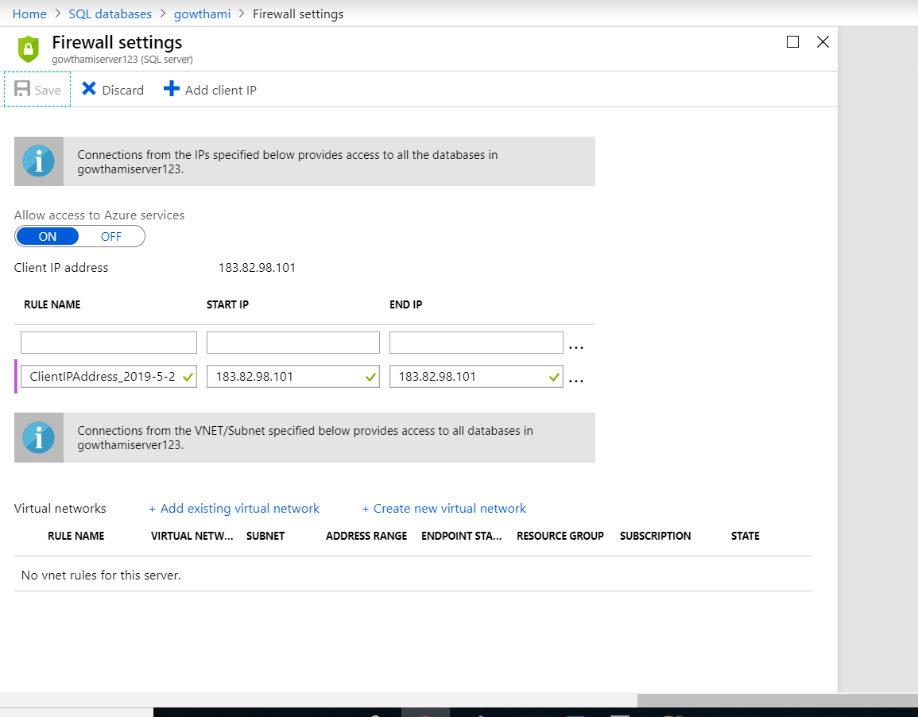

8.Connecting Azure SQL Database in local SSMS.

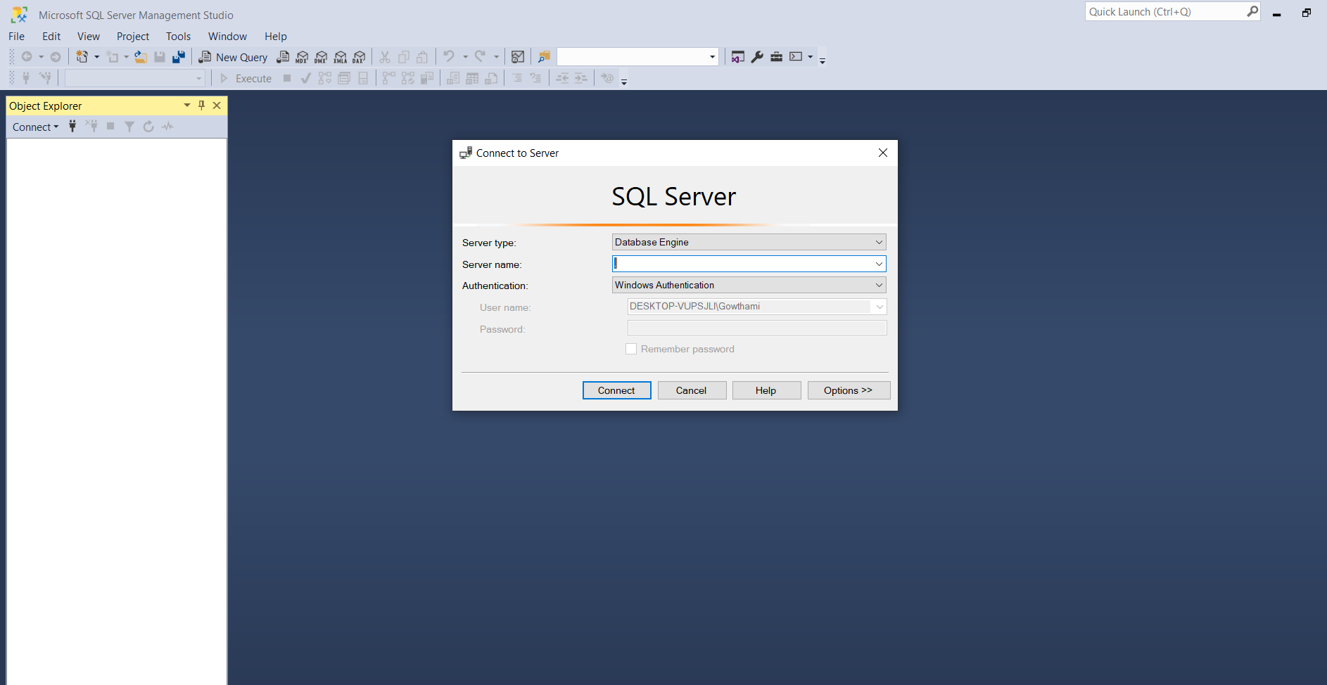

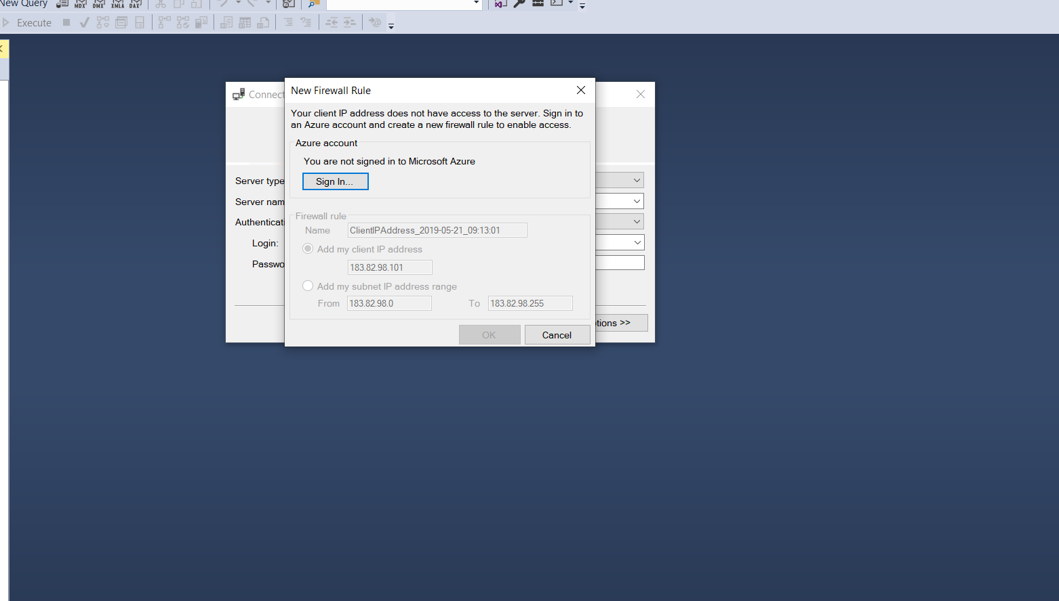

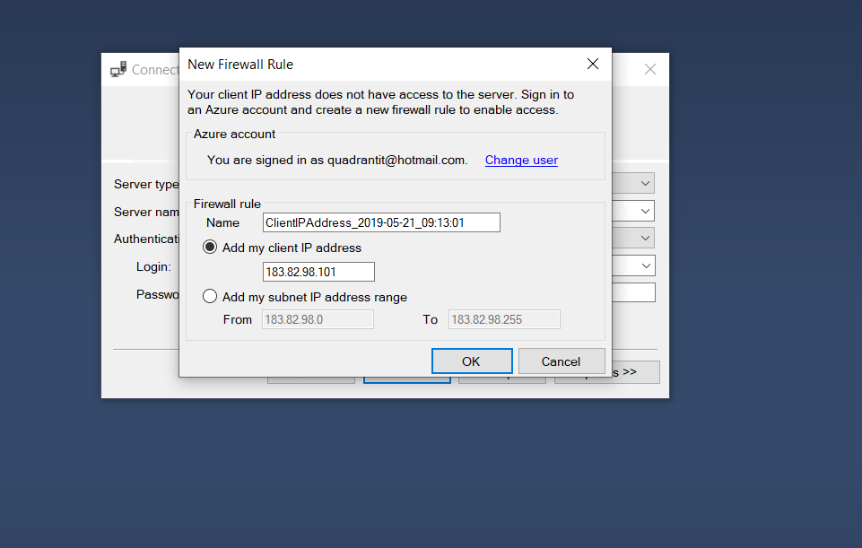

8.Azure Sql Connected in SSMS.

