**Storage Account:**

**First In portal Create Resource Group by using this repository create storage account in that create container in that page blob will be created.**

**1.Create Resource Group.**

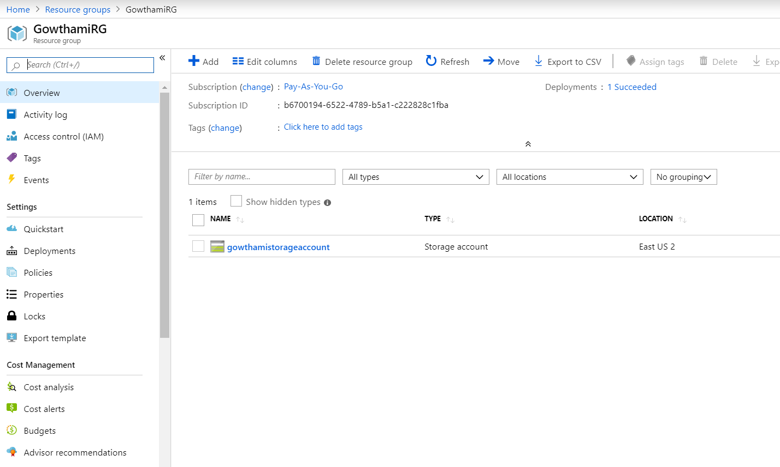

2.Creating Storage Account.

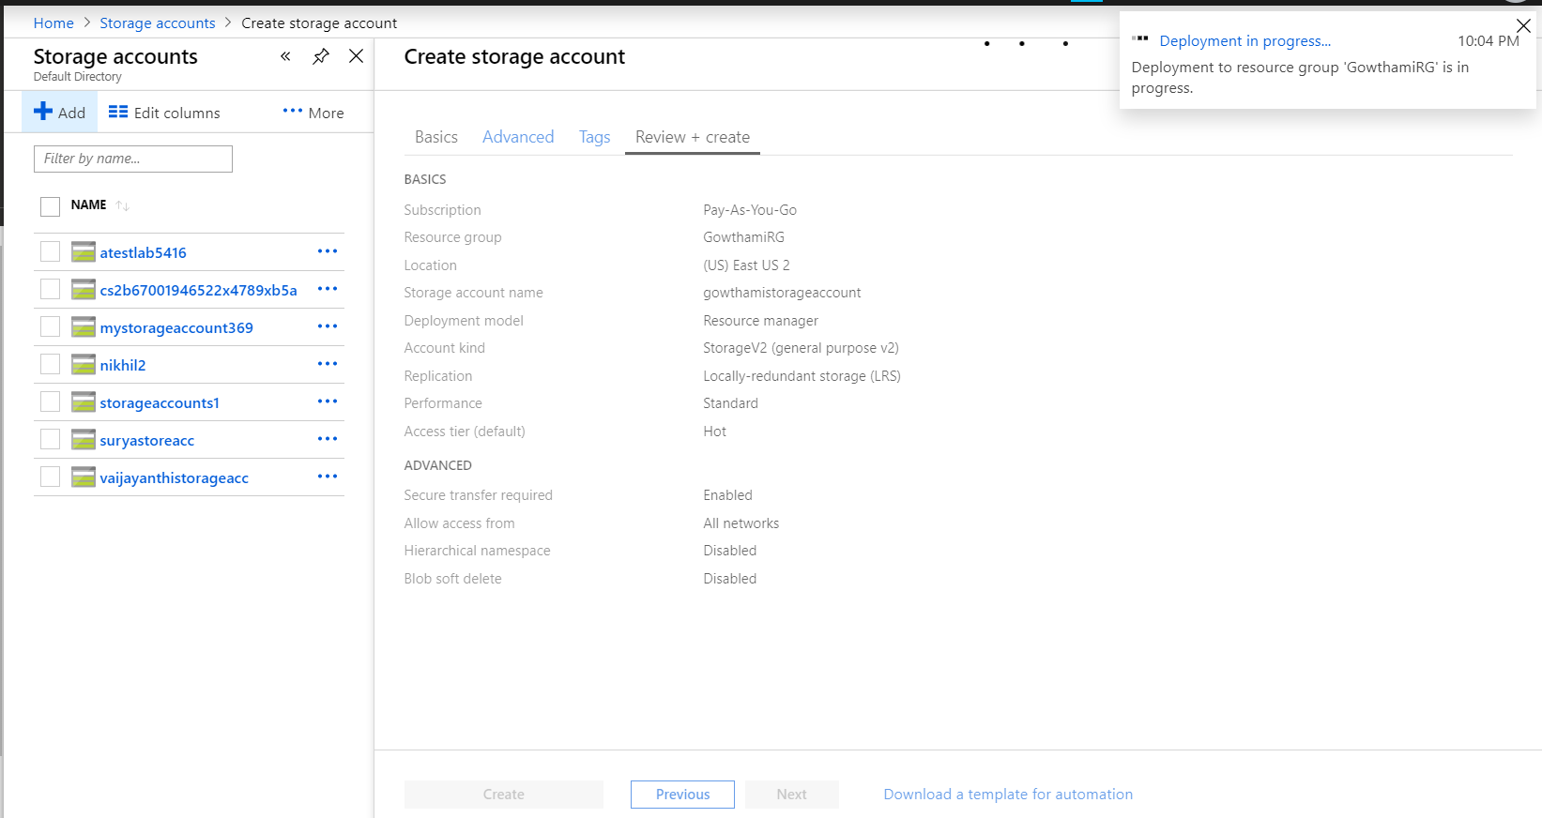

3.After creating storage account.

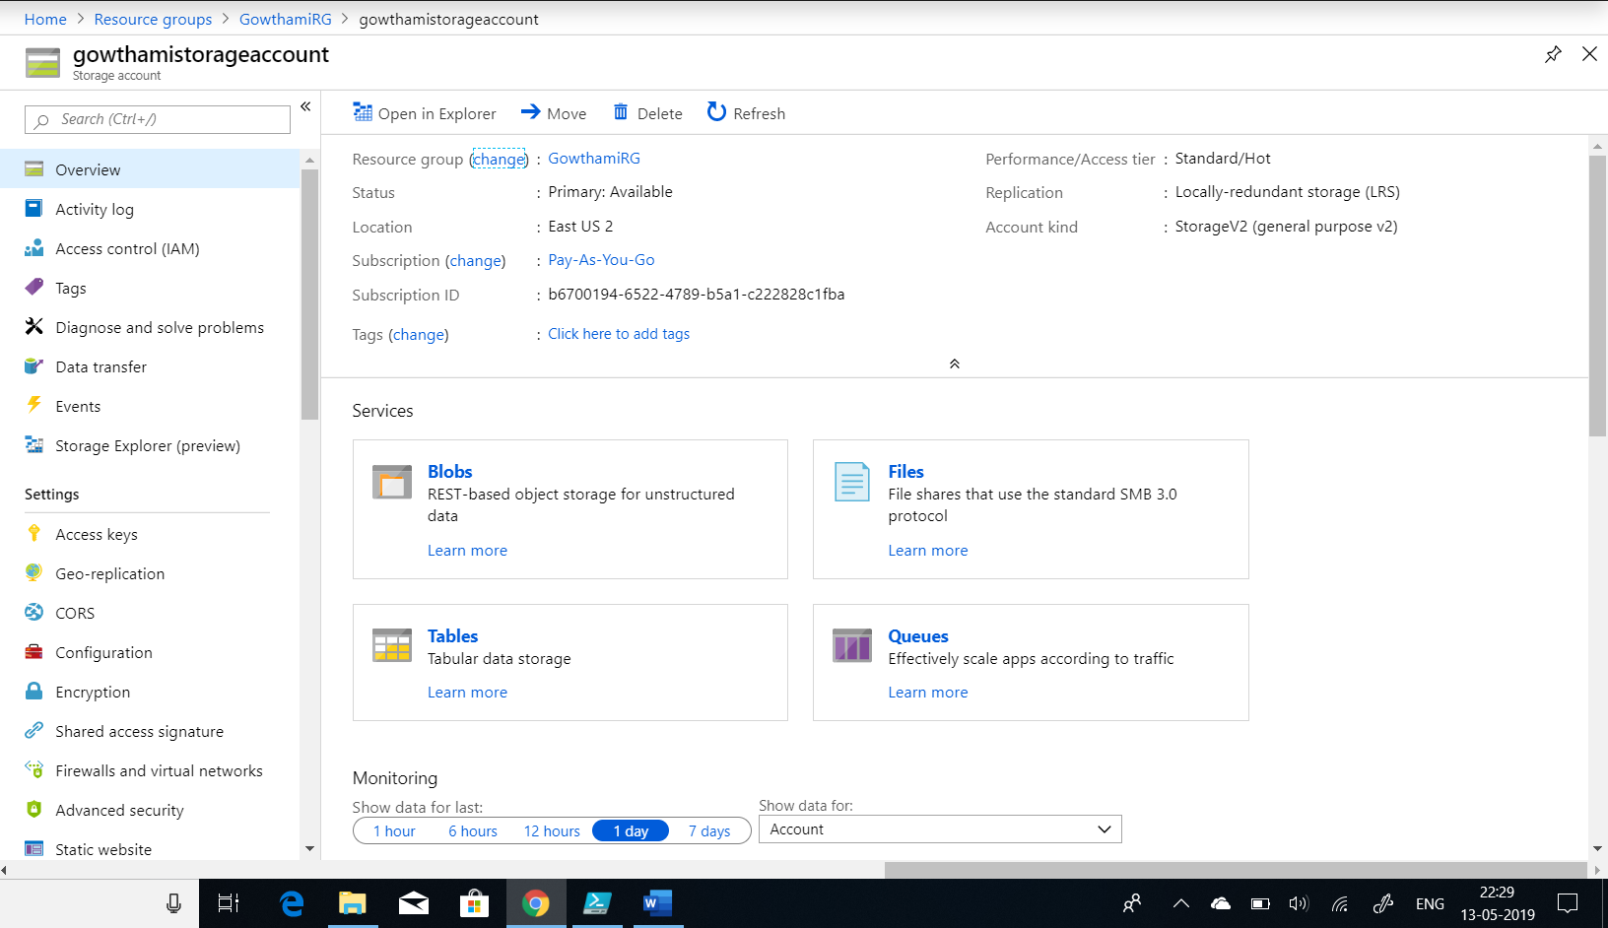

4.Creating container in the page blob.

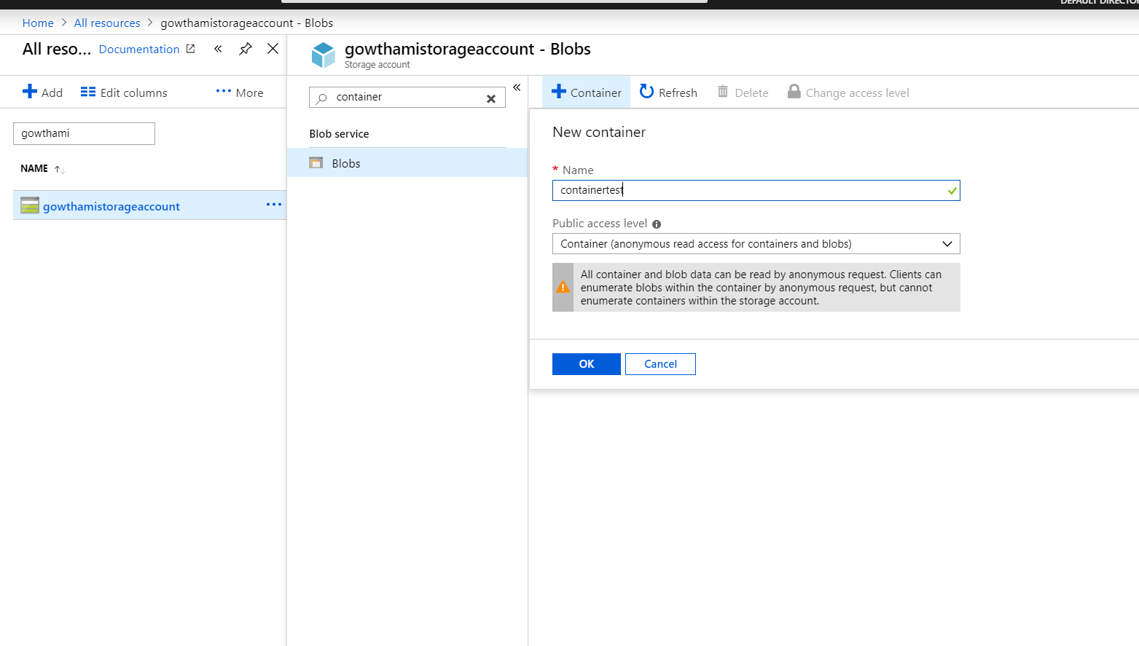

5.In Storage account we observe the storage explorer.

