**Task:**

**Create two repositories in github keep name as one for Developer and one for DevOps.In the Developer repository create submodule. After that do the changes in DevOps check the those updates reflecting Developer or not.**

**1.Creating two Repositories.**

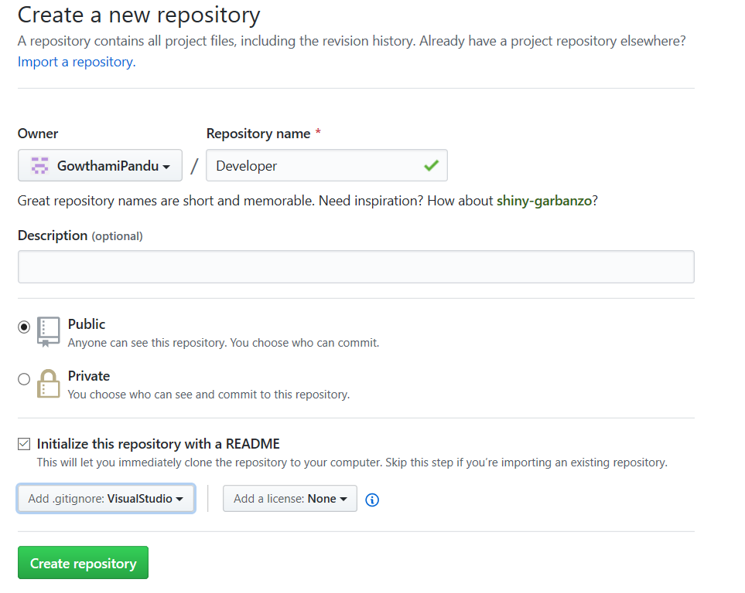

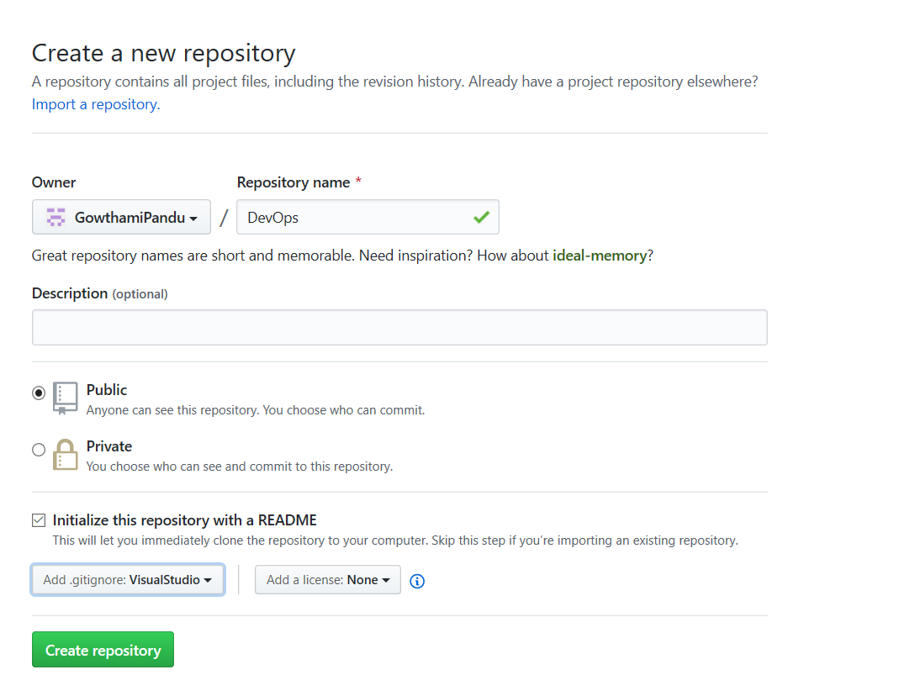

**2.Creating a branch in developer repository.**

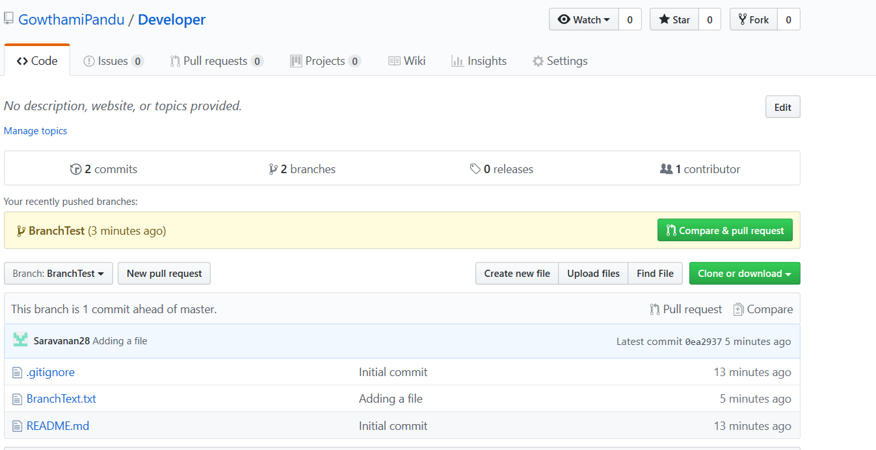

**Git Commands for Creating Branch.**

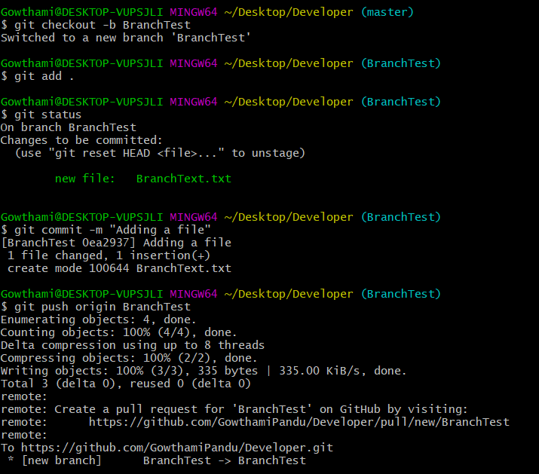

**2.Created Submodule in Developer branch name as Branch Test.**

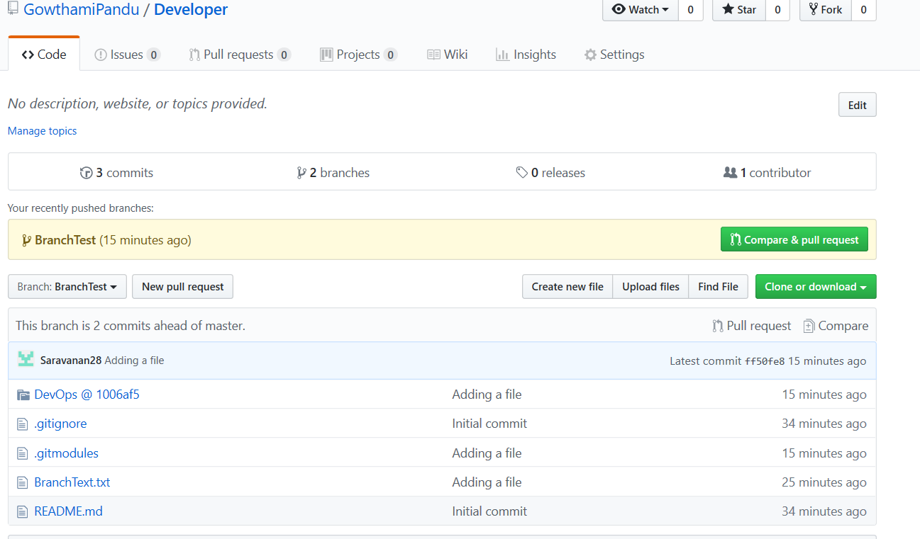

**Git commands for Creating submodule.**

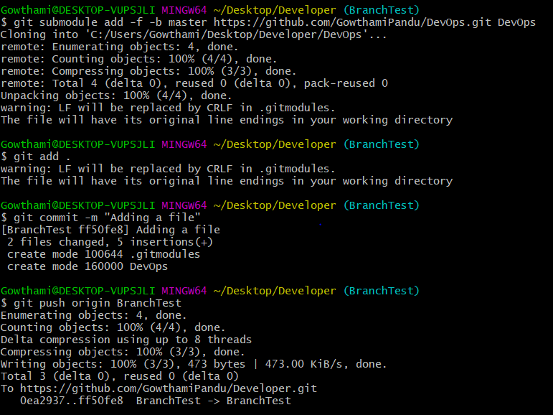

**3.Did gitignore in devops.**

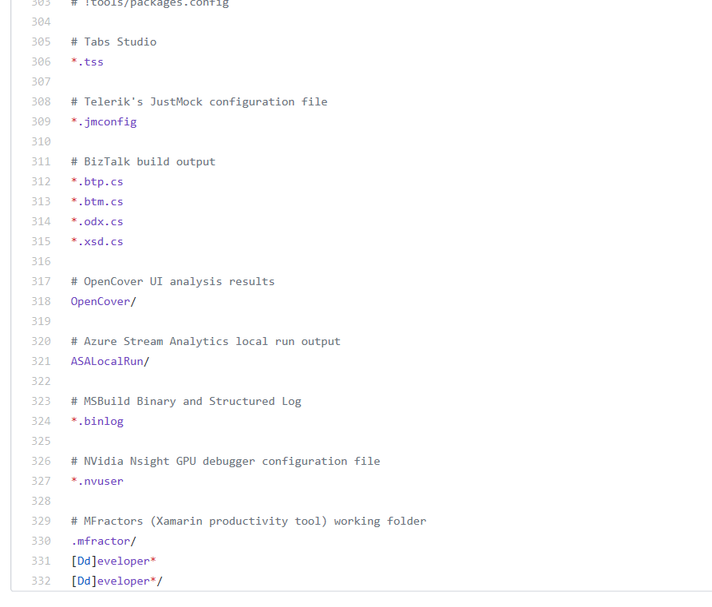

**Doing Some changes in DevOps**

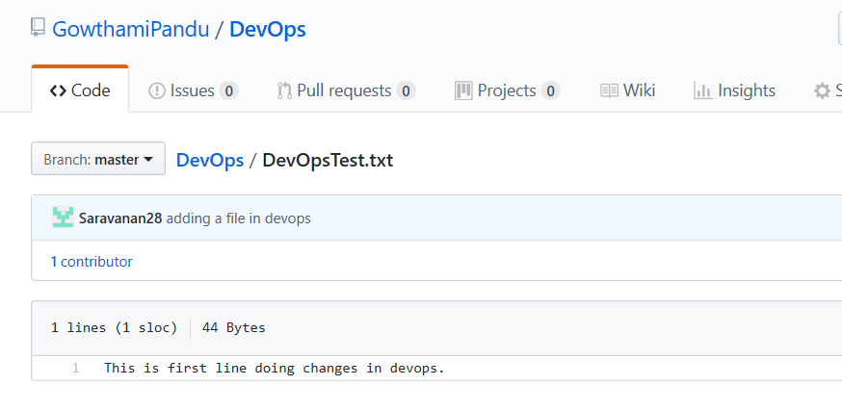

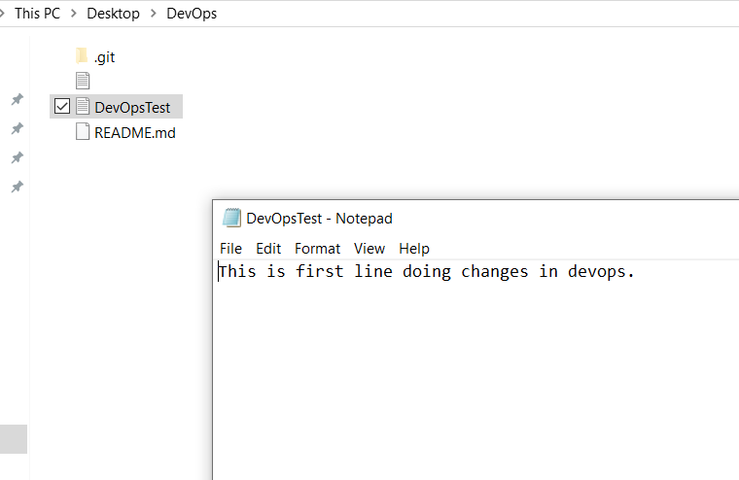

**4.After changing devops repository that reflecting in developer submodule by doing update&foreach.**

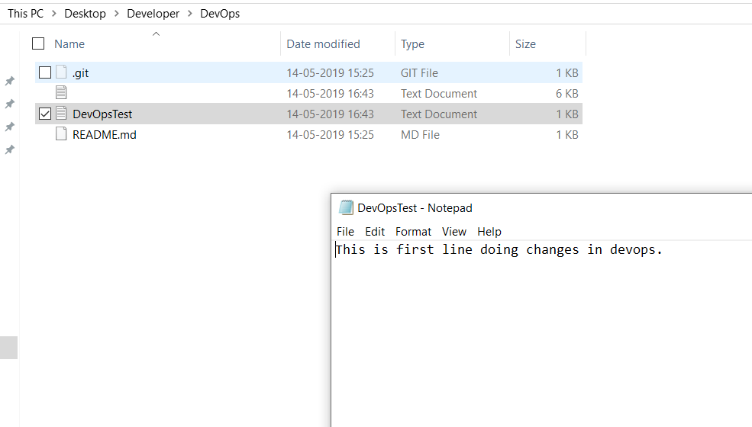

**After reflecting changes in developer submodule in github.**

