1.Created Virtual network-1 in that created subneting1(Frontend).

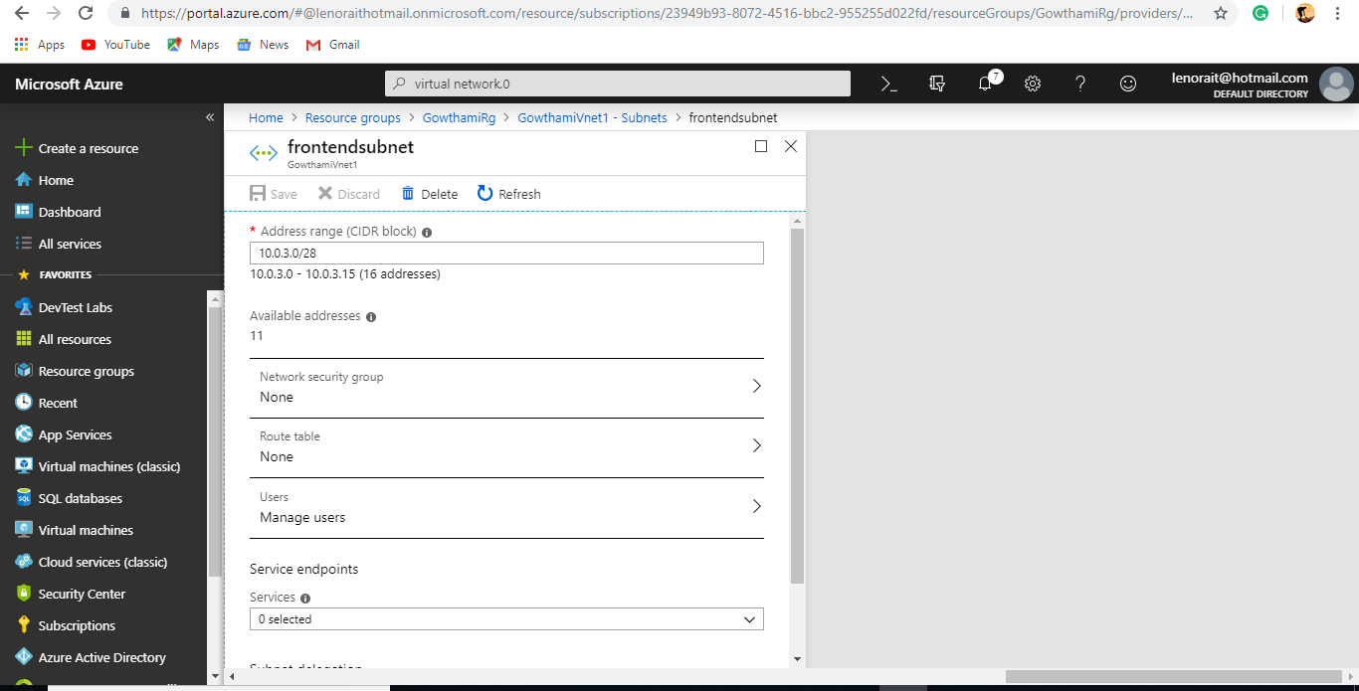

2.Created Virtual Network-1 in that Created subnet2(Backend).

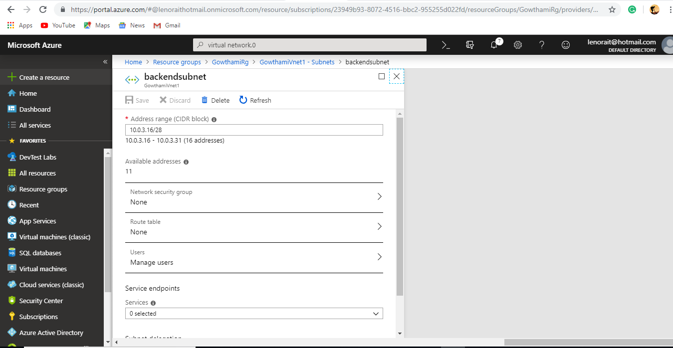

3.Created Virtual Network-2 in that Created subnet1(Frontend).

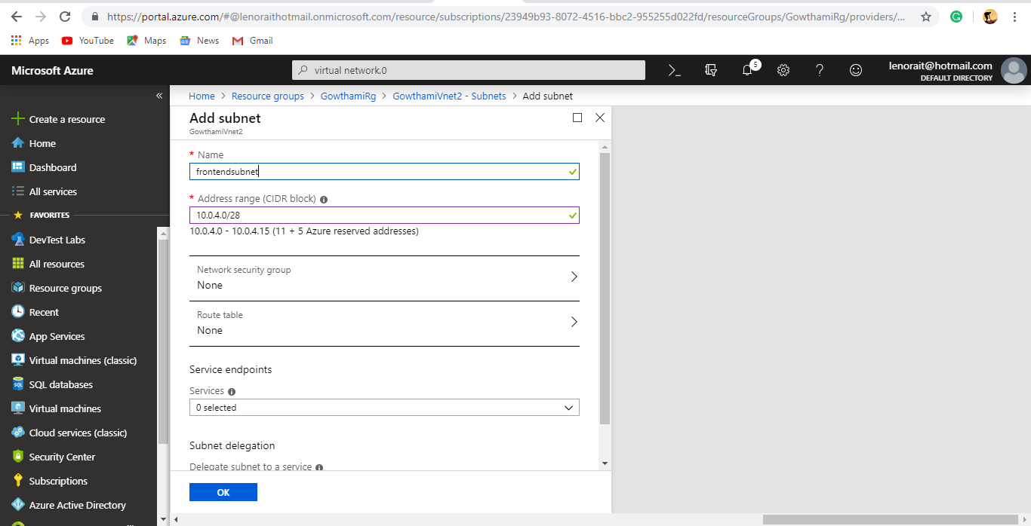

4.Created Virtual Network-2 in that Created subnet2(backend).

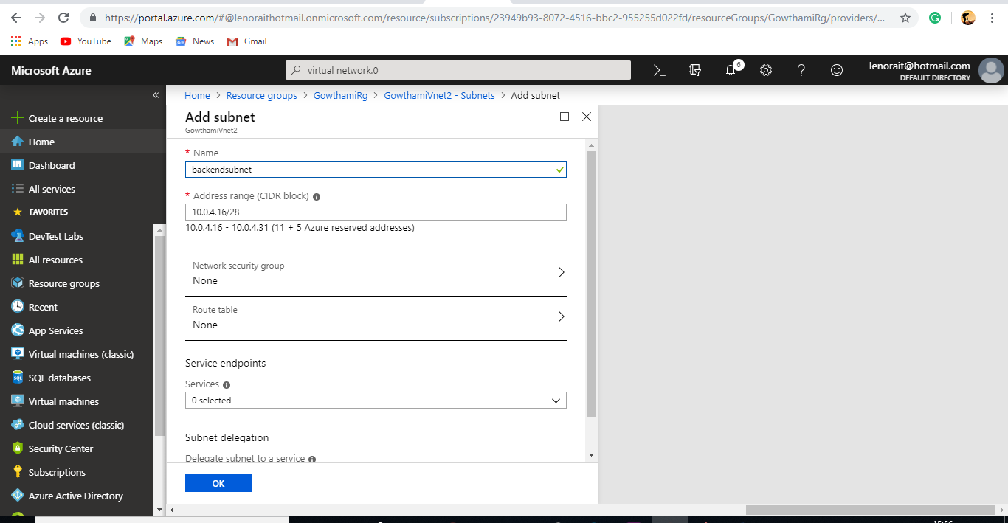

5.Created Virtual Network-3 in that Created subnet1(frontend).

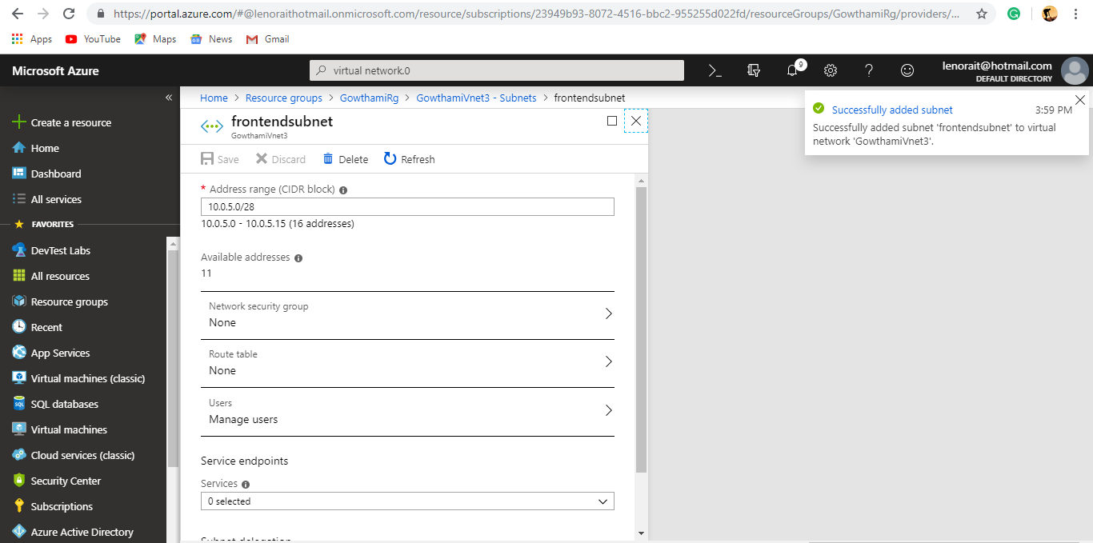

6. Created Virtual Network-3 in that Created subnet2(backend).

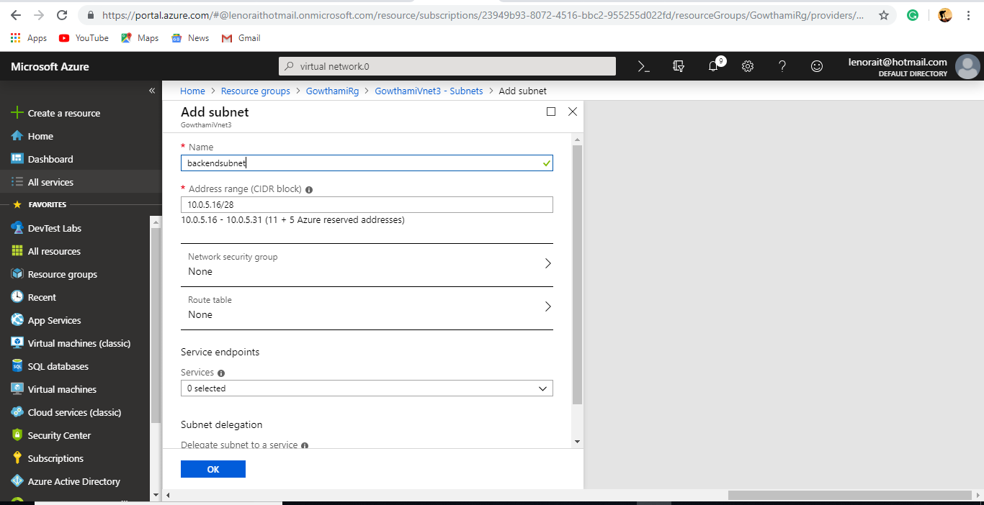

7.Created Gateway subnet in vnet1.

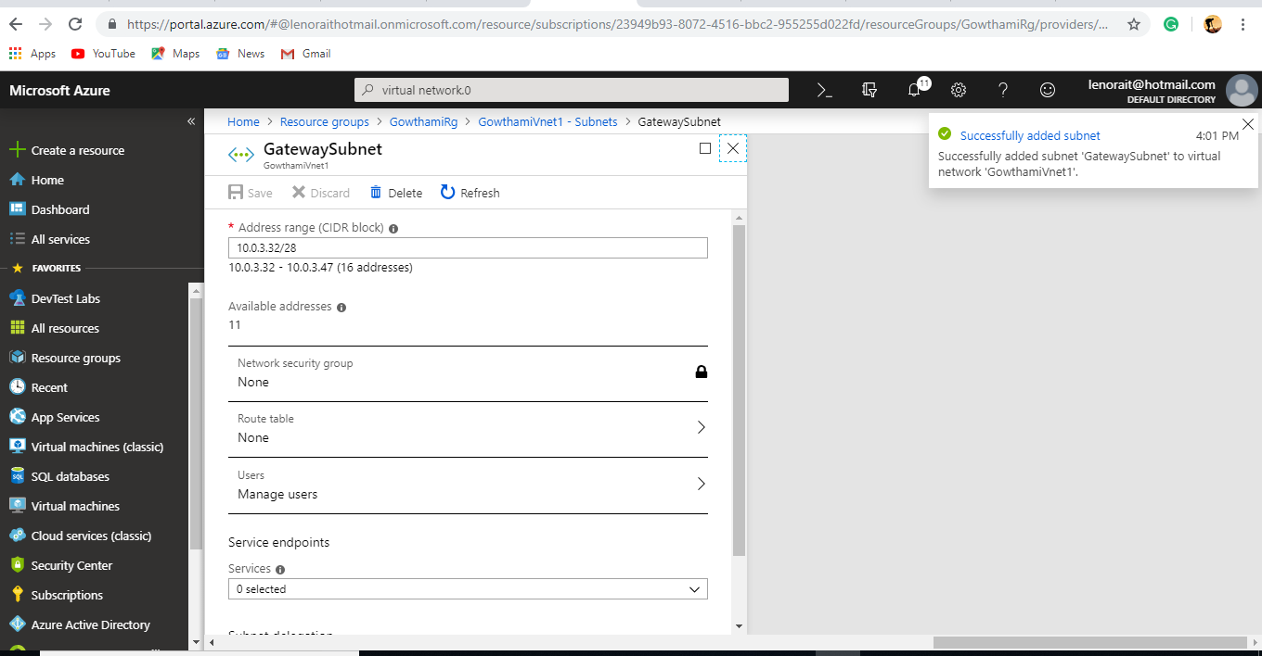

8.Created Gateway subnet in vnet2.

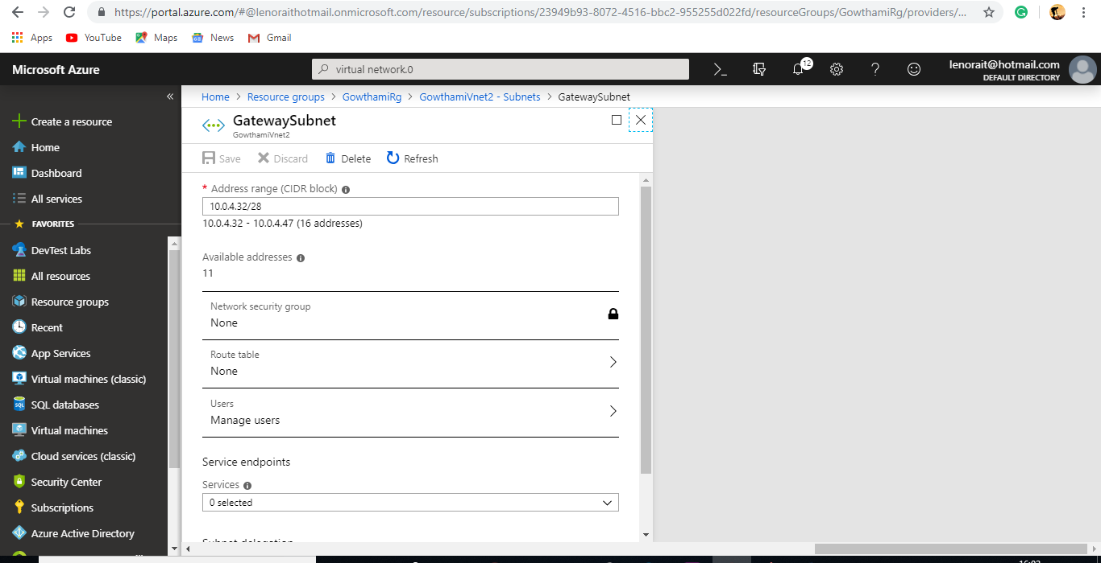

9.Created Gateway subnet in vnet3.

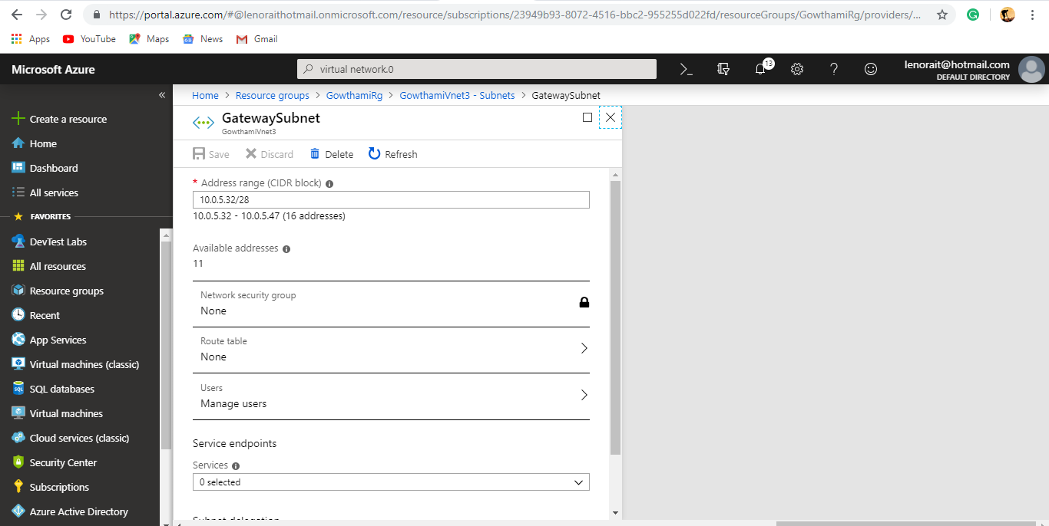

10.Created VPN Gateway in vnet1.

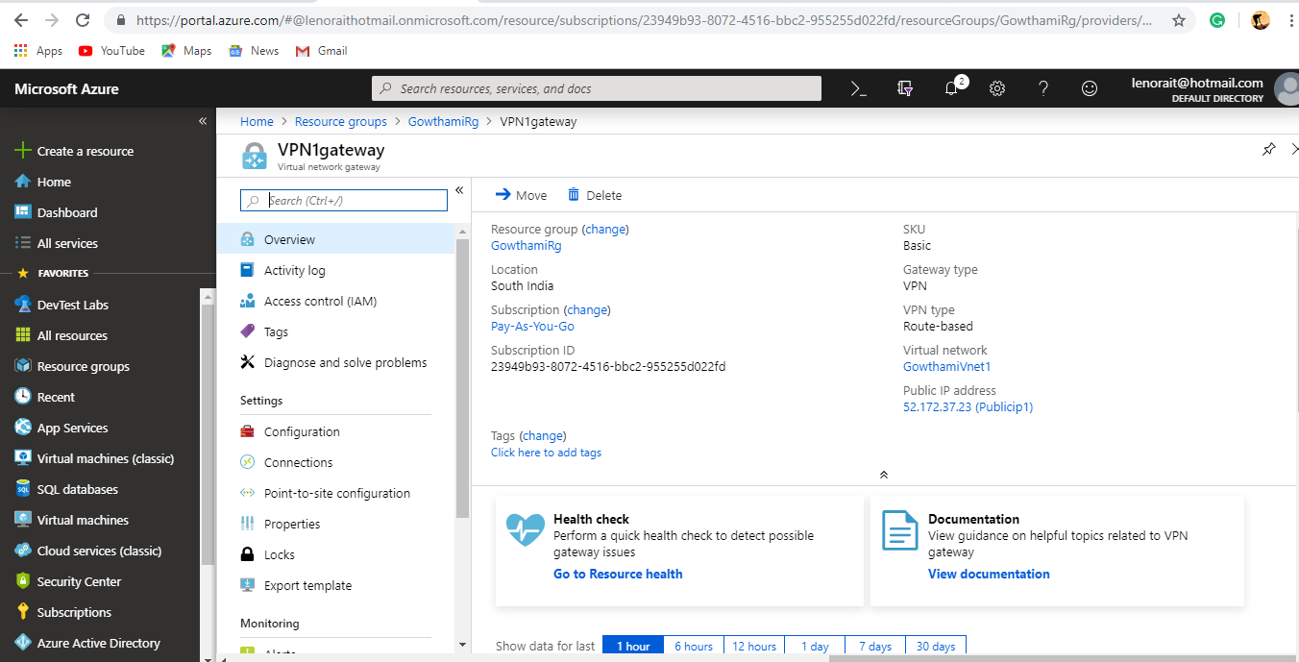

11.Created VPN Gateway in vnet2.

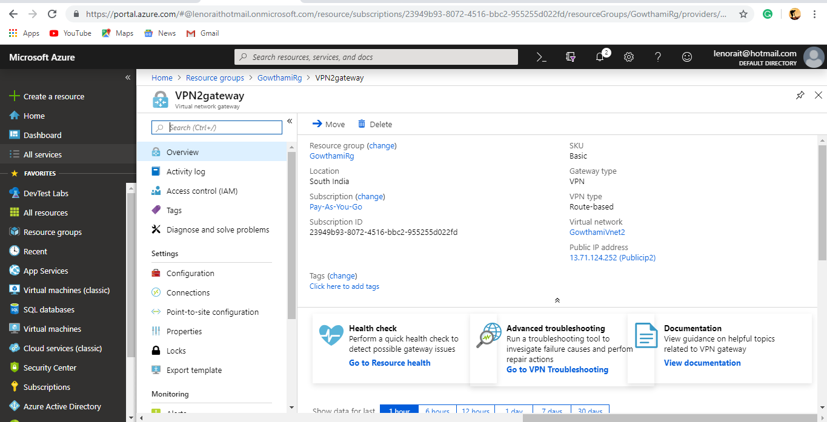

12.Created VPN1 Gateway in that set VPN connection.

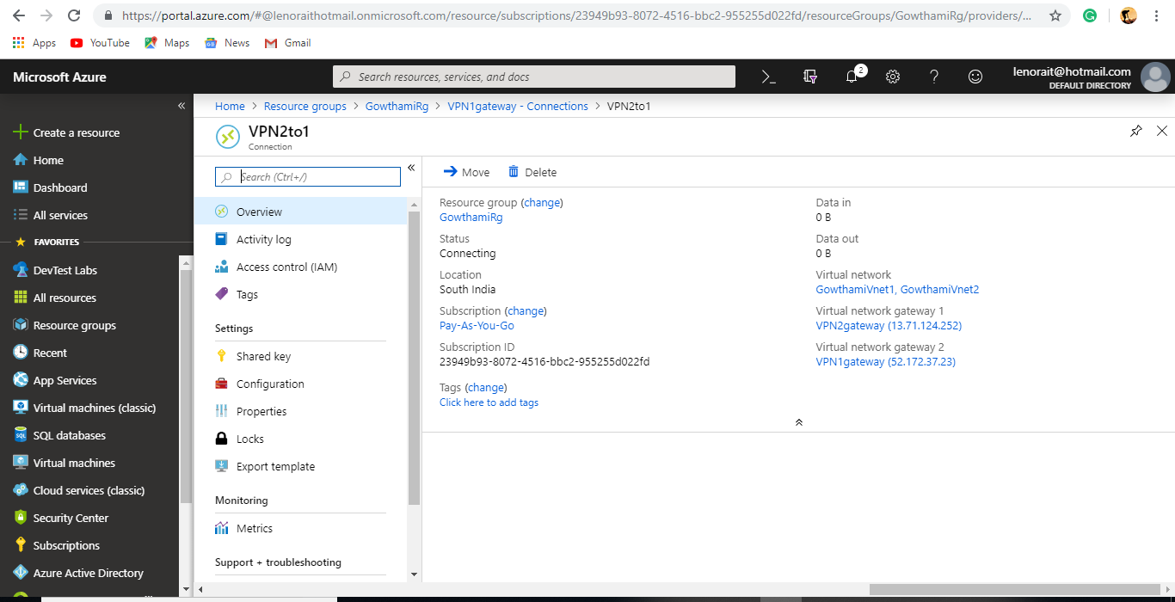

13.Created VPN2 Gateway in that set VPN connection.

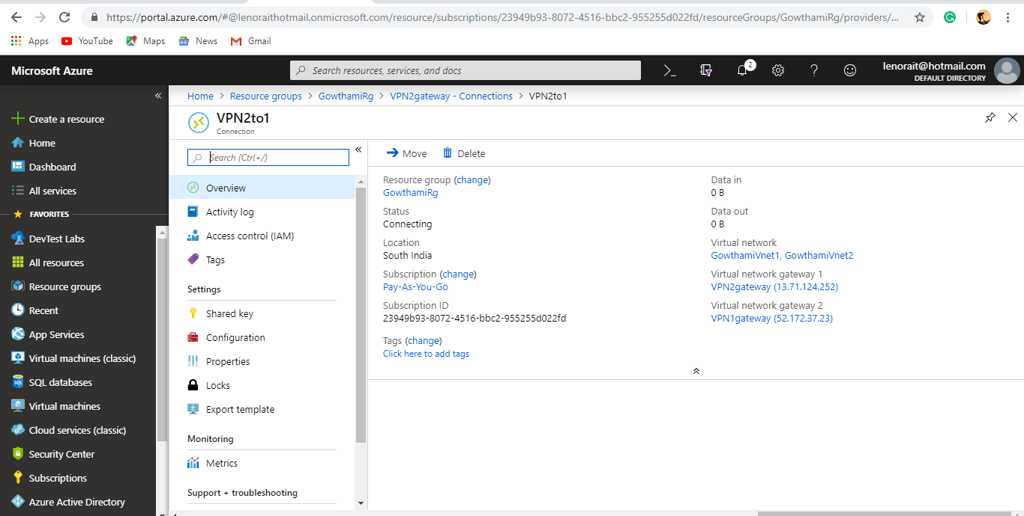

14.In Virtual Network-2 did Peering for hub.

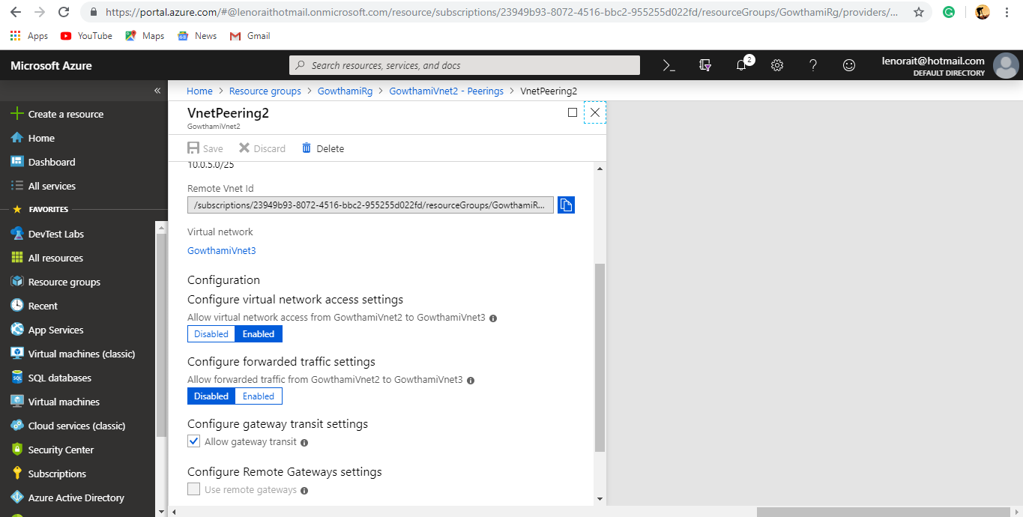

15.In Virtual Network-3 did Peering for Spoke.

