1.Created Resource-Group in azure portal.

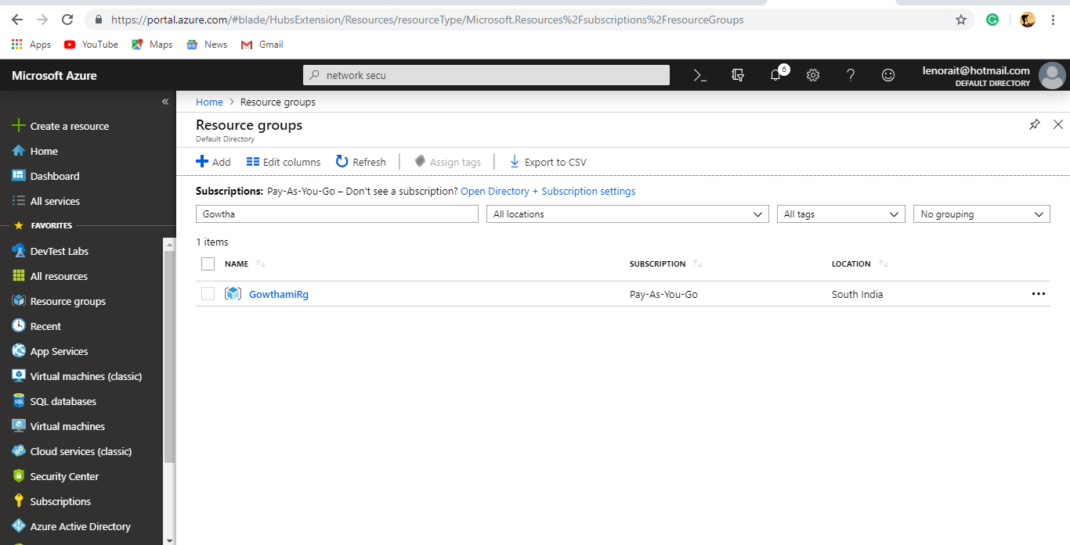

2.Created Virtual Network in Azure portal.

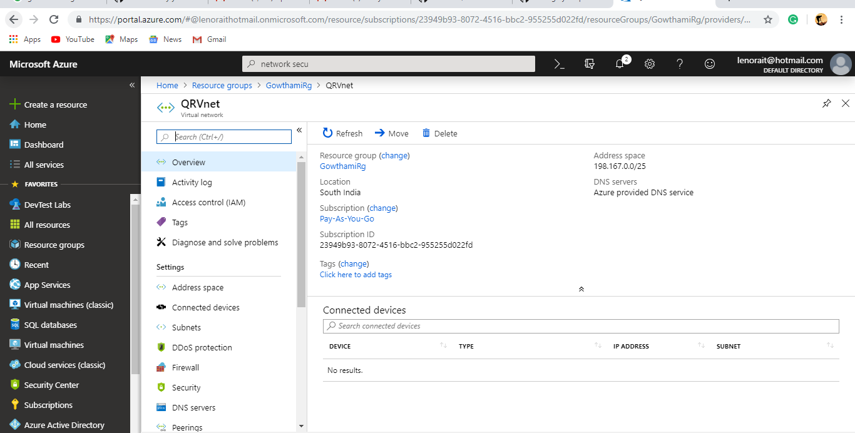

3.Created Network Security group added subnets(frontend,backend).

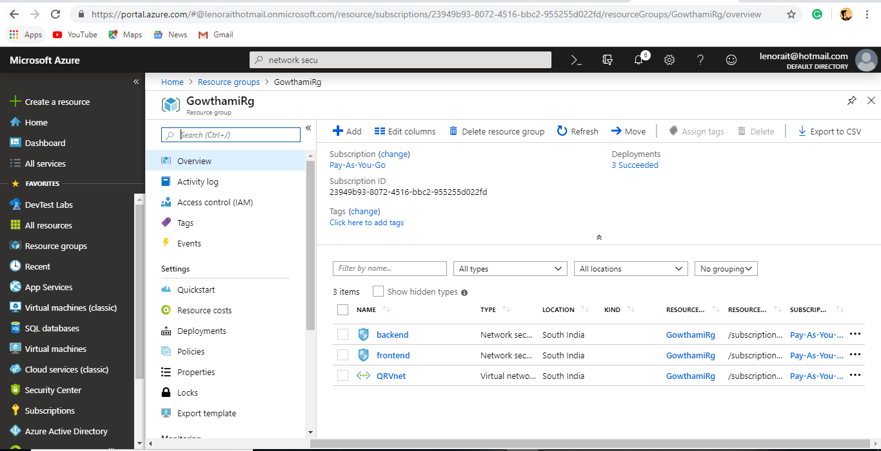

4.Added Inbound and outbound rules in subnet1(frontend).

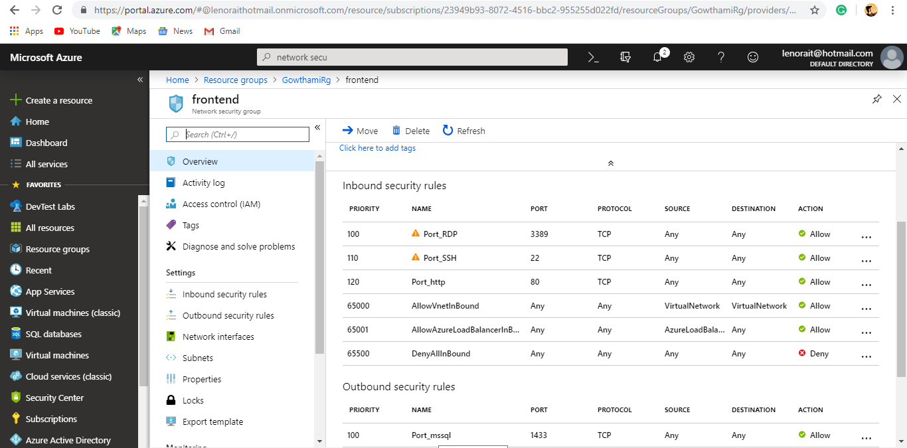

5.Added inbound and outbound rules in subnet2(backend).

