1.Created a Resource group with name **Task2VnetVPN**

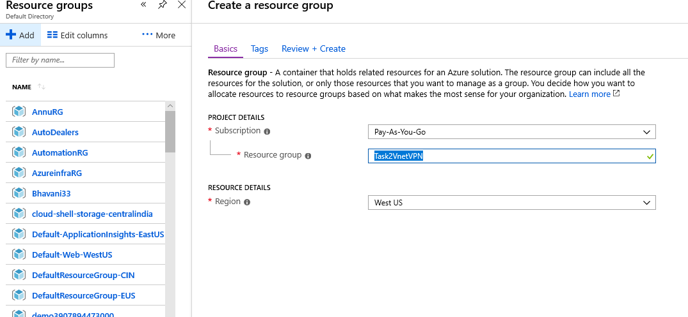

2.Creating vnet with Name **T2Vnet1** Address space **192.163.0.0/24** and FrontEndSubnet Name **FrontEndS1** Address Space **192.163.0.0/28** Backend Subnet **192.163.0.32/28** and Gatewaysubnet

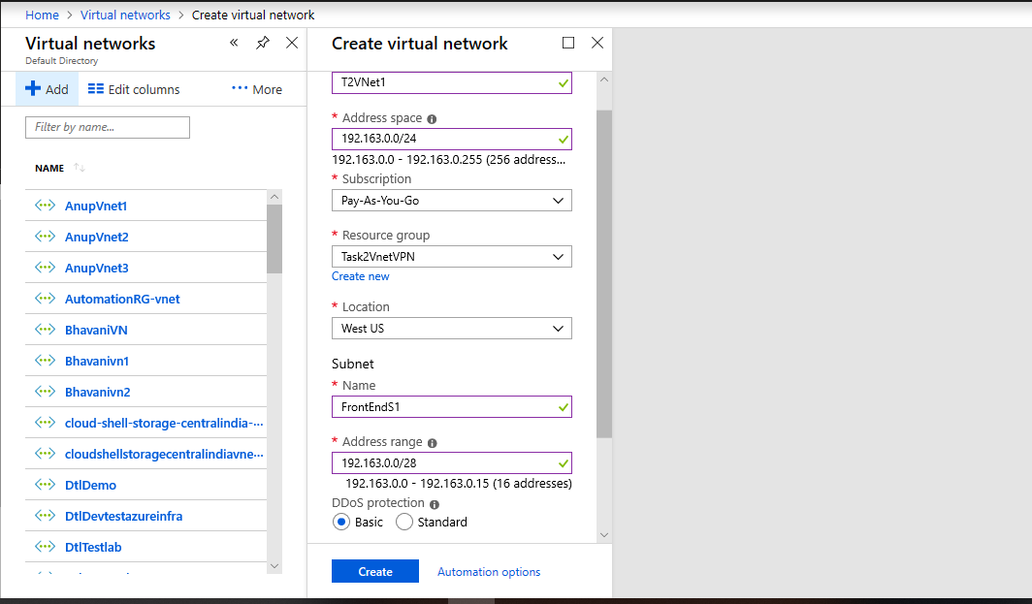

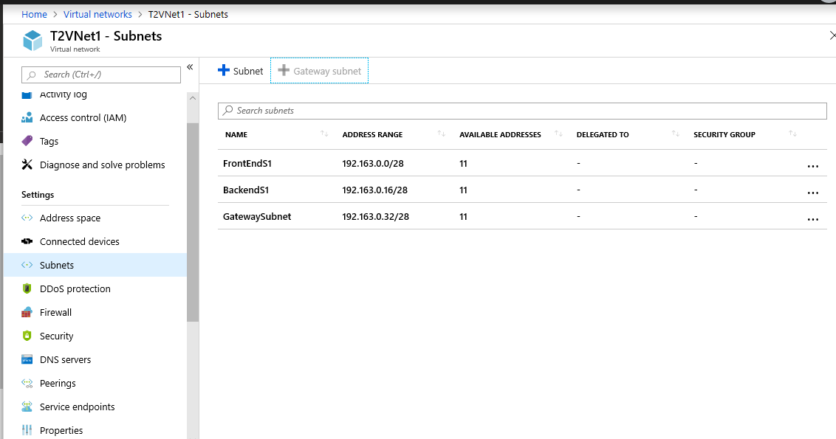

3.Creating vnet with Name **T2Vnet2** Address space **192.163.1.0/24** and FrontEndSubnet Name **FrontEndS1** Address Space **192.163.1.0/28** Backend Subnet **192.163.1.32/28** and GatewaySubnet

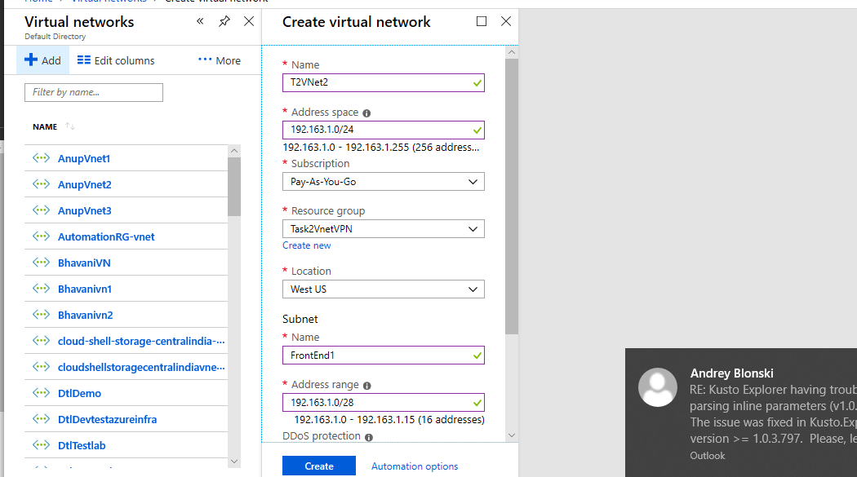

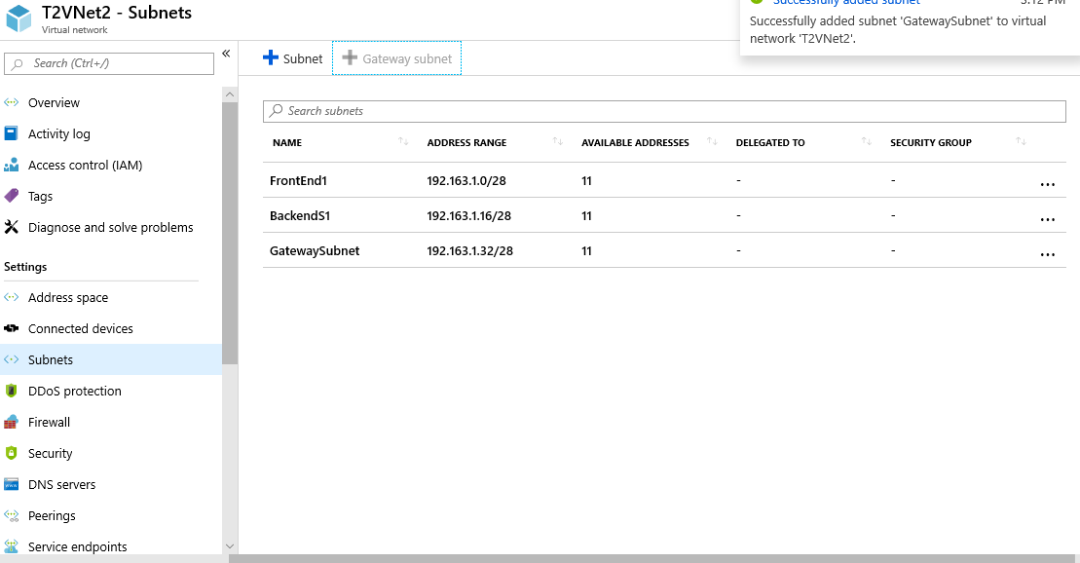

3.Creating vnet with Name **T2Vnet2** Address space **192.163.2.0/24** and FrontEndSubnet Name **FrontEndS1** Address Space **192.163.2.0/28** Backend Subnet **192.163.2.32/28** and gatewaysubnet

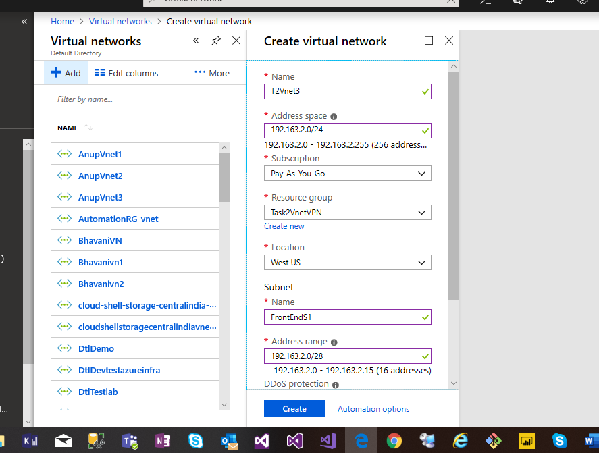

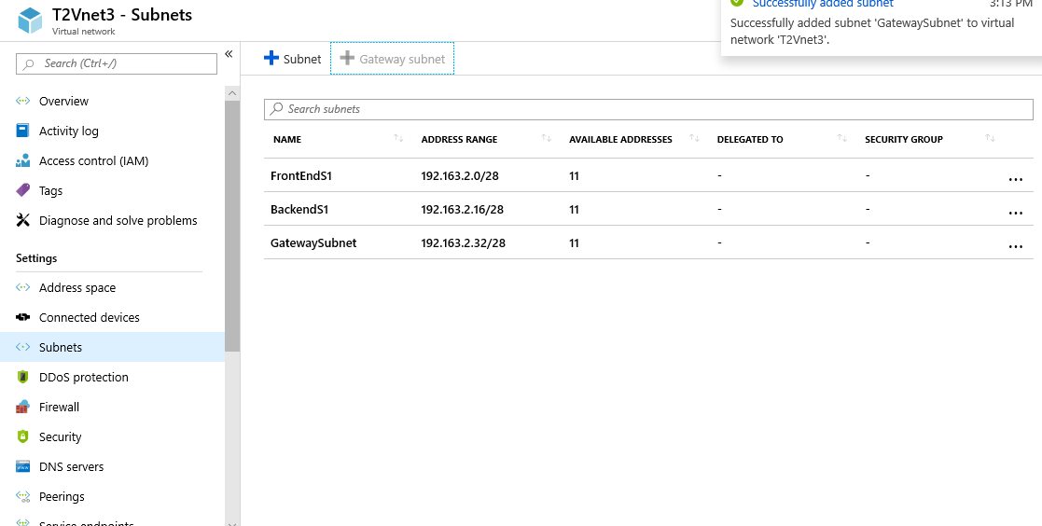

Vnet Peering between T2Vnet2 to T2Vnet3 and making T2Vnet as hub and T2Vnet3 as Spoke

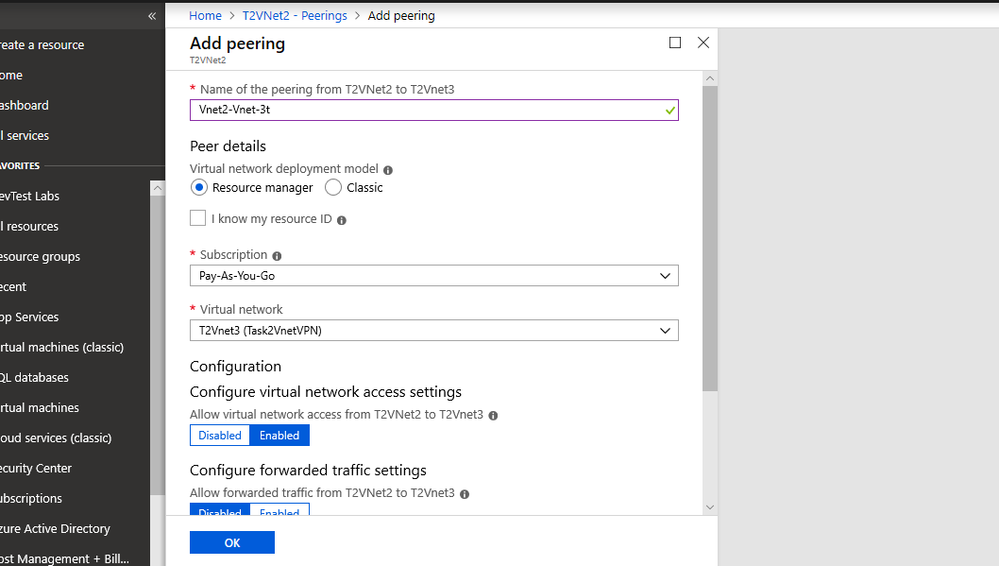

Created 2 VPN Gateways for T2vPNG1 and T2VPNG2 established Vnet to Vnet connection between both

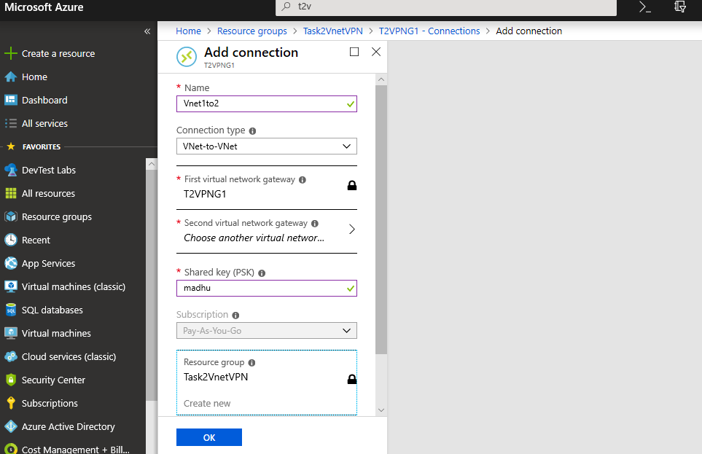

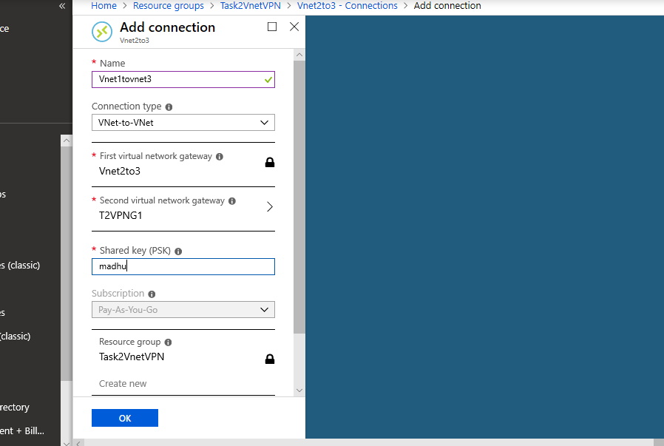

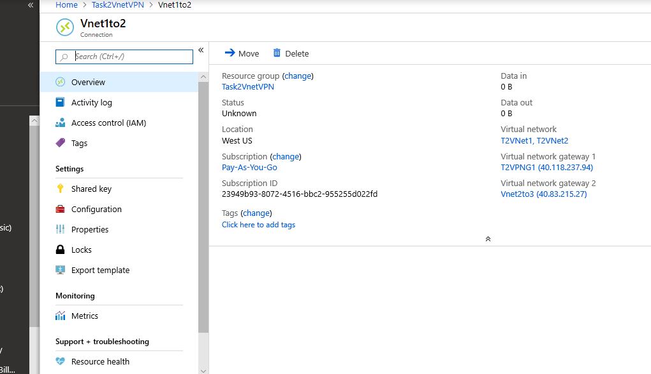

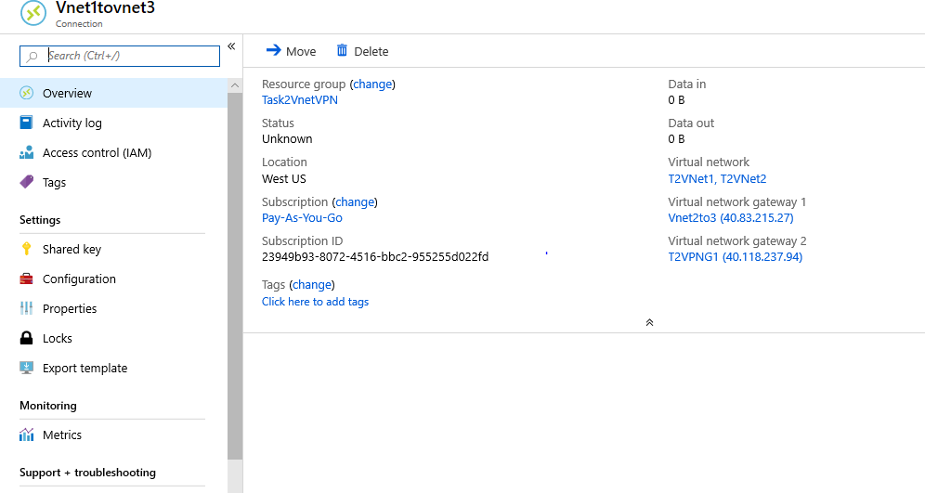

**Using Powershell**

Login-AzureRmAccount

New-AzResourceGroup -Name MadhaviRG -Location WestUS

$virtualNetwork1 = New-AzVirtualNetwork -ResourceGroupName MadhaviRG -Location WestUS -Name T2Vnet1 -AddressPrefix 192.163.0.0/24

$subnetfriont1 = Add-AzVirtualNetworkSubnetConfig -Name FrnotEnd -AddressPrefix 192.163.0.0/28 -VirtualNetwork $virtualNetwork1

$subnetBackend1 = Add-AzVirtualNetworkSubnetConfig -Name Backend -AddressPrefix 192.163.0.32/28 -VirtualNetwork $virtualNetwork1

$virtualNetwork1 | Set-AzVirtualNetwork

$virtualNetwork2 = New-AzVirtualNetwork -ResourceGroupName MadhaviRG -Location WestUS -Name T2Vnet1 -AddressPrefix 192.163.1.0/24

$subnetfriont2 = Add-AzVirtualNetworkSubnetConfig -Name FrnotEnd2 -AddressPrefix 192.163.1.0/28 -VirtualNetwork $virtualNetwork2

$subnetBAckend2 = Add-AzVirtualNetworkSubnetConfig -Name Backend2 -AddressPrefix 192.163.1.32/28 -VirtualNetwork $virtualNetwork2

$virtualNetwork2| Set-AzVirtualNetwork

$virtualNetwork1 = New-AzVirtualNetwork -ResourceGroupName MadhaviRG -Location WestUS -Name T2Vnet1 -AddressPrefix 192.163.2.0/24

$subnetfriont3 = Add-AzVirtualNetworkSubnetConfig -Name FrnotEnd3 -AddressPrefix 192.163.2.028 -VirtualNetwork $virtualNetwork3

$subnetbackend3 = Add-AzVirtualNetworkSubnetConfig -Name Backend3 -AddressPrefix 192.163.2.32/28 -VirtualNetwork $virtualNetwork3

$virtualNetwork3 | Set-AzVirtualNetwork