1.Created a Resource group with name **Task2VnetVPN**

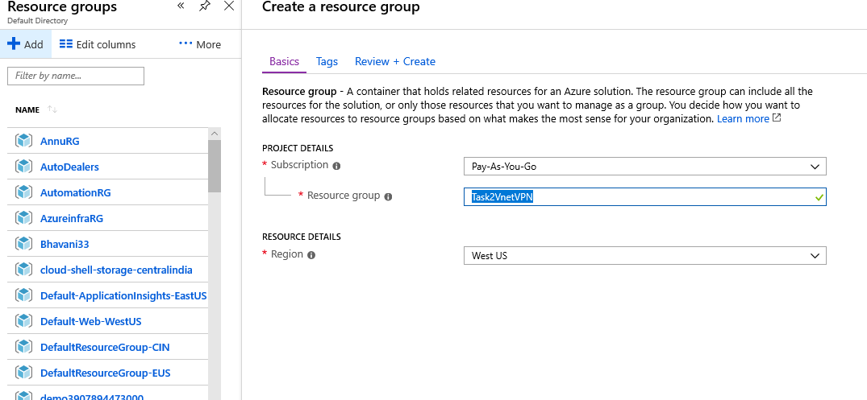

2.Creating vnet with Name **T2Vnet1** Address space **192.163.0.0/24** and FrontEndSubnet Name **FrontEndS1** Address Space **192.163.0.0/28** Backend Subnet **192.163.0.32/28** and Gatewaysubnet

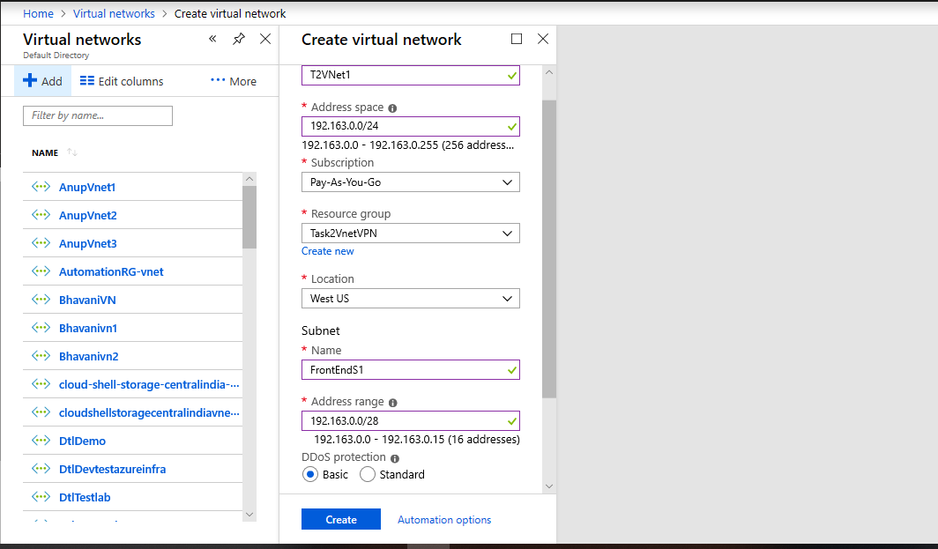

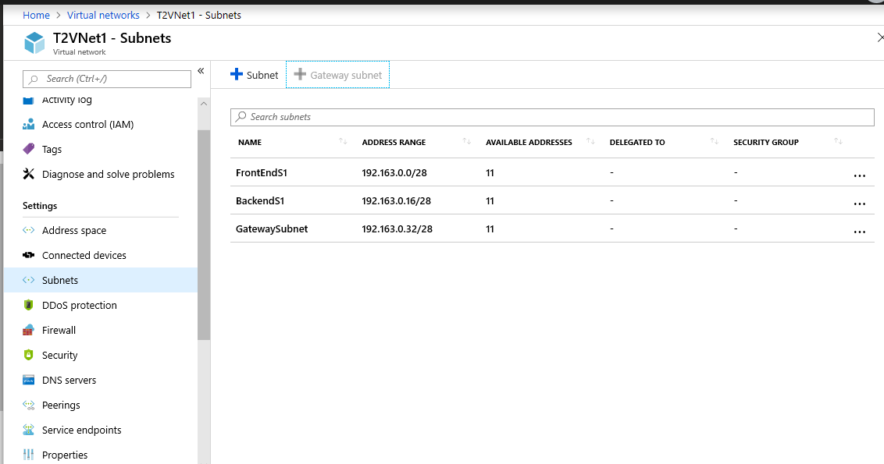

3.Creating vnet with Name **T2Vnet2** Address space **192.163.1.0/24** and FrontEndSubnet Name **FrontEndS1** Address Space **192.163.1.0/28** Backend Subnet **192.163.1.32/28** and GatewaySubnet

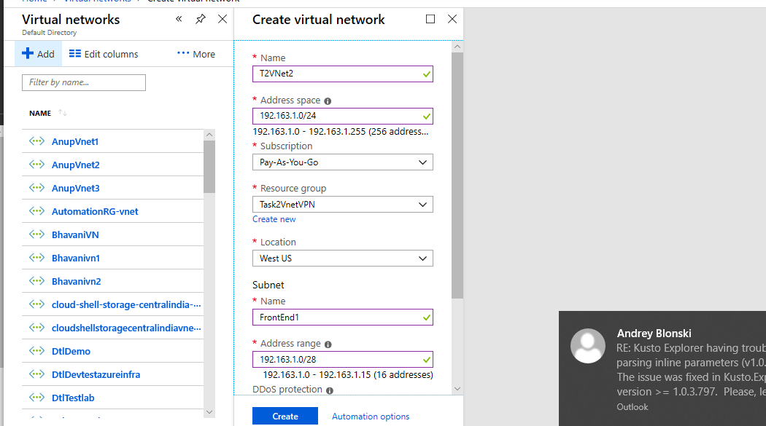

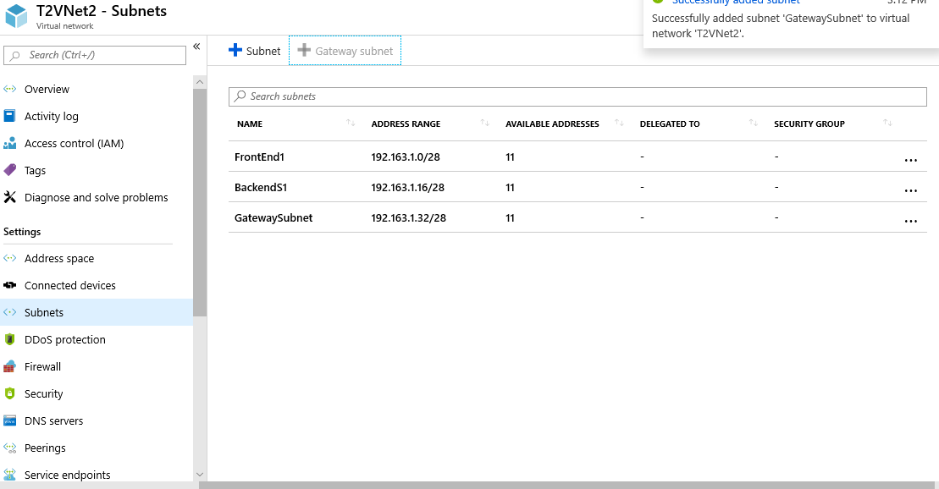

3.Creating vnet with Name **T2Vnet2** Address space **192.163.2.0/24** and FrontEndSubnet Name **FrontEndS1** Address Space **192.163.2.0/28** Backend Subnet **192.163.2.32/28** and gatewaysubnet

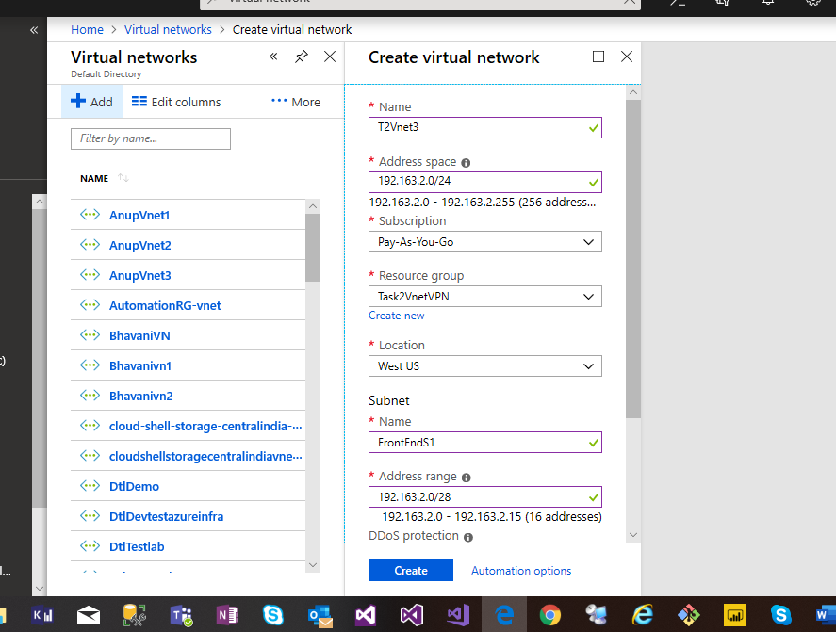

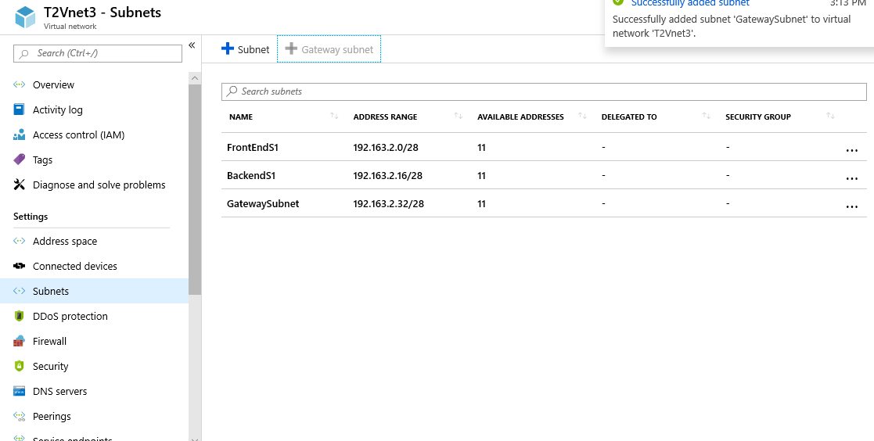

Vnet Peering between T2Vnet2 to T2Vnet3 and making T2Vnet as hub and T2Vnet3 as Spoke

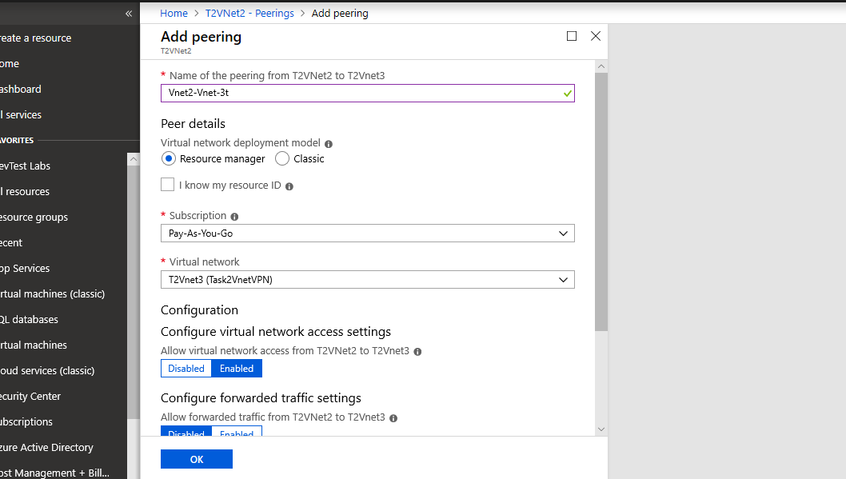

Created 2 VPN Gateways for T2vPNG1 and T2VPNG2 established Vnet to Vnet connection between both

