1.Created a resource group with name Madhavi

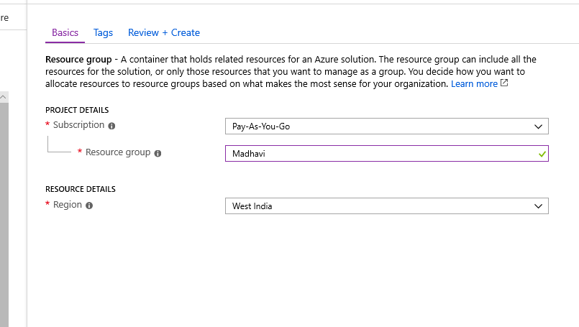

2.Created Virtual Network with name Madhu_Vnet

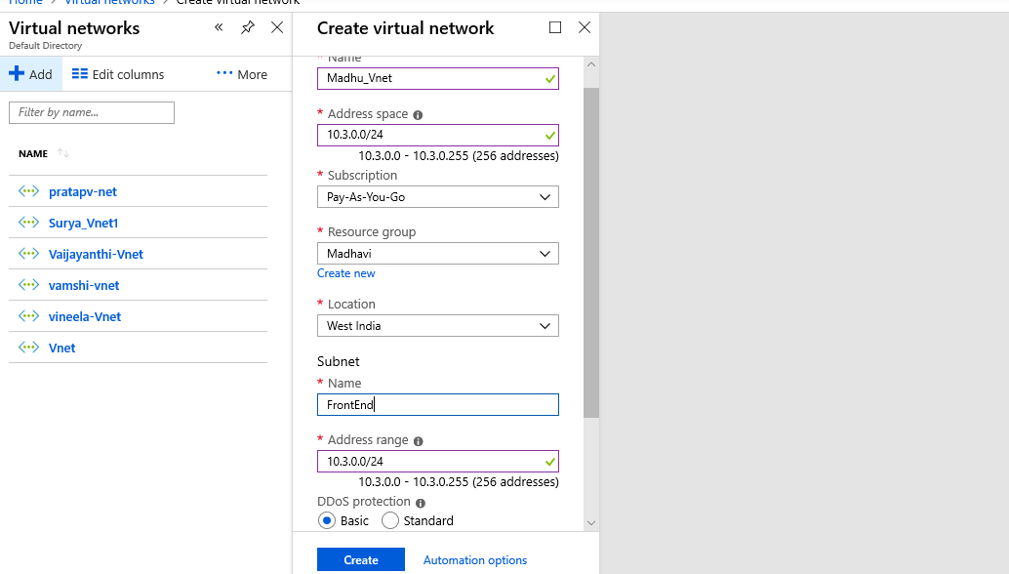

Created VM with Name MadhuVM

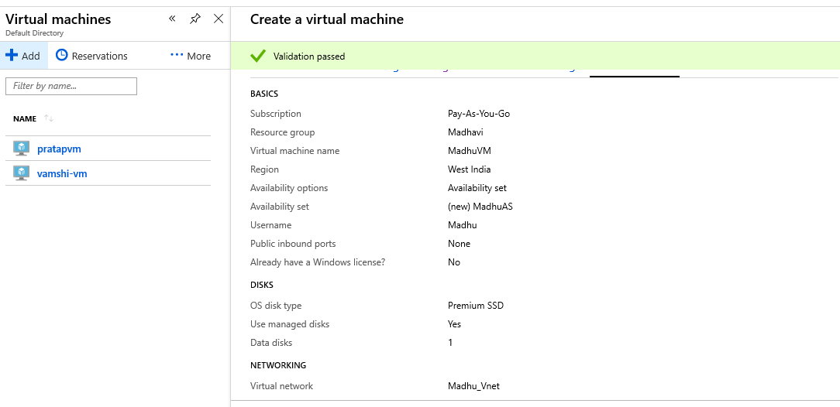

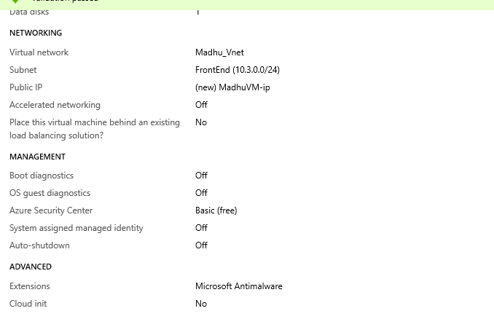

Created Snapshot

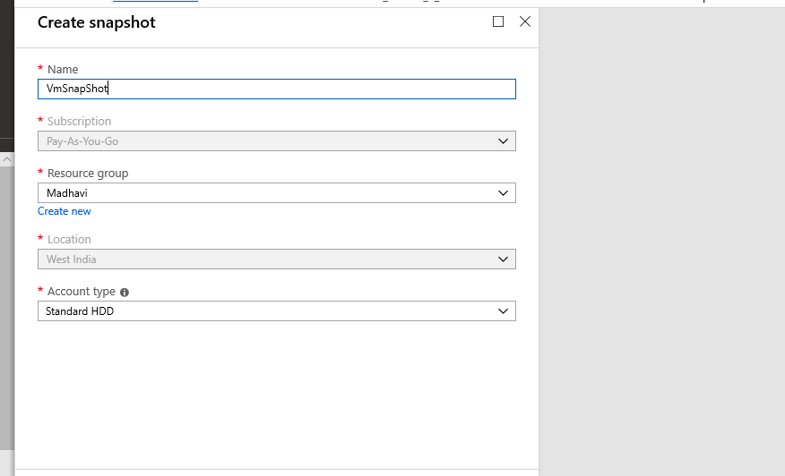

Created Image for VM MadhuVM1

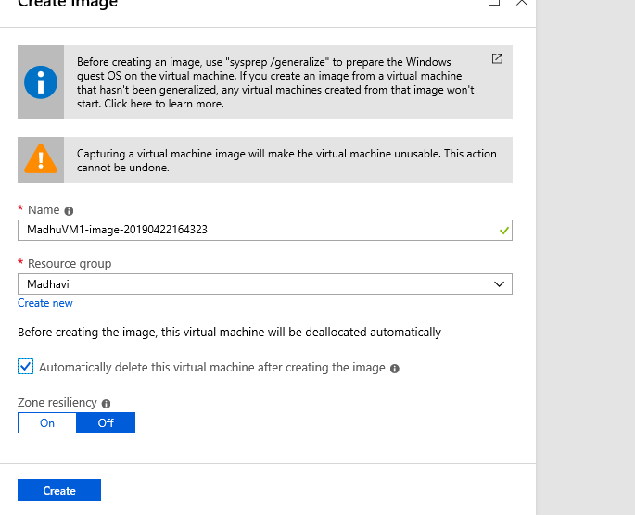

Created Snapshot for Managed Disk

Created Snapshot for Managed Disk 