1.Created Resource Group: Vnet1RG

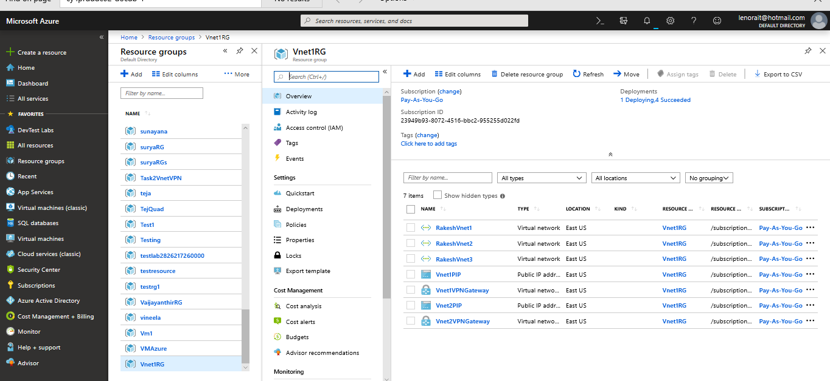

2.Created Vnet by name Rakesh Vnet1

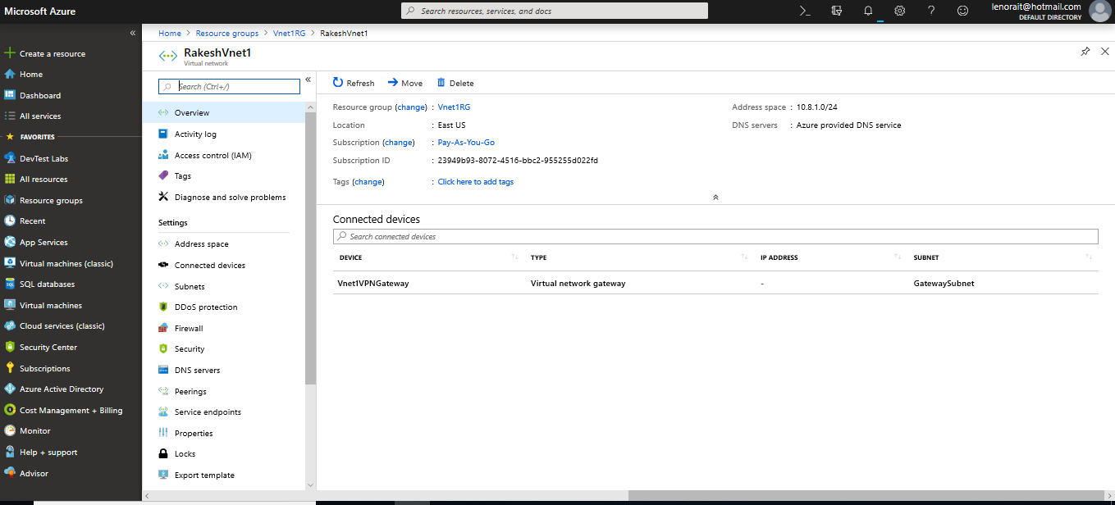

3.Created Vnet by name Rakesh Vnet2

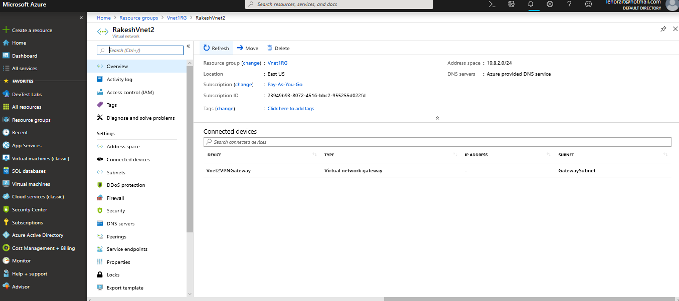

4. Created Vnet by name Rakesh Vnet3

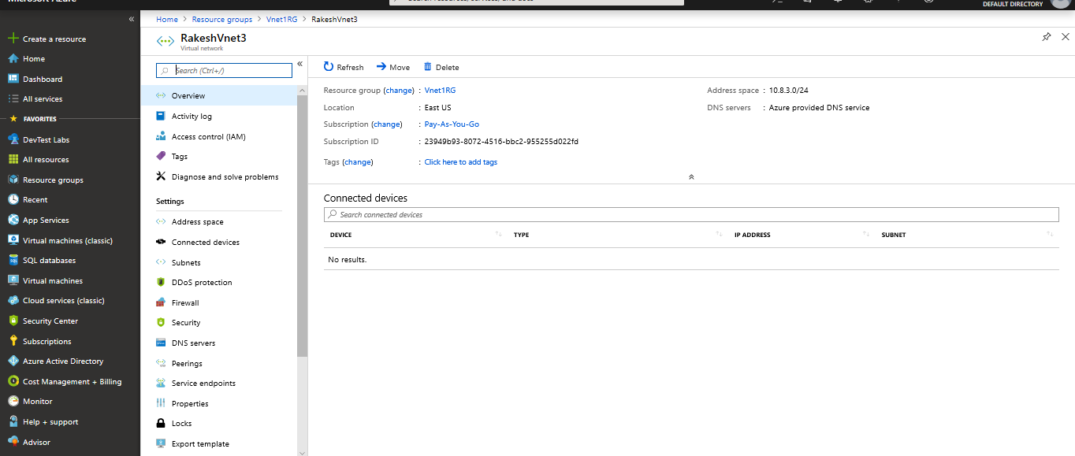

5.Created VPN Gateway By name Vnet1VPNGateway

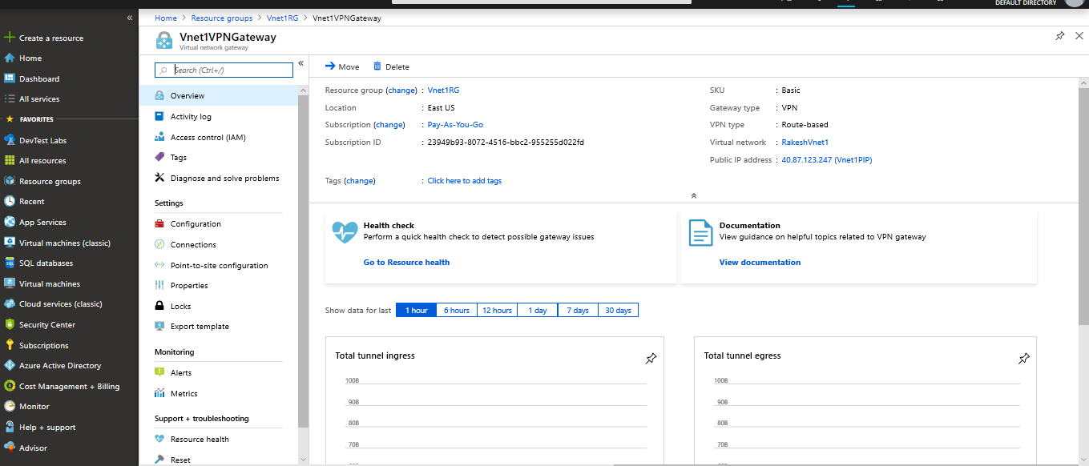

6. Created VPN Gateway By name Vnet2VPNGateway

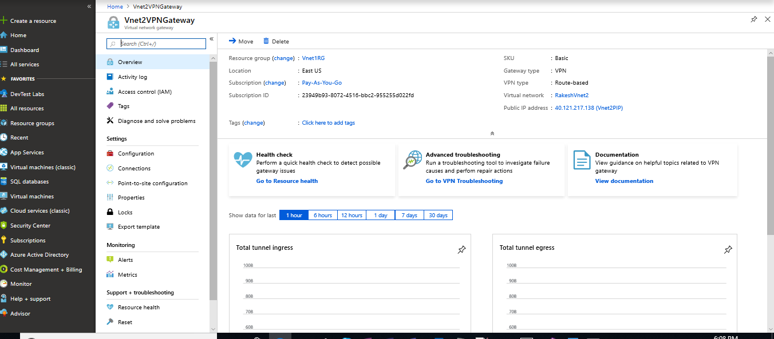

7.Established connection from Vnet1VPNGateway to Vnet2VPNGateway

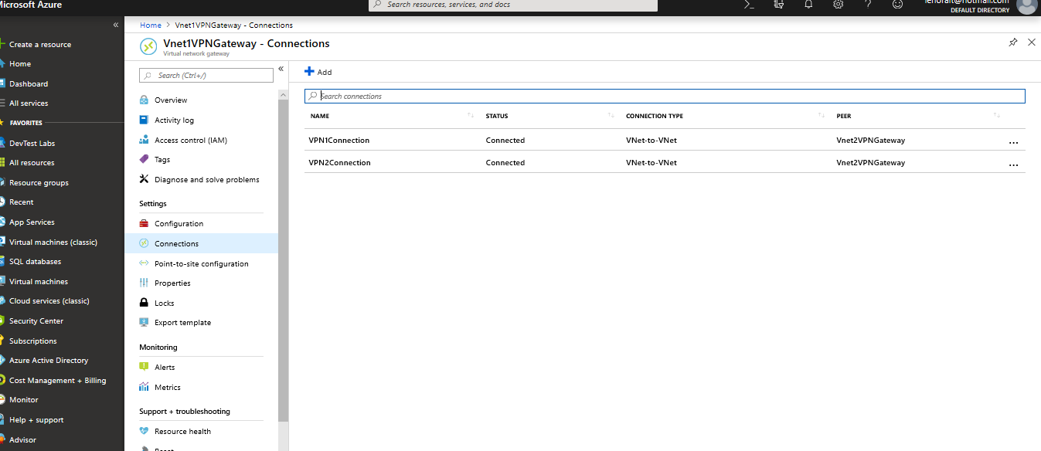

8.Established Vnet peering between Vnet2 and Vnet3

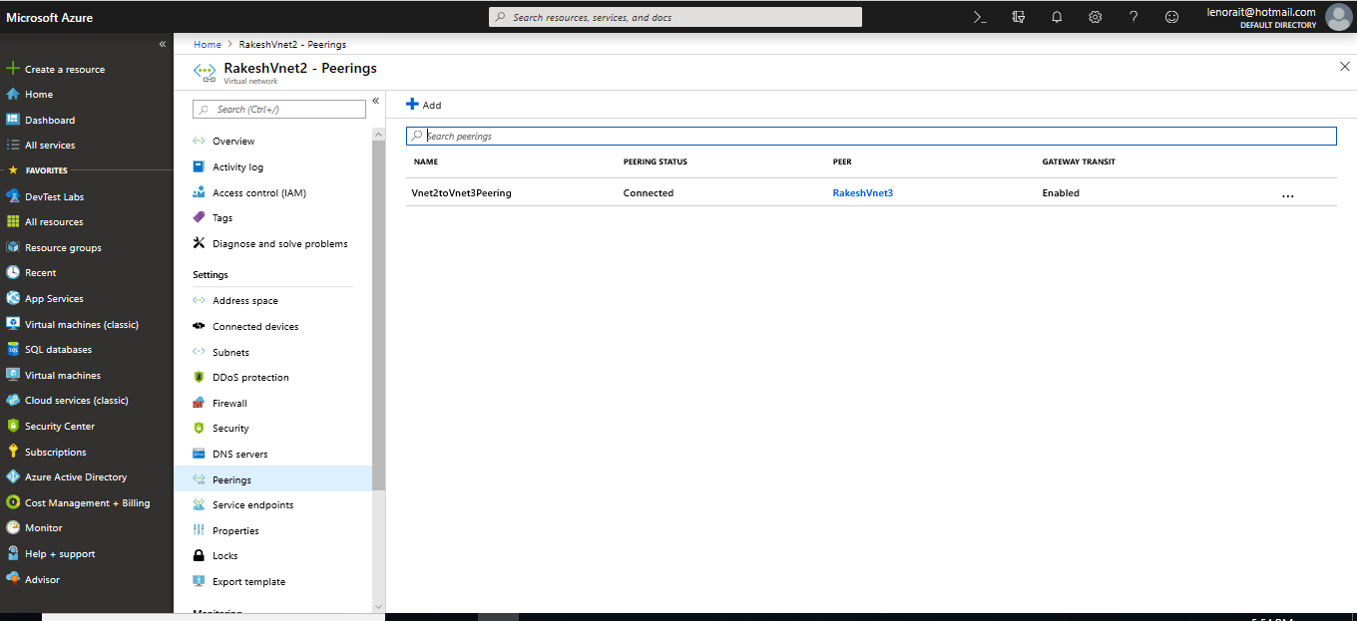

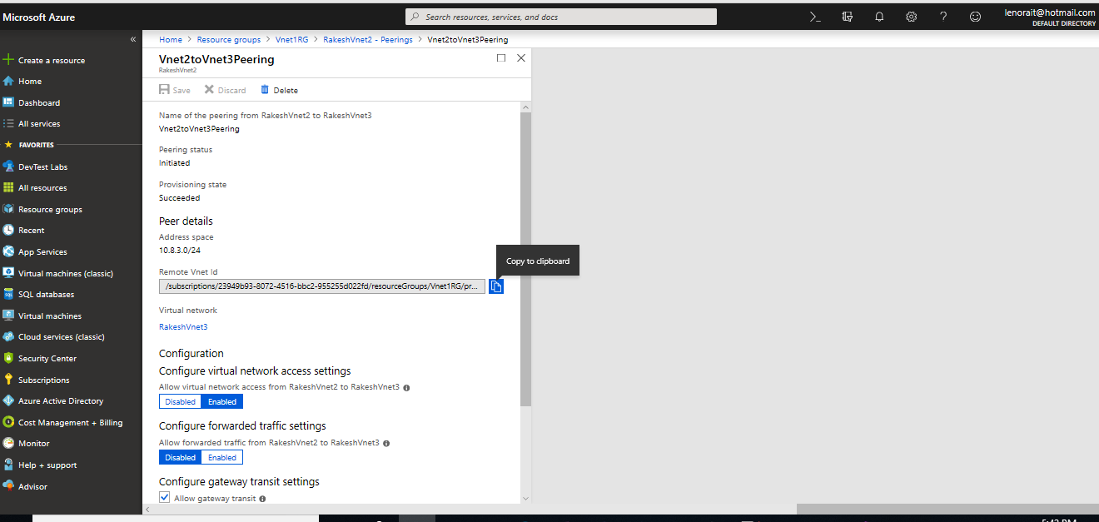

9.Established Vnet peering between Vnet3 and Vnet2

