VNet, Subnet, NSG & Rules

**Task:** Creating a VNet in the Resource group and adding Frontend, Backend Subnets along with FrontendNSG, BackendNSG network security groups and adding rules to it using CLI.

1. Created a Resource Group

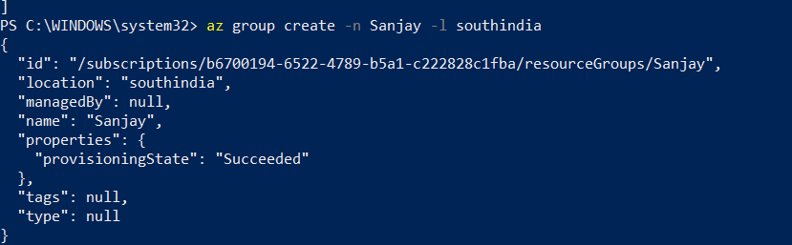

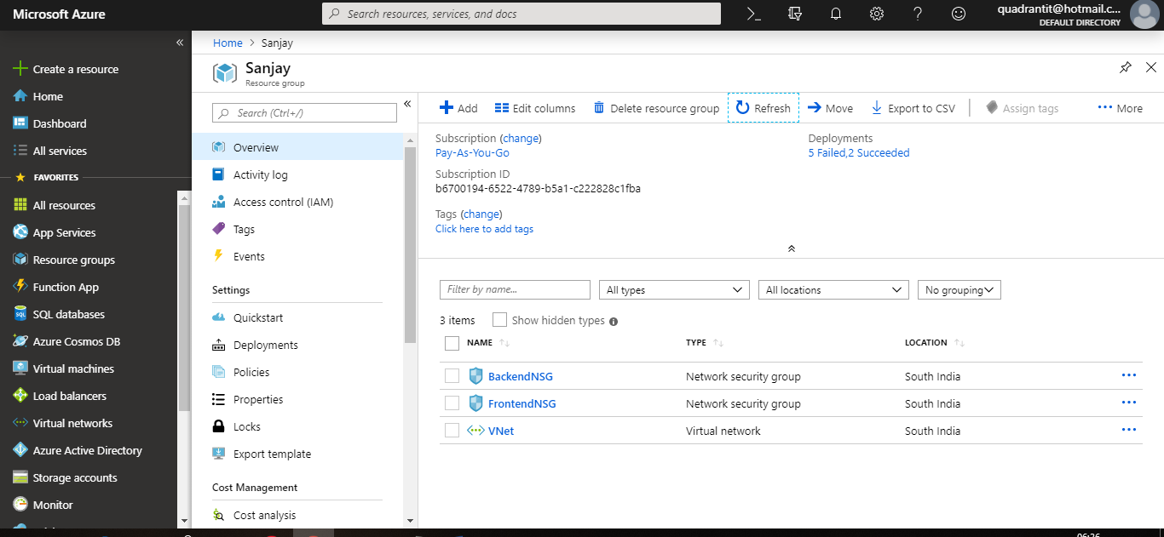

1. Created a Virtual Network “VNet”.

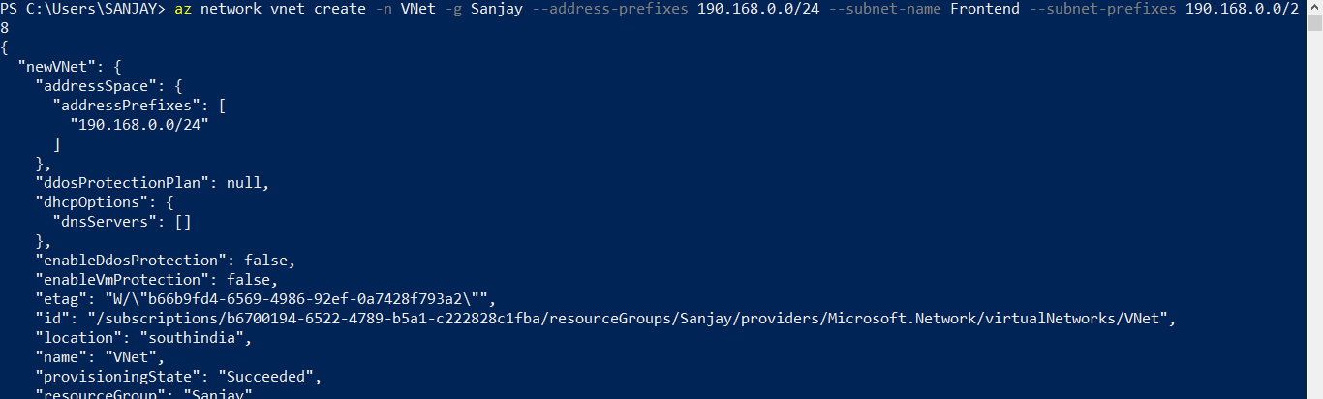

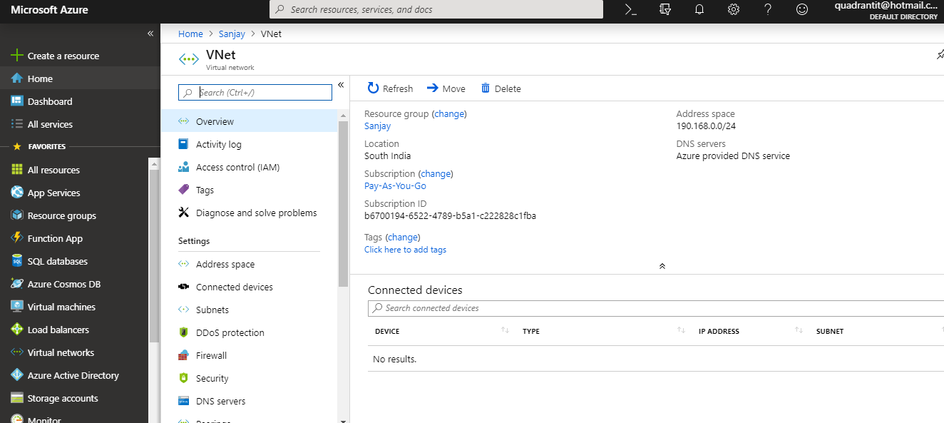

1. Created 2 Subnets in VNet as Frontend and Backend.

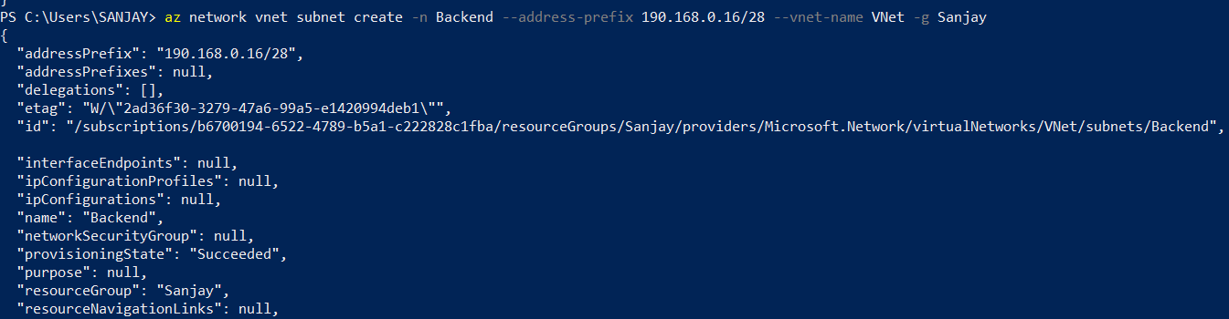

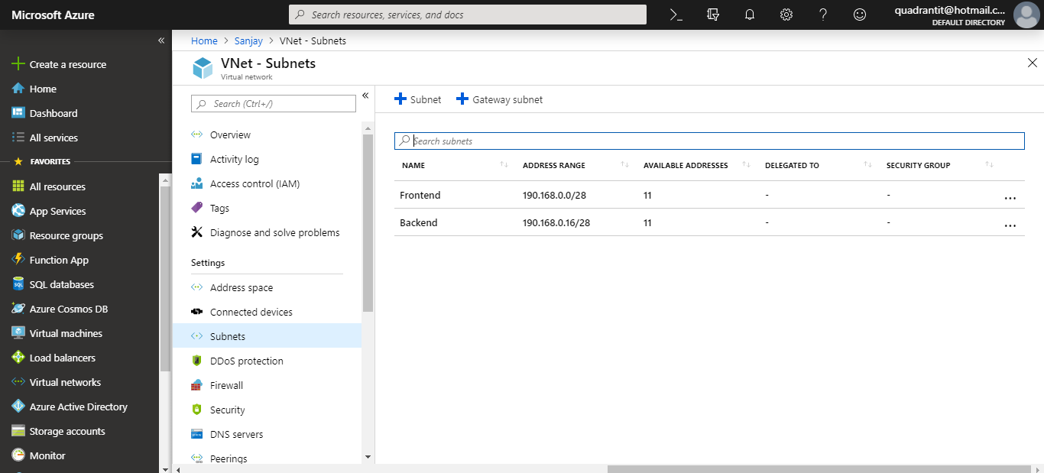

1. Created 2 NSG as FrontendNSG and BackendNSG.

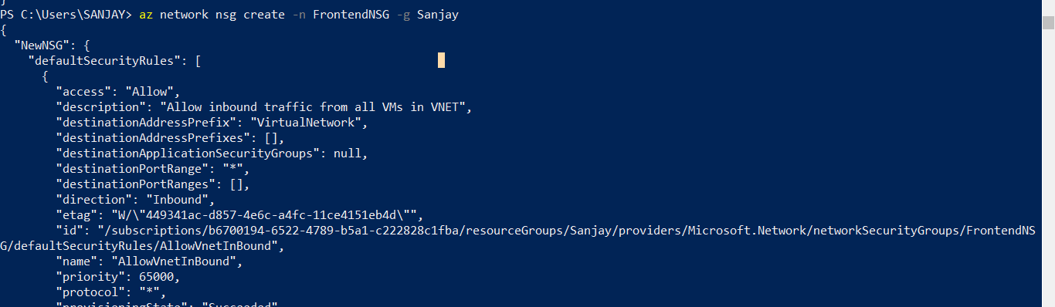

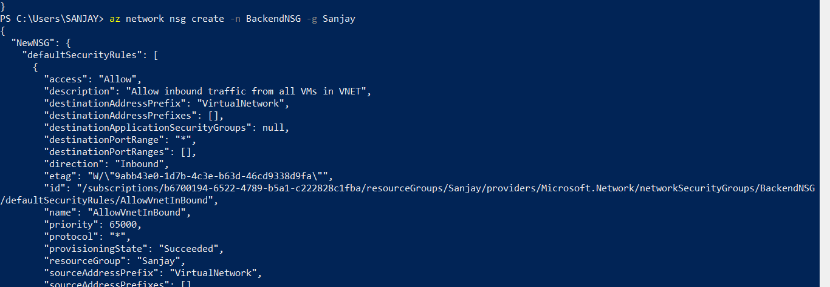

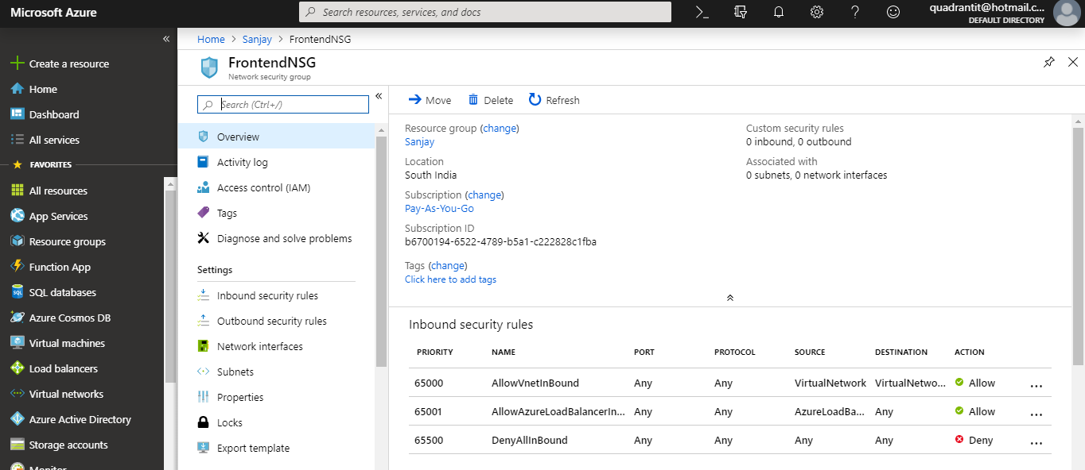

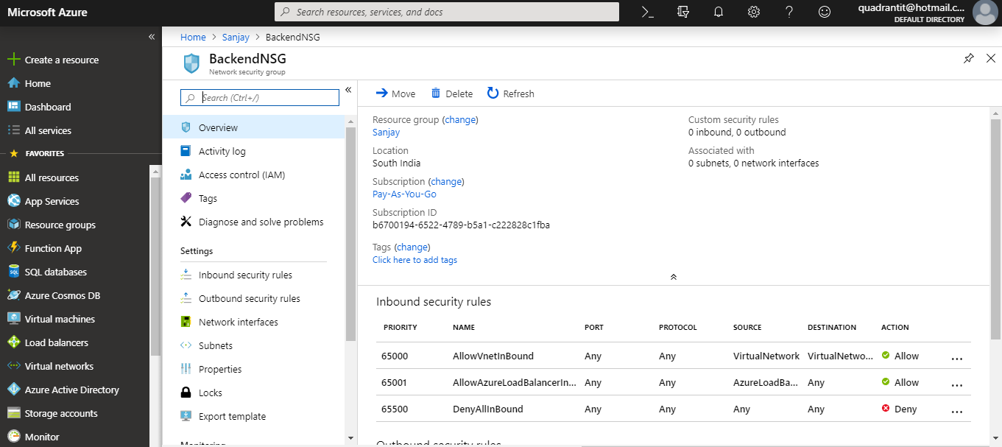

1. Added an inbound security rule for FrontendNSG and allowed RDP,HTTP,HTTPS,SSH

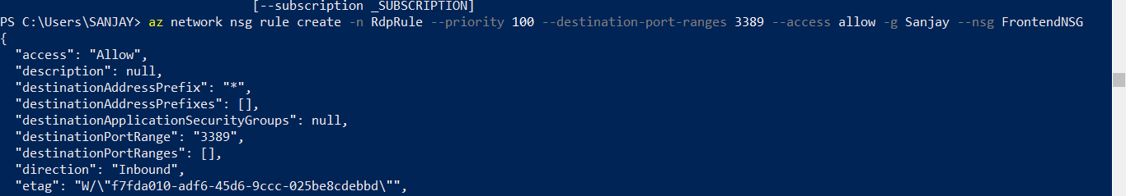

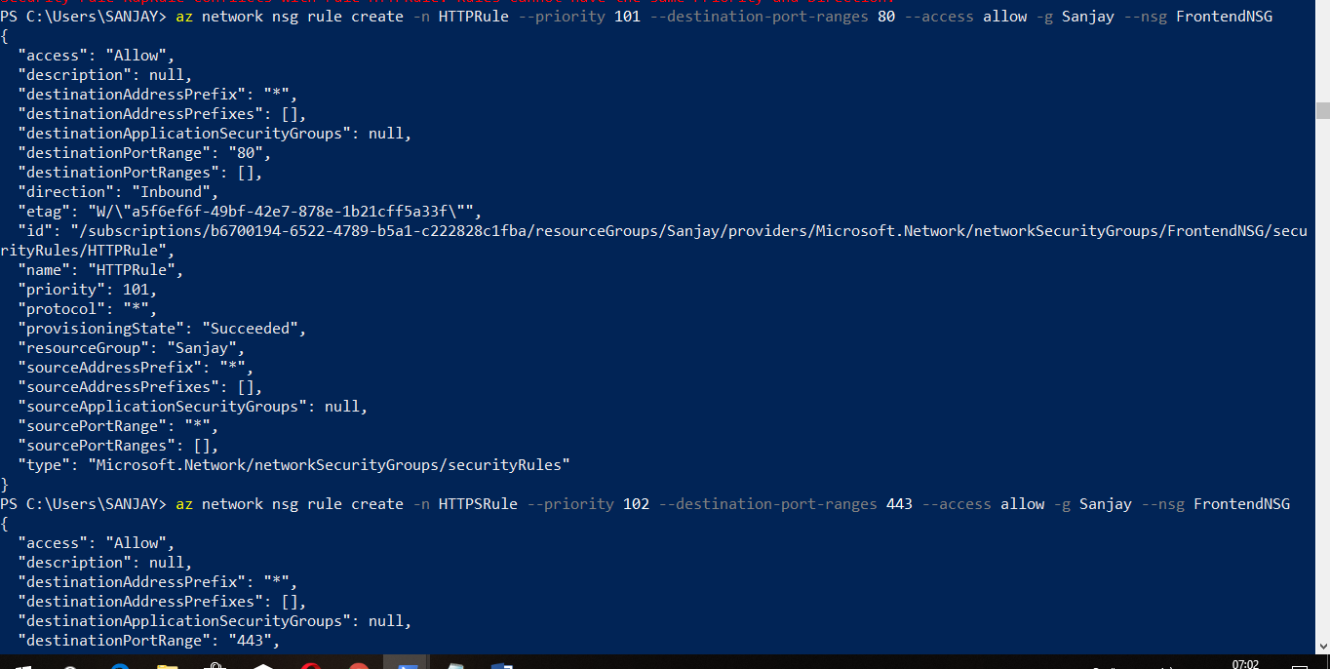

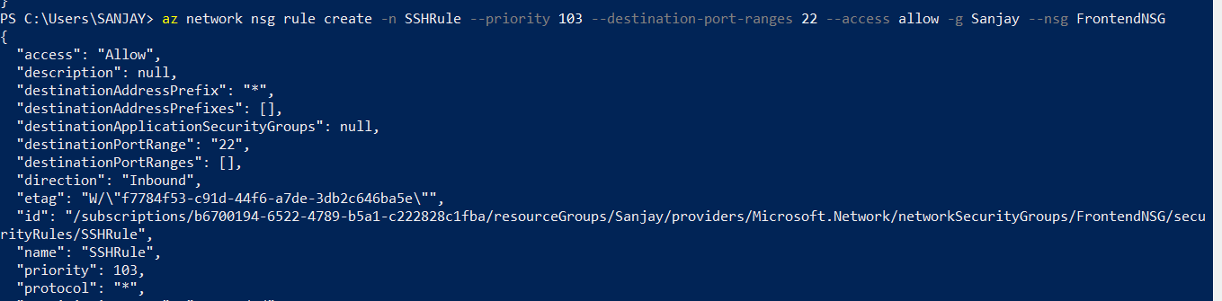

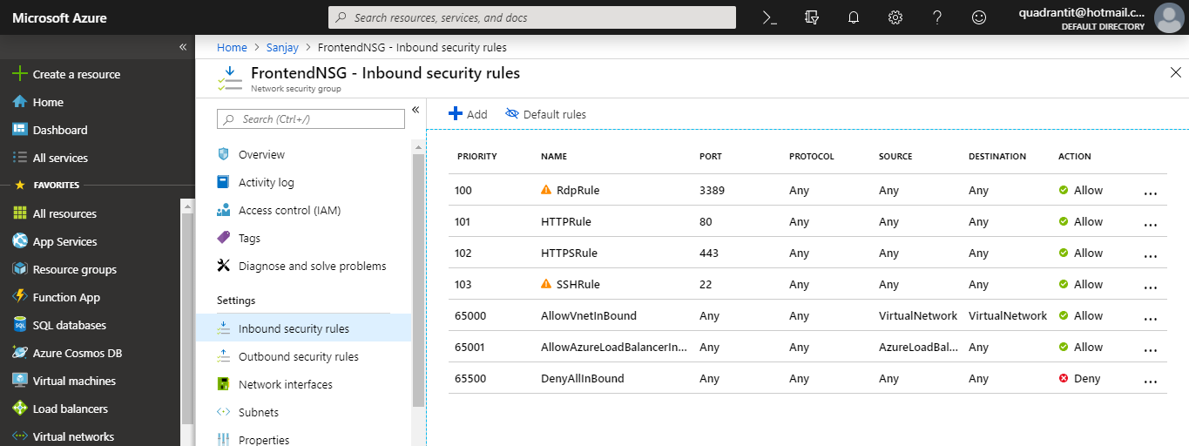

4. Created rules for BackendNSG and Allowed MSSql,RDP in Inbound and Denied HTTP in Outbound.

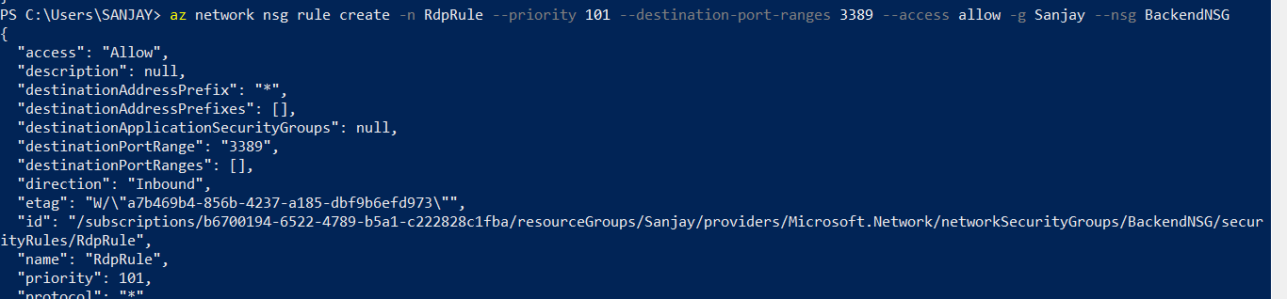

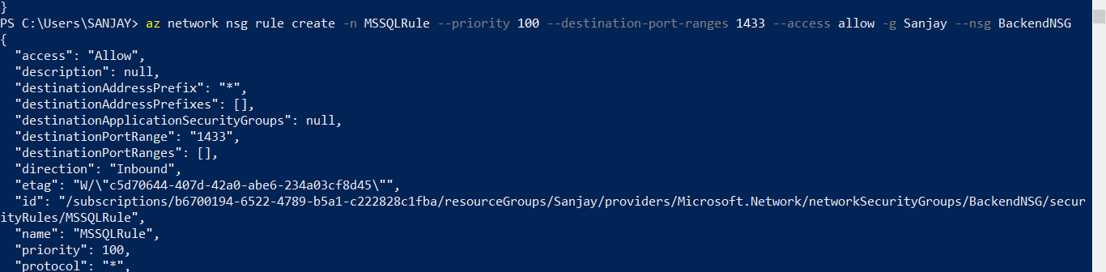

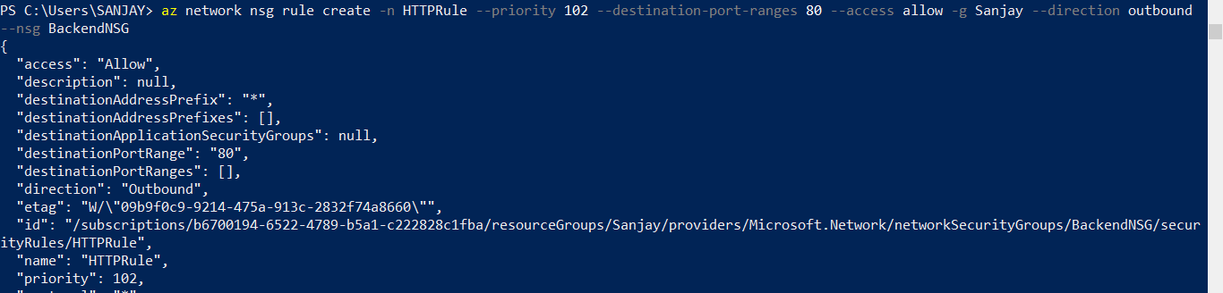

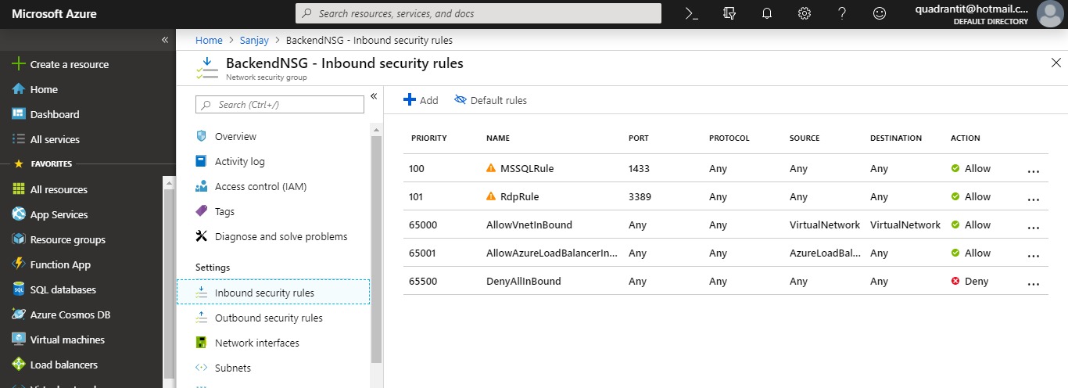

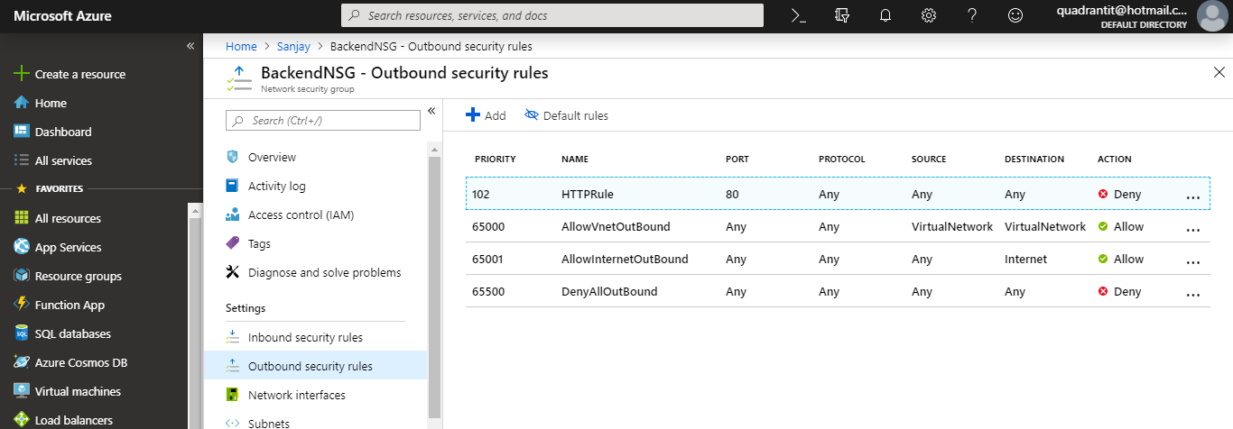

1. Attached the NSG to each one of the Subnets in VNet.

