VNet,Subnet, NSG, Rules

1. Created a Resource Group

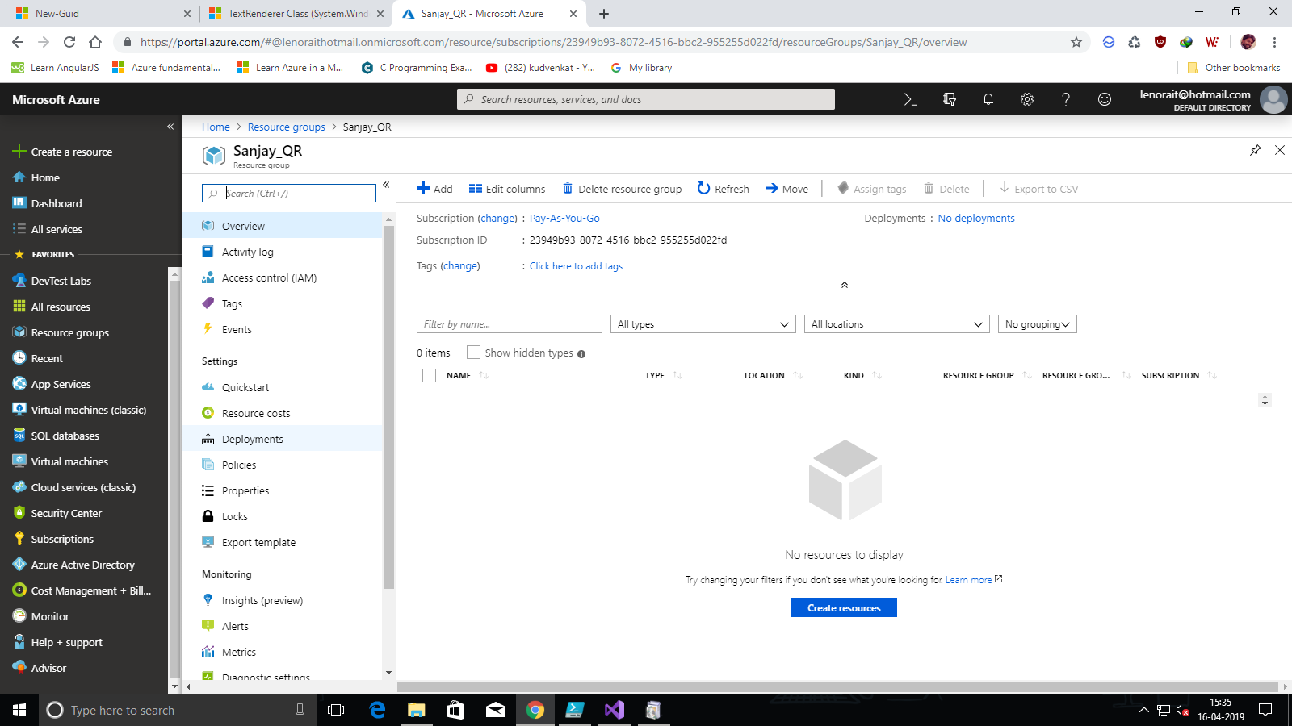

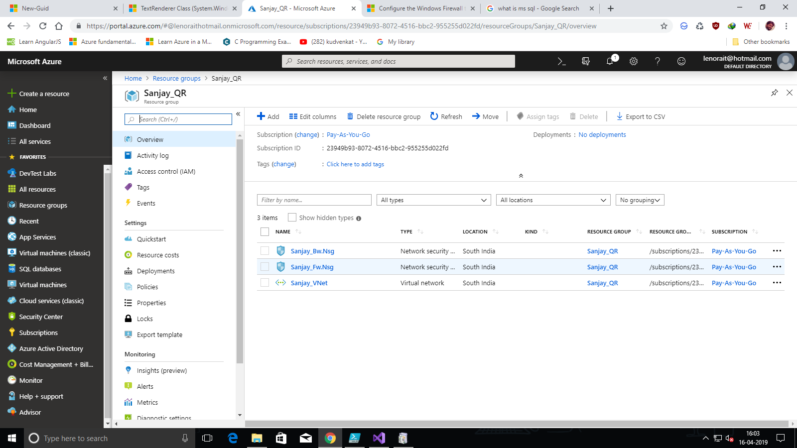

1. Created a Virtual Network

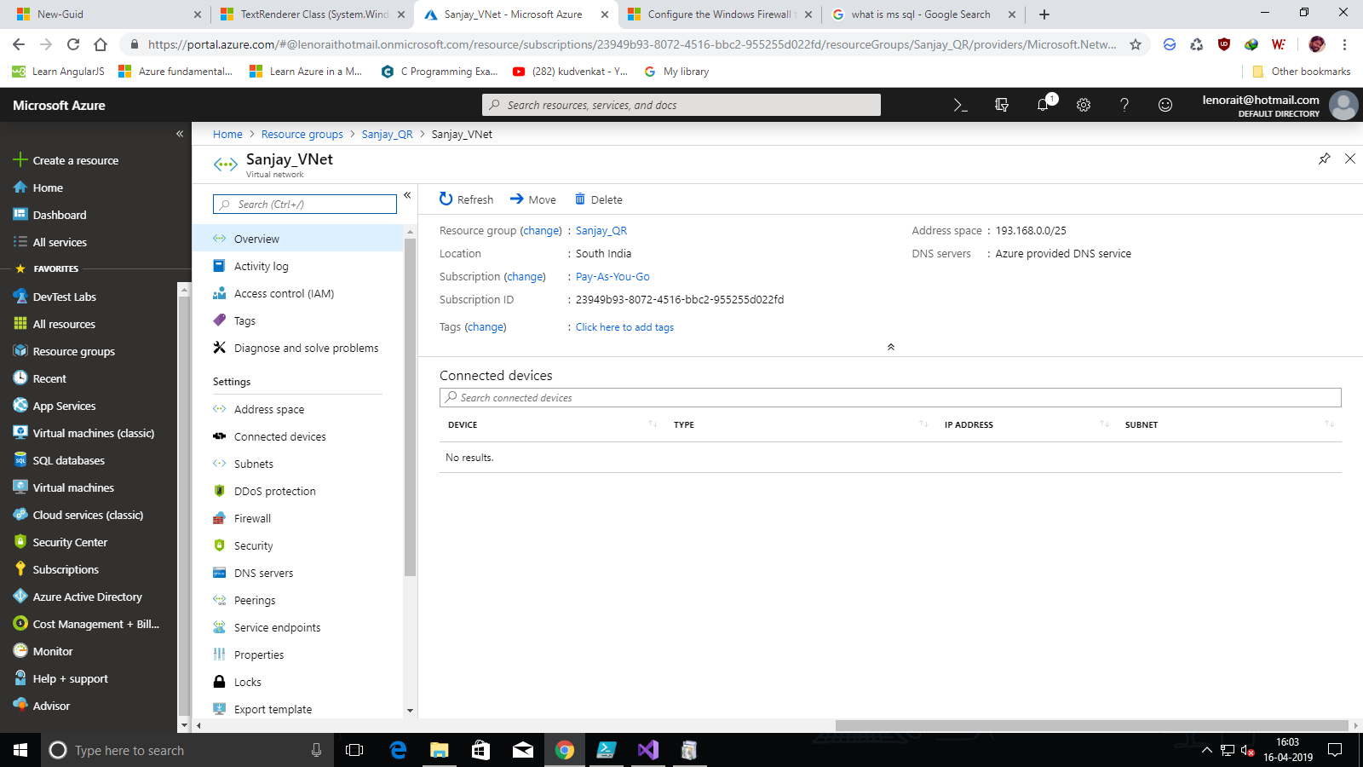

1. Created Frontend and Backend Subnets for VNet.

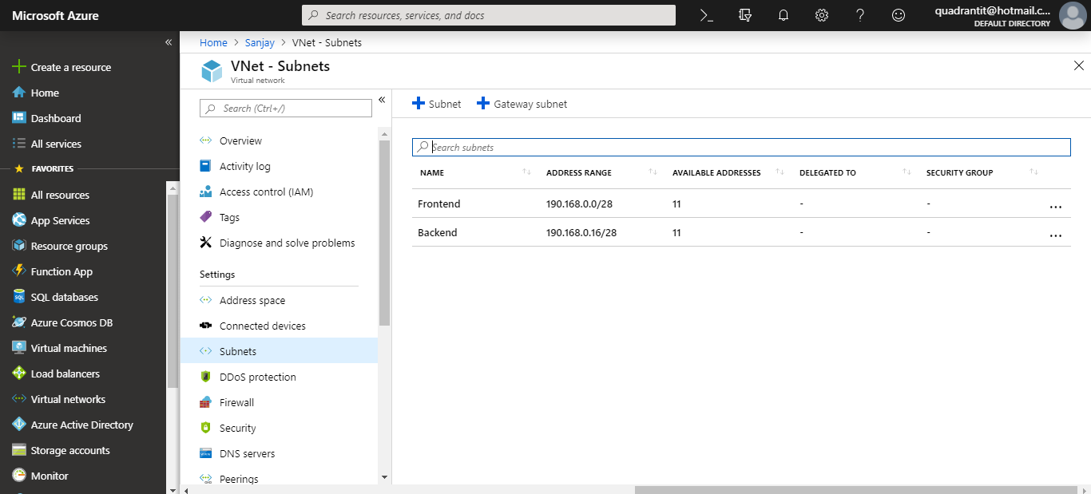

1. Created a Frontend NSG and allowesd Inbound rules for Frontend NSG

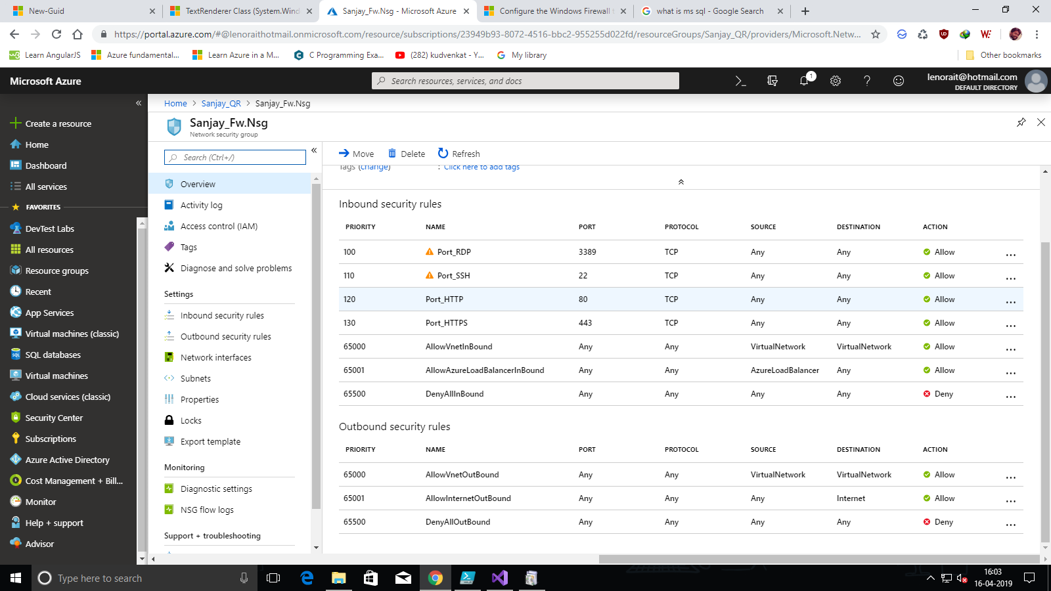

5 . Created a Backend NSG and allowed inbound rules and Denied HTTp in Outbound rules.

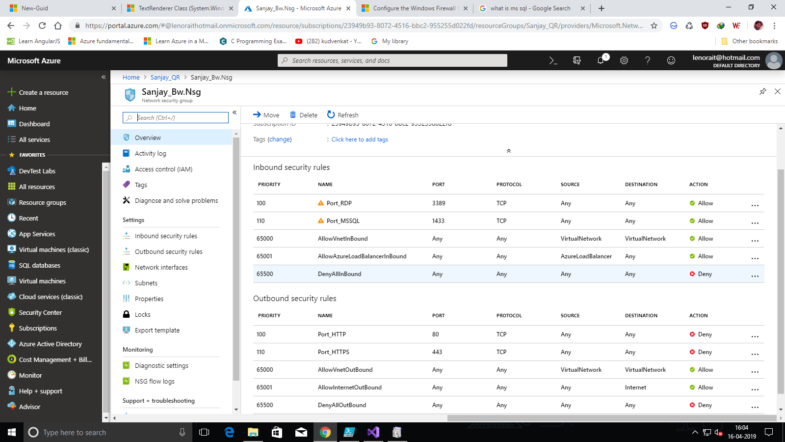

1. Attached NSG to Subnets in VNet.

