1. Created a Resouce Group

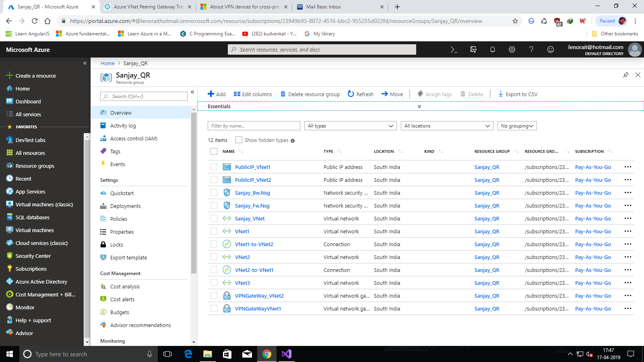

1. Created a 3 VNets **as VNet 1, VNet 2, VNet 3** with 2 Subnets as Frontend and Backend with Gateway Subnet with 16 IP Addresses in Each VNet.
2. VNet1

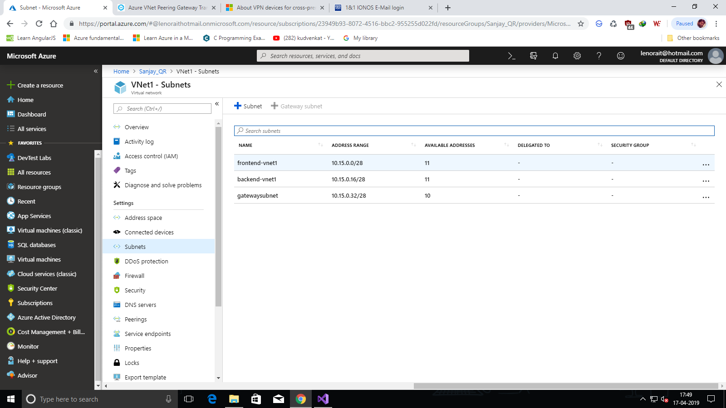

1. VNet2

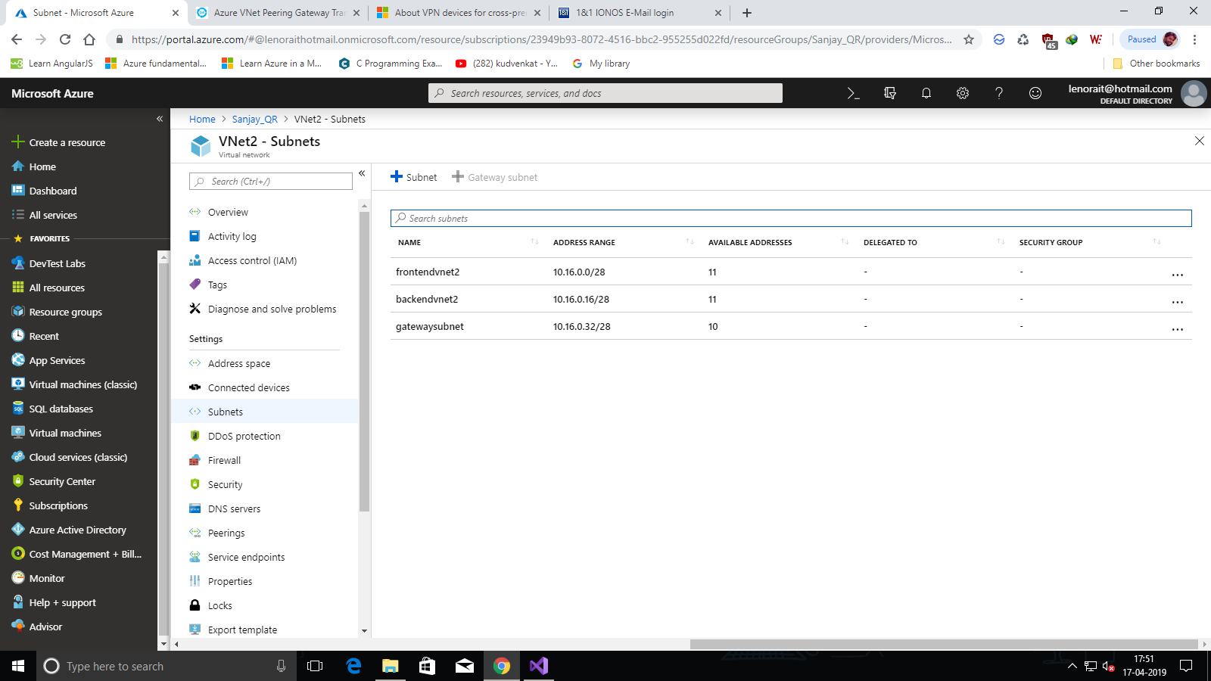

c.VNet3

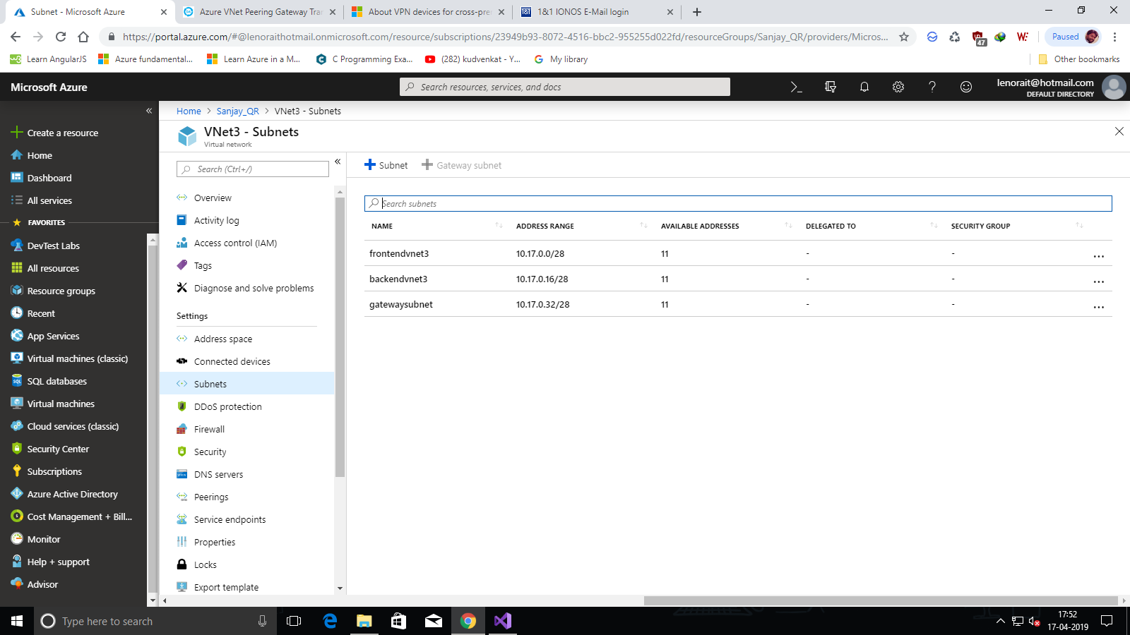

1. Created a VPN Gateway for VNet1

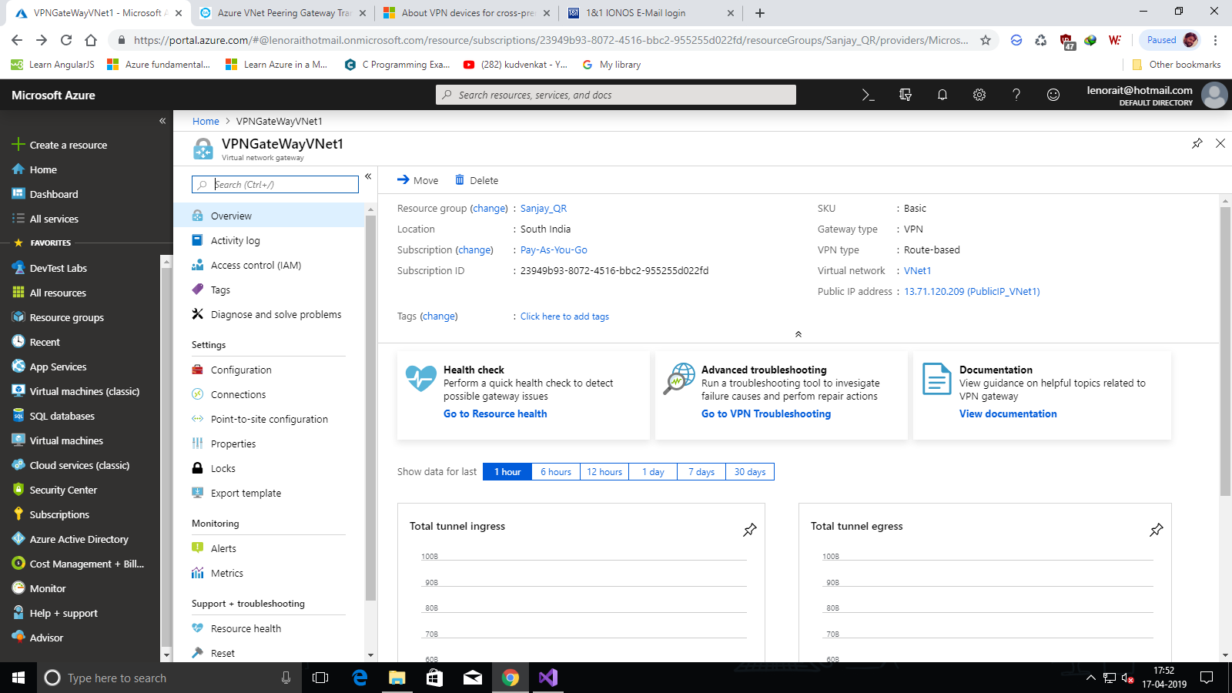

1. Created a VPN Gateway for VNet2

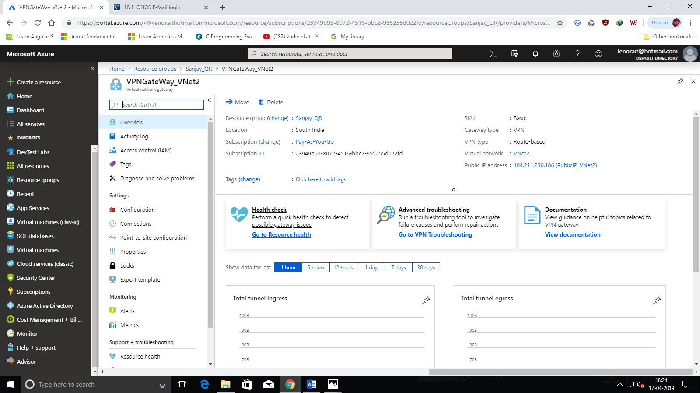

1. Created a VPN Connection for VNet1 & VNet2 using VPN GateWay for VNet1.

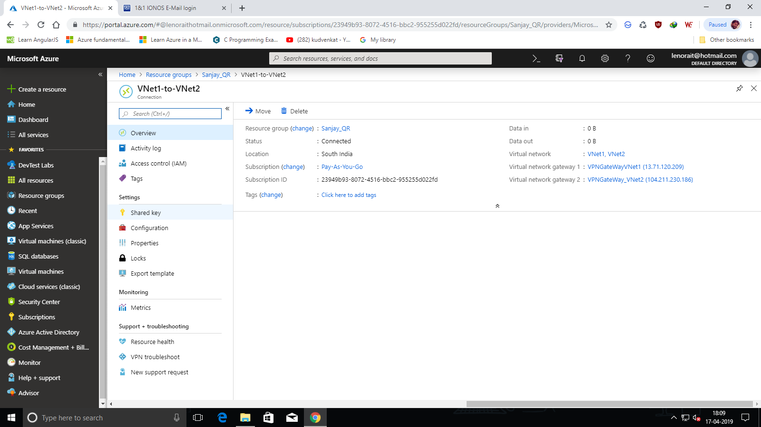

6. Created a VPN Connection for VNet2 & VNet1 using VPN GateWay for VNet2.

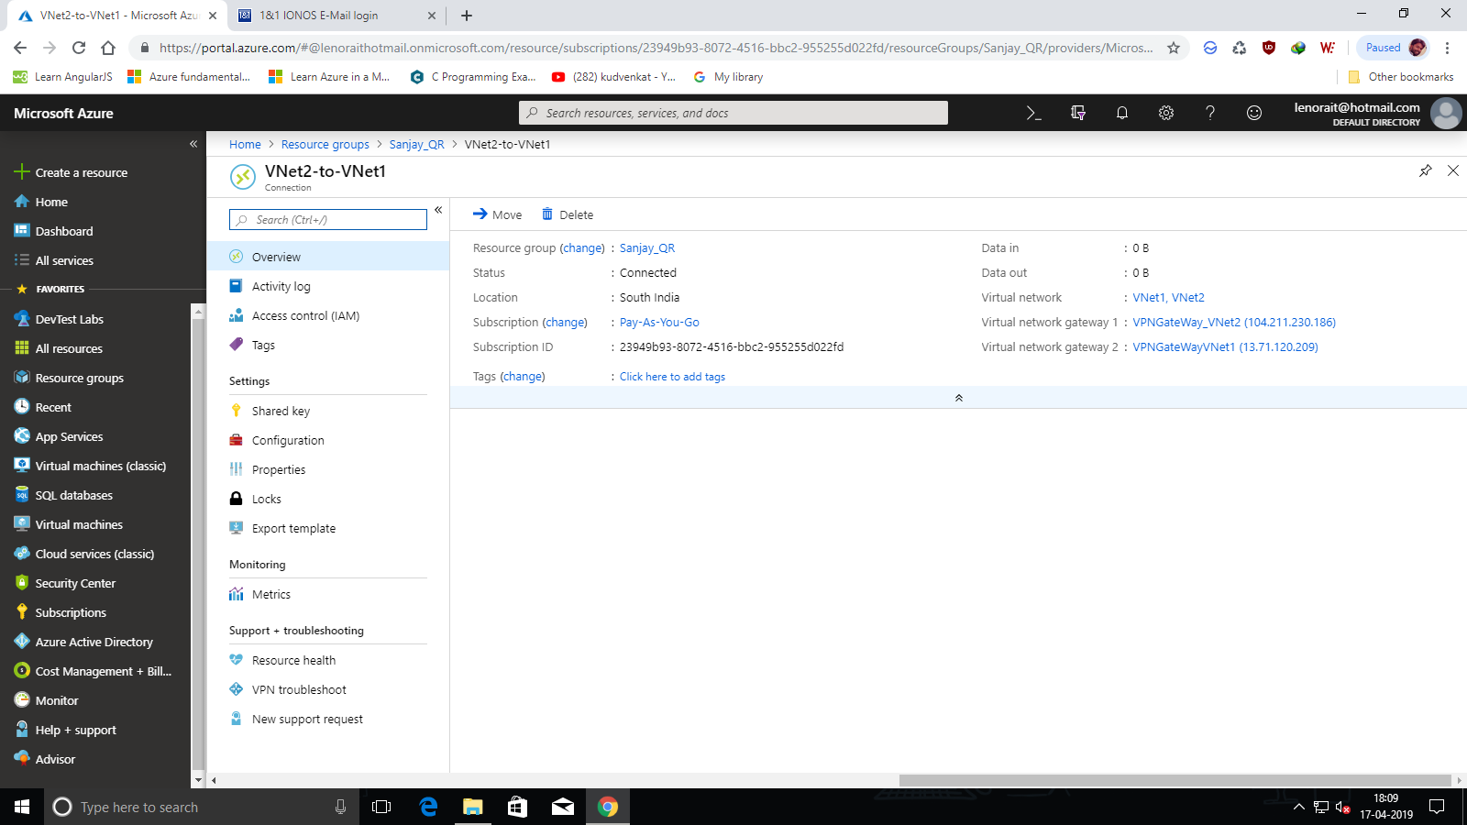

7.Created a VPN Peering for VNet2 to VNet3 using Vnet2 Peering

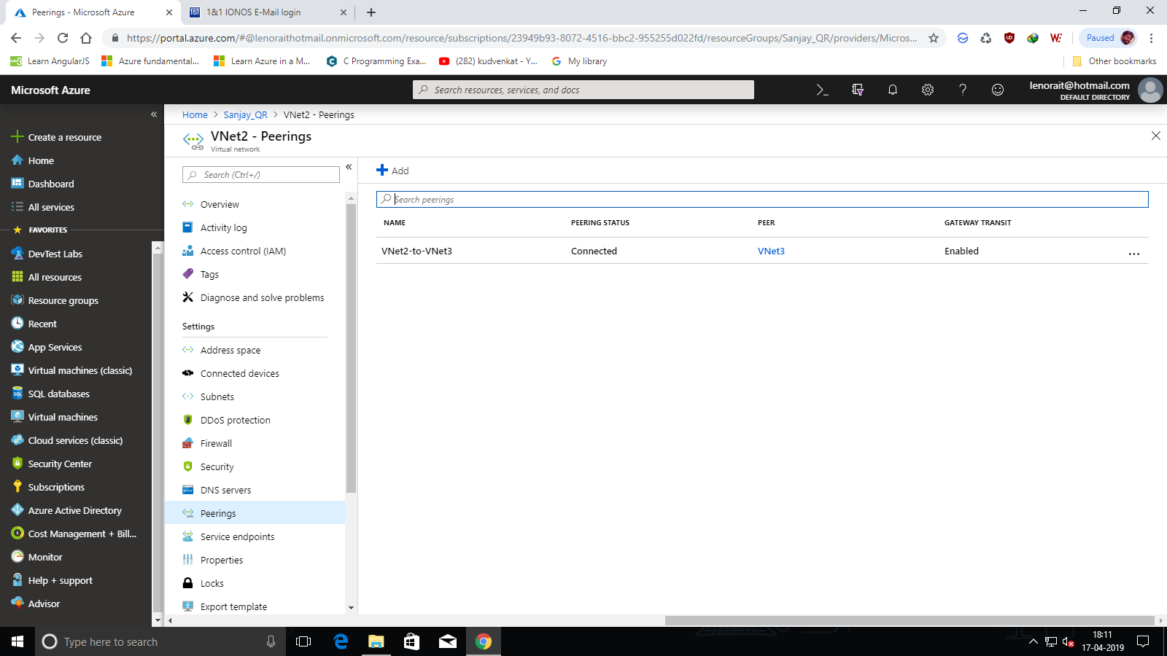

8. Created a VPN Peering for VNet3 to VNet2 using Vnet3 Peering

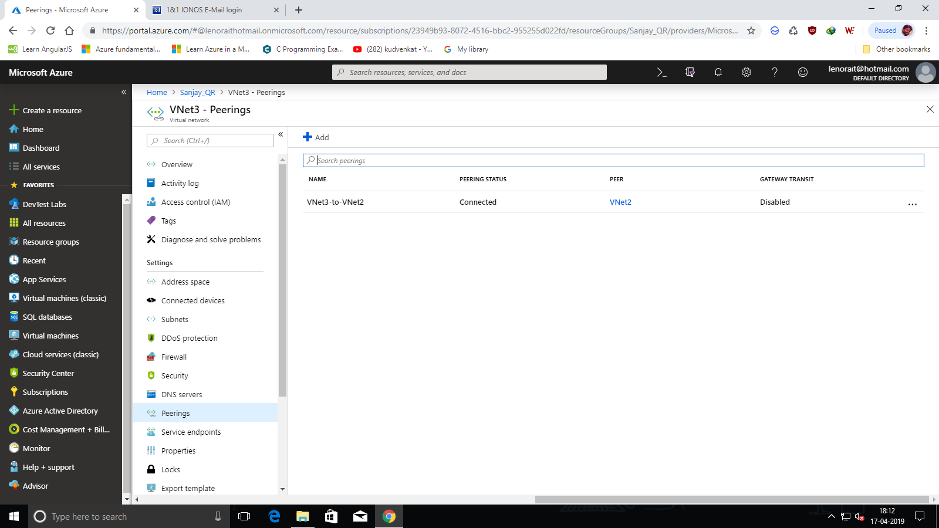

9. Created a **“HUB”** **for VNet2** by Selecting **“Allow Gateway Transit”.**

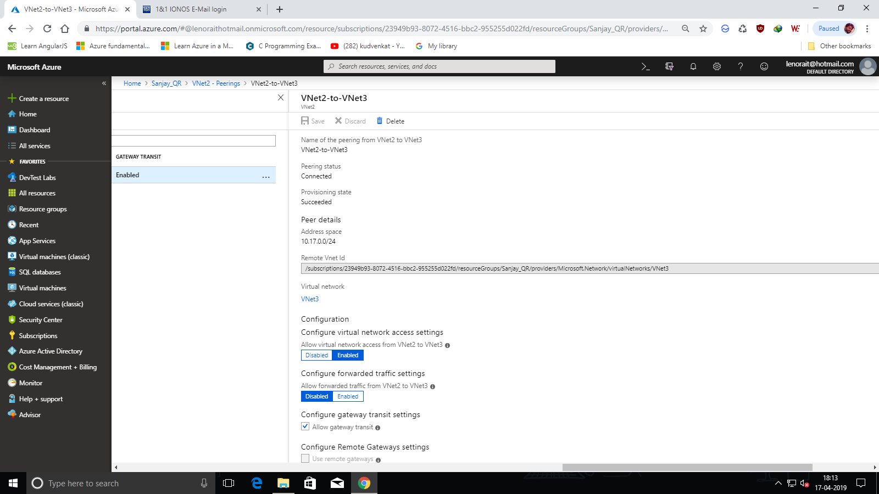

10. Created **a “Spoke” for Vnet3** by Selecting **“Use Remote Gateways”.**

