Task 3

Task: Create a VM1 in a resource group and take snapshot of that VM2 and add it in another VM, and create an Another VM for creating an image by Capturing VM1 by doing it VM1 Should be deleted.

1. Created a Resource Group “Sanjay-Resources”.

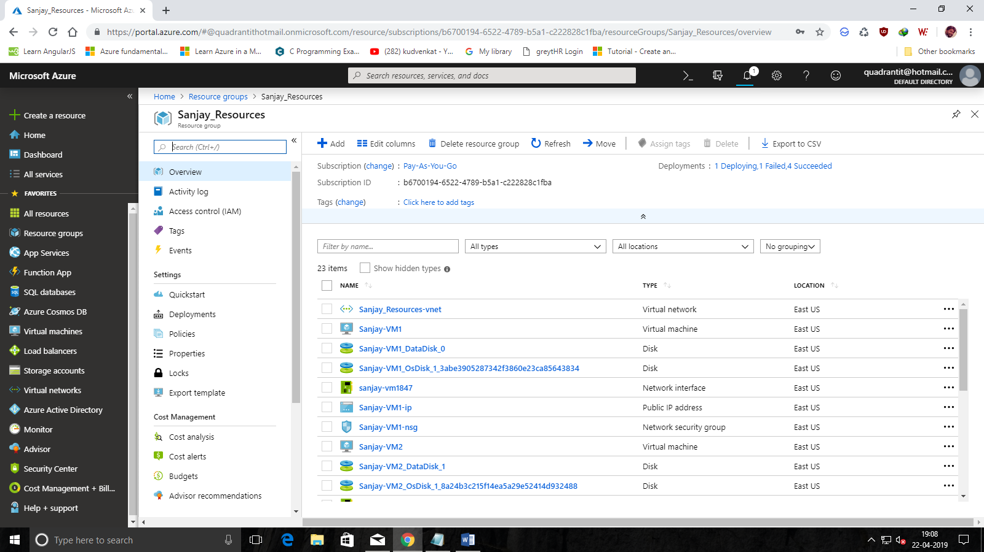

1. Created One Virtual Machine “Sanjay-VM1”.

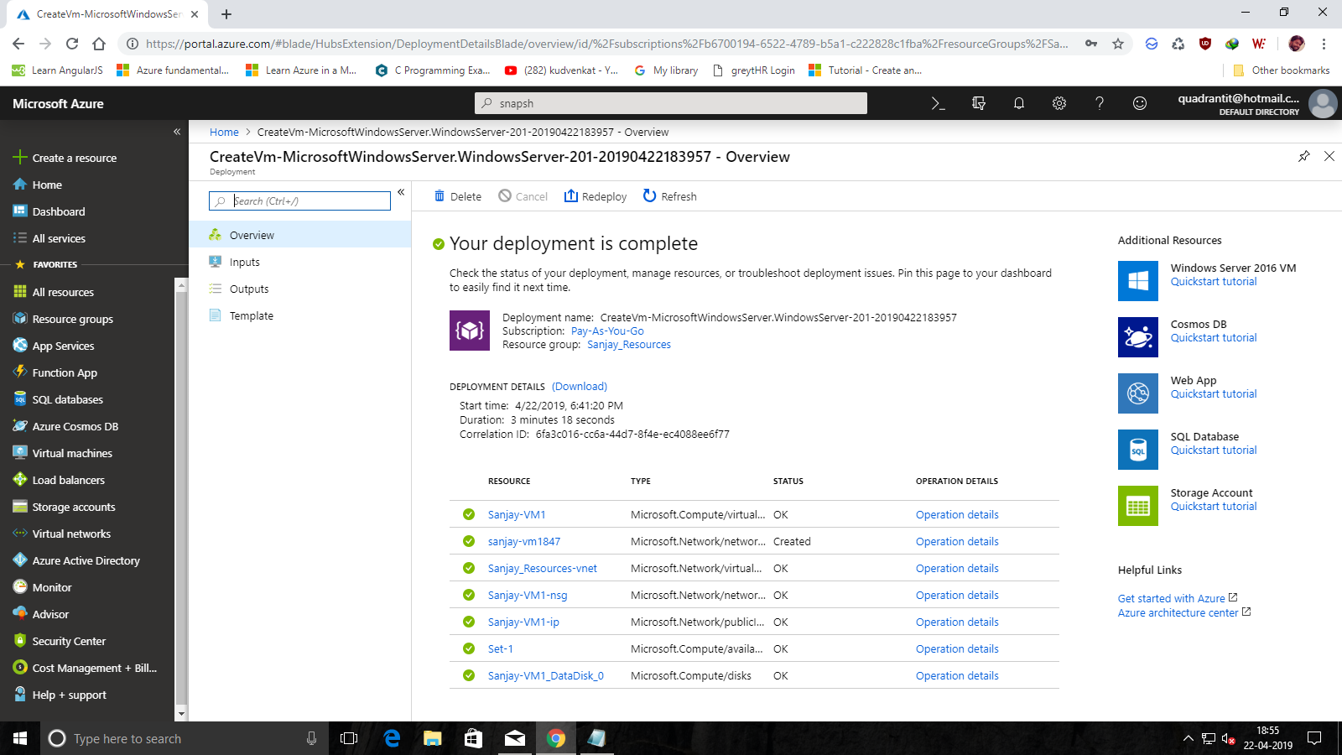

3. Created a Snapshot of “Sanjay-VM1”.

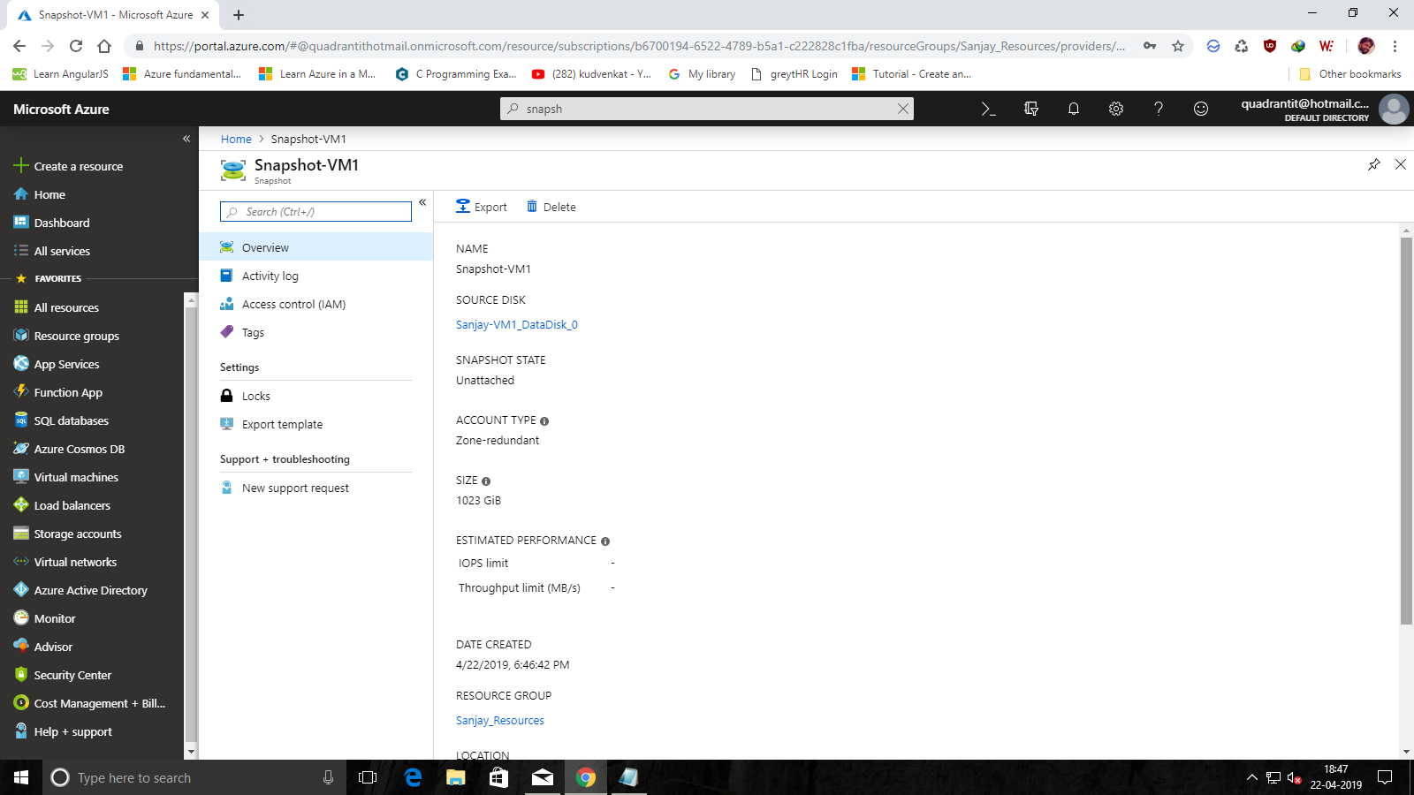

1. Created another VM “Sanjay-VM2” by adding an Existing disk using the Snapshot of VM1.

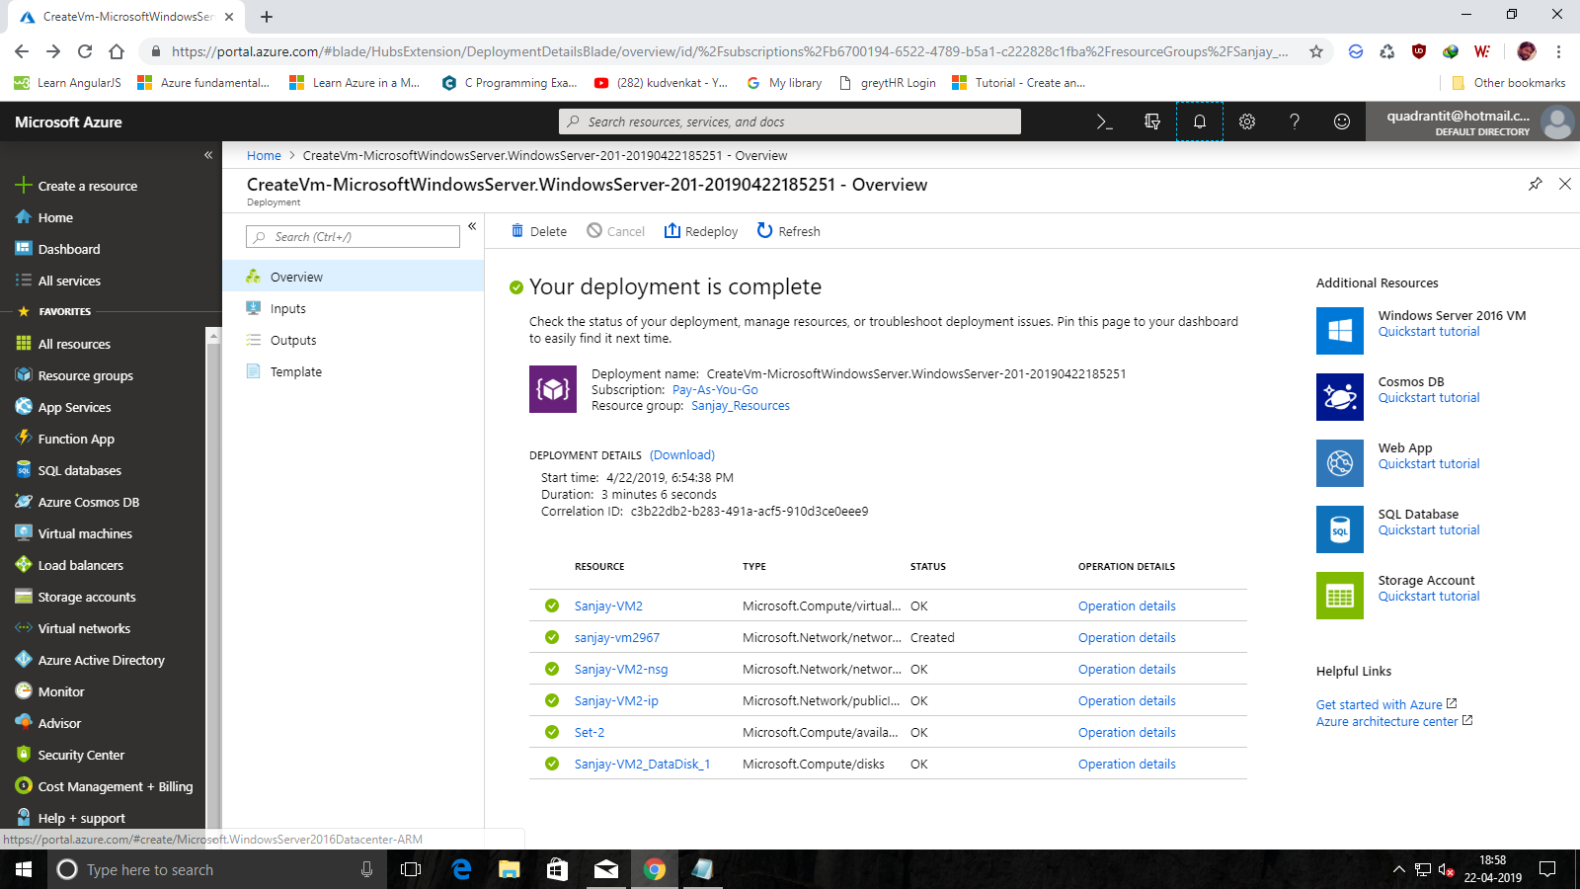

1. Created an Image for “Sanjay-VM1” in which in turn deletes the VM “Sanjay-VM1”.

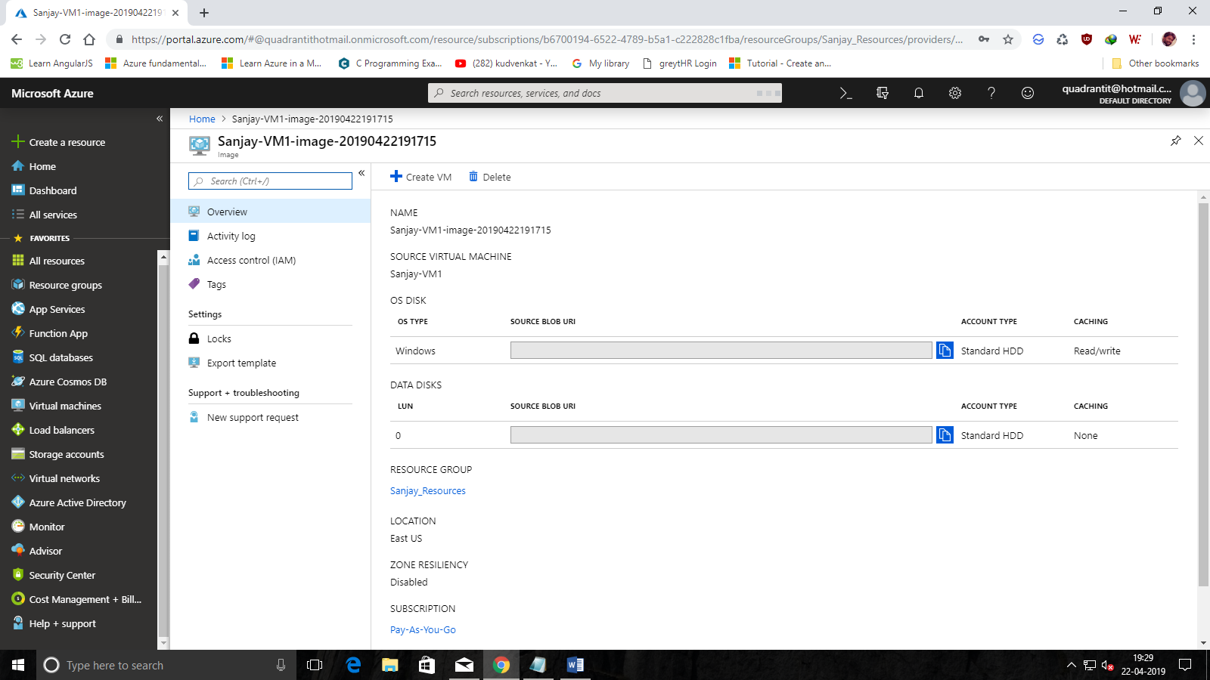

5. After Creating the Image for VM1 the VM1 gets deleted.

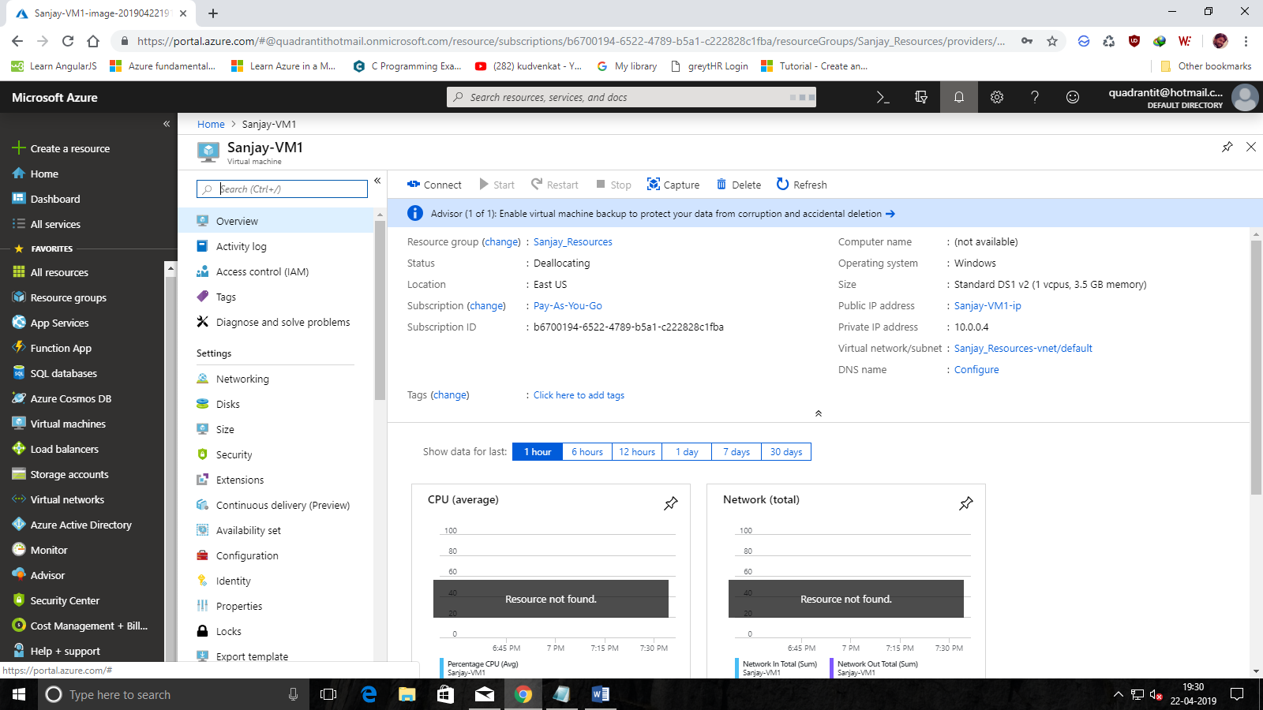

1. Creating VM3 “Sanjay-VM3” using the existing Image of VM1.

