**Task-1:**

1.Creating V-net

2.Creating Sub Nets

3.Creating NSG and adding Inbound and Outbound Rules.

1.Created Resource-Group in azure portal.

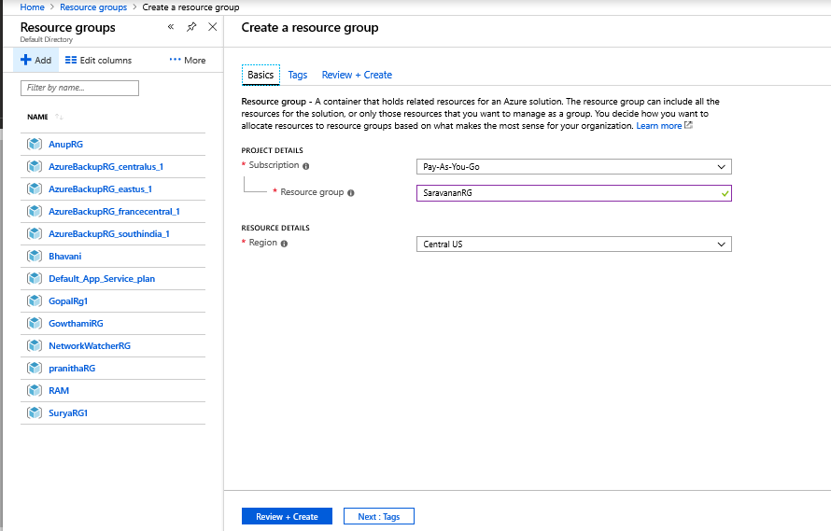

2.Created Virtual Network in Azure portal.

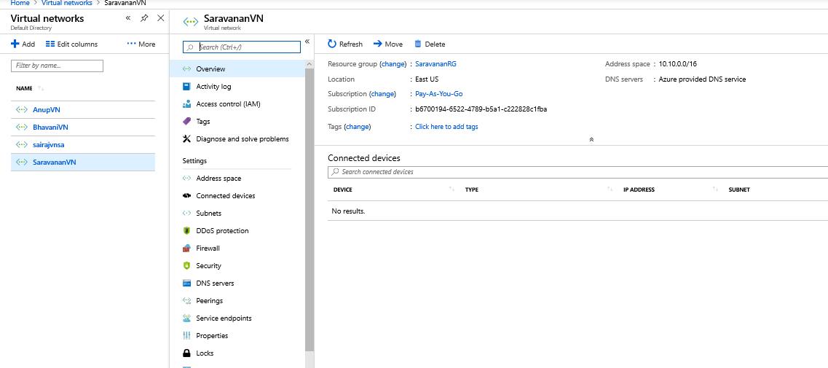

3.Creating Frontend and Backend Subnets:

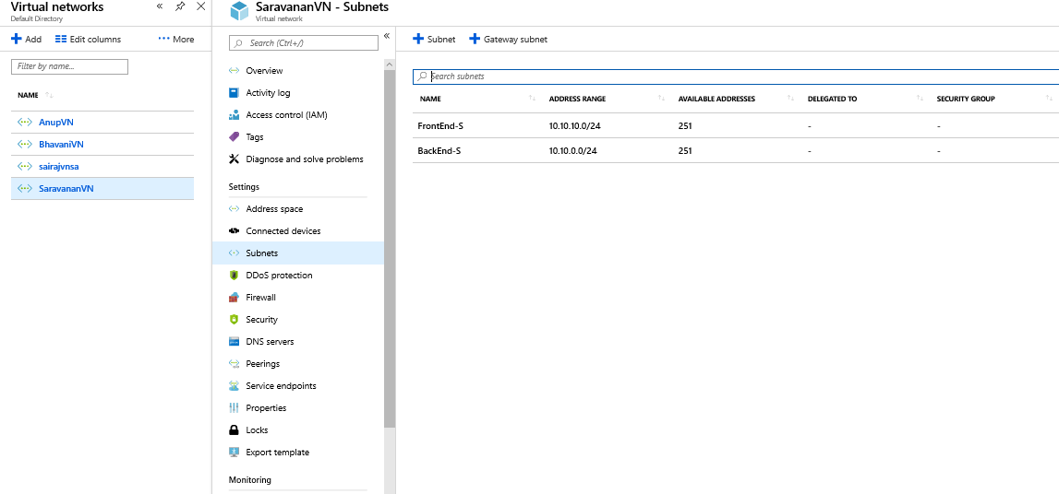

3.Created Network Security group added subnets(frontend,backend).

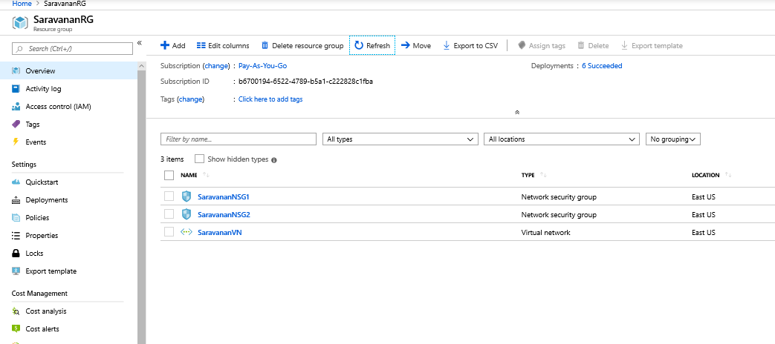

4.Added Inbound and outbound rules in subnet1(frontend).

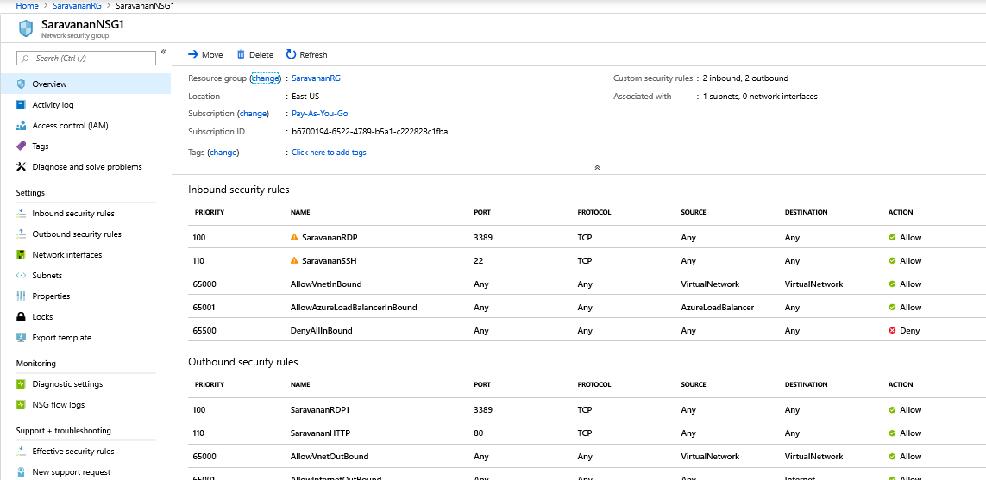

5.Added inbound and outbound rules in subnet2(backend).

