1.Created Resource Group in portal.

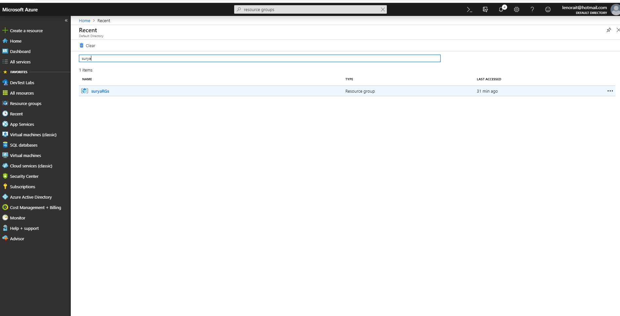

2.Created Vnet azure portal.

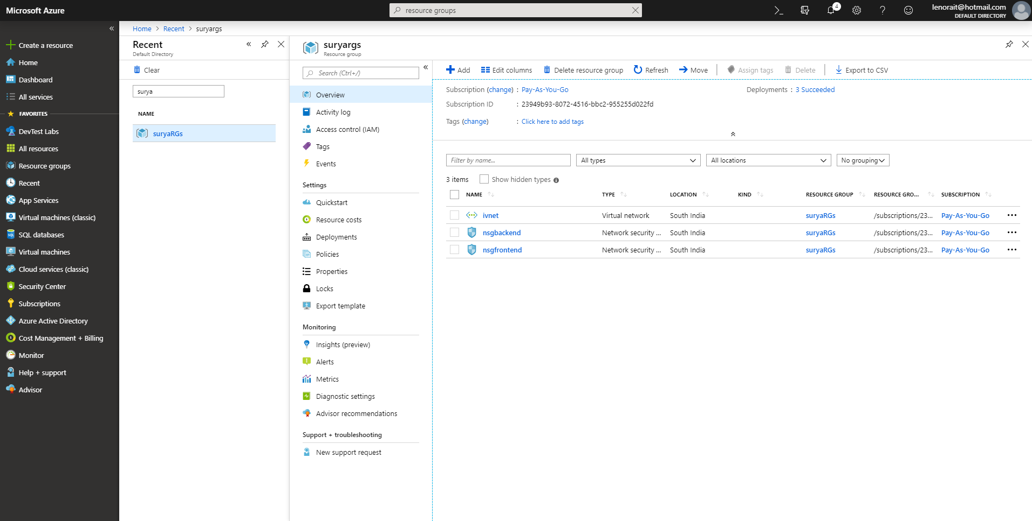

3.Created subnet(Frontend) in that added inbound and outbound rules.

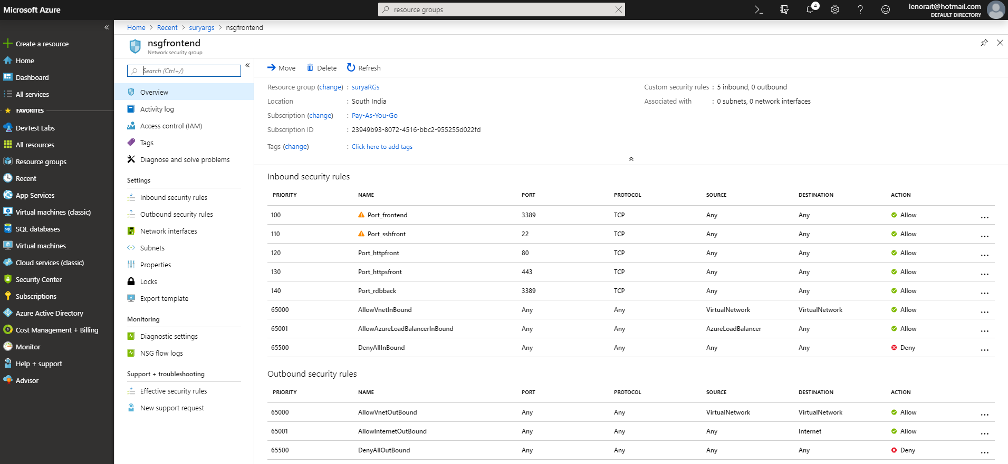

4.Created subnet(backtend) in that added inbound and outbound rules.

