Created Storage Account, Blob Container and uploaded .jpg file and downloaded .jpg file through PowerShell

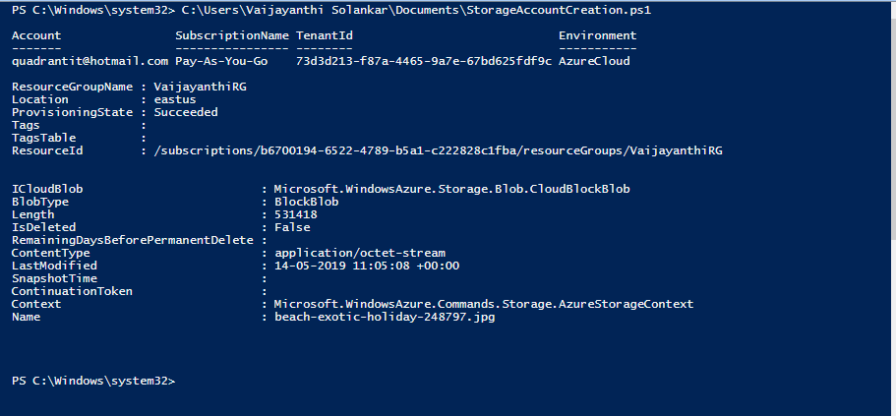

* Uploaded .jpg file in portal.

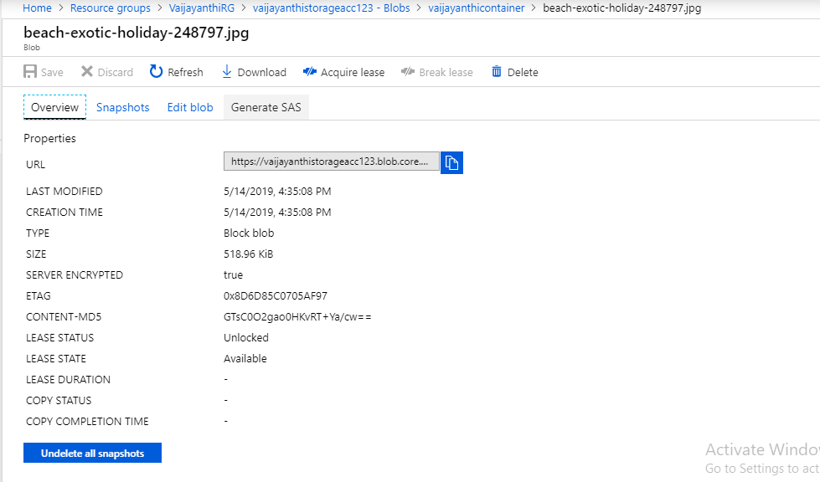

* Downloaded .jpg file.

