Creating Submodule in git

**Step1:** Create two Repositories in git with name DevOps and Developer with Readme, gitignor file.

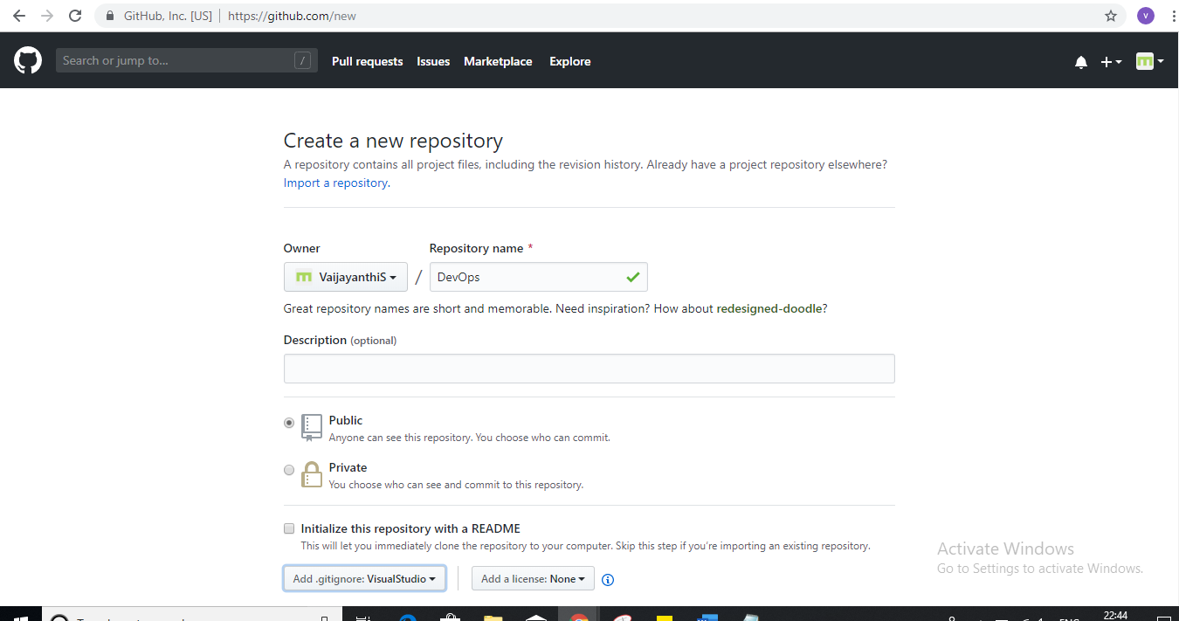

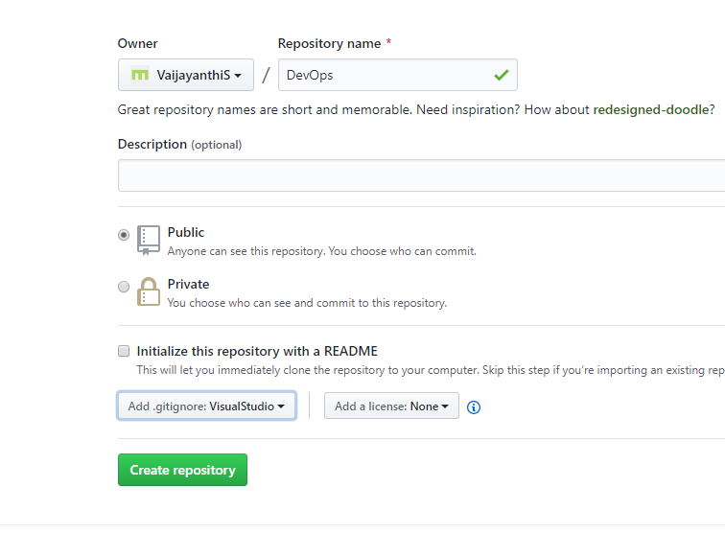

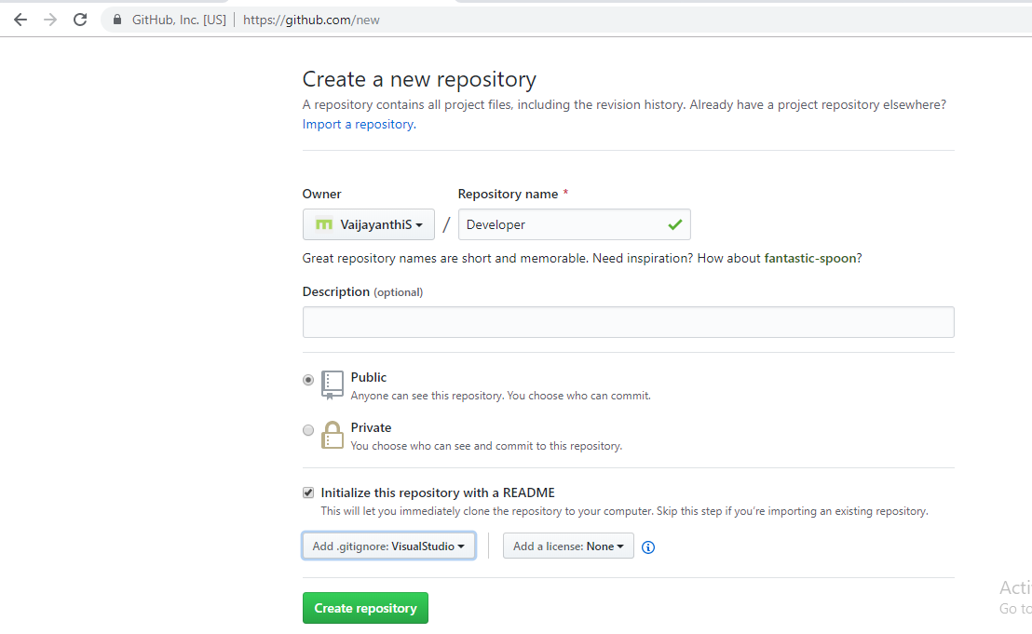

**Step2:** Create Submodule in Developer Repository by executing below command.

git submodule add -f -b master git@github.com:VaijayanthiS/DevOps.git SubmoduleBranch

git add .

git commit -m “Linking Submodule”

git push origin master

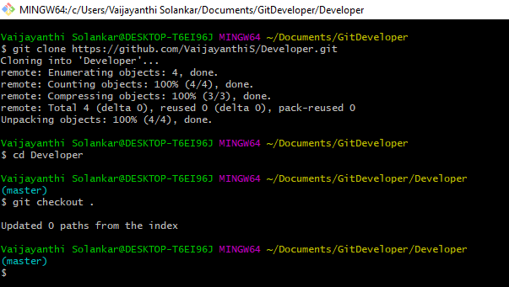

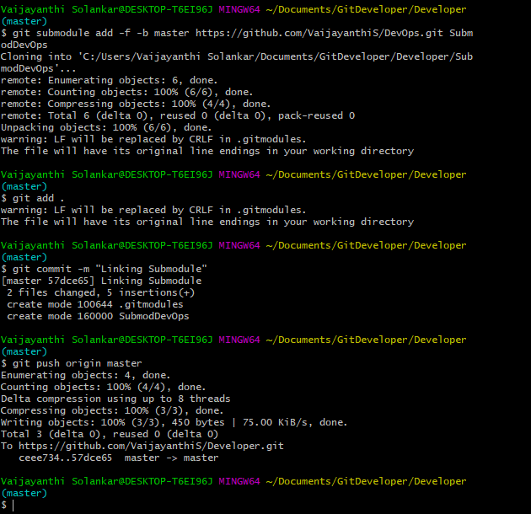

* Submodule will be created in Developer with name SubmodDevOps.

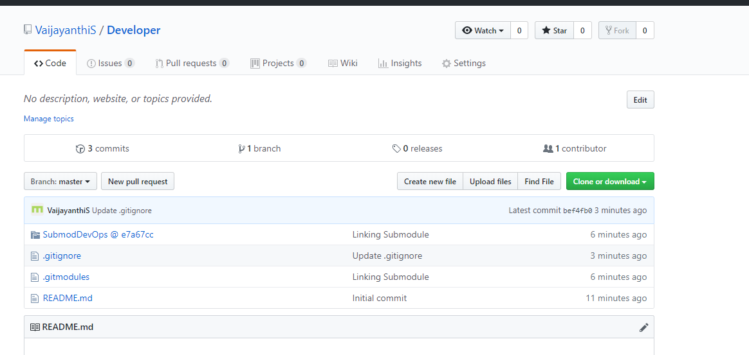

**Step3:** Add

[Dd]eveloper*

[Dd]eveloper/* in gitignore file.

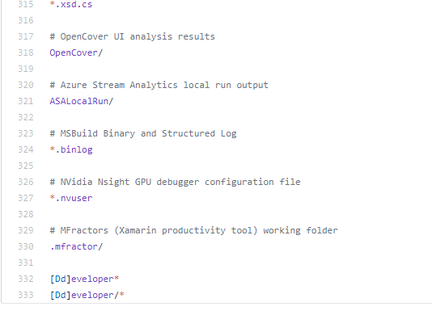

**Step4:** Add/Modify in DevOps Repository and execute below commands.

git add .

git commit -m “txt file added”

git push origin master

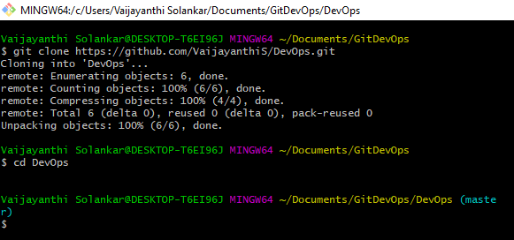

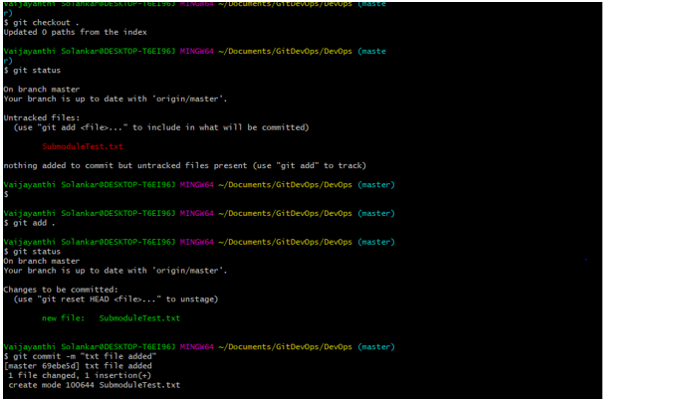

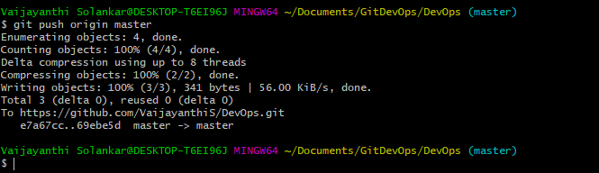

* .txt file is created in DevOps Repository.

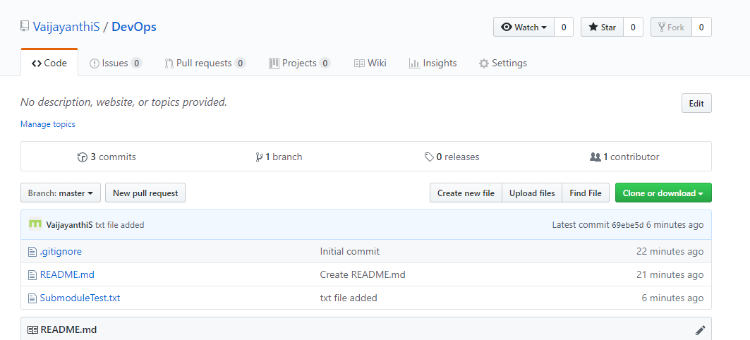

**Step5:** Execute the below commands in Developer Repository.

git submodule update --recursive --init

git submodule foreach git pull origin master

