SSH Public & Private Key generation and cloning through SSH

Step1: Generated Public Key and Private Key.

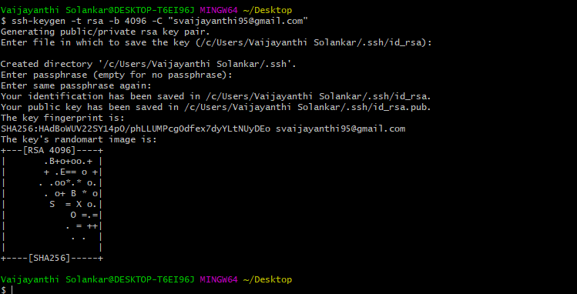

**Step2:** Go to C:\users\username\.ssh

There will be two keys generated, one will be Public Key and another will be private key. Copy public key from the folder.

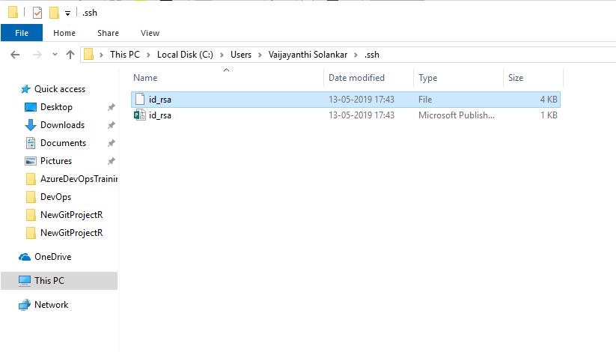

**Step3:** Go to GitHub-> Settings->SSH and GPG keys-> Click on “New SSH Key”.

Enter name in Title, paste Public Key in SSH key and Click on “Add SSH key”.

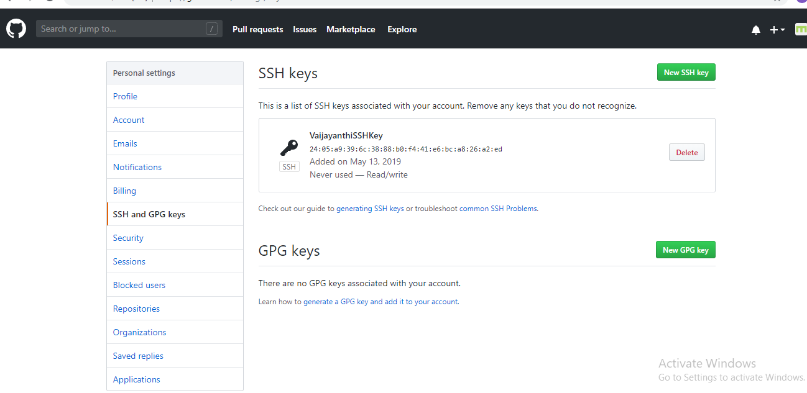

**Step4:** Able to get SSH key option.

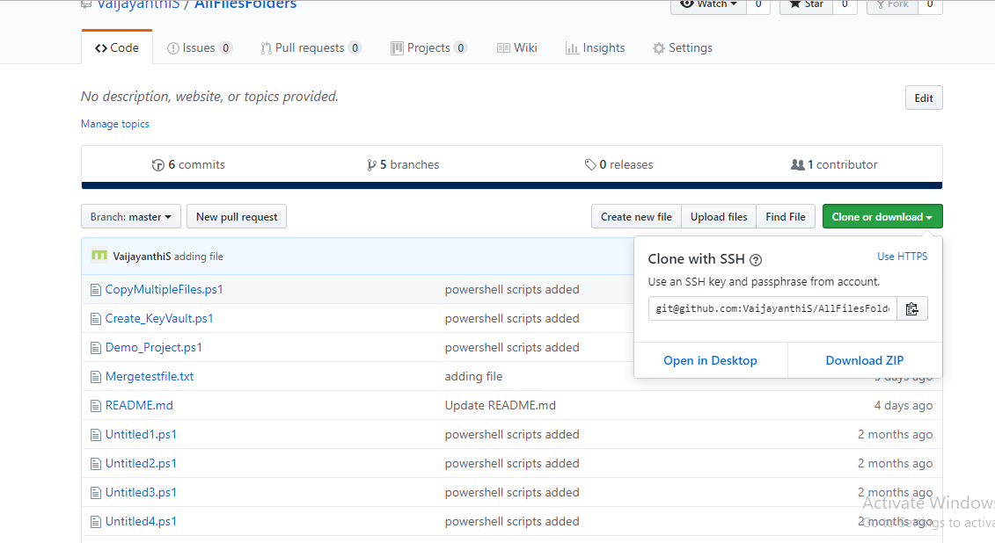

**Step5:** Cloning repository using SSH Key.

