Creating Azure SQL Database and setting firewall rules to access certain range of IPs

* Created SQL server.

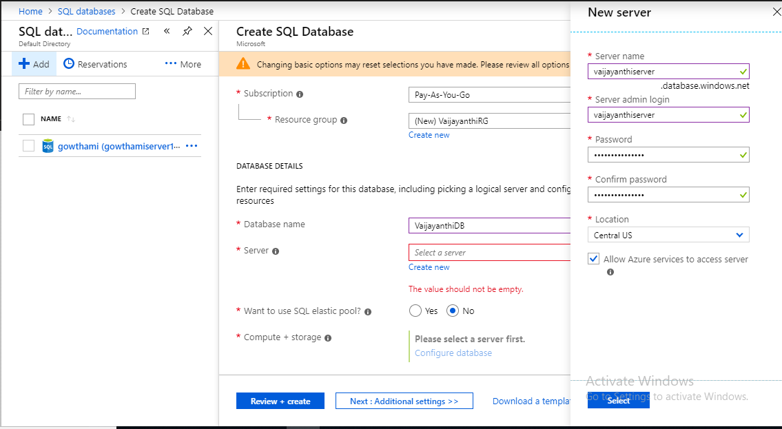

* Selected Basic DTU.

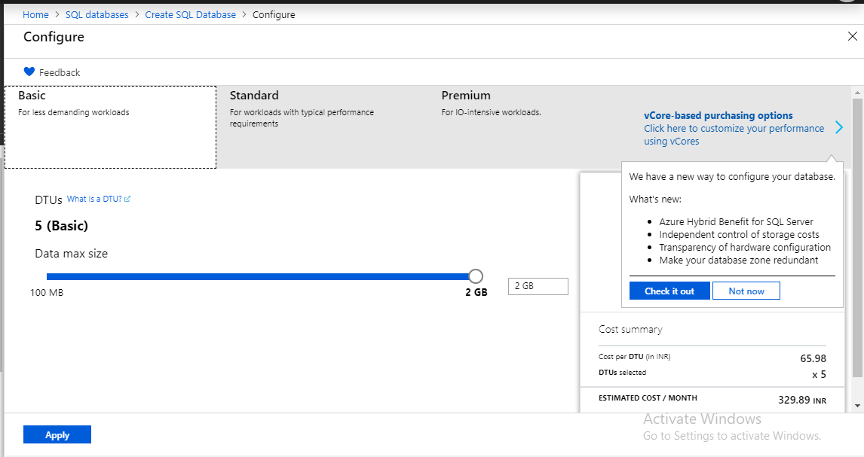

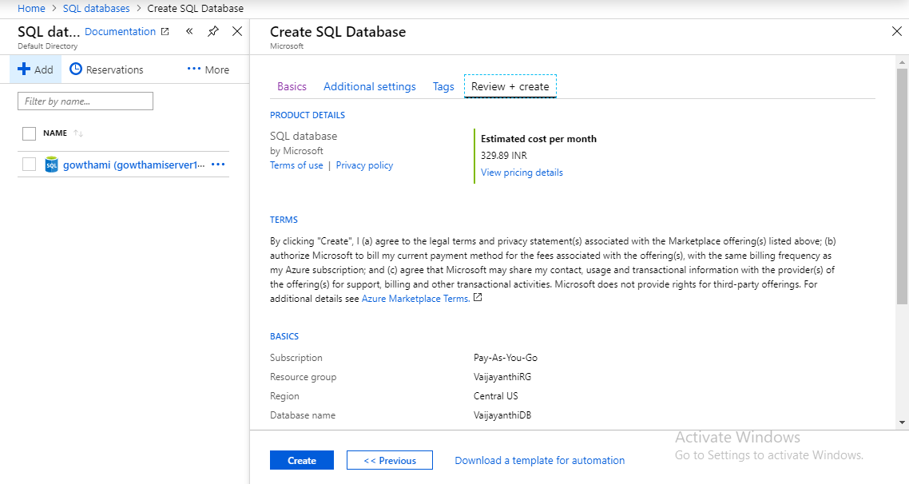

* Setting IP range to provide access(Firewall).

