Task4: Creating VM Scale Set, Recovery & backup of VM and VM disk encryption

* Created Resource Group with name VaijayanthiRG.

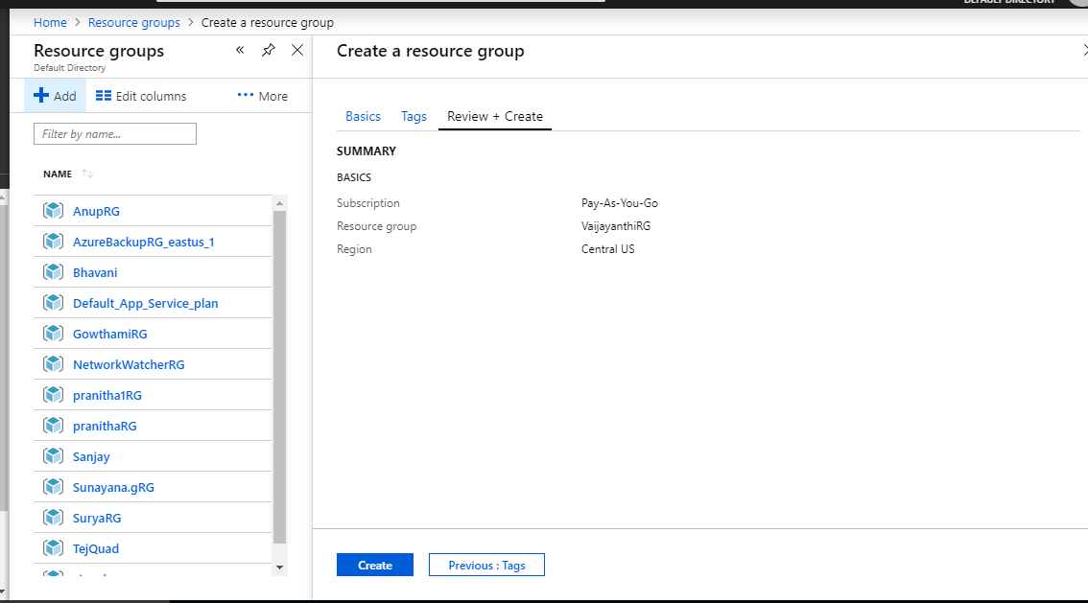

**Steps to create Virtual Machine Scale Set.**

1. Created Virtual Machine Scale Set.

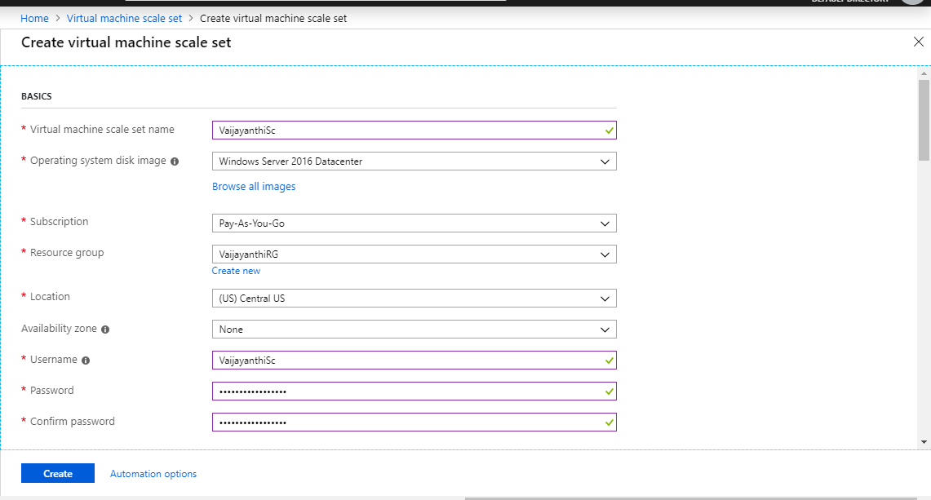

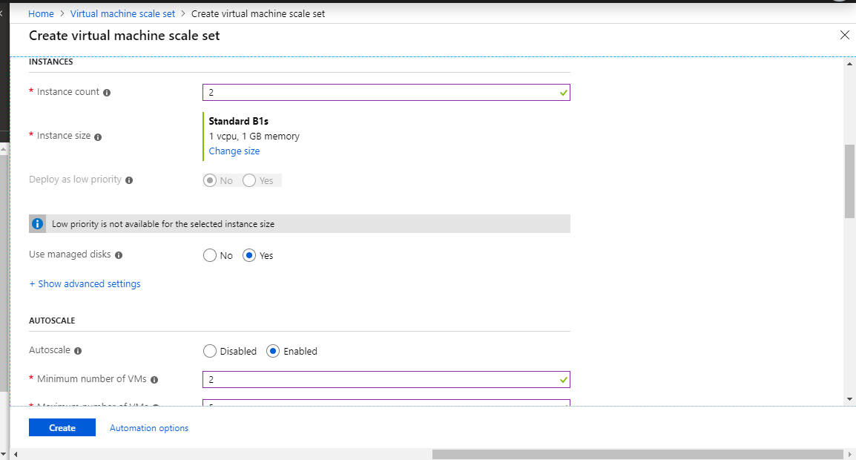

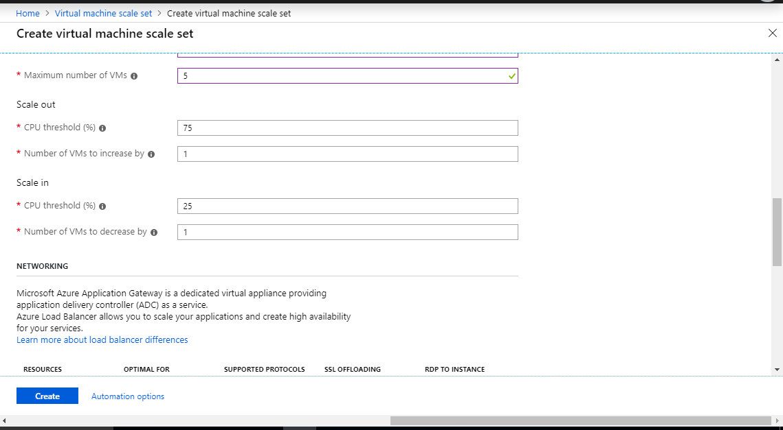

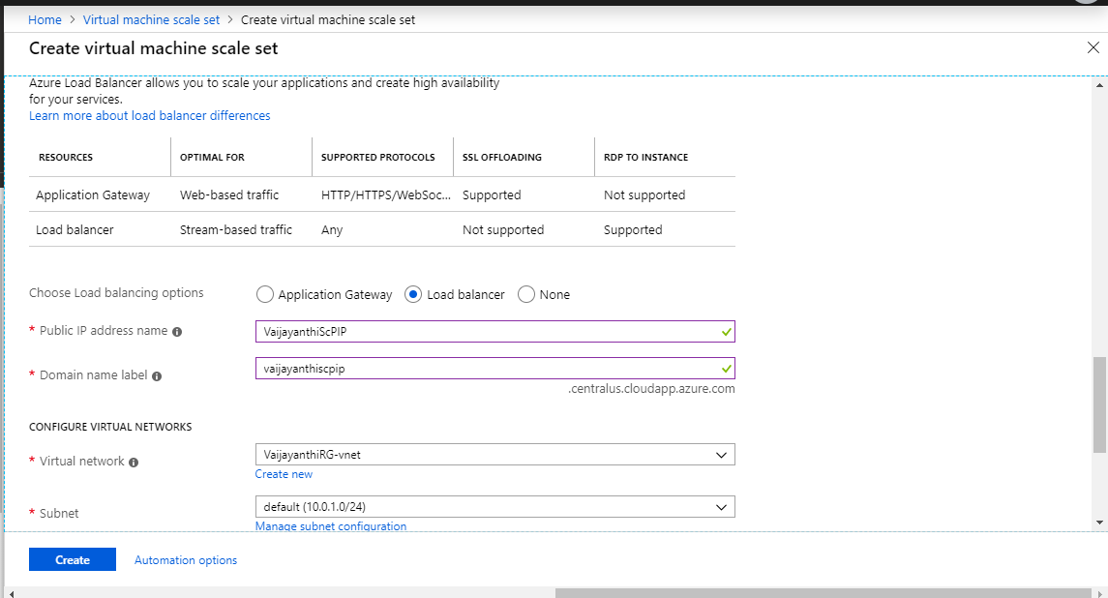

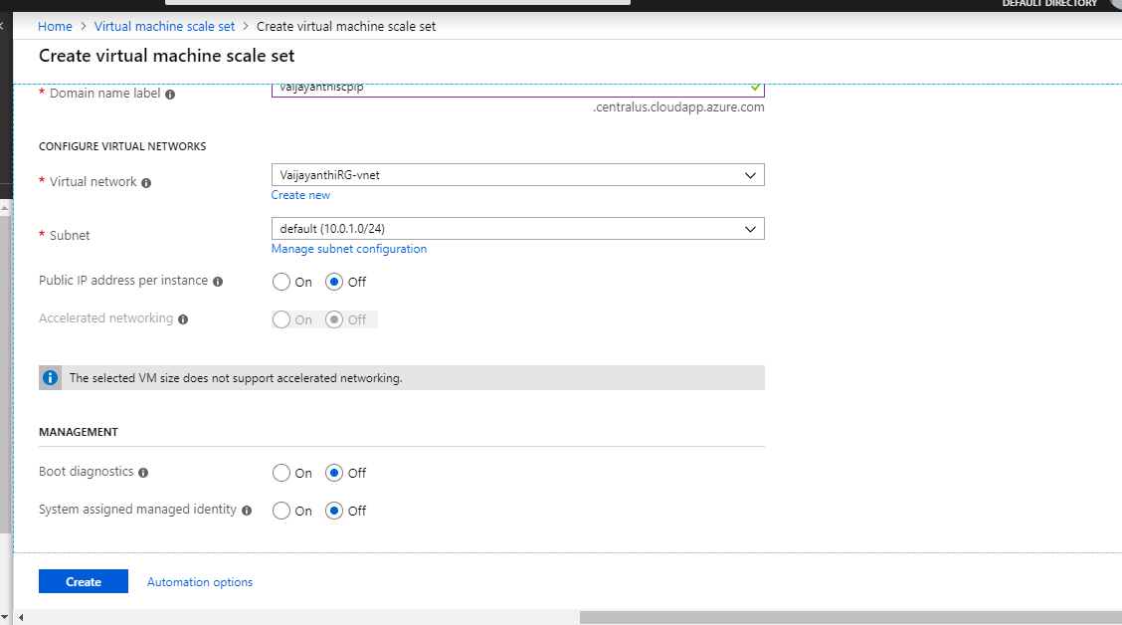

**Steps for Recovery & backup of VM.**

1. Created Recovery Service Vault.

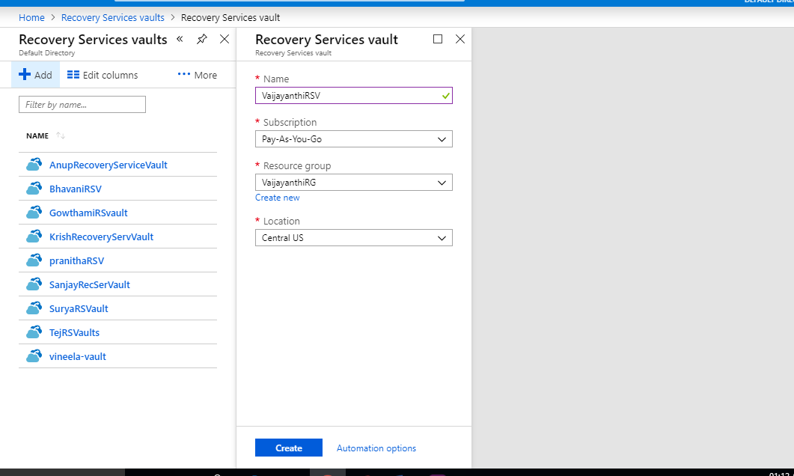

1. Goto Backup Policies->Add->Create Backup Policy.

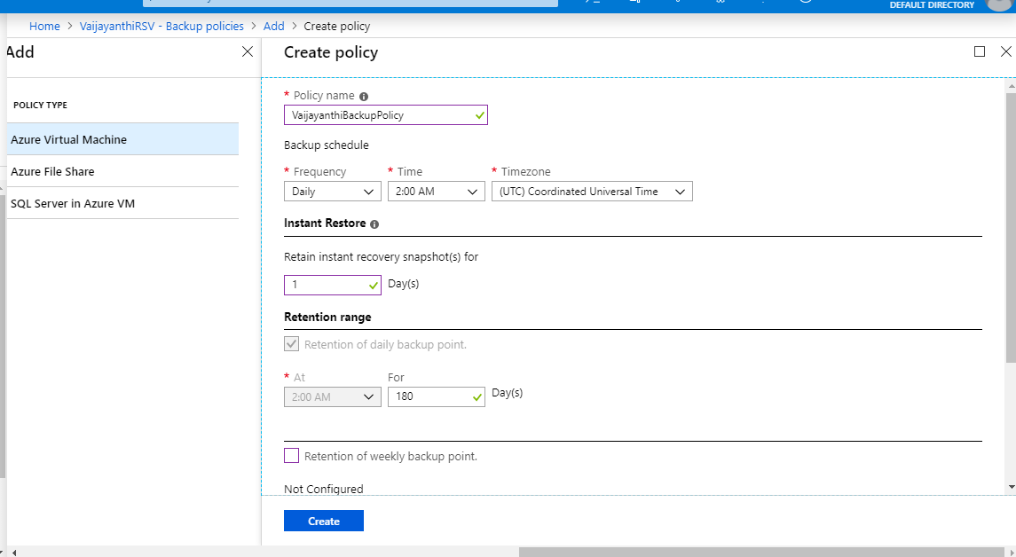

1. Addeding/applied Policy to Recovery service Vault.

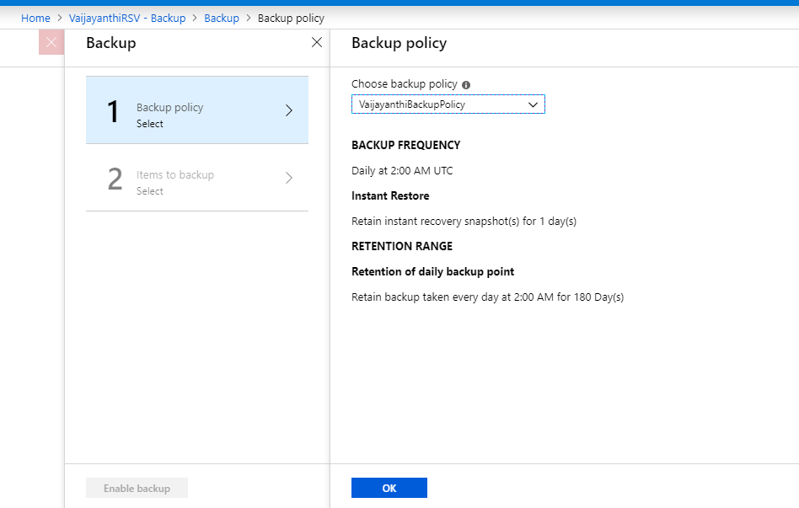

1. Selected Virtual Machine for backup.

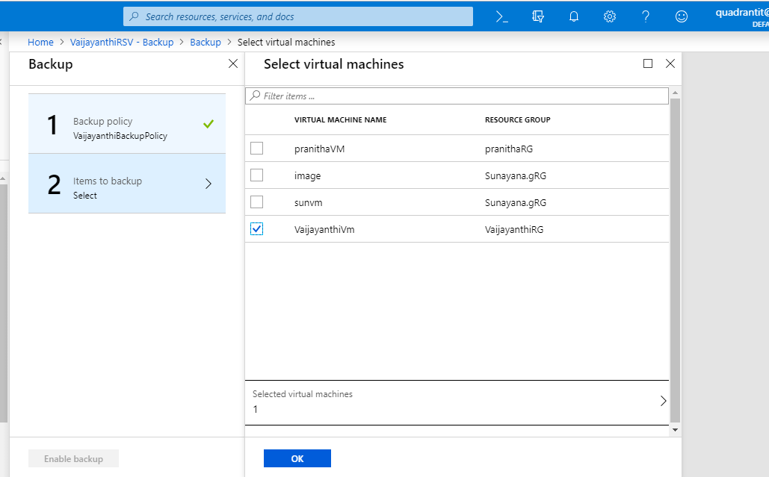

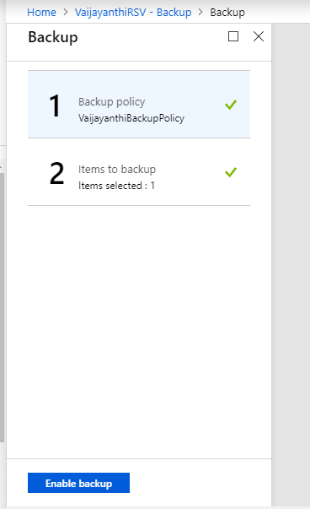

**Steps to Traffic manager of type Performance, priority, weighted.**

1. Created Traffic Manager with Routing Method=Performance.

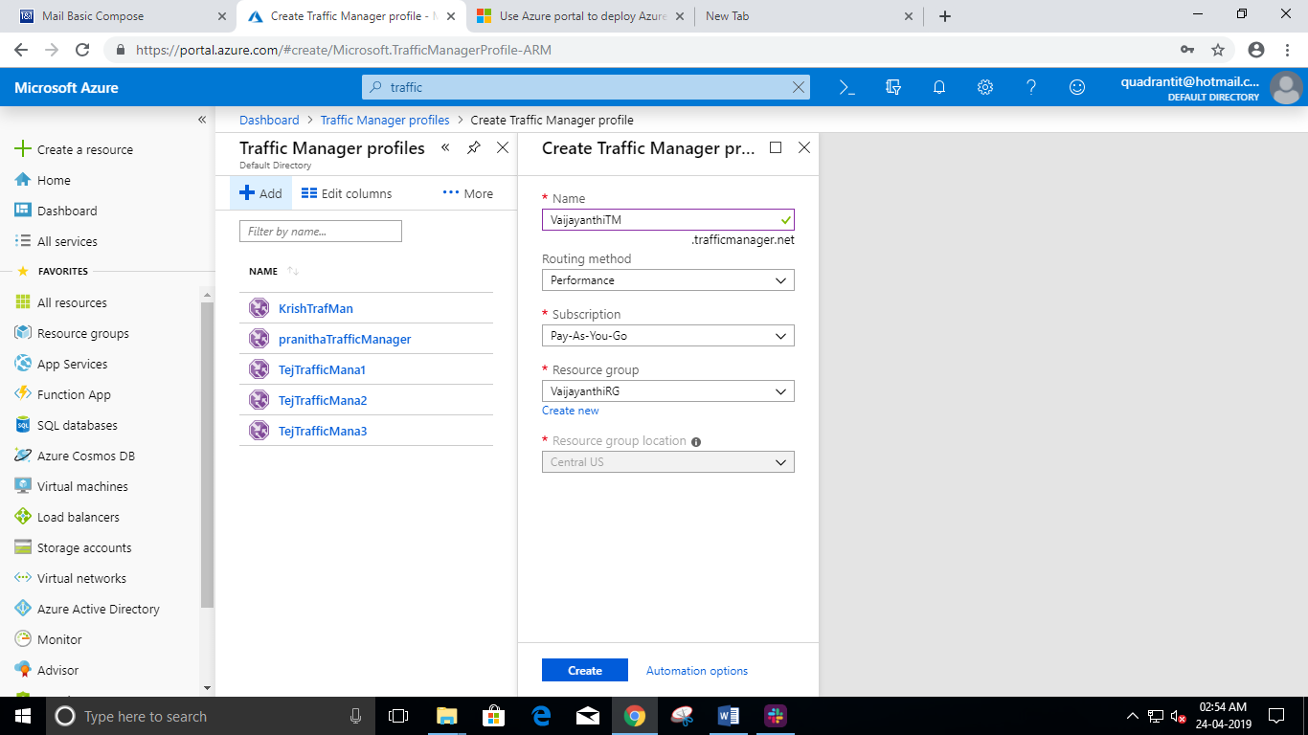

1. Added endpoint in Performance Traffic manager.

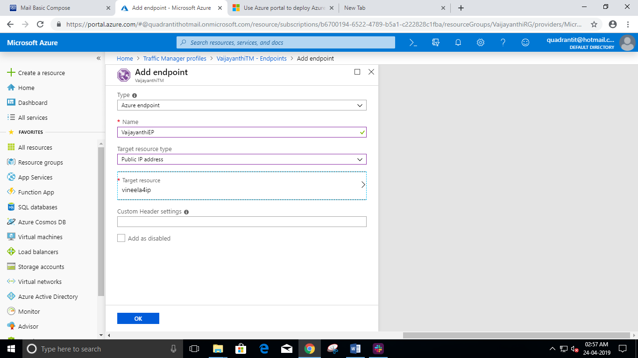

1. Created Traffic Manager with Routing Method=Priority.

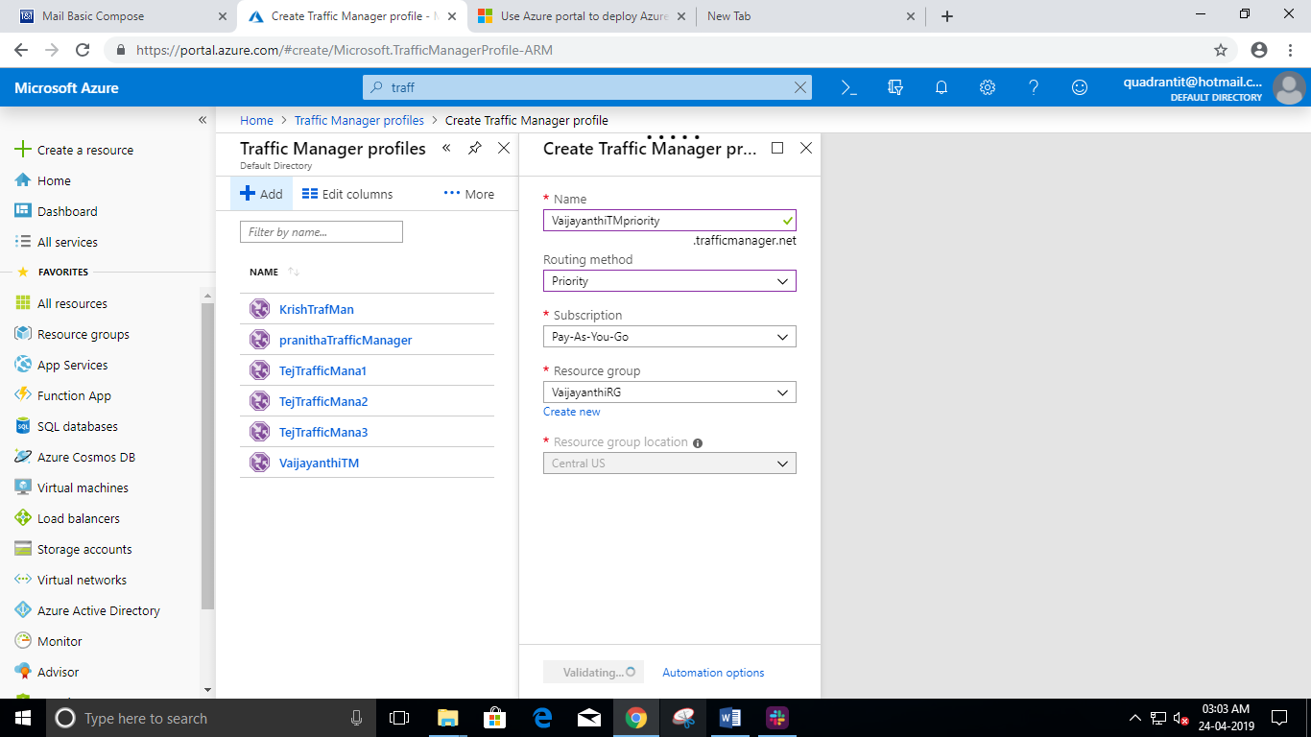

1. Added endpoint in Priority Traffic manager.

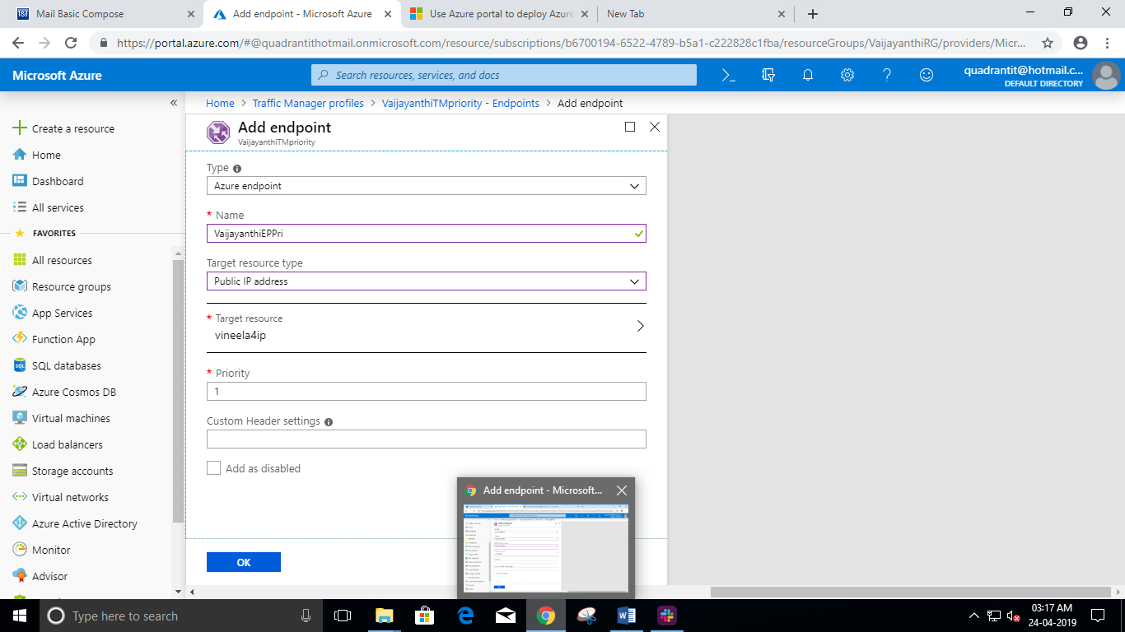

1. Created Traffic Manager with Routing Method=Weighted.

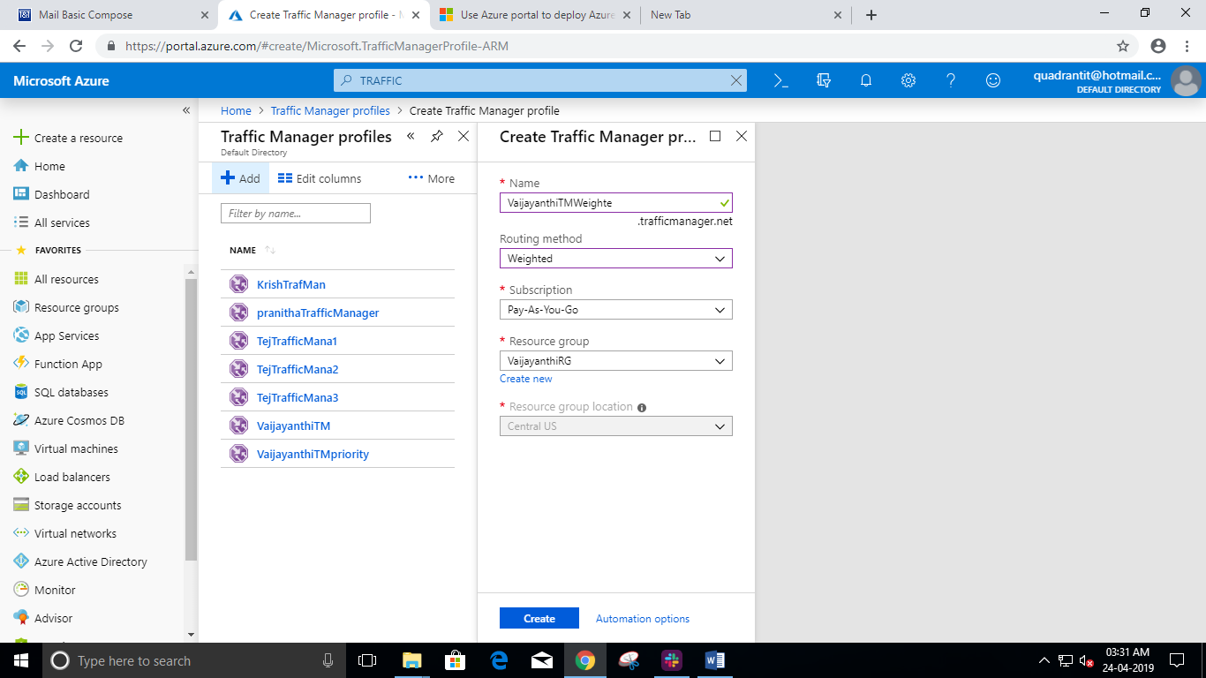

1. Added endpoint in Weihted Traffic manager.

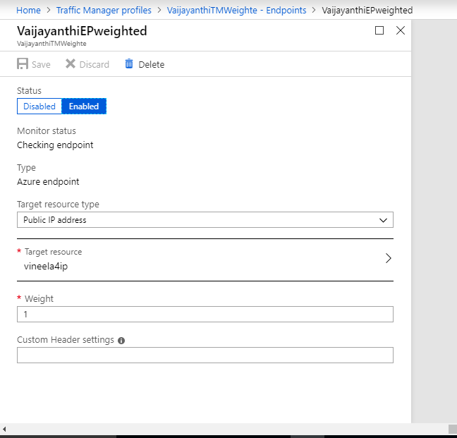

**Steps for Encryption of VM Disk.**

1. Goto Active Directory->Application Registories->Create App Registry.

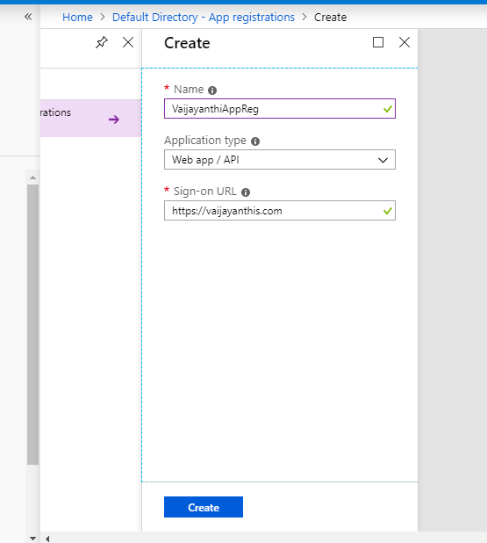

1. Create Key Vault.

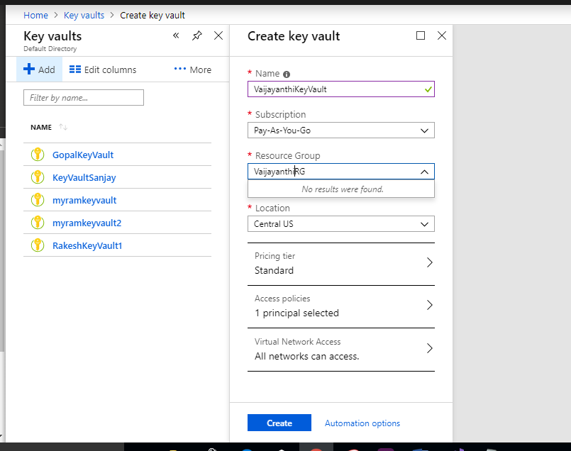

1. Goto Key Vault->Access Policies->Add Access Policy.

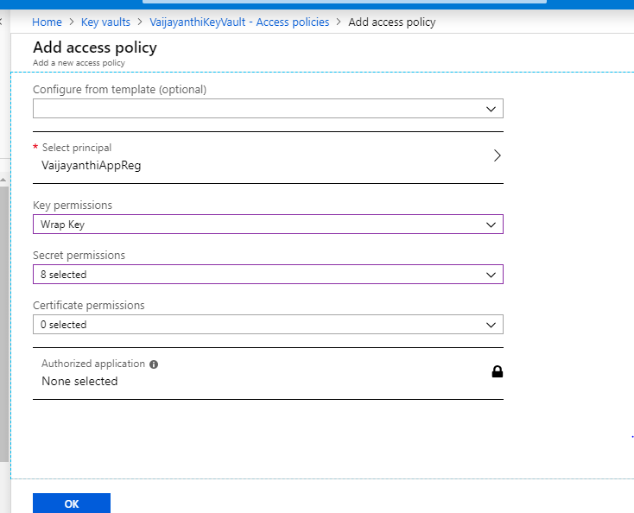

1. Goto Azure Active Directory->Application Registories->Settings->Keys, fill Description, expiries->Save.

Key will be generated, copy the key and save it.

**Note**: Key cannot be displayed once you leave the below page.

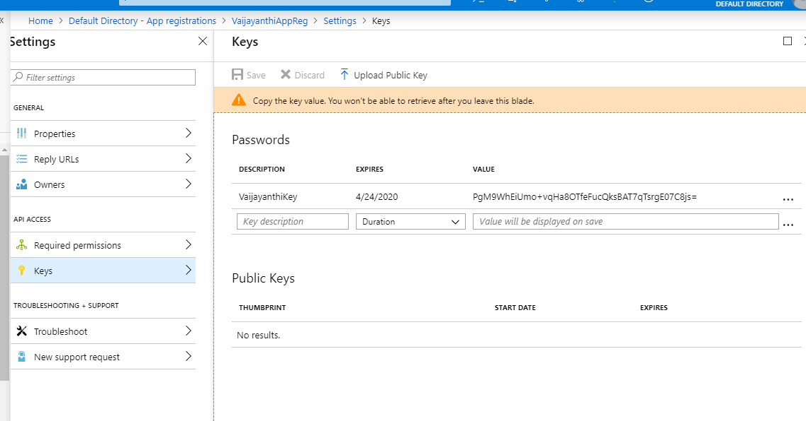

1. Goto browser and search “201-encrypt-running-windows-vm” or below link.

<https://github.com/Azure/azure-quickstart-templates/tree/master/201-encrypt-running-windows-vm> then Click on Deploy to Azure, then the below for will be displayed. Fill the form->click on T&C check box->Purchase.

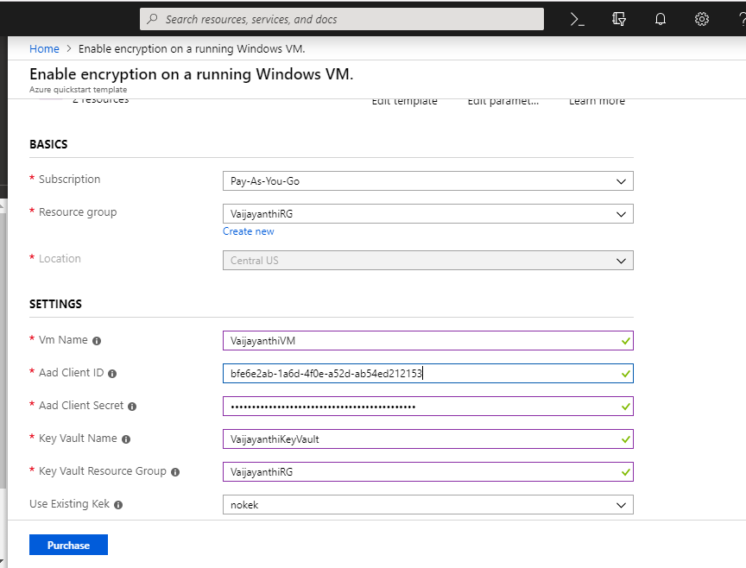

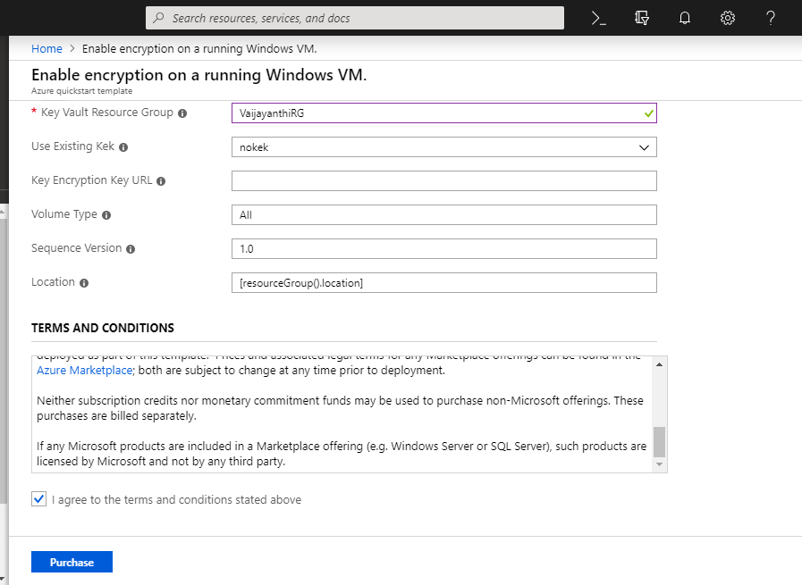

1. Goto VM->Disk and check encryption is enabled or not.

