* Created Vnet1, Vnet2, Vnet3:

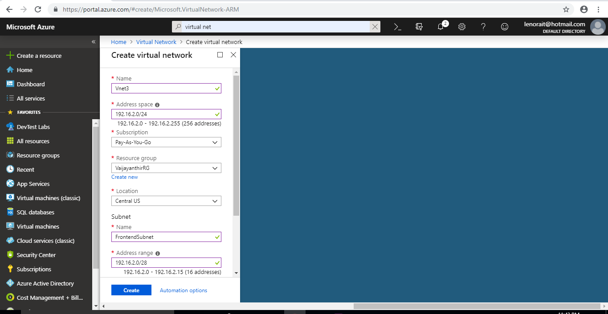

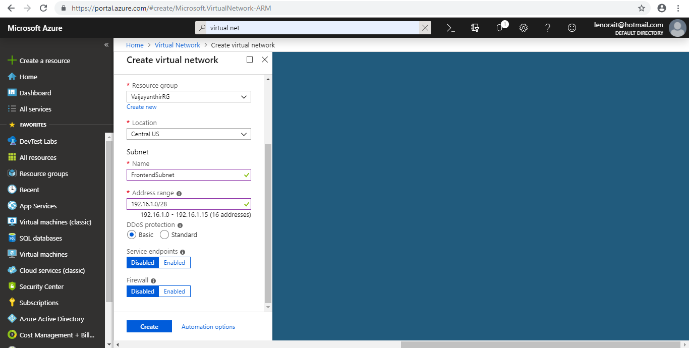

* Created Frontend Subnet, Backend Subnet and Gateway subnet in Vnet1, Vnet2, Vnet3.

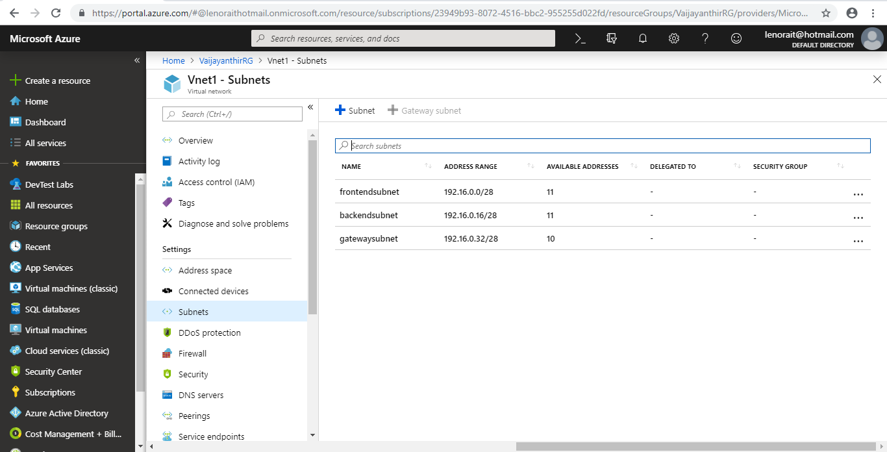

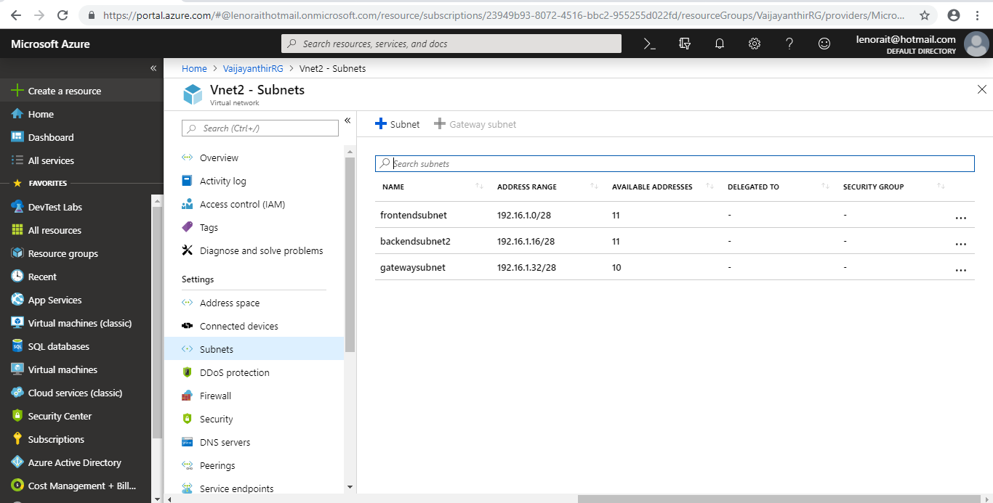

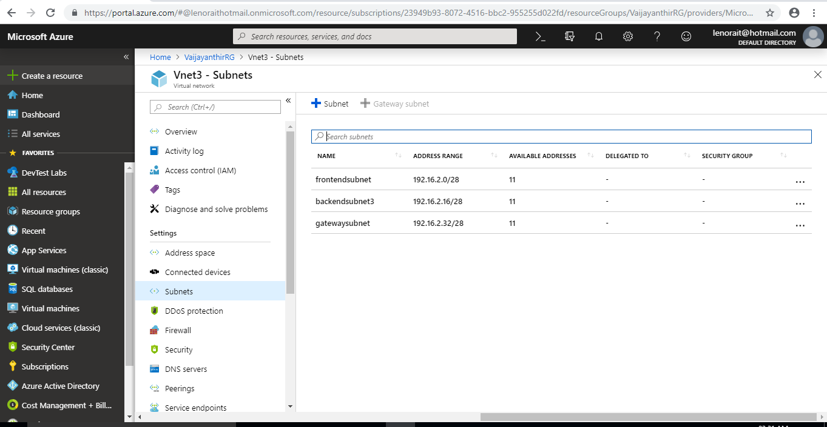

* Created VPN Gateway1, VPN Gateway2 for Vnet1 and Vnet2 respectively:

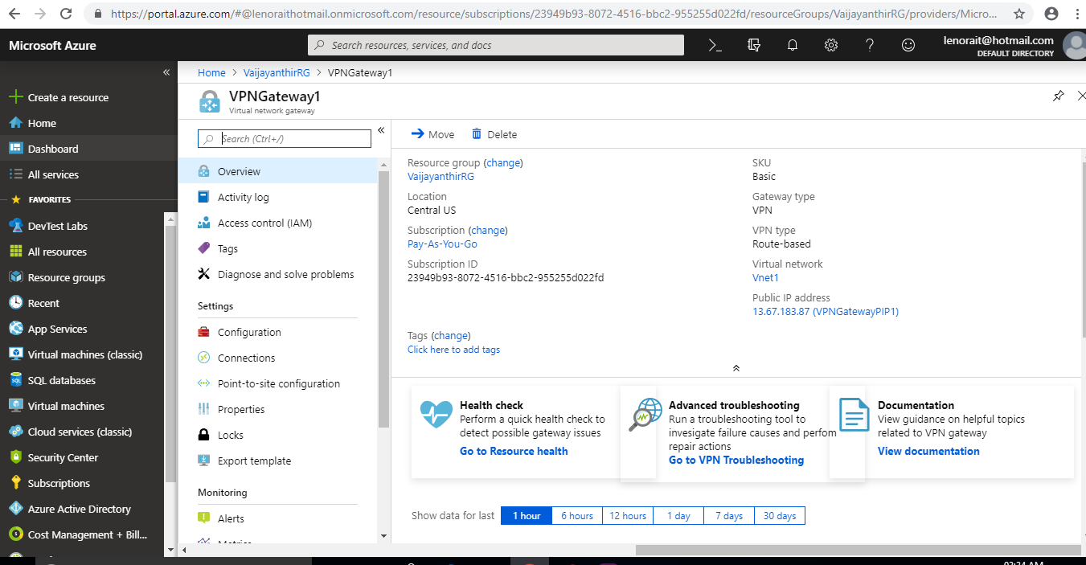

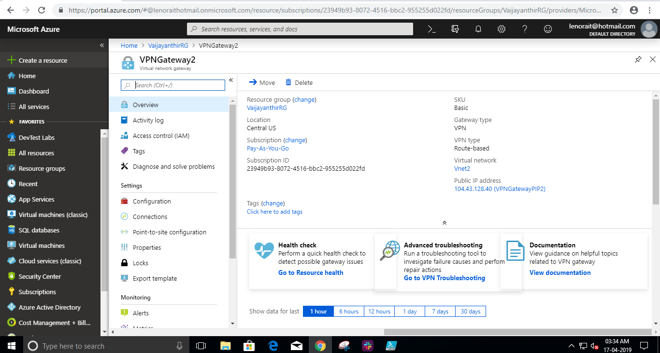

* Created Public IP1, Public IP12 for VPN Gateway1 and VPN Gateway2 respectively:

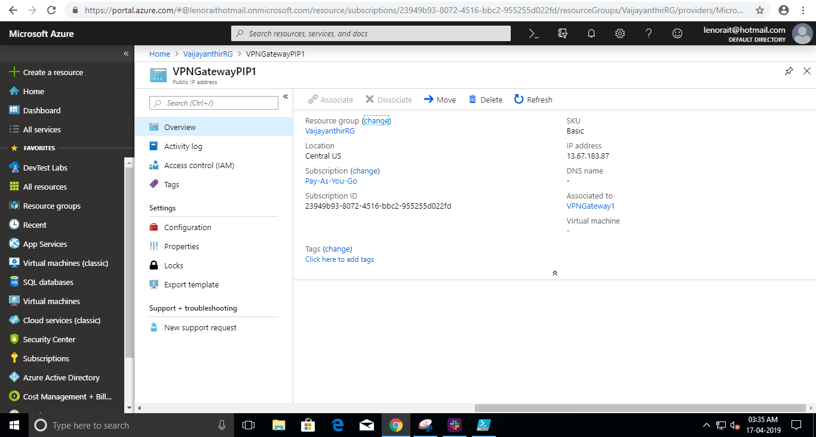

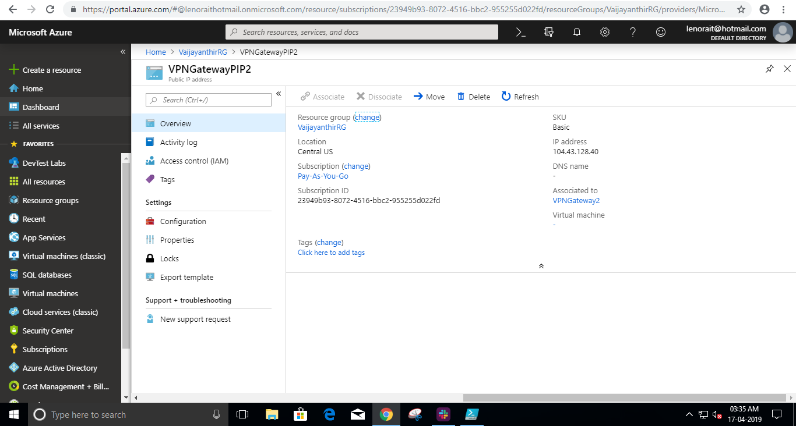

* Established VPN Connection(Vnet-to-Vnet) between VPN Gateway1 and VPN Gateway2(Vnet1, Vnet2):

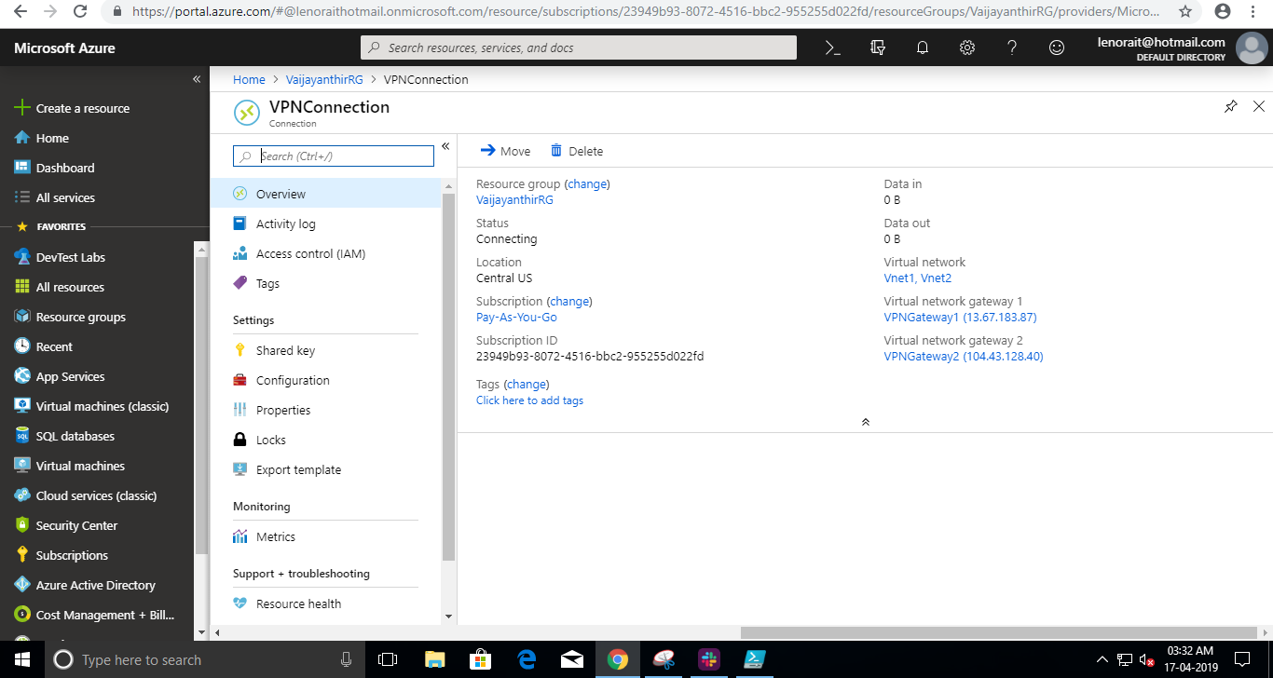

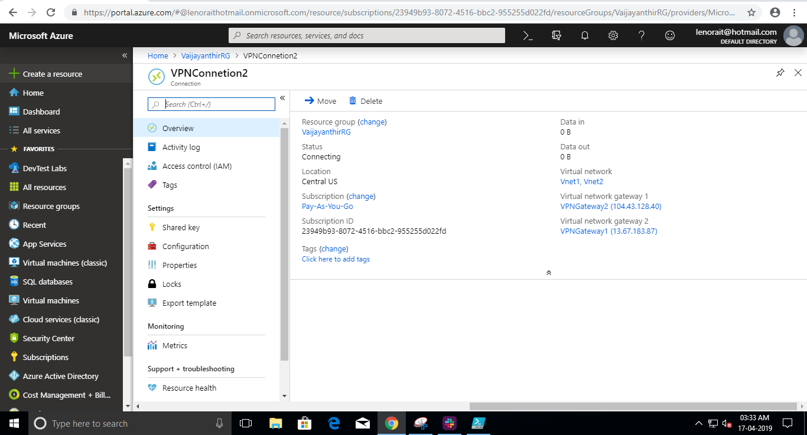

* Peering Vnet2 to Vnet3 and set Vnet2 as Hub.

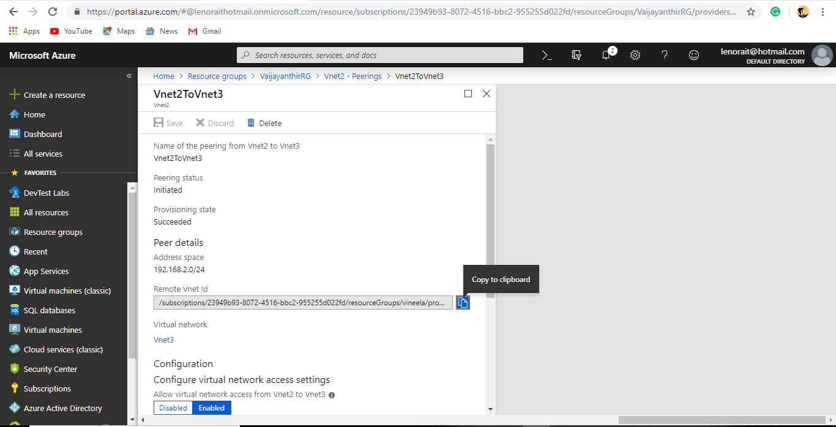

* Peering Vnet3 to Vnet2 and set Vnet3 as spoke.

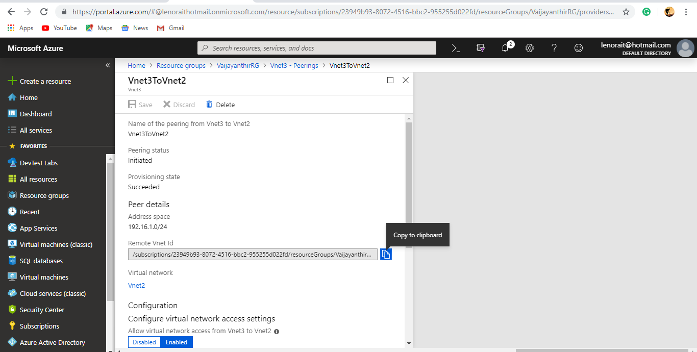

* Following Resource Group shows all the created resources in it.

