**Task-2**

1.Creating virtual network1(subnets and gateway subnet)

A.vitual network is created

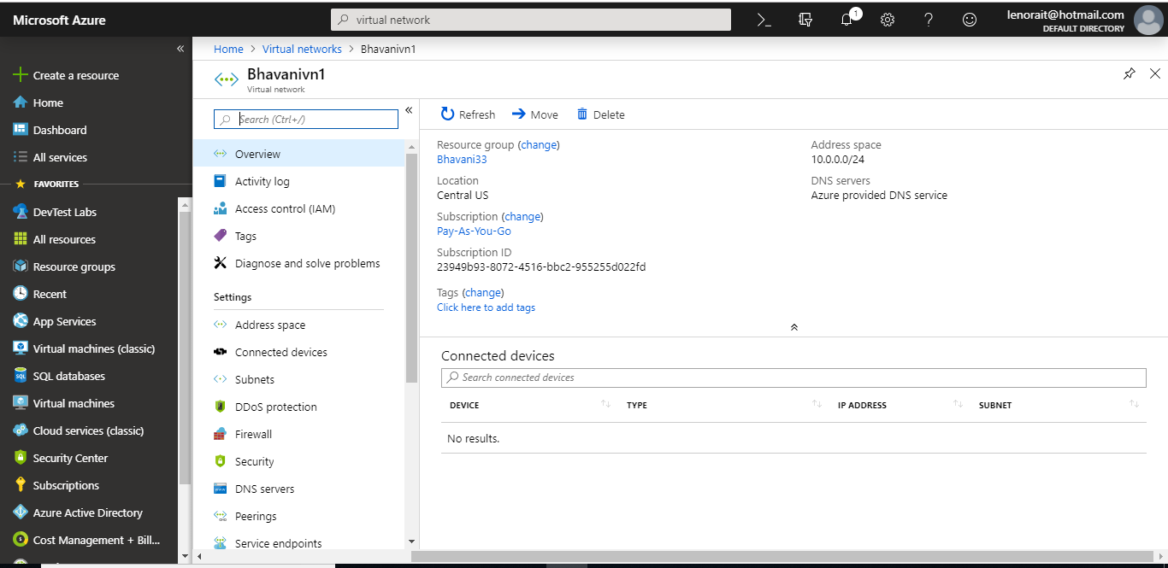

B.subnets and gateway subnet is created(frontend subnet,backend subnet)

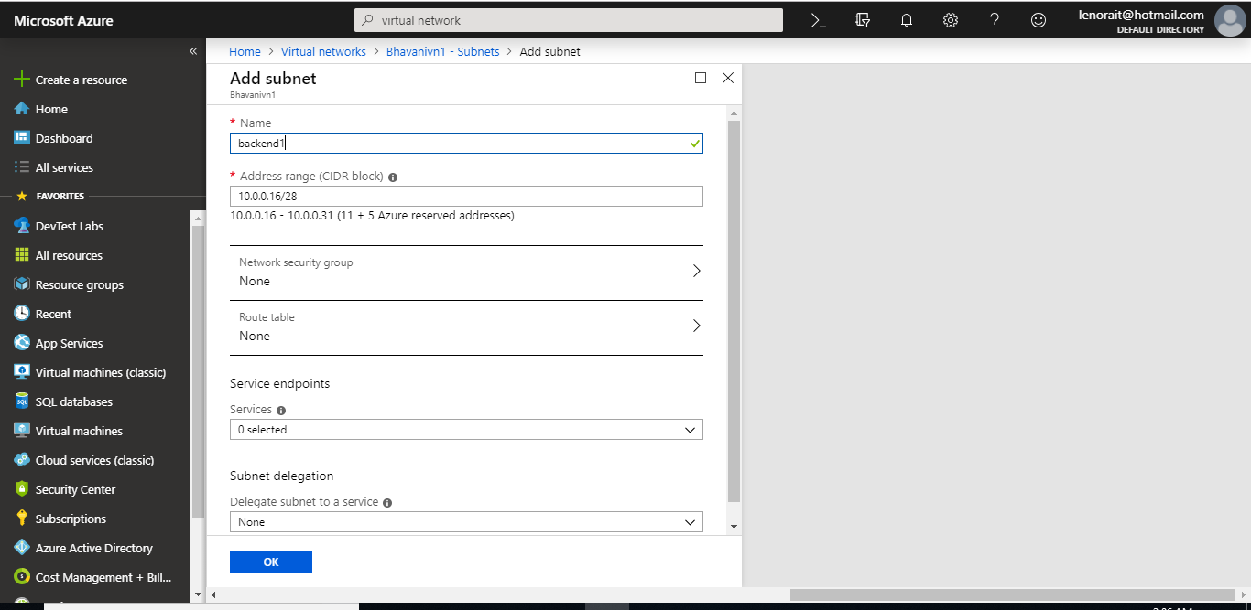



Created subnets and gateway subnet

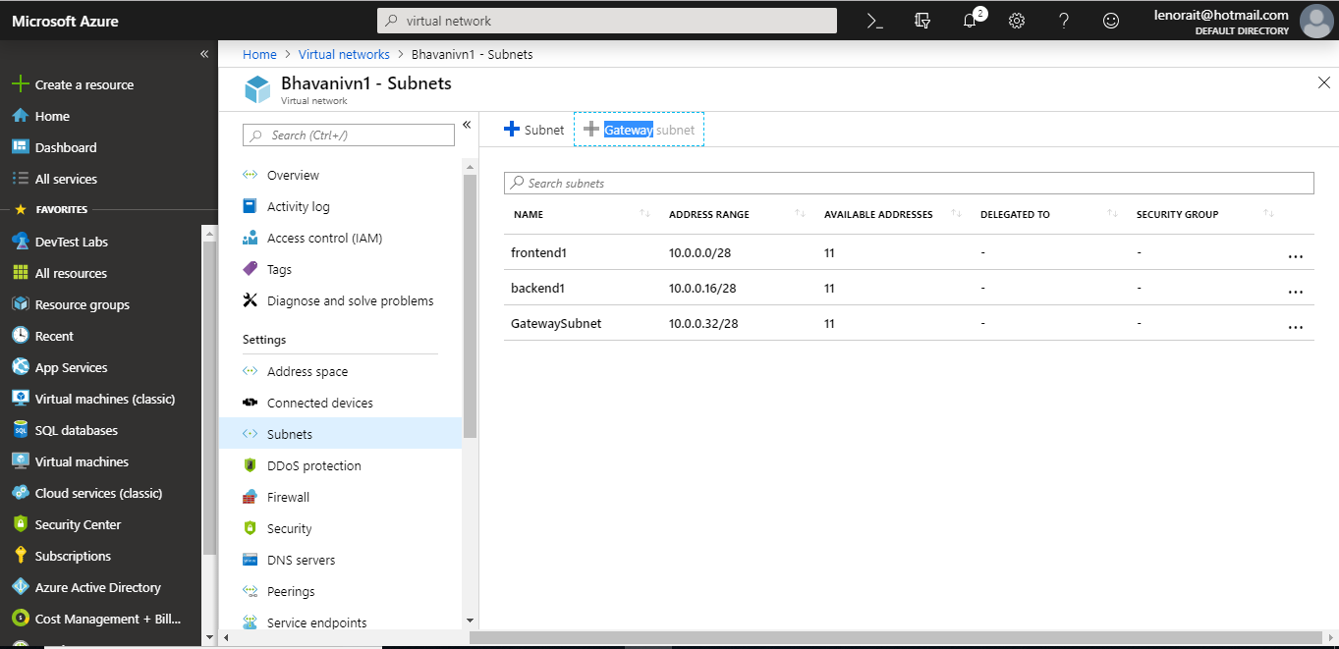

2.creating virtualnetwork2(subnets,gatewaysubnet)

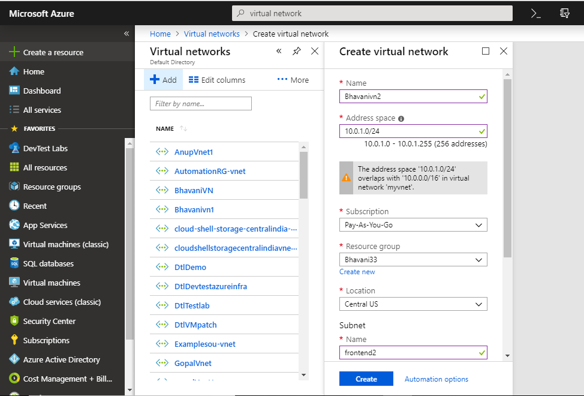

Creating bakend subnet:

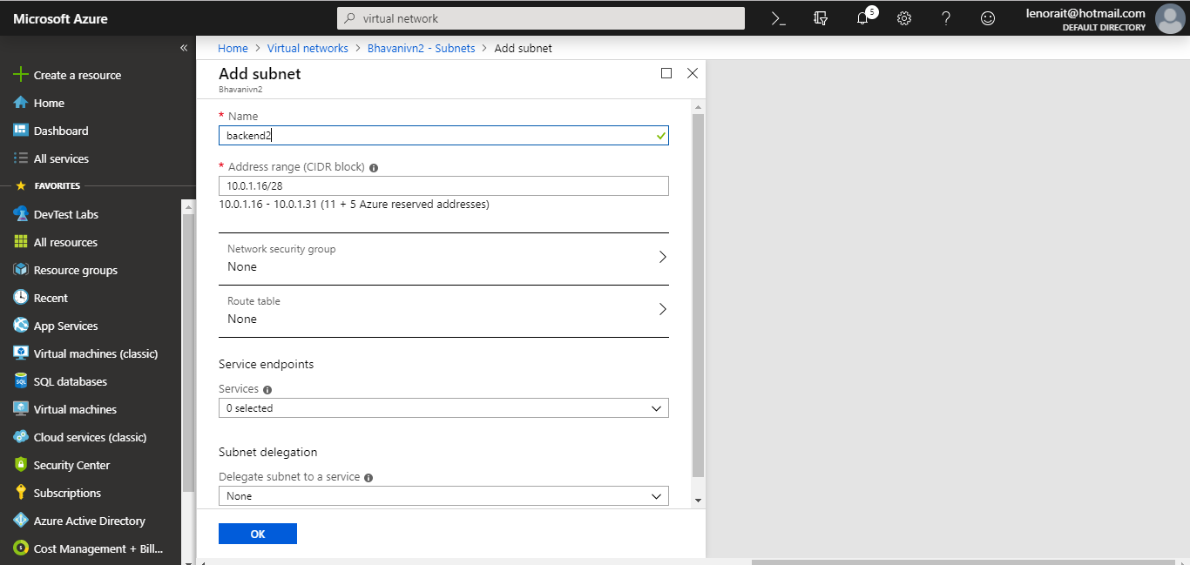

Created subnets and gateway subnets in virtual network2:

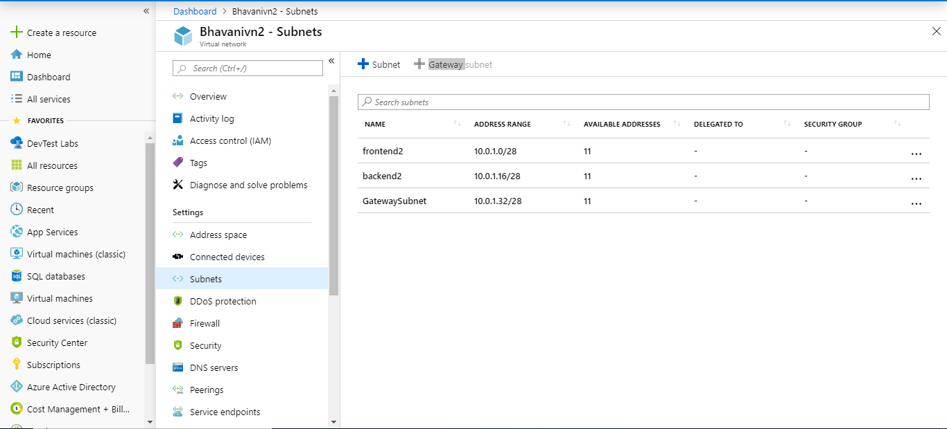

3.Creating virtualnetwork3(subnets,gateway subnet)

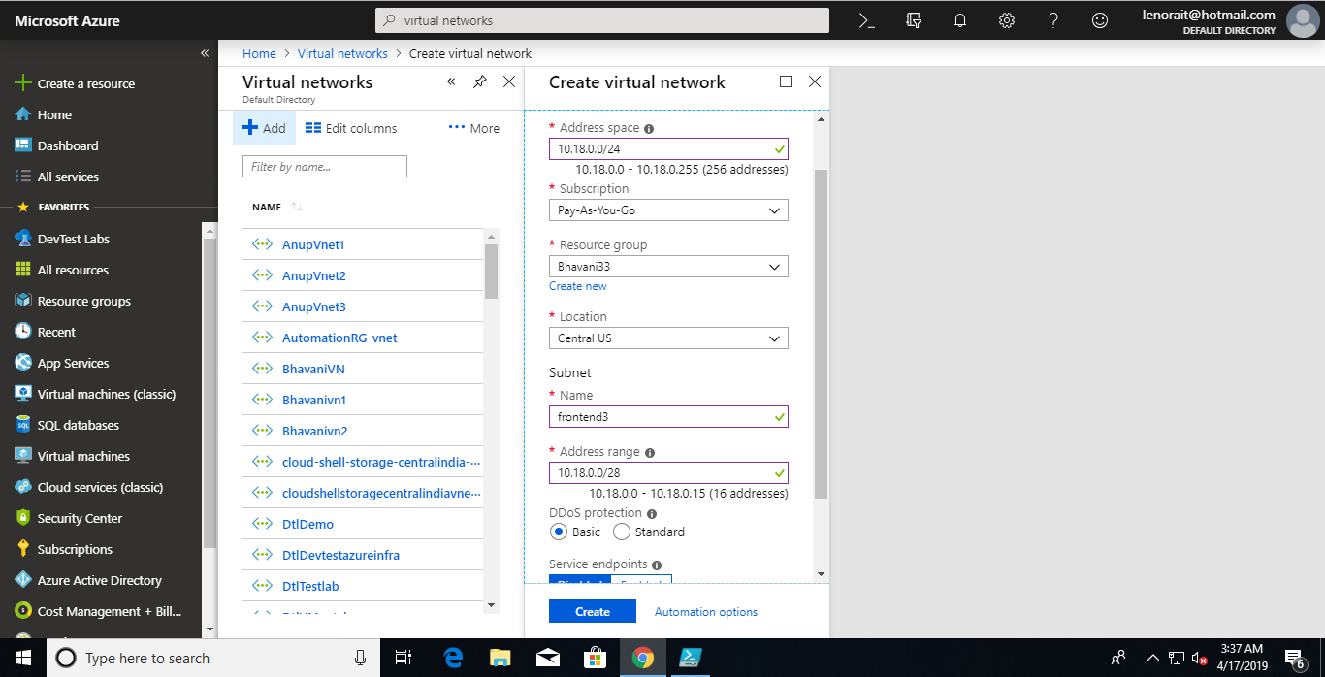

Created subnets and gateway subnet of virtualnetwork3:

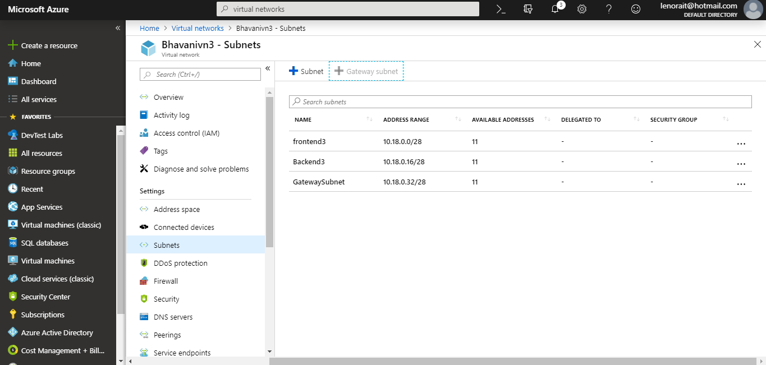

4.Creating virtual Network Gateway in VN1 and VN2:

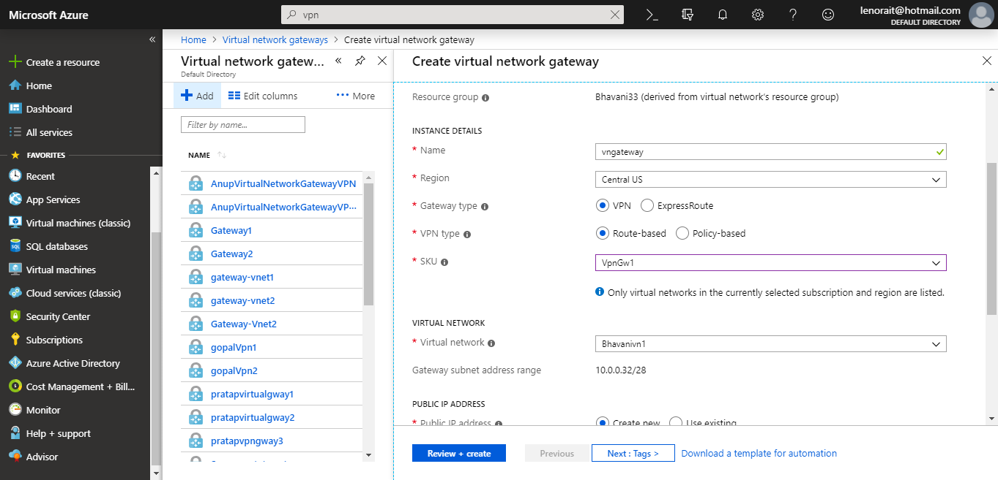

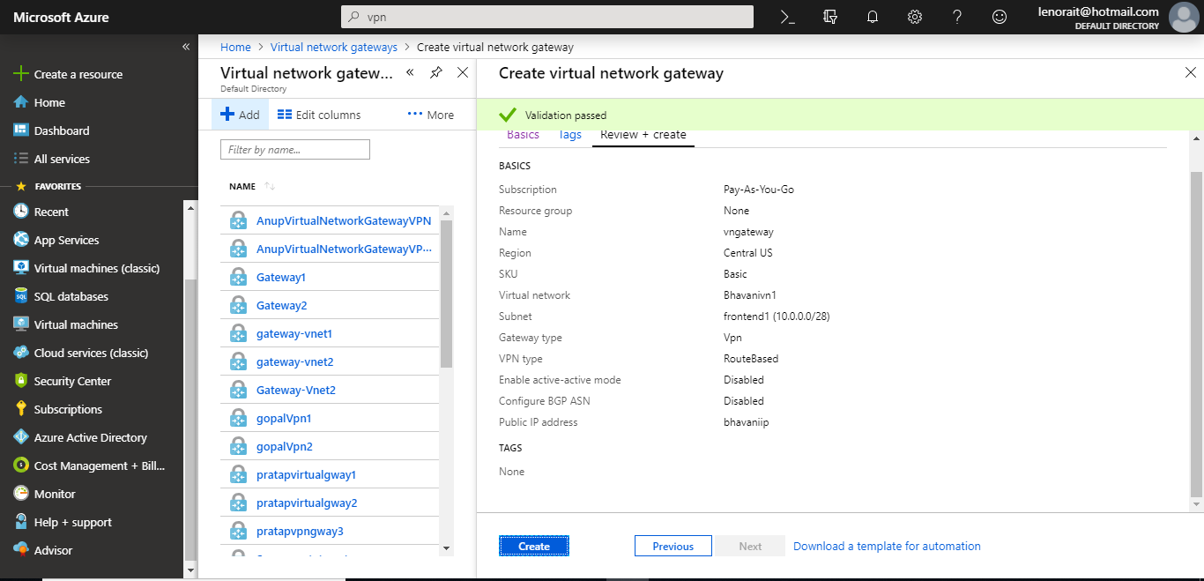

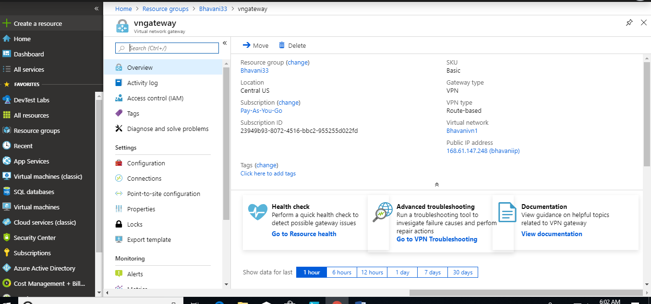

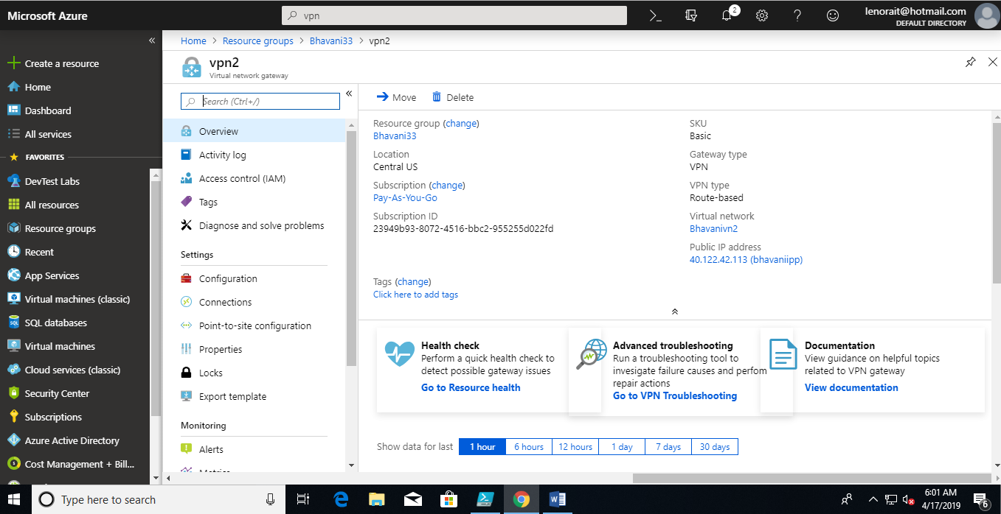

5.connection between two gateways:

a.connection from vn1 to vn2

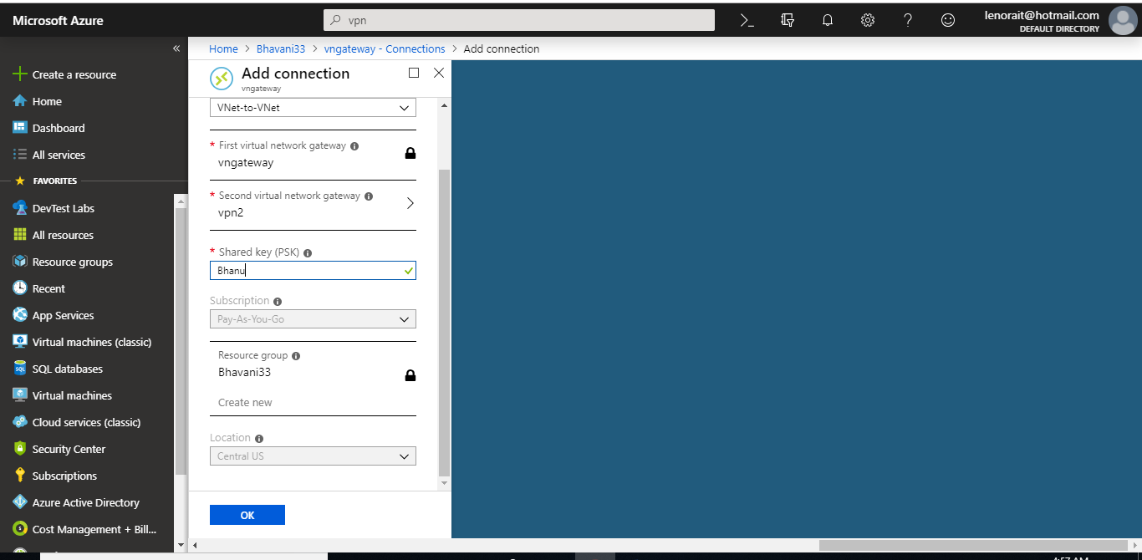

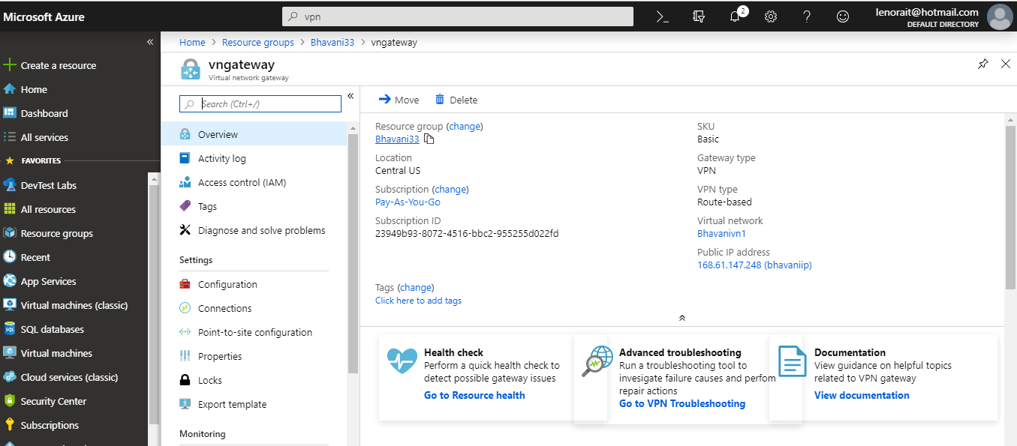

b.connection from vn2 to vn1:

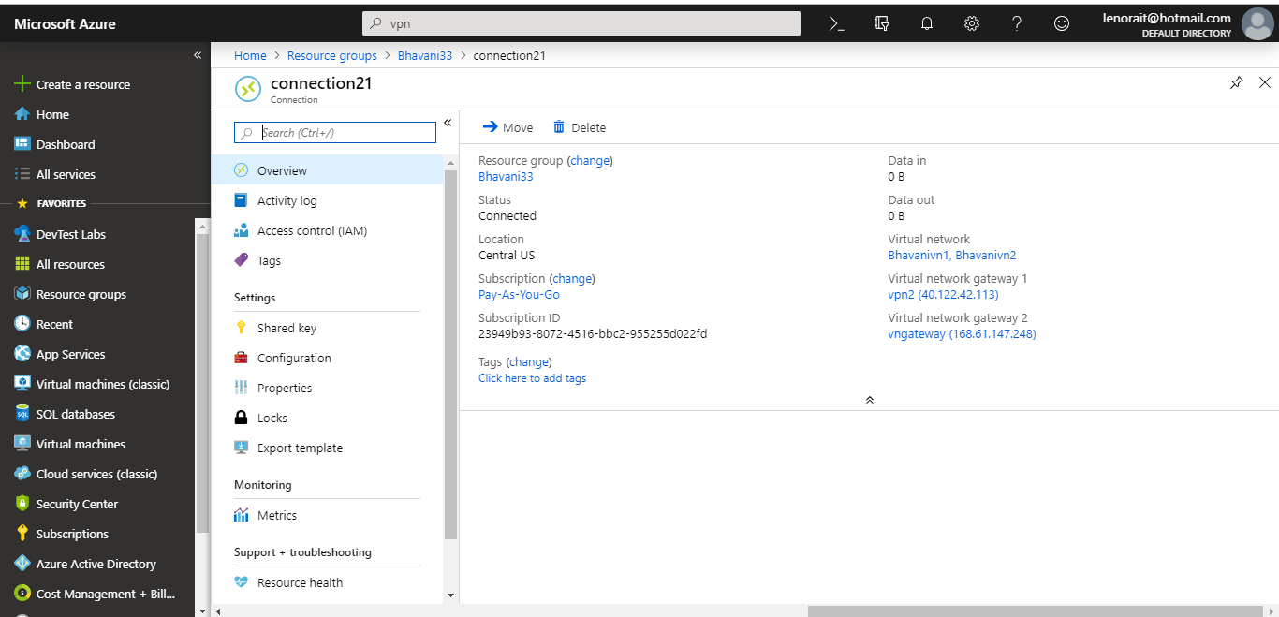

6.peering from VN2 to VN3 and make VN2 as HUB:

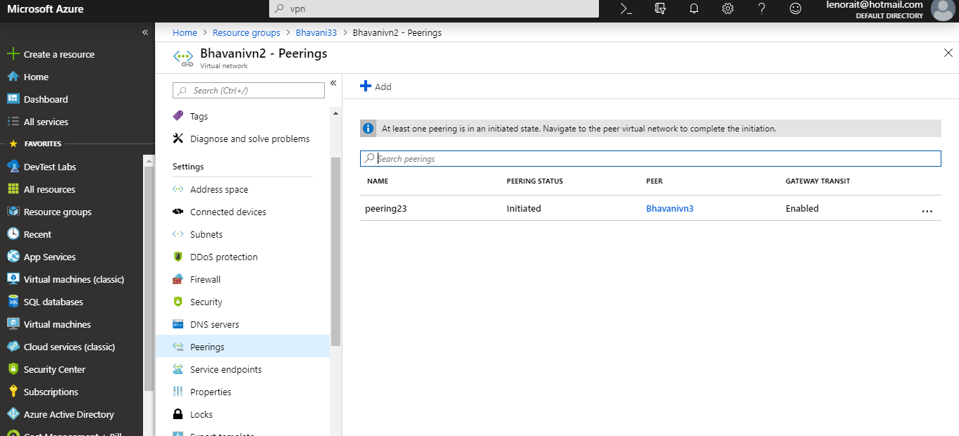

Peering from VN3 to VN2 and make VN3 as spoke

