1.Created Resource Group in Portal Azure…

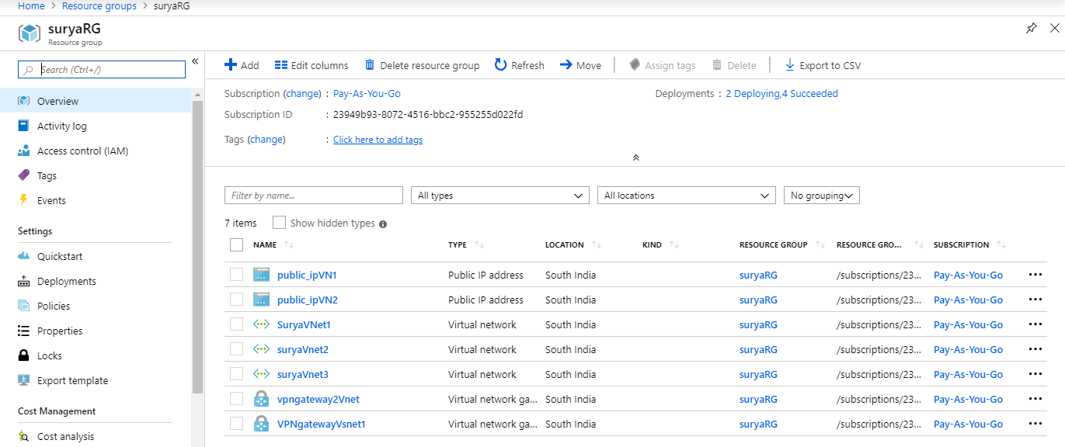

2.Created Virtual Networks (Vnet1,Vnet2,Vnet3)..

A.created virtual network subnet 1.

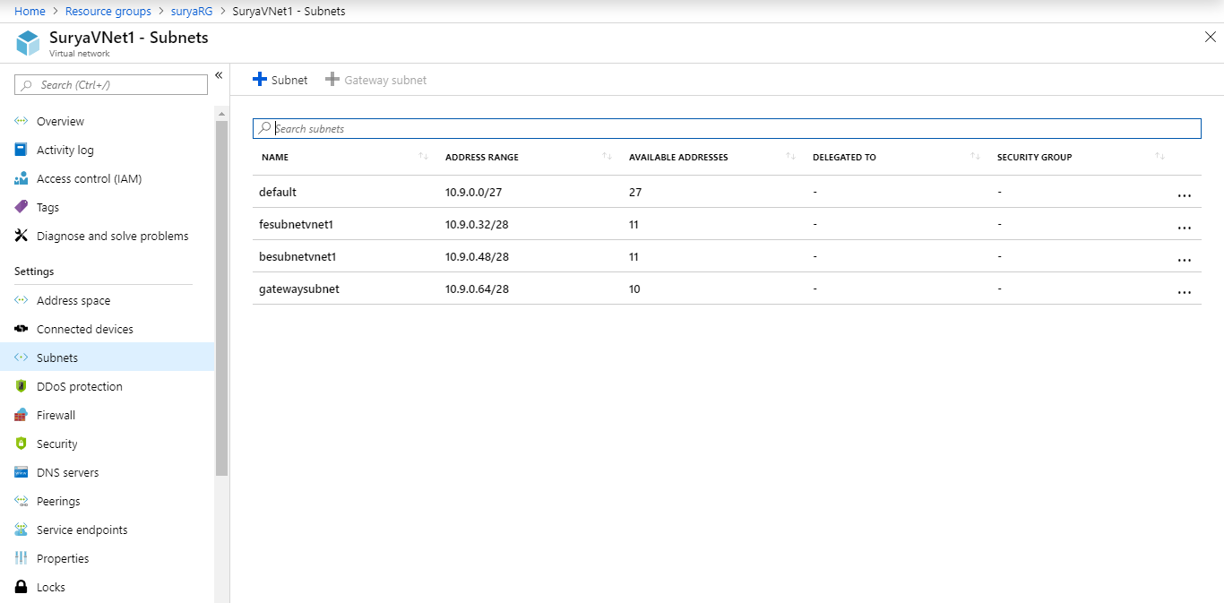

B.Cretaed Virtual Network Subnet 2.

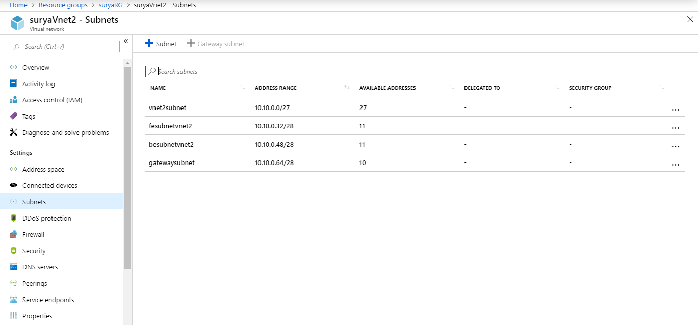

C. Created Virtual Network Subnet 3..

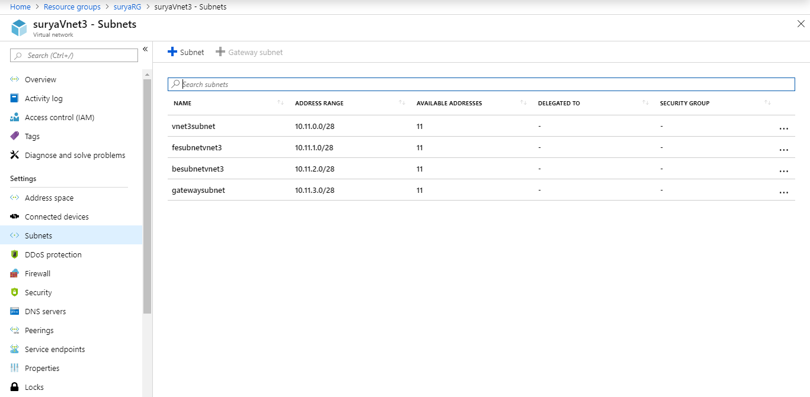

3.Created VPN Virtual Network Gateway 1….

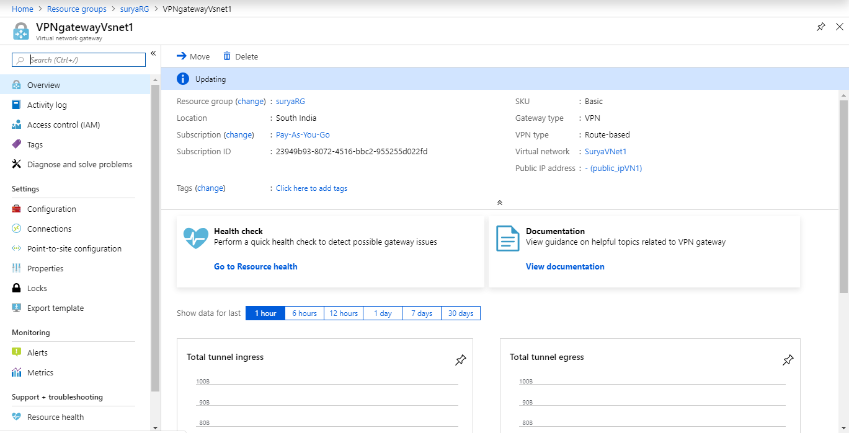

4.Created VPN Virtual Network Gateway..

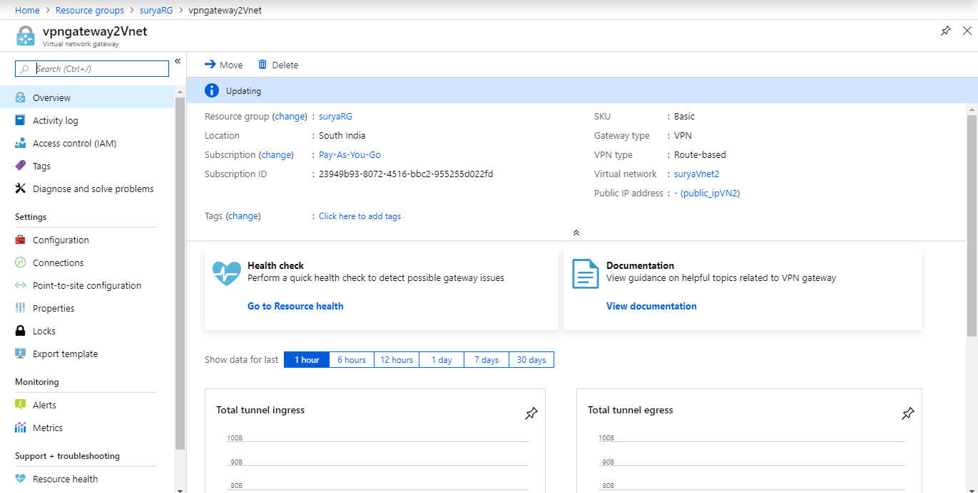

5.Created Vnet1-t0-Vnet2…

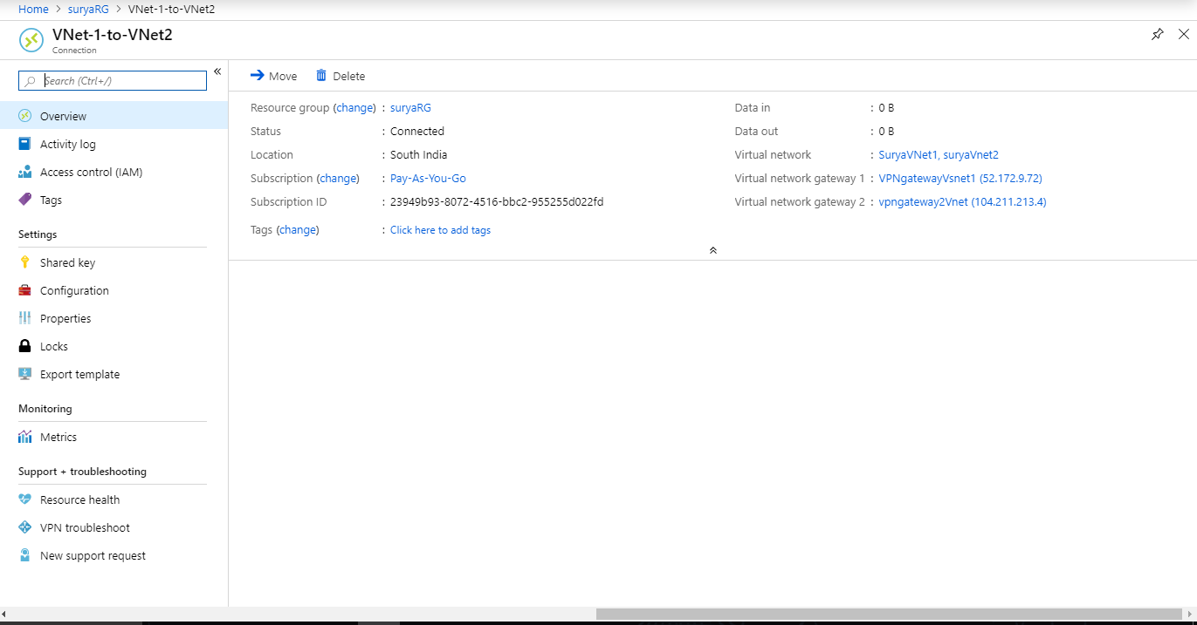

6.Created Vnet2-to-Vnet1..

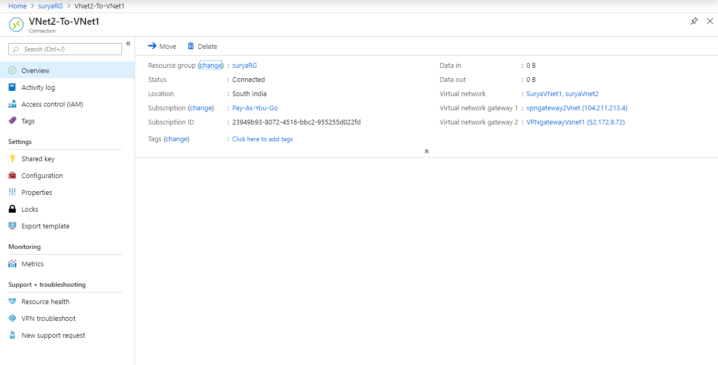

7.Created Connections to Vnet2-to-Vnet3…

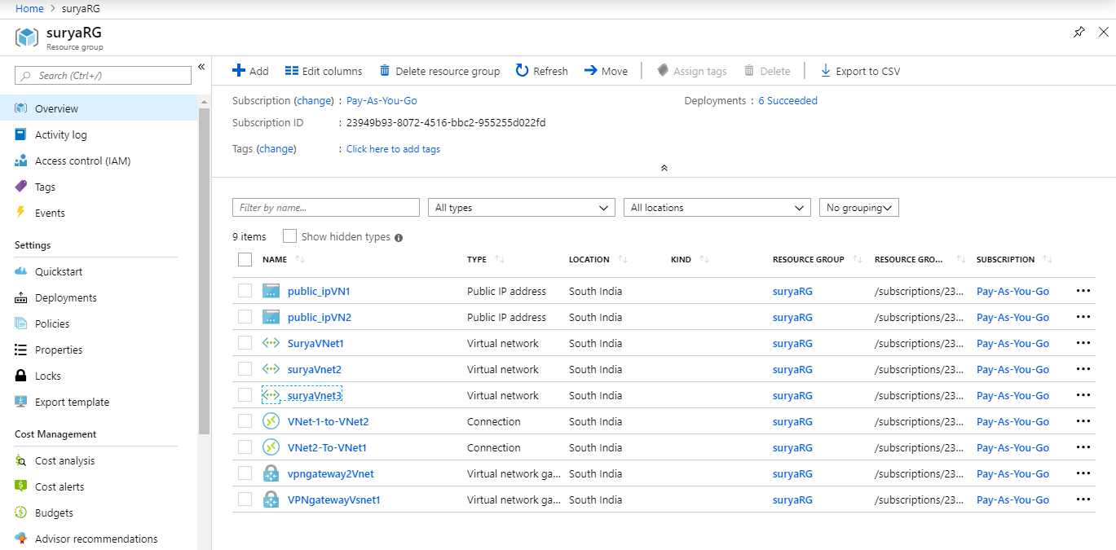

8.Public ip Address for Vnet1…

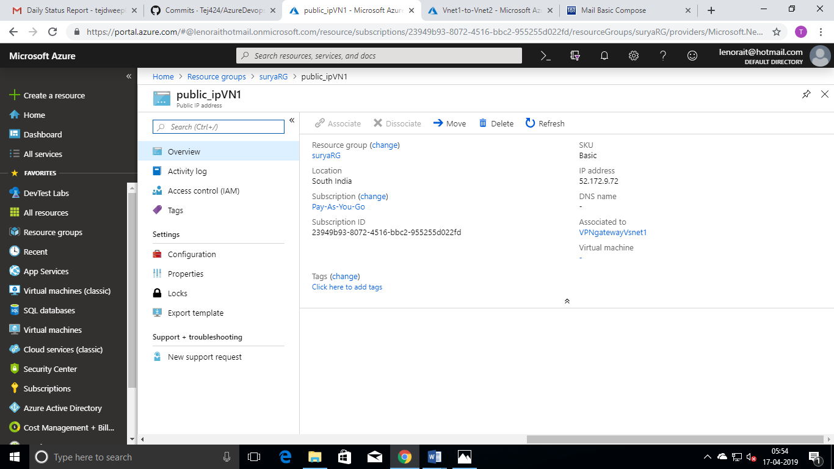

9.created public ip Address for Vnet2..

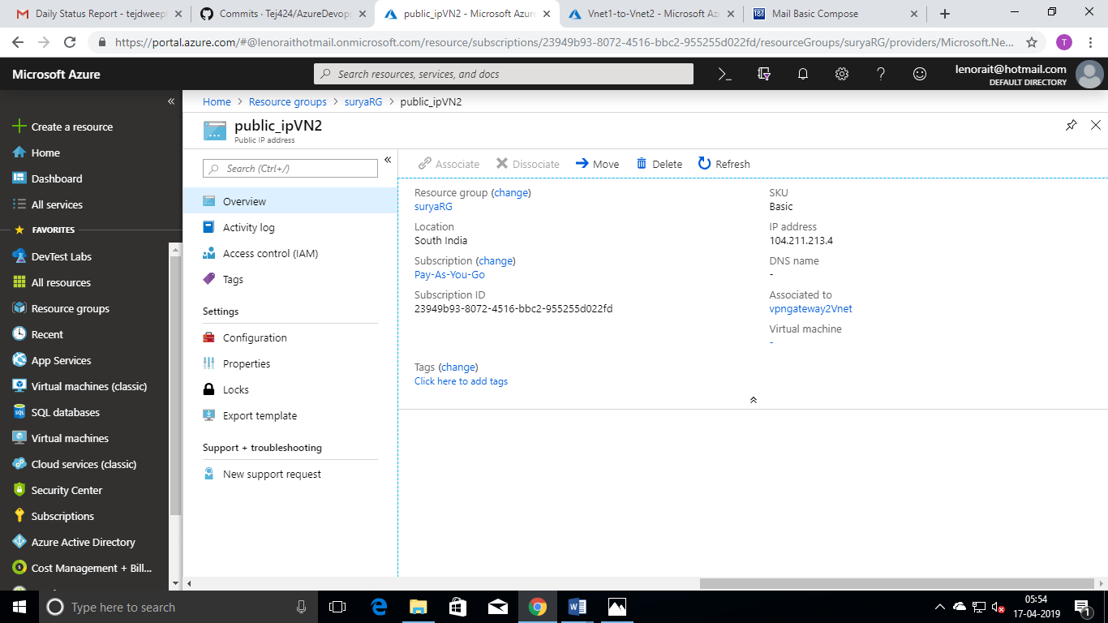

10.Created peering VNet2-to-Vnet3..

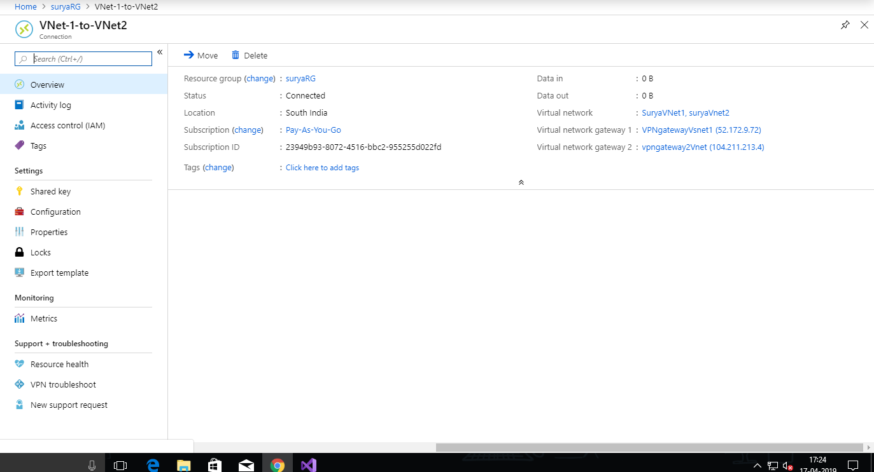

11.Created peering with spoke from Vnet3-to-Vnet2 using connections…

