**TASK-4**

**Create Scale set,Backup&Restore,Encryption,and Traffic manager.**

Created Resource group with the name of SuryaRG1.

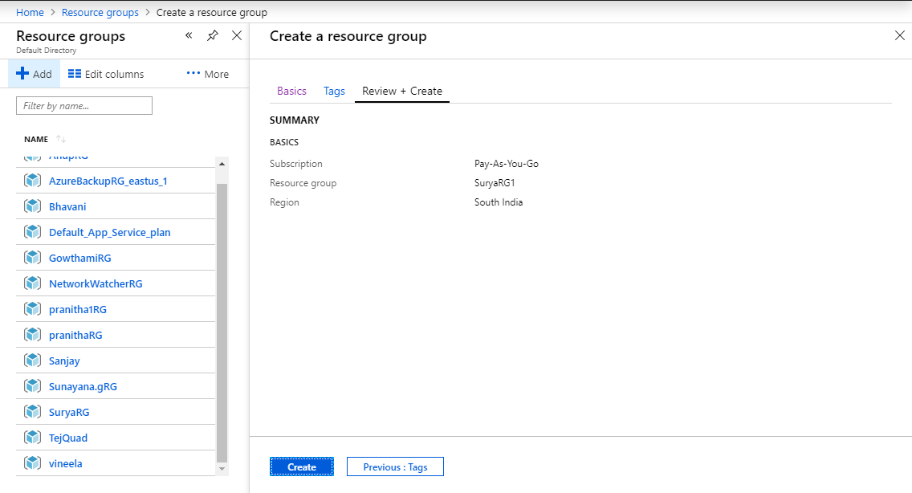

Created virtual machine scale sets.

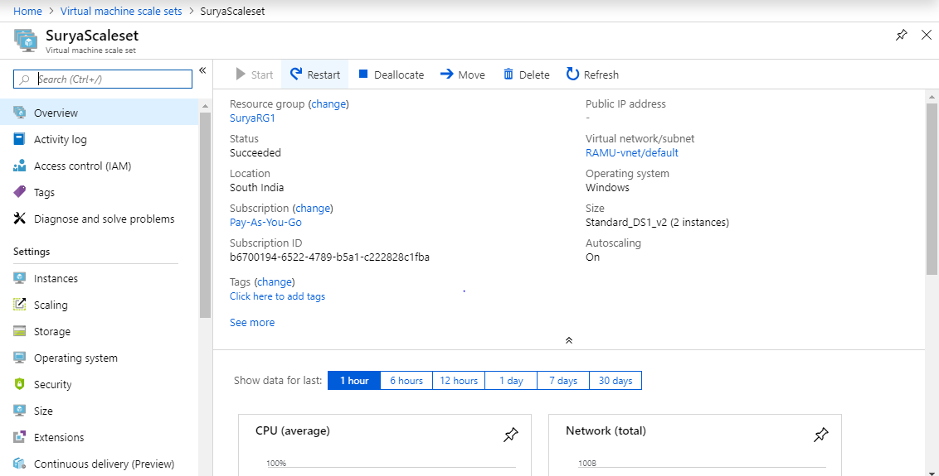

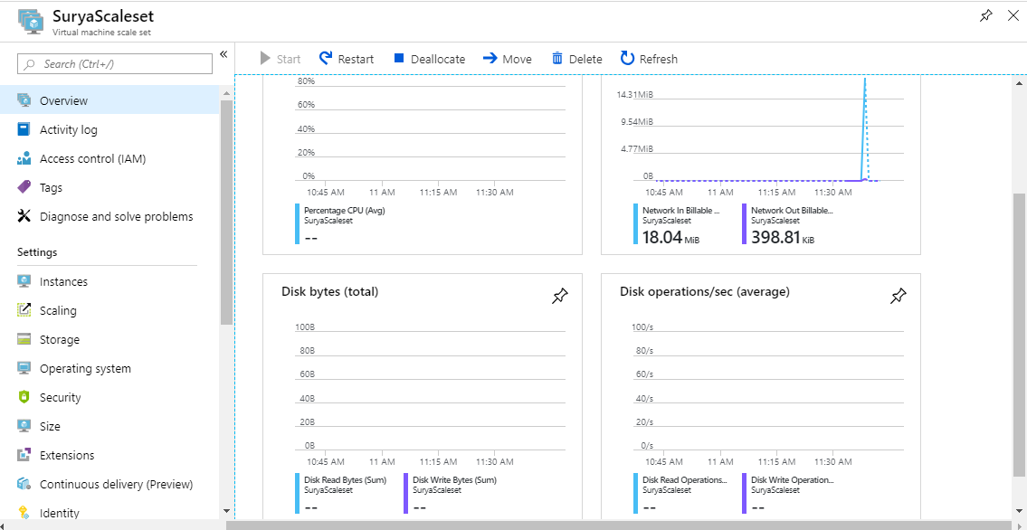

Created Recovery Service Vault.

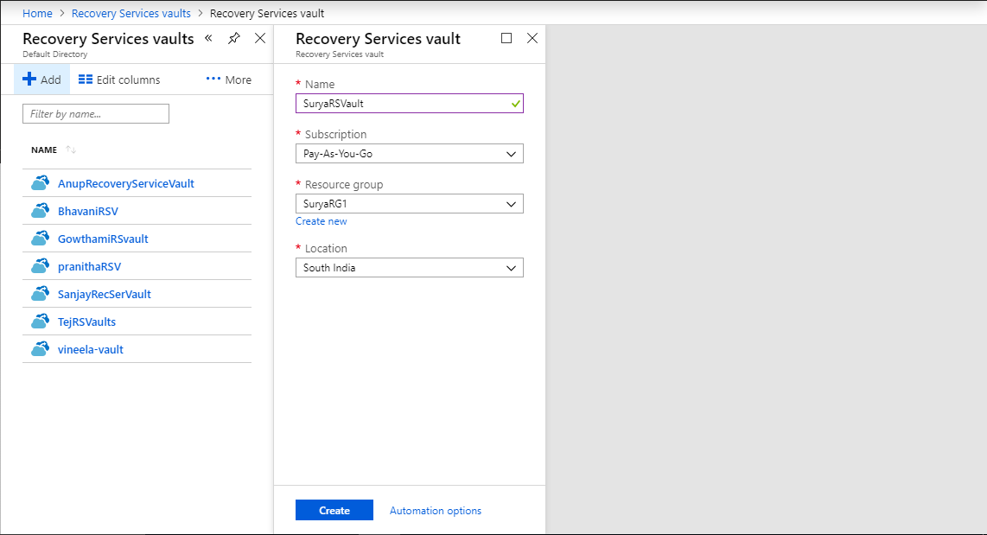

Created Backup Policies.

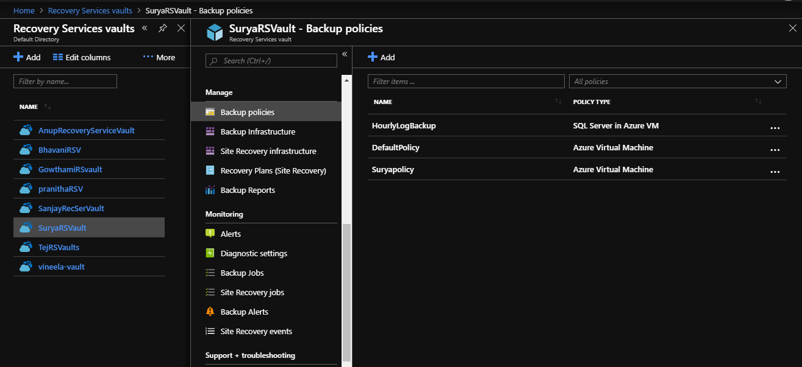

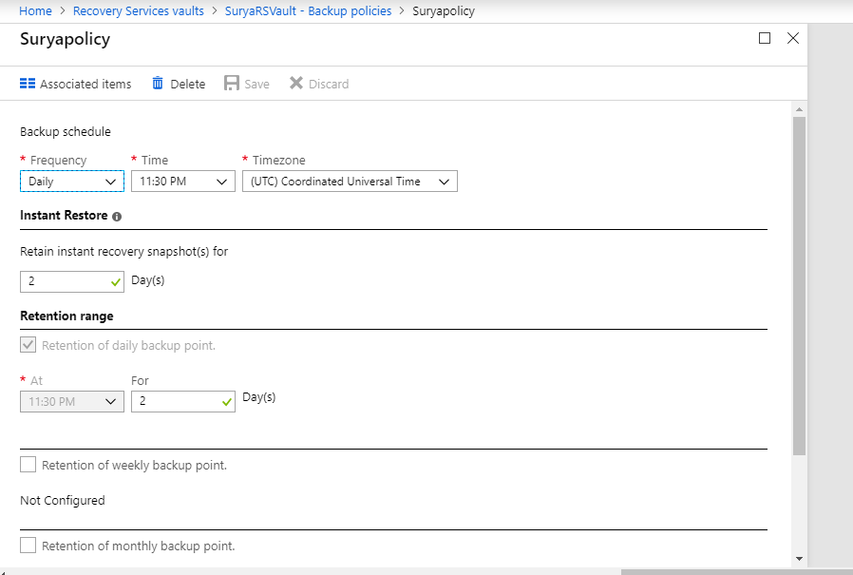

Created virtual machine.

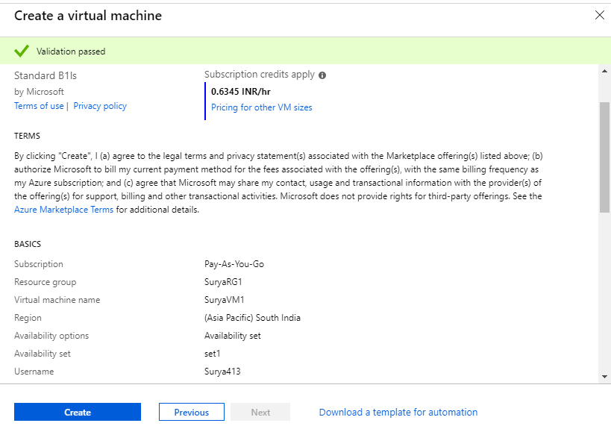

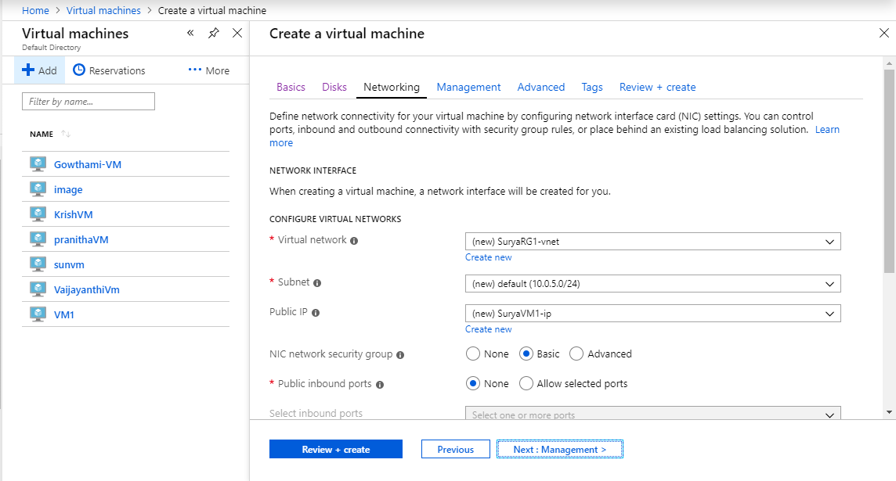

Created disk in virtual machine.

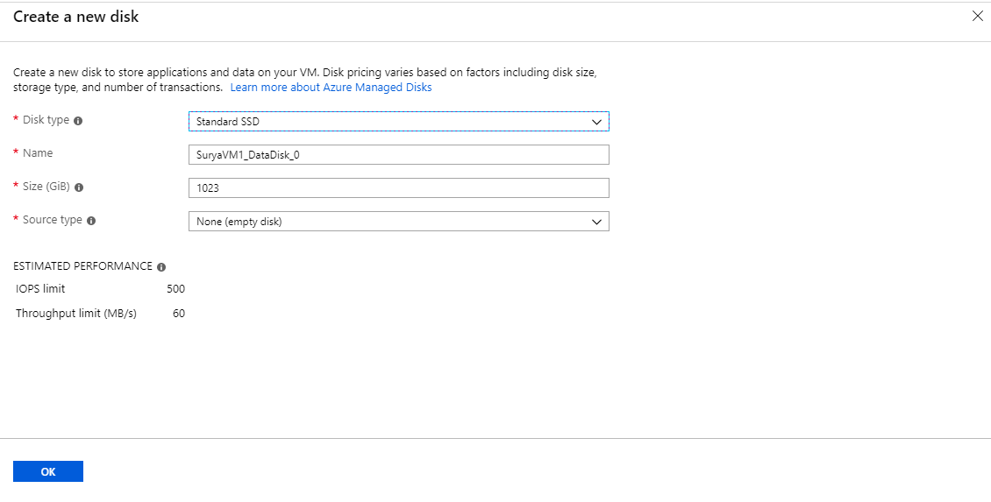

Created Networking in virtual machine.



Created Management.

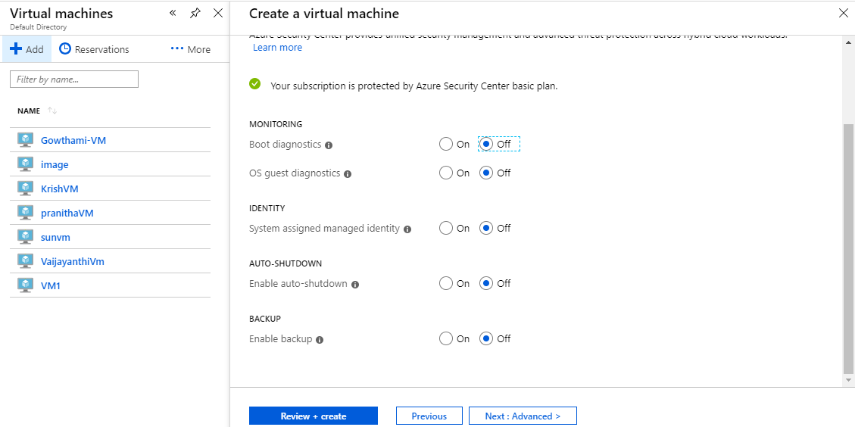

Created Advanced selection extension.

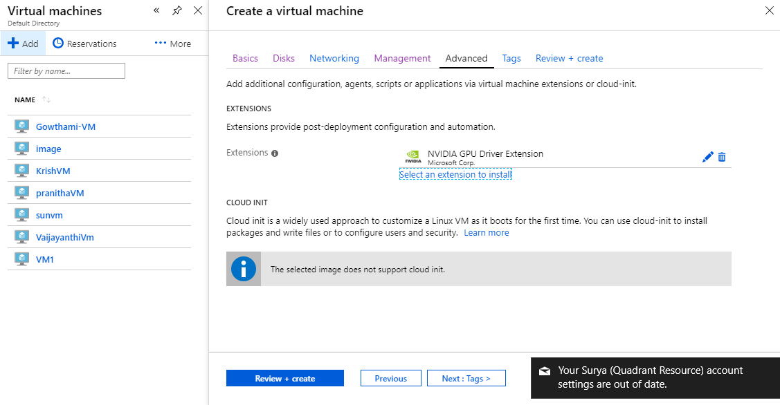

Created virtual machine with the name of suryavm1.

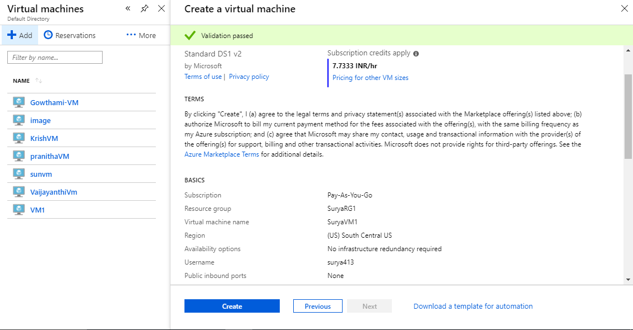

Select virtual machines with items to backup.

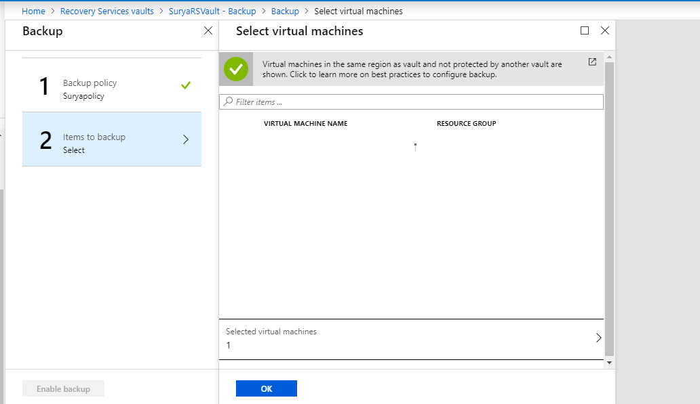

Created a Application Registration with the name of **Suryaapreg.**

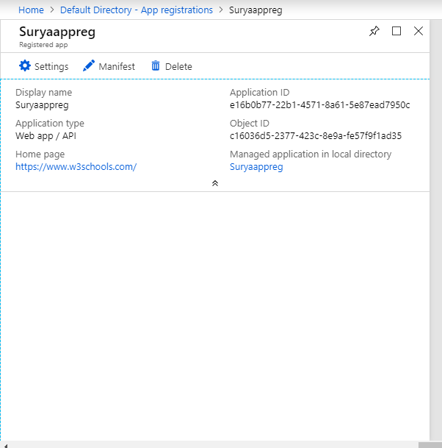

**Created Access key vault Polices with the name of Suryakeyvault.**

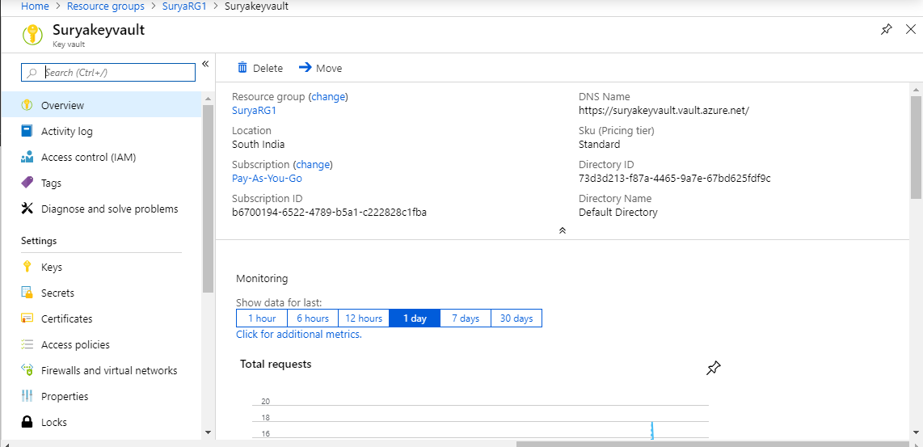

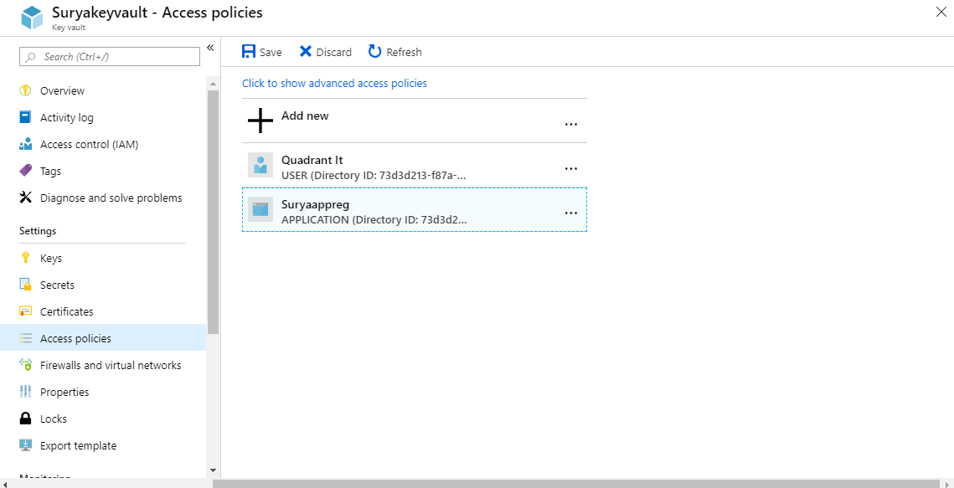

**Created 3Traffice managers profiles TM,TM1,TM3.**

**Created traffic manager 1 with priority.**

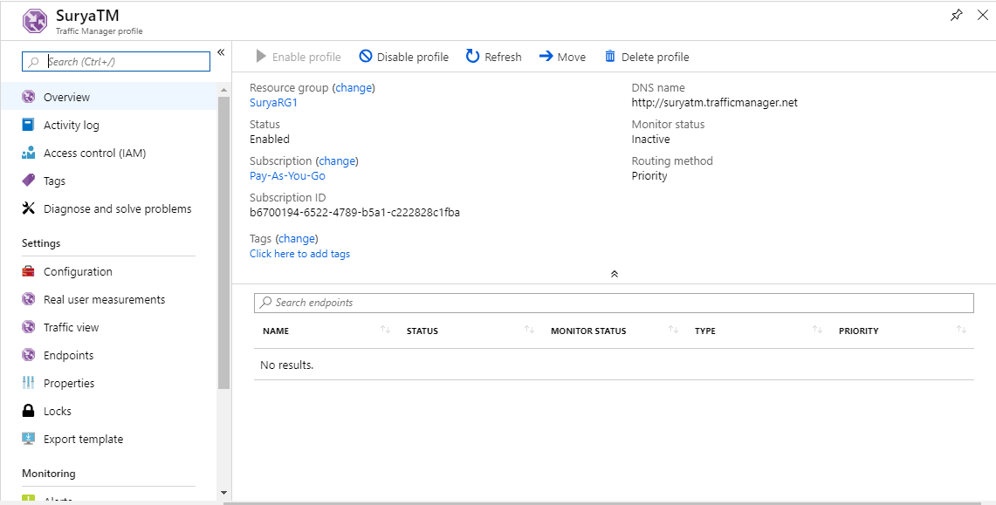

**Created traffic manager 1 with performance.**

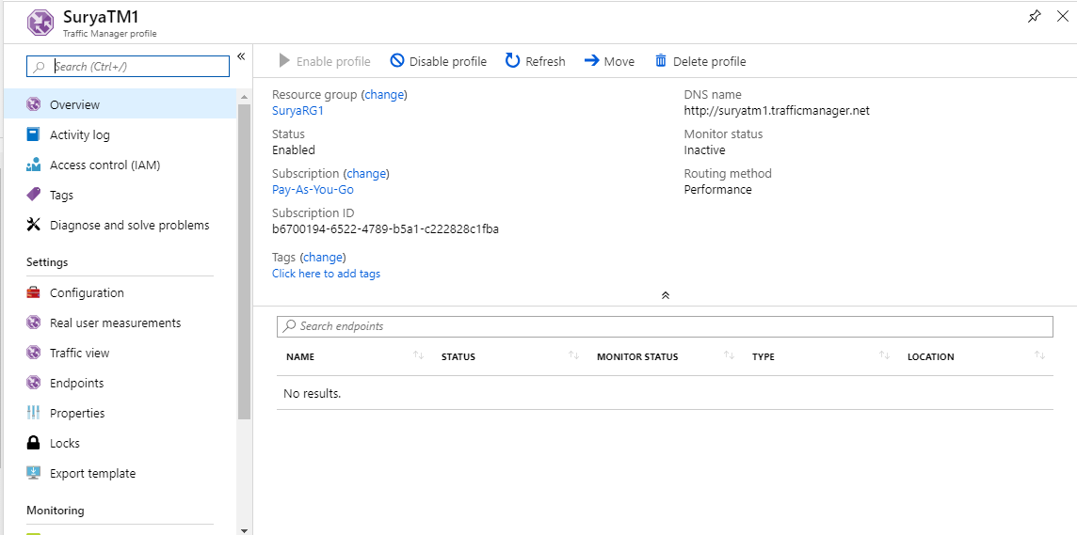

**Created traffic manager TM3 with weighted.**

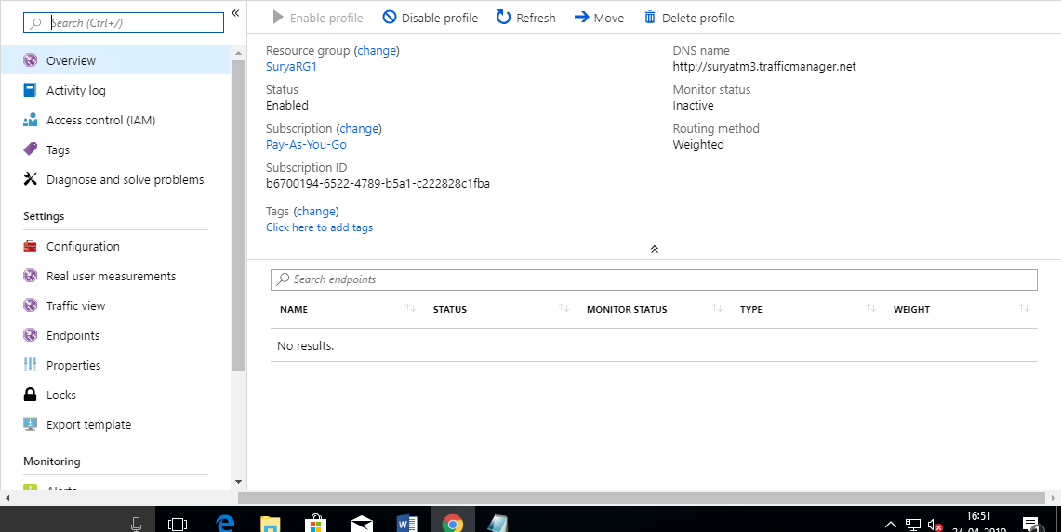

**Created availability set with the name set1.**

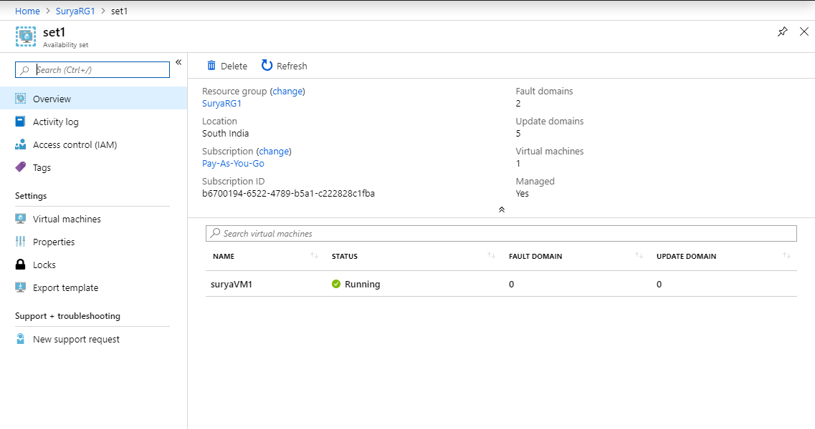

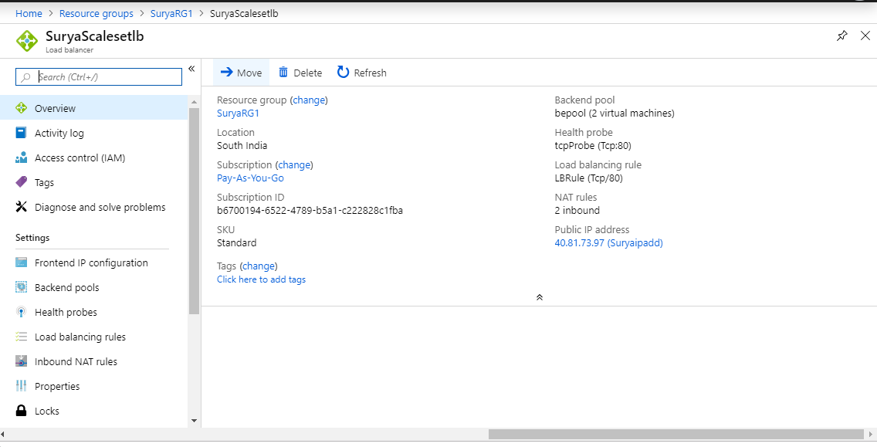

**Created Access Policies with suryakeyvault-access policies**.

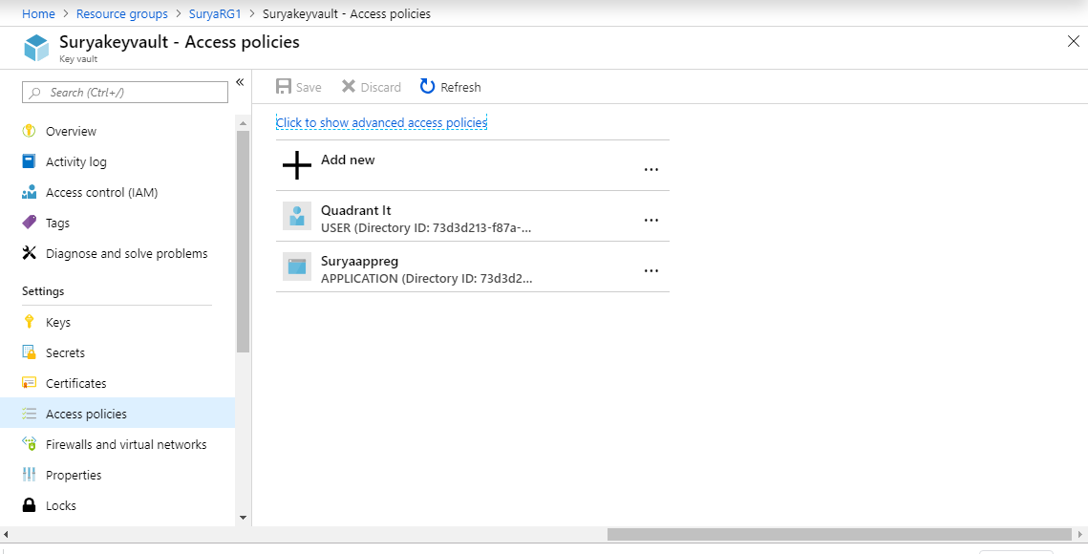

**Application registration with suryaAppReg.**

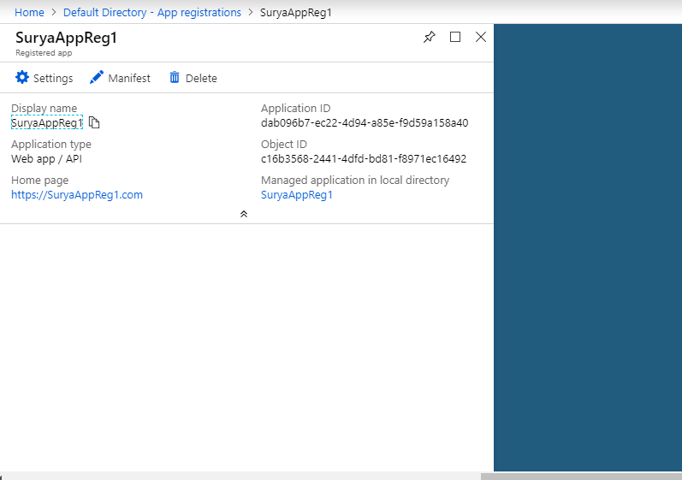

**Enable encryption on running windows VM.**

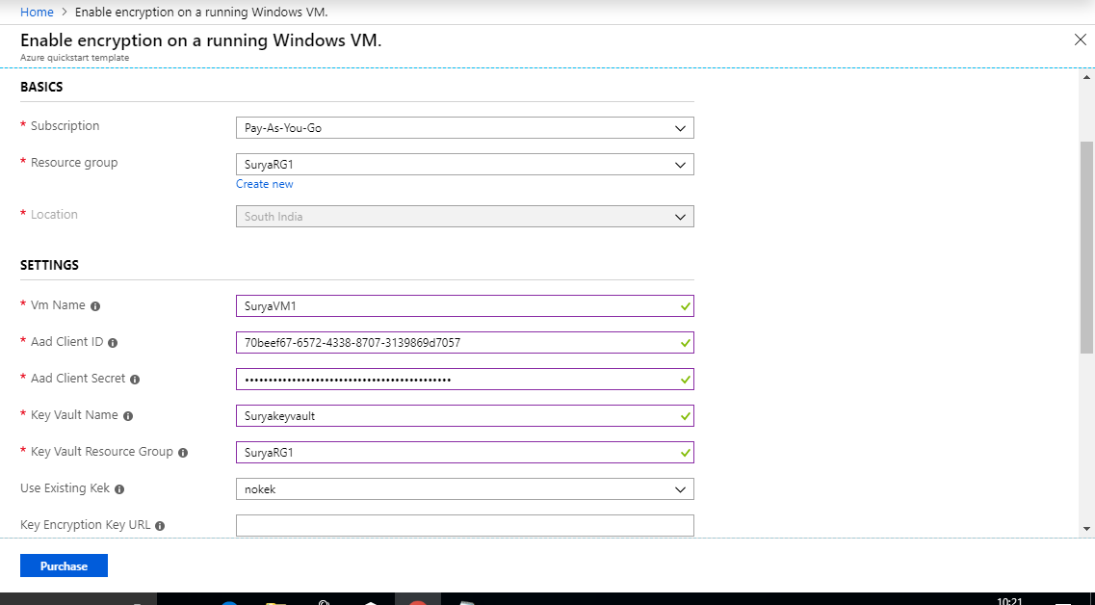

**Finally the Disk is encryption is enabled.**

