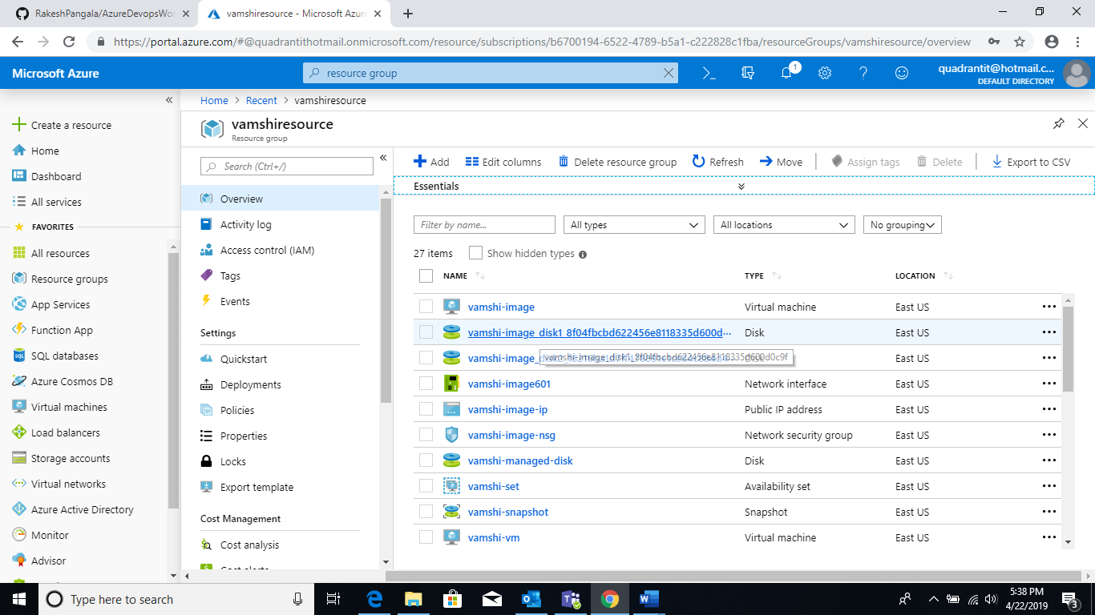

Resource group:Vamshi-resource .

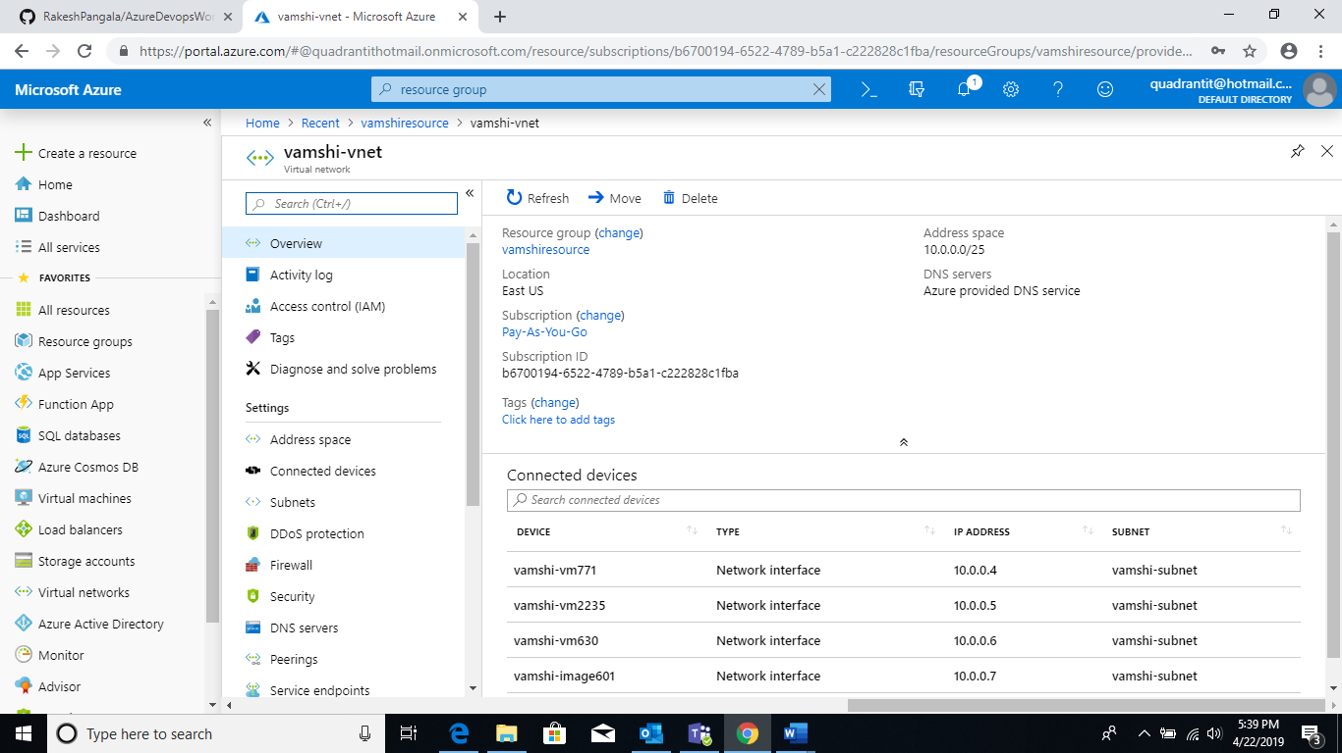

Creating vnet:Vamshi-vnet.

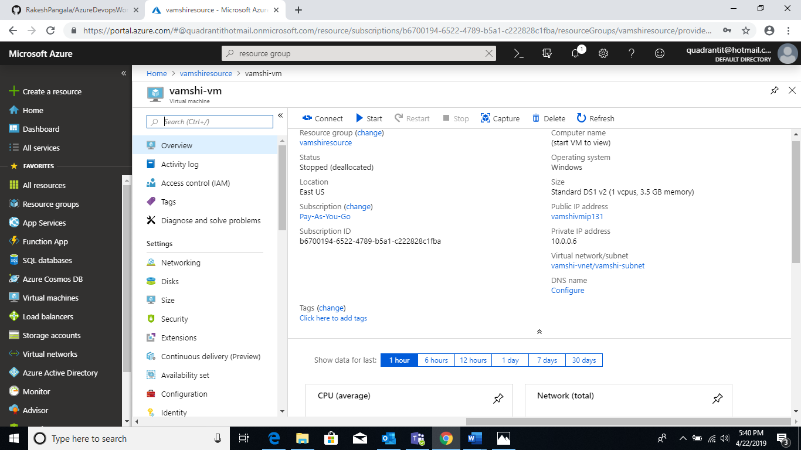

Vm installation:Vamshi-vm.

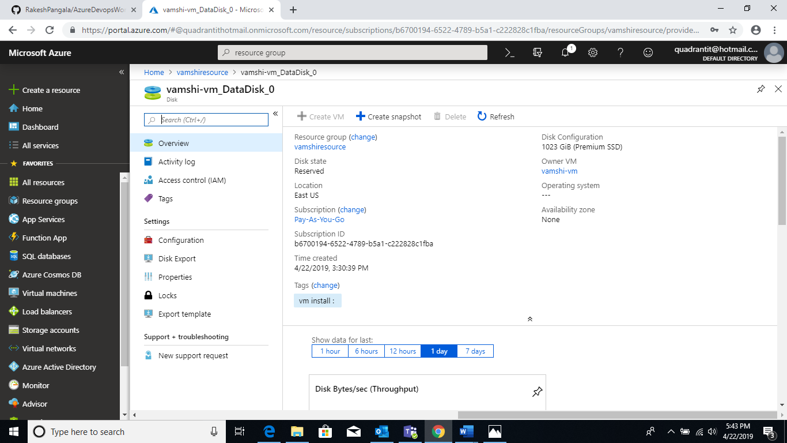

Vamshi-vm data disk.

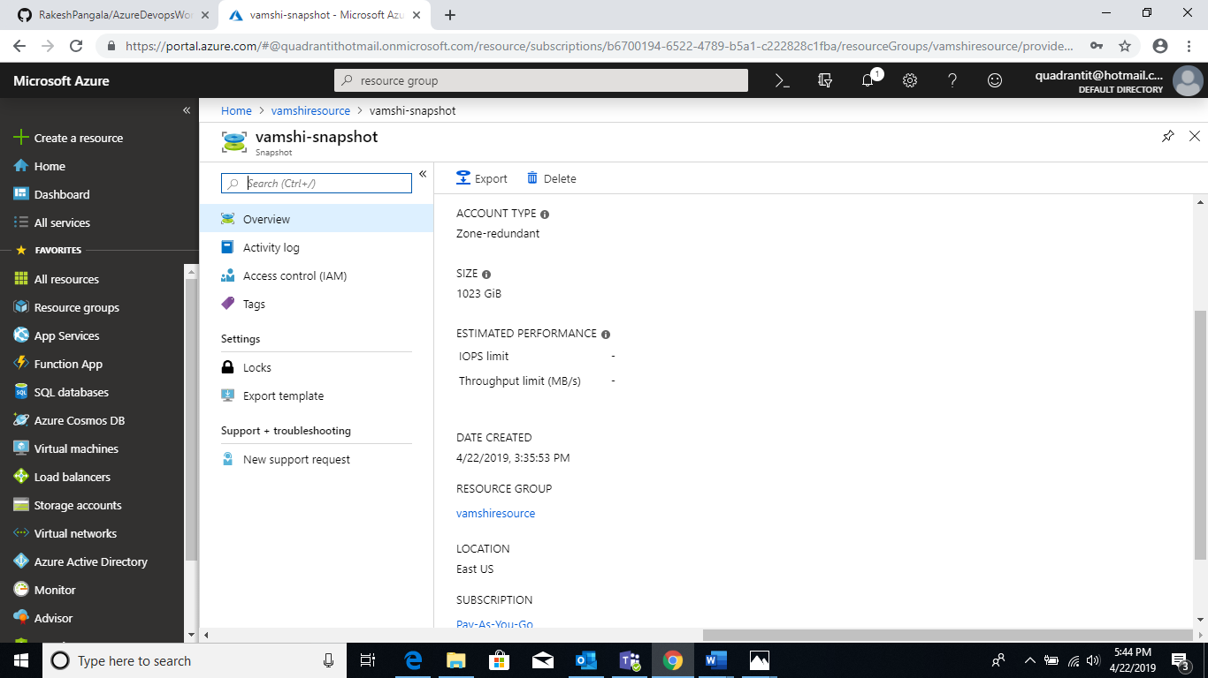

Snapshort of Vamshi-vm data disk :Vamshi-snapshort.

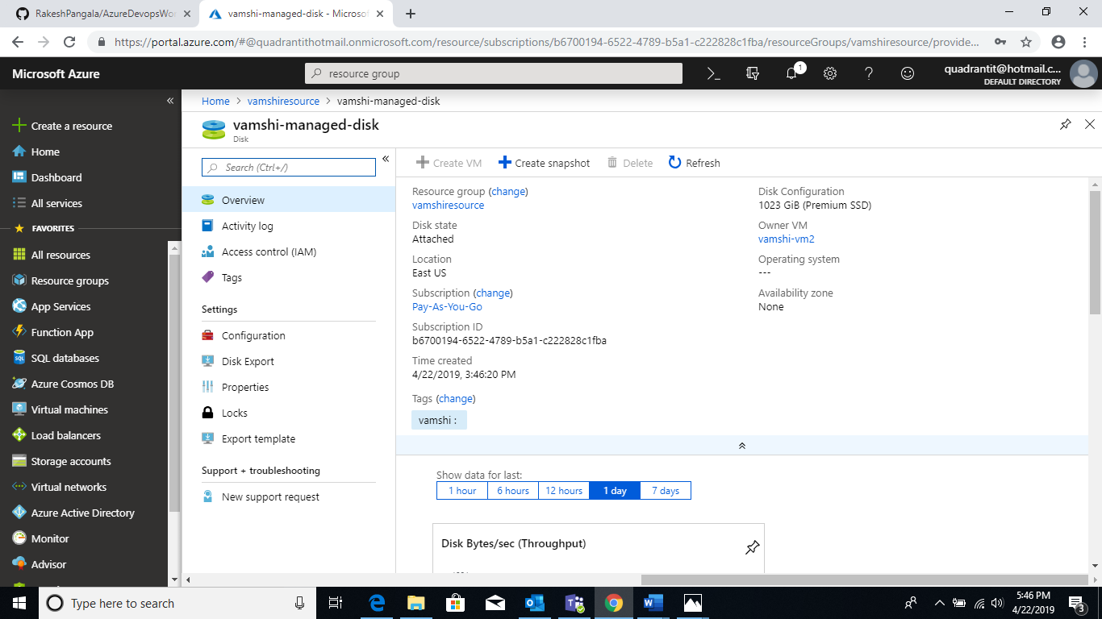

Coverting snap short into managed disk:Vamshi-managed-disk.

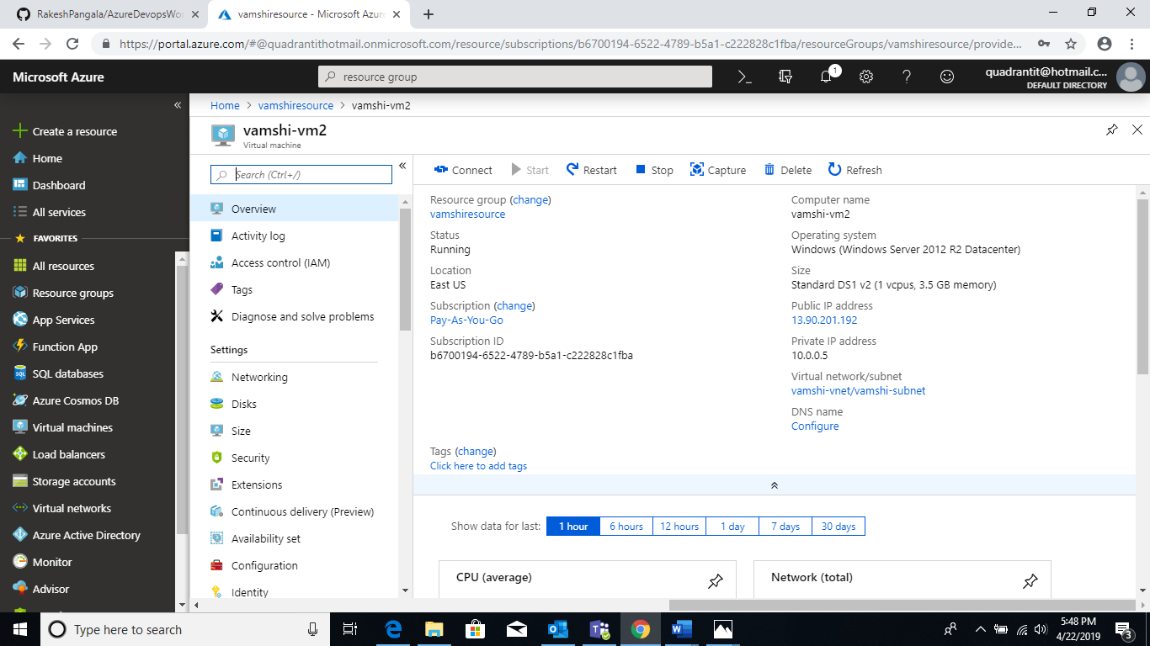

Creating vm2 using snapshort :Vamshi-vm2.

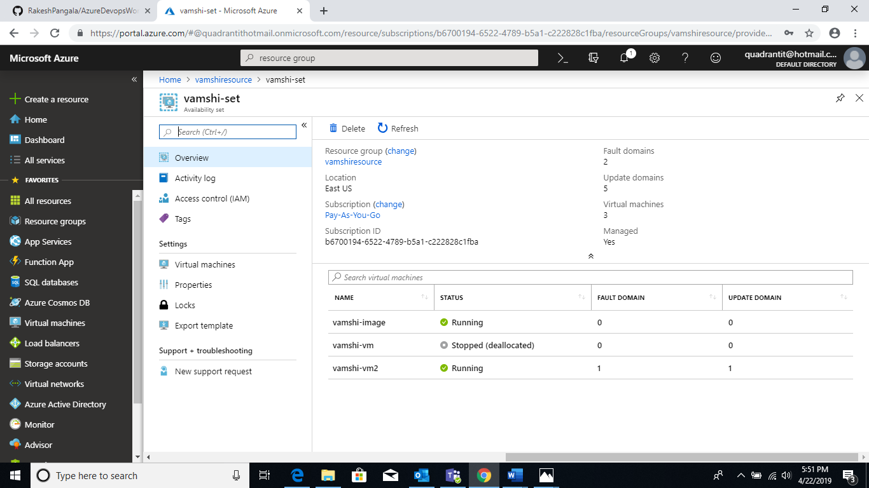

Application-set:Vamshi-set.

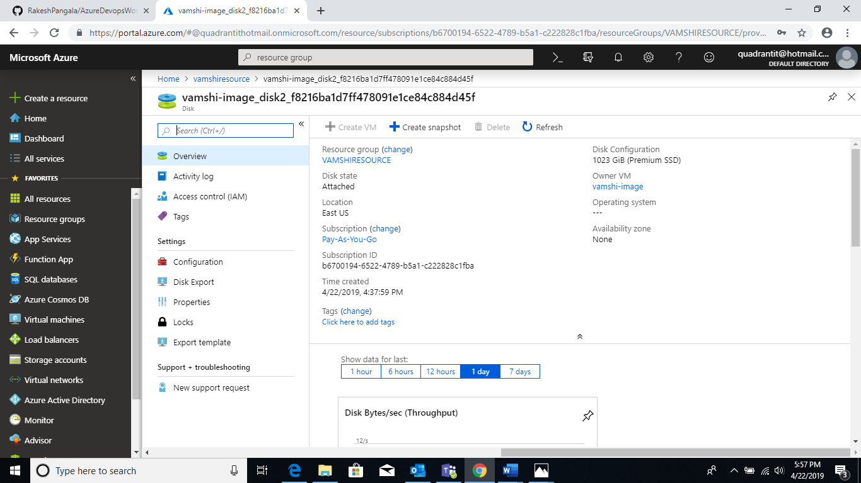

Creating image: **vamshi-image_disk2_f8216ba1d7ff478091e1ce84c884d45f**

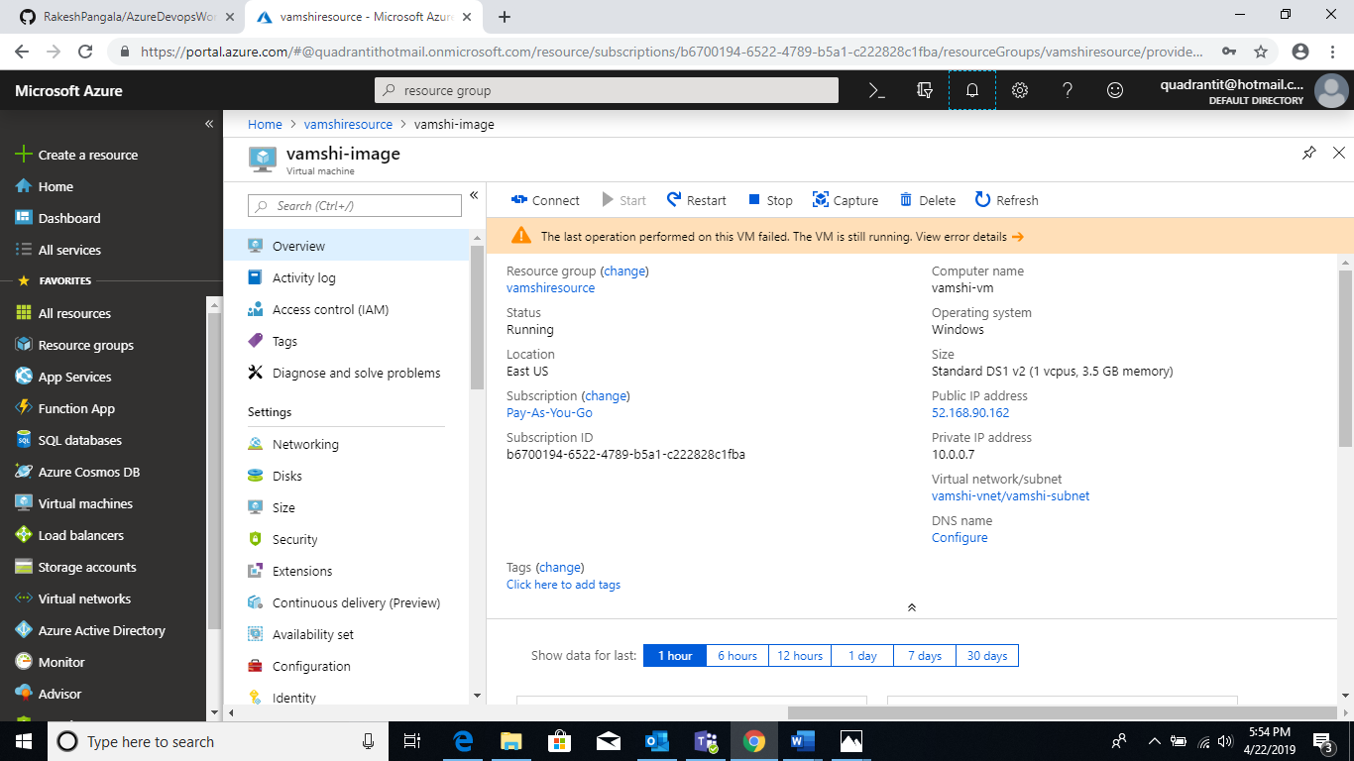

Creating vmusing image:vamsshi-image.