Excel Basics Assignment – Rakesh Ponnoju
Drive Link - https://drive.google.com/drive/folders/1uTEnoTyD_w_hUBIHLc8r2VP-X6LmnrFf?usp=sharing
1. Explain the difference between Relative, Absolute and Mixed Cell Referencing.
Relative Cell Reference
A relative cell reference changes automatically when a formula is copied from one cell to another.
Explain the difference between Relative, Absolute and Mixed Cell Referencing.
Vehicle | Price | Relative | Absolute | Mixed
Car | 500000 | 510500 | 510500 | 500000
Bicycle | 10500 |  | 510500 | 10500
Auto-Rickshaw | 25000 |  | 510500 | 25000
Absolute Cell Reference
An absolute cell reference remains fixed when copied to another cell. Dollar signs ($) are used to lock the row and column.
Mixed Cell Reference
A mixed cell reference locks either the row or the column only.
2. Write a formula to calculate the total sales of Car and Bicycle only.
Vehicle | Price
Car | 500000
Bicycle | 10500
Auto-Rickshaw | 25000
CAR & BICYCLE | 510500
=SUM(B11:B12)
3. Using the data below, write a formula to calculate the average sales of items priced above 100 but less than 300.
A | B | C
Item | Price | Sales
Item A | 90 | 1000 | 1350
Item B | 150 | 1200
Item C | 250 | 1500
=AVERAGEIFS(C19:C21,B19:B21,">100",B19:B21,"<300")
4. Count how many customer names are recorded.
=COUNTA(B2:B51) - 50
5. Calculate the Total Sales for each row using a formula.
=E2*F2
Quantity | UnitPrice | Total sales
10 | 50 | 500
20 | 10 | 200
15 | 25 | 375
5 | 50 | 250
30 | 5 | 150
12 | 50 | 600
25 | 8 | 200
18 | 10 | 180
22 | 25 | 550
8 | 50 | 400
40 | 5 | 200
35 | 8 | 280
14 | 50 | 700
28 | 10 | 280
12 | 25 | 300
25 | 5 | 125
20 | 8 | 160
10 | 50 | 500
15 | 10 | 150
18 | 25 | 450
9 | 50 | 450
35 | 5 | 175
30 | 8 | 240
11 | 50 | 550
14 | 10 | 140
16 | 25 | 400
22 | 5 | 110
27 | 8 | 216
13 | 50 | 650
32 | 10 | 320
10 | 25 | 250
18 | 5 | 90
22 | 8 | 176
17 | 50 | 850
19 | 10 | 190
15 | 25 | 375
28 | 5 | 140
24 | 8 | 192
16 | 50 | 800
27 | 10 | 270
21 | 25 | 525
30 | 5 | 150
26 | 8 | 208
14 | 50 | 700
20 | 10 | 200
17 | 25 | 425
19 | 5 | 95
32 | 8 | 256
12 | 50 | 600
25 | 10 | 250
6. Calculate the total sales of Notebooks in the North region only.
=SUMIFS(G2:G51,D2:D51,"Notebook",C2:C51,"North")
2900

7. Create a column chart showing total sales by product.
Product | Total Sales
Notebook | 7550
Pen | 2180
Marker | 3650
Pencil | 1235
Eraser | 1928
=SUMIF(D2:D51,"Notebook",G2:G51)
=SUMIF(D2:D51,"Pen",G2:G51)
=SUMIF(D2:D51,"Marker",G2:G51)
=SUMIF(D2:D51,"Pencil",G2:G51)
=SUMIF(D2:D51,"Eraser",G2:G51)
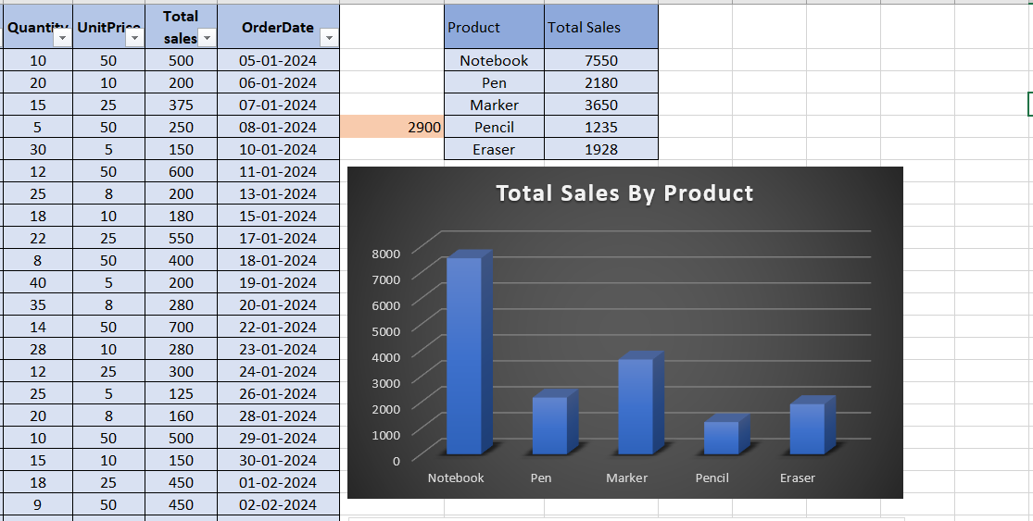
8. Insert a line chart showing daily sales trend
