Model Context Protocol (MCP) – Discovery Report (Azure Focused)

1. Executive Summary
This report outlines the assessment, readiness, and recommended architecture for implementing the Model Context Protocol (MCP) within Microsoft Azure. MCP provides a standardized framework for integrating enterprise systems, APIs, data sources, and tools with Azure-hosted LLMs (Azure OpenAI, GPT-4.1, GPT-4o, Phi-3).

What is MCP (Model Context Protocol)
MCP is an open-source standard for connecting AI applications to external systems, enabling AI applications like Claude or ChatGPT to connect to data sources (e.g., local files, databases), tools (e.g., search engines, calculators), and workflows (e.g., specialized prompts). It standardizes the format for function calls, tool usage, memory, and state.

Core Architecture
The architecture is based around three primary components: Host, Client, and Server.
Host: The LLM application / environment (e.g., Claude Desktop, coding IDE, conversational AI) that needs context or tools. The host manages multiple client instances, enforces security policies, and coordinates context exchange.
Client: Located within the host, the MCP client translates between the LLM and MCP servers. It discovers available servers, converts requests into MCP protocol format, and handles session management including timeouts and reconnections. Each client maintains a 1:1 relationship with a specific server.
Server: External systems providing additional capabilities to the models. MCP servers can offer three primary types of capabilities to clients:
- Resources: Provide context and data that can be accessed by either the user or the AI model
- Prompts: Deliver templated messages and structured workflows for suggested user interactions
- Tools: Expose functions that AI models can call to perform specific tasksMCP Architecture
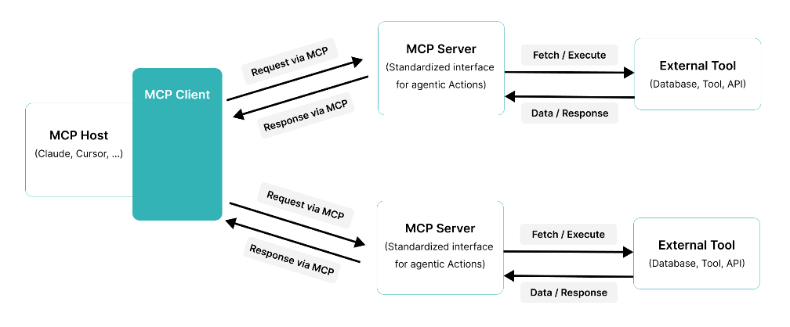

Benefits
Faster integration – Single protocol to connect LLM hosts to multiple tool/data server. It reduces custom connector work and integration debt.
Real-time Response – LLMs can access up-to-date documents, DB records, diagnostic, tools at runtime – improving accuracy, support complex and multi-step workflows that combine data retrieval and business process automation.
Reusability and Scalability – Build once (server or client) and reuse across teams, tools, and different LLMs. Single MCP client can access multiple servers, enabling comprehensive data integration across enterprise systems.

Prerequisites
- Azure subscription with Owner or User Access Administrator access
- Azure Storage Account
- Microsoft Foundry Project
- Azure MCP Server Tools required
  - Azure user credentials or managed identity with RBAC based on which tool we used

ROI
Estimate 40-60% reduction in integration development time compared to custom implementation. Ongoing maintenance costs decline significantly as MCP server are maintained centrally rather than duplicated across applications. Elimination of point-to-point integration code reduces technical debt and support burden. A single tea can manage MCP server deployment for multiple AI applications, versus requiring dedicated integration teams per application.

https://medium.com/@izuafa123abdulrafiu/mcp-in-azure-ai-foundry-the-usb-c-for-your-ai-agents-8bbbccdfb0c9

Appendix 1

Azure MCP Server
The Azure MCP Server enables AI-driven development tools to seamlessly interact with Azure cloud services using the Model Context Protocol (MCP). It provides a standardized and unified interface for managing Azure resources, deploying applications, and querying cloud services directly from supported development environments.
Developers and automation platforms can connect to the Azure MCP Server using a wide range of tools, programming languages, and frameworks
Connect using VS Code
- Install Azure MCP Server Extension in VS Code.
- After you install the extension, open GitHub Copilot and select Agent Mode.
- Refresh the tools list to see Azure MCP Server as an available option:

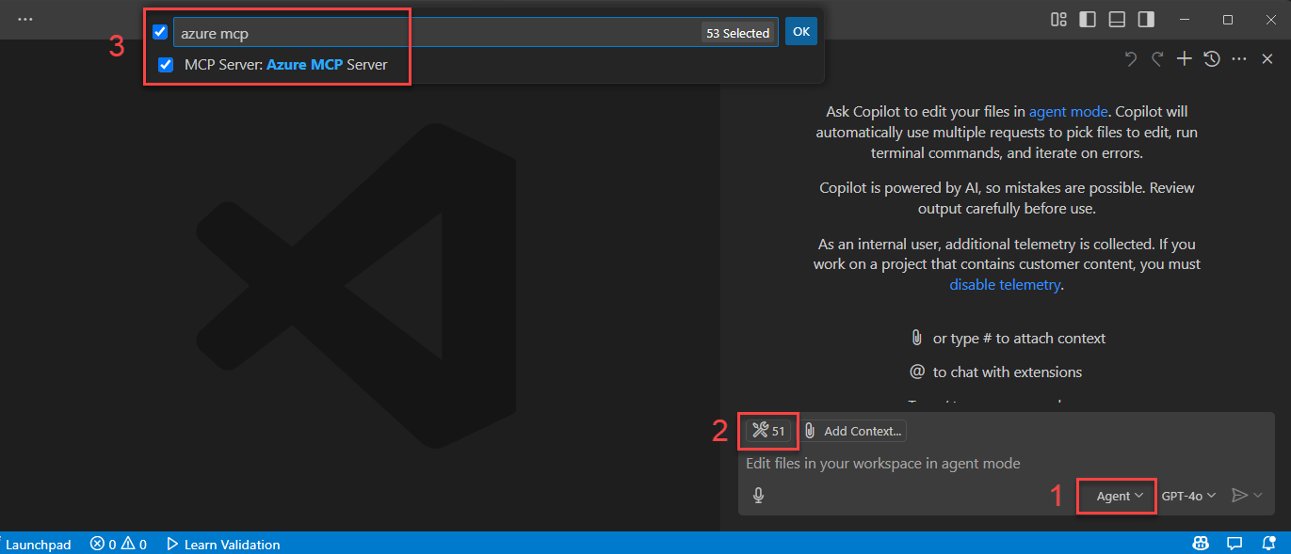

- Authentication to Azure - Azure MCP Server provides a seamless authentication experience using Azure accounts and Microsoft Entra ID. To use Azure MCP Server, you must first authenticate to Azure using local development tools such as the Azure CLI, Azure Developer CLI, Visual Studio, or Visual Studio Code. Azure MCP Server automatically discovers your credentials from these tools and uses them to authenticate to Azure services
- Use Prompt to test the Azure MCP Server
- Open GitHub Copilot and select Agent Mode.
- Enter a prompt that causes the agent to use Azure MCP Server tools, such as List my Azure resource groups.
- Output for the prompt

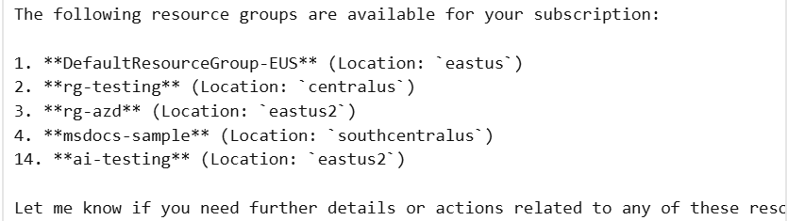

Deploy a self-hosted remote Azure MCP Server and connect to it using Microsoft Foundry
Deploy the Azure MCP Server as a self-hosted remote server over HTTPS. Agents in Microsoft Foundry and Microsoft Copilot Studio can securely connect to and call MCP tools using the deployed Azure MCP Server to run Azure operations.
Deploy the Azure MCP server to Azure Container Apps
- Clone and initialize the azmcp-foundry-aca-mi template with the azd init command.
azd init -t azmcp-foundry-aca-mi
When prompted, enter an environmental name
- Run the template with the azd up command
azd up
azd uses the template files to provision the following resources and configurations:
- Azure Container App: Runs the Azure MCP server and provides the storage namespace.
- Microsoft Entra ID role assignments: Assign roles to the Azure Container Apps managed identity for outbound authentication to the storage account you specify with the storage resource ID:
  - Reader: Read-only access to storage account properties.
  - Storage Blob Data Reader: Read-only access to blob data.
- Entra app registration: Provides OAuth 2.0 authentication for clients like agents that have the Mcp.Tools.ReadWrite.All role. The template assigns this role to the managed identity of the Microsoft Foundry project you specify.
- Application Insights: Provides telemetry and monitoring.

- Use Azure MCP Server from AI Foundry Agent
After deployment, connect your AI Foundry agent to the Azure MCP Server running on Azure Container Apps. The agent authenticates using its managed identity to gain access to the configured Azure Storage tools
- Go to your Foundry project at https://ai.azure.com/nextgen.
- Select Build → Create agent.
- Select + Add in the tools section.
- Select the Custom tab.
- Select Model Context Protocol, then select Create.

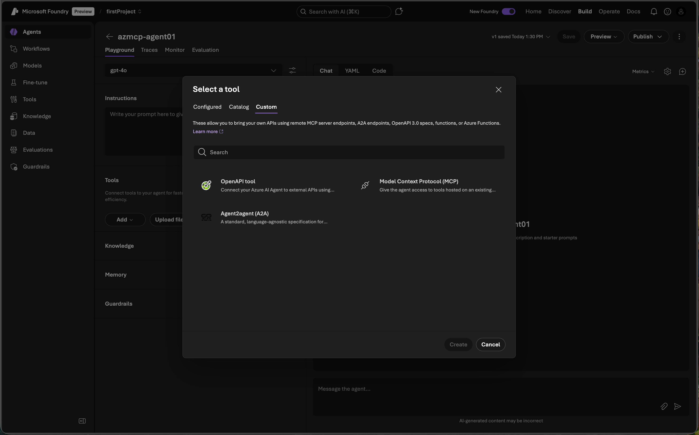
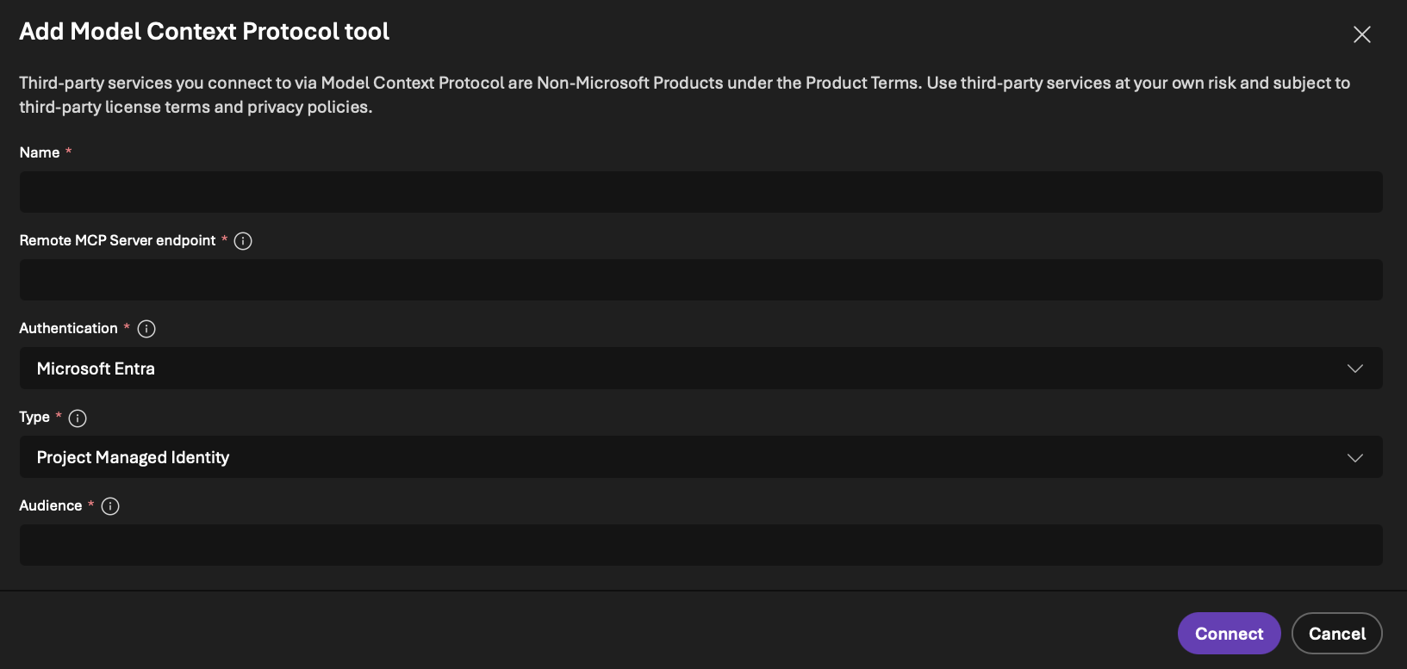

- Configure the MCP connection values:
- Name: Provide a name for the tool.
- Remote MCP Server: Enter the CONTAINER_APP_URL value from the azd output for the tool endpoint.
- Authentication: Select Microsoft Entra → Project Managed Identity.
- Type: Select Project Managed Identity.
- Audience: Enter the ENTRA_APP_CLIENT_ID value from the azd output.
- Select Connect to associate the connection with the agent.

https://github.com/microsoft/mcp/tree/main/servers/Azure.Mcp.Server

Current State Assessment
• Azure OpenAI models in use
• Existing automation (Azure Functions, Logic Apps, APIM)
• Present data sources (SQL, Blob, Data Lake)
• Security posture (Key Vault, RBAC, Private Endpoints)
• Gaps in structured tool calling, context passing, and governance

4. MCP Readiness Analysis
Readiness was evaluated across seven areas:
1. LLM Readiness – Azure OpenAI supports all MCP tool calling modalities.
2. API & Service Readiness – Azure Functions/APIM ready to be exposed as MCP tools.
3. Identity & Security Readiness – Entra ID + Managed Identity supported.
4. Logging & Governance – Azure Monitor, Log Analytics, Sentinel integrations available.
5. Data Access – Blob/Data Lake/SQL can attach as MCP context providers.
6. Infrastructure – Container Apps/AKS available for MCP server hosting.
7. Tooling – CI/CD using Azure DevOps supported.

5. Use Case Discovery & Mapping
High-value use cases identified:
1. SOC & Security Automation using Sentinel & Defender APIs
2. IT Operations Automation (VM, Network, User Ops)
3. Data Engineering – SQL/Data Lake ingestion and querying
4. Business Process Integration – CRM/ERP via APIM
5. Compliance Reporting & Audit Automation
Each use case mapped to MCP tools with priority ranking.

6. Azure Security & Compliance Assessment
• Authentication: Managed Identity, Entra ID OAuth2
• Authorization: RBAC, APIM policies, Key Vault secrets
• Compliance: ISO 27001, SOC 2, DPDP Act (India)
• Threat Modeling: Focus on tool over-permissioning, misuse of context, and API exposure
• Logging: Azure Monitor, Sentinel, App Insights

7. Target State Architecture
Target architecture defines:
• MCP Server on Azure Container Apps
• MCP Tools hosted as Functions, APIM Backends, Logic Apps
• Context providers using Blob/SQL/Data Lake
• Secure communication via Private Endpoints and Managed Identity
The LLM interacts with MCP for tool discovery, schema validation, and execution routing.

8. Implementation Roadmap
Phase 1 – Foundation (1–2 Weeks)
• Deploy MCP server
• Configure APIM integration
• Create first MCP tools (Azure Functions)
Phase 2 – Expansion (2–4 Weeks)
• Add advanced tools (Sentinel, Graph, SQL)
• Enable monitoring & governance
• UAT with pilot teams
Phase 3 – Production Readiness (2 Weeks)
• Harden security, RBAC, audit
• Deploy CI/CD
• Final go-live

9. Risks, Gaps & Mitigation
Key Risks:
• Over-permissioned tools → Mitigation: RBAC + token scoping
• API misconfiguration → Mitigation: APIM policies
• High complexity for data lineage → Mitigation: Metadata tagging
• Model misuse → Mitigation: Prompt governance and Sentinel monitoring

10. Conclusion & Recommendations
MCP is fully suitable for Azure-based enterprises and enables structured, secure integration between LLMs and operational systems. The architecture ensures alignment with Azure native identity, security, compliance, and DevOps standards. It is recommended to proceed with a phased implementation starting with high-value tools such as Sentinel KQL, Azure Functions, and APIM-based business systems.

