Model Context Protocol (MCP) – Discovery Report (Azure Focused)

1. Executive Summary
This report outlines the assessment, readiness, and recommended architecture for implementing the Model Context Protocol (MCP) within Microsoft Azure. MCP provides a standardized framework for integrating enterprise systems, APIs, data sources, and tools with Azure-hosted LLMs (Azure OpenAI, GPT-4.1, GPT-4o, Phi-3).

Purpose
The purpose of this document is to assess the readiness, architecture, and implementation approach for integrating MCP within Azure-based AI ecosystems. It outlines technical capabilities, enterprise requirements, security implications, and operational standards necessary for enabling safe and scalable AI-driven automation and development workflows using MCP.

What is MCP (Model Context Protocol)
MCP is an open-source standard for connecting AI applications to external systems, enabling AI applications like Claude or ChatGPT to connect to data sources (e.g., local files, databases), tools (e.g., search engines, calculators), and workflows (e.g., specialized prompts). It standardizes the format for function calls, tool usage, memory, and state.

Core Architecture
The architecture is based around three primary components: Host, Client, and Server.
Host: The LLM application / environment (e.g., Claude Desktop, Azure OpenAI, Foundry Agents, GitHub Copilot) that needs context or tools. The host manages multiple client instances, enforces security policies, and coordinates context exchange.
Client: Located within the host, the MCP client translates between the LLM and MCP servers. It discovers available servers, converts requests into MCP protocol format, and handles session management including timeouts and reconnections. Each client maintains a 1:1 relationship with a specific server.
Server: External systems providing additional capabilities to the models. MCP servers can offer three primary types of capabilities to clients:
- Resources: Provide context and data that can be accessed by either the user or the AI model (like API response or file contents)
- Prompts: Deliver templated messages and structured workflows for suggested user interactions
- Tools: Expose functions that AI models can call to perform specific tasks (with user approval)

MCP Architecture
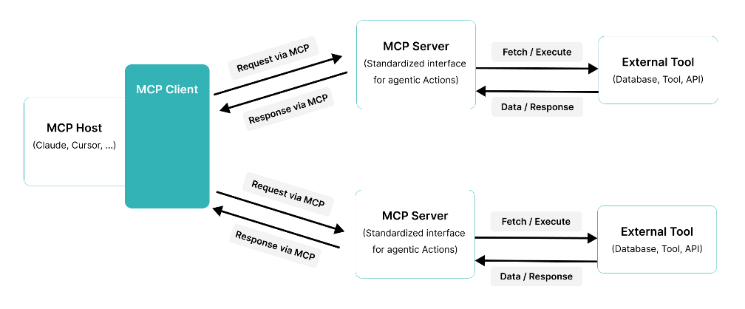

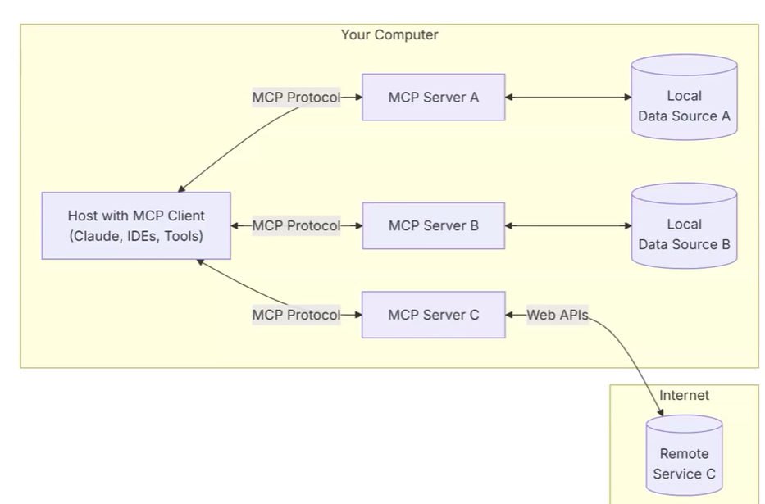

Benefits
Faster integration – Single protocol to connect LLM hosts to multiple tool/data server. It reduces custom connector work and integration debt.
Real-time Response – LLMs can access up-to-date documents, DB records, diagnostic, tools at runtime – improving accuracy, support complex and multi-step workflows that combine data retrieval and business process automation.
Reusability and Scalability – Build once (server or client) and reuse across teams, tools, and different LLMs. Single MCP client can access multiple servers, enabling comprehensive data integration across enterprise systems.

Build an MCP server using Claude
Pre-requisites
MCP Document - https://modelcontextprotocol.io/llms-full.txt
Read me for either from - https://github.com/modelcontextprotocol/python-sdk or https://github.com/modelcontextprotocol/typescript-sdk
Paste these documents into your conversation with Claude
Creating a Prompt
Add a prompt to the conversation with the following information clearly specified
- What resources your server will expose
- What tools it will provide
- Any prompts it should offer
- What external systems it needs to interact with
E.g. Prompt
Build on MCP server that interacts with the GitHub API to get profile information, top projects, and top languages of a user
Basic structure looks like
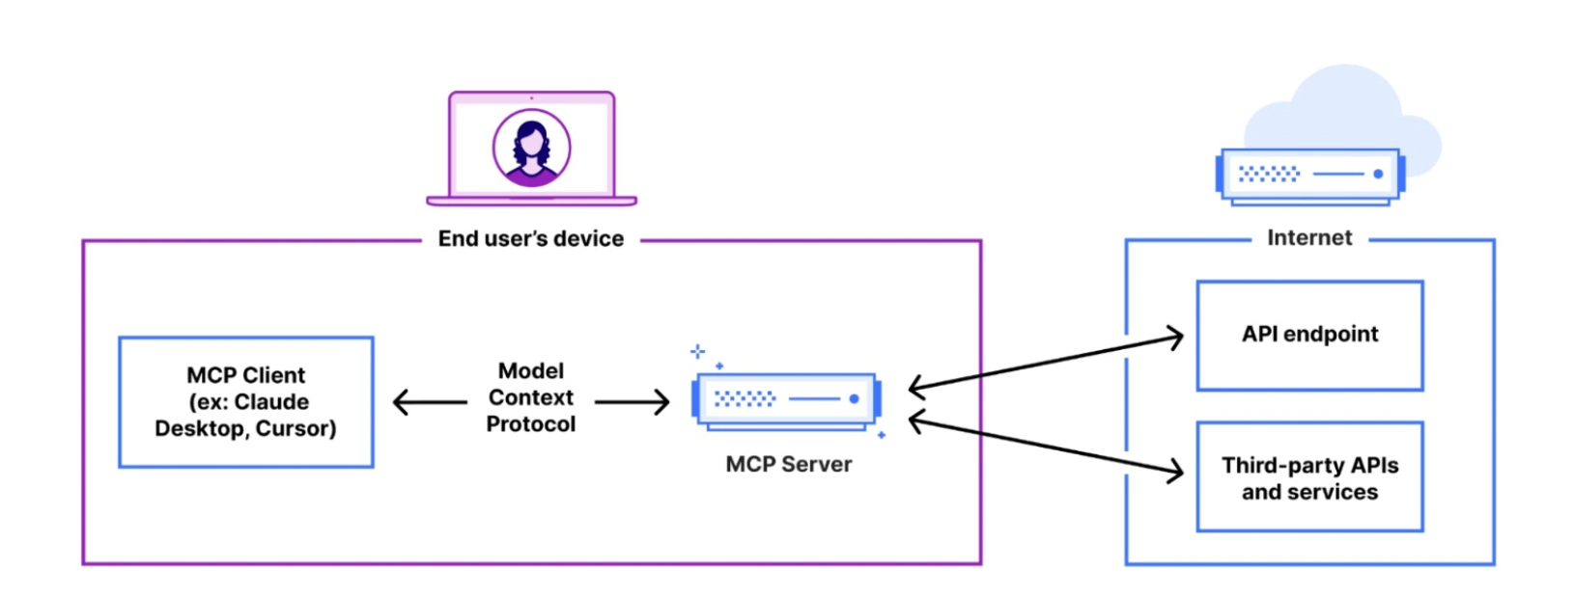

Prerequisites
Platform Requirements
- Azure Subscription
- Azure Resource Group
- Azure Container App or App Service (running MCP Server)
- Application Insights
- Azure Key Vault for secrets
Identity Requirements
- Entra ID Tenant Access
- Manage Identity or Service Principal
- RBAC roles (Reader, Storage blob data reader, Contributor as needed)
Development Requirements
- Node.js 18+ or Python 3.10+ runtime
- Azure CLI
- GitHub Copilot Agent Mode or Foundry Access

ROI
Estimate 40-60% reduction in integration development time compared to custom implementation. Ongoing maintenance costs decline significantly as MCP server are maintained centrally rather than duplicated across applications. Elimination of point-to-point integration code reduces technical debt and support burden. A single team can manage MCP server deployment for multiple AI applications, versus requiring dedicated integration teams per application.

Azure Use Cases for MCP
Operational Use Cases:
- Query Azure Resources (Resource Graph queries)
- Retrieve logs from Azure Storage
- Execute Azure Functions
- Manage resource groups and deployments
- Microsoft Graph operations (Users, Groups, Devices)
- Execute Sentinel KQL queries via MCP tool
Developer Use Cases:
- Manage Azure from VS Code via natural language
- DevOps automation through LLM-triggered workflows
- Deploy infrastructure as part of AI-driven CI/CD

Conclusion & Recommendations
MCP is fully suitable for Azure-based enterprises and enables structured, secure integration between LLMs and operational systems. The architecture ensures alignment with Azure native identity, security, compliance, and DevOps standards. It is recommended to proceed with a phased implementation starting with high-value tools such as Sentinel KQL, Azure Functions, and APIM-based business systems.

Appendix 1

Azure MCP Server
The Azure MCP Server enables AI-driven development tools to seamlessly interact with Azure cloud services using the Model Context Protocol (MCP). It provides a standardized and unified interface for managing Azure resources, deploying applications, and querying cloud services directly from supported development environments.
Developers and automation platforms can connect to the Azure MCP Server using a wide range of tools, programming languages, and frameworks
Connect using VS Code
- Install Azure MCP Server Extension in VS Code.
- After you install the extension, open GitHub Copilot and select Agent Mode.
- Refresh the tools list to see Azure MCP Server as an available option:

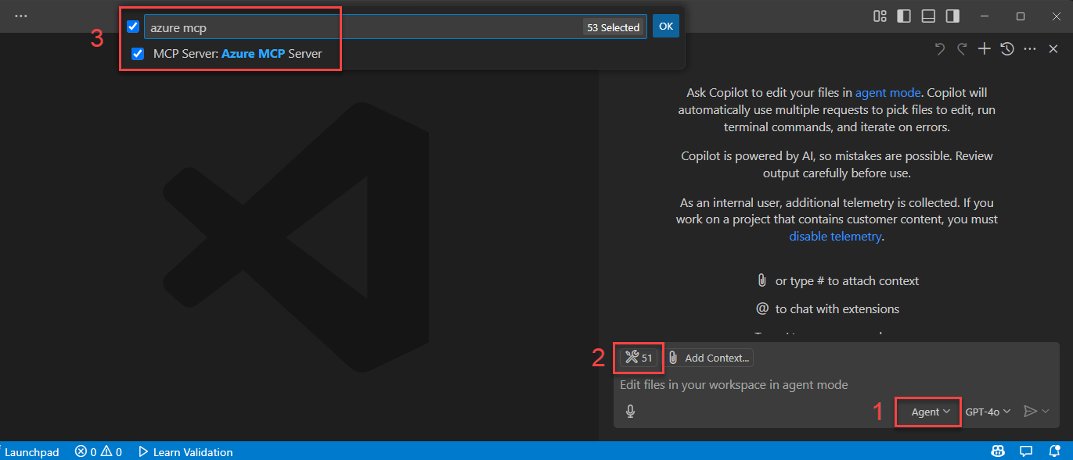

- Authentication to Azure - Azure MCP Server provides a seamless authentication experience using Azure accounts and Microsoft Entra ID. To use Azure MCP Server, you must first authenticate to Azure using local development tools such as the Azure CLI, Azure Developer CLI, Visual Studio, or Visual Studio Code. Azure MCP Server automatically discovers your credentials from these tools and uses them to authenticate to Azure services
- Use Prompt to test the Azure MCP Server
- Open GitHub Copilot and select Agent Mode.
- Enter a prompt that causes the agent to use Azure MCP Server tools, such as List my Azure resource groups.
- Output for the prompt

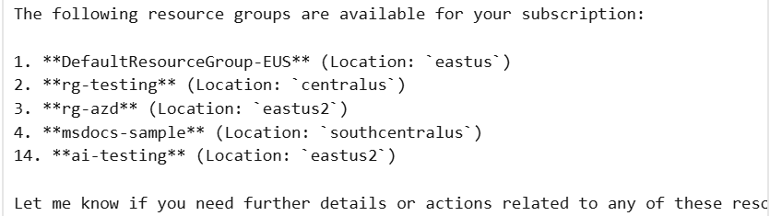

Deploy a self-hosted remote Azure MCP Server and connect to it using Microsoft Foundry
Deploy the Azure MCP Server as a self-hosted remote server over HTTPS. Agents in Microsoft Foundry and Microsoft Copilot Studio can securely connect to and call MCP tools using the deployed Azure MCP Server to run Azure operations.
Deploy the Azure MCP server to Azure Container Apps
- Clone and initialize the azmcp-foundry-aca-mi template with the azd init command.
azd init -t azmcp-foundry-aca-mi
When prompted, enter an environmental name
- Run the template with the azd up command
azd up
azd uses the template files to provision the following resources and configurations:
- Azure Container App: Runs the Azure MCP server and provides the storage namespace.
- Microsoft Entra ID role assignments: Assign roles to the Azure Container Apps managed identity for outbound authentication to the storage account you specify with the storage resource ID:
  - Reader: Read-only access to storage account properties.
  - Storage Blob Data Reader: Read-only access to blob data.
- Entra app registration: Provides OAuth 2.0 authentication for clients like agents that have the Mcp.Tools.ReadWrite.All role. The template assigns this role to the managed identity of the Microsoft Foundry project you specify.
- Application Insights: Provides telemetry and monitoring.

- Use Azure MCP Server from AI Foundry Agent
After deployment, connect your AI Foundry agent to the Azure MCP Server running on Azure Container Apps. The agent authenticates using its managed identity to gain access to the configured Azure Storage tools
- Go to your Foundry project at https://ai.azure.com/nextgen.
- Select Build → Create agent.
- Select + Add in the tools section.
- Select the Custom tab.
- Select Model Context Protocol, then select Create.

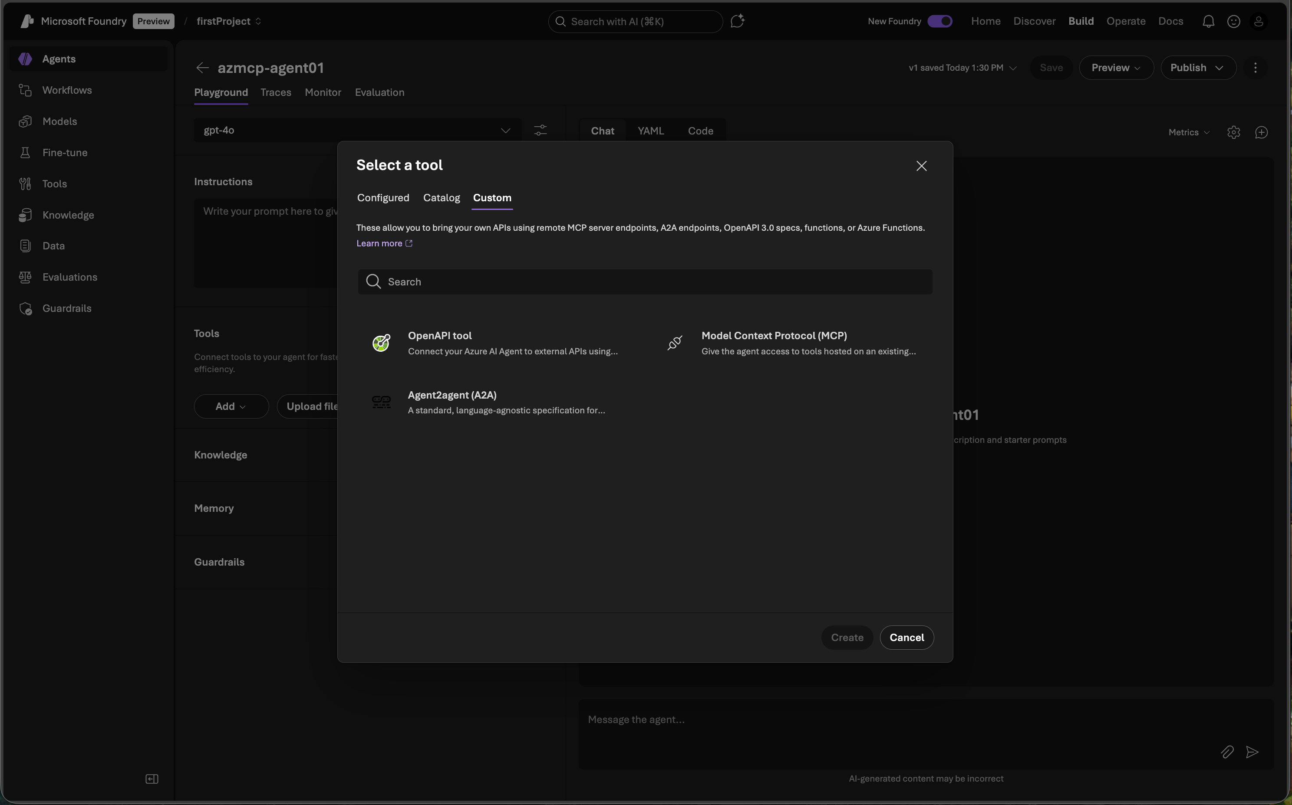
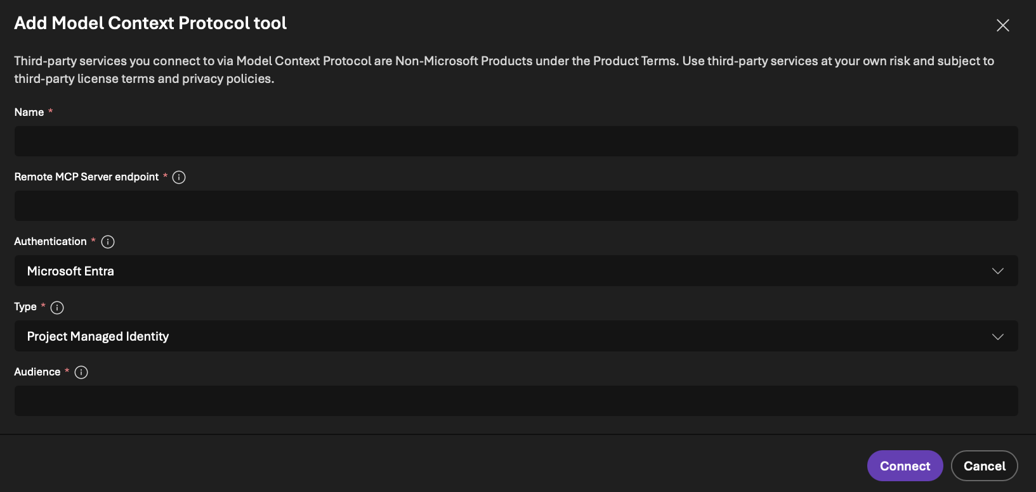

- Configure the MCP connection values:
- Name: Provide a name for the tool.
- Remote MCP Server: Enter the CONTAINER_APP_URL value from the azd output for the tool endpoint.
- Authentication: Select Microsoft Entra → Project Managed Identity.
- Type: Select Project Managed Identity.
- Audience: Enter the ENTRA_APP_CLIENT_ID value from the azd output.
- Select Connect to associate the connection with the agent.

Appendix 2
Reference
Azure MCP Server Github
Azure MCP Server Document
MCP Azure AIFoundry

