**Service Mesh POC**

**1: Default Inbuild Flask Server:**

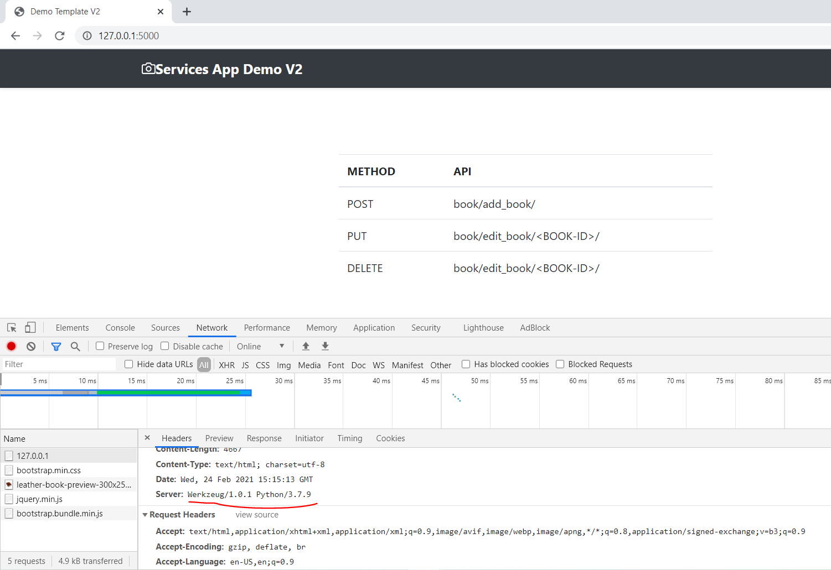

**2: Gunicorn Server:** 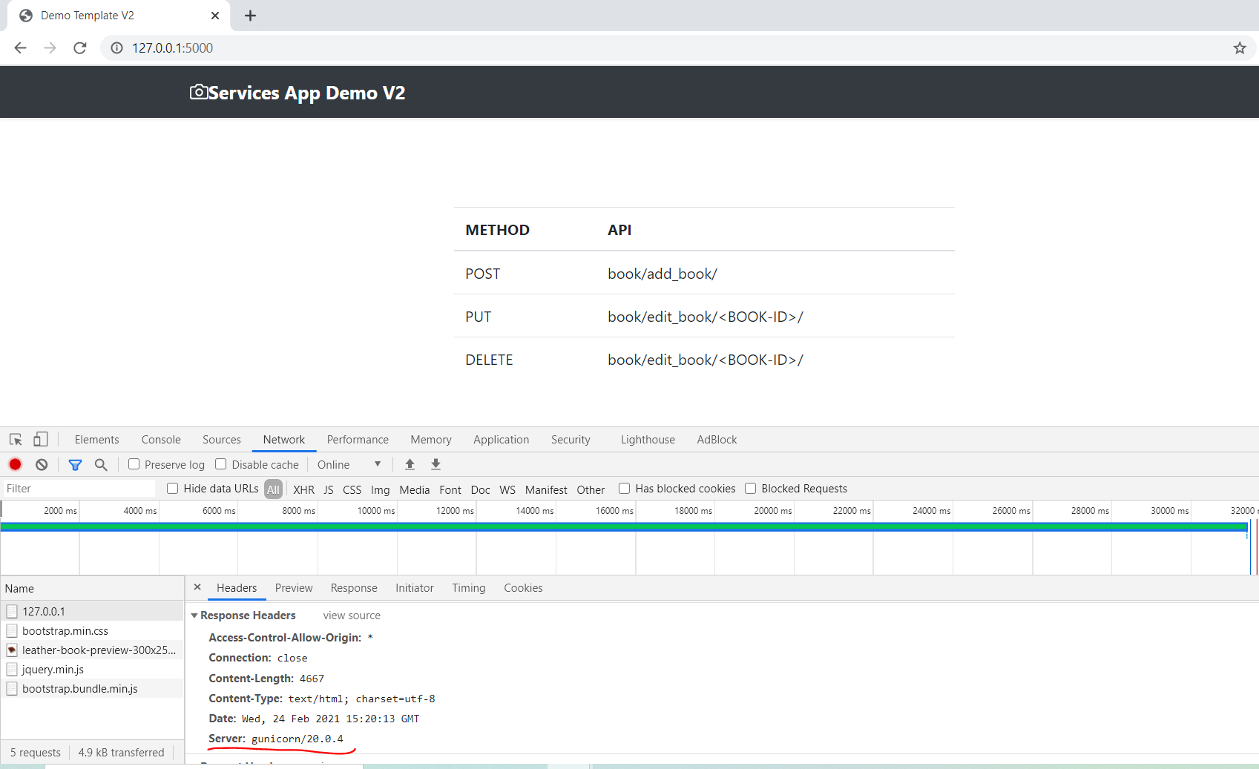

**3: Nginx Server on Port 80:**

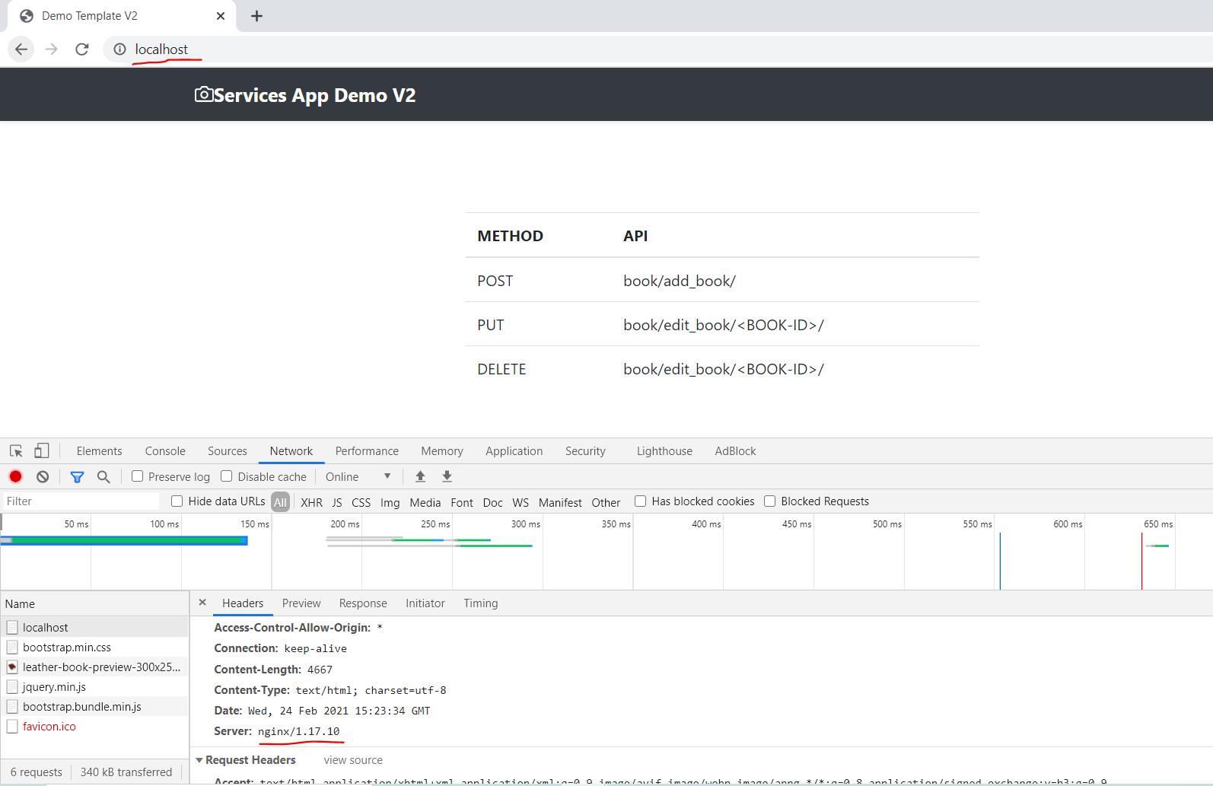

**REST Operations:**

**1: POST:**

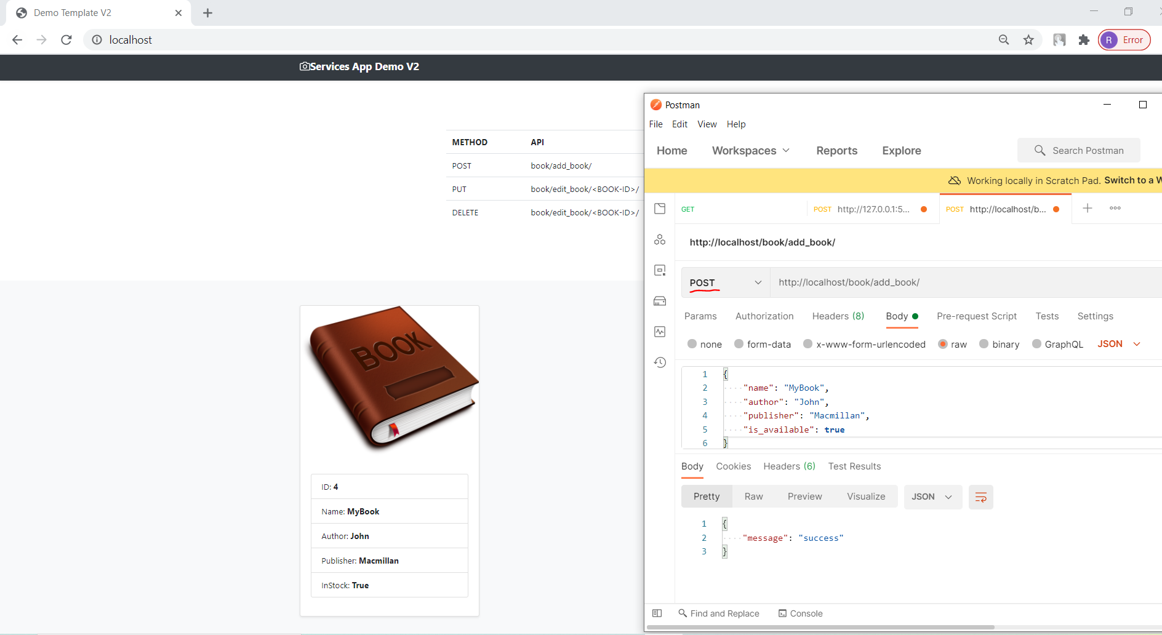

**2: PUT:**

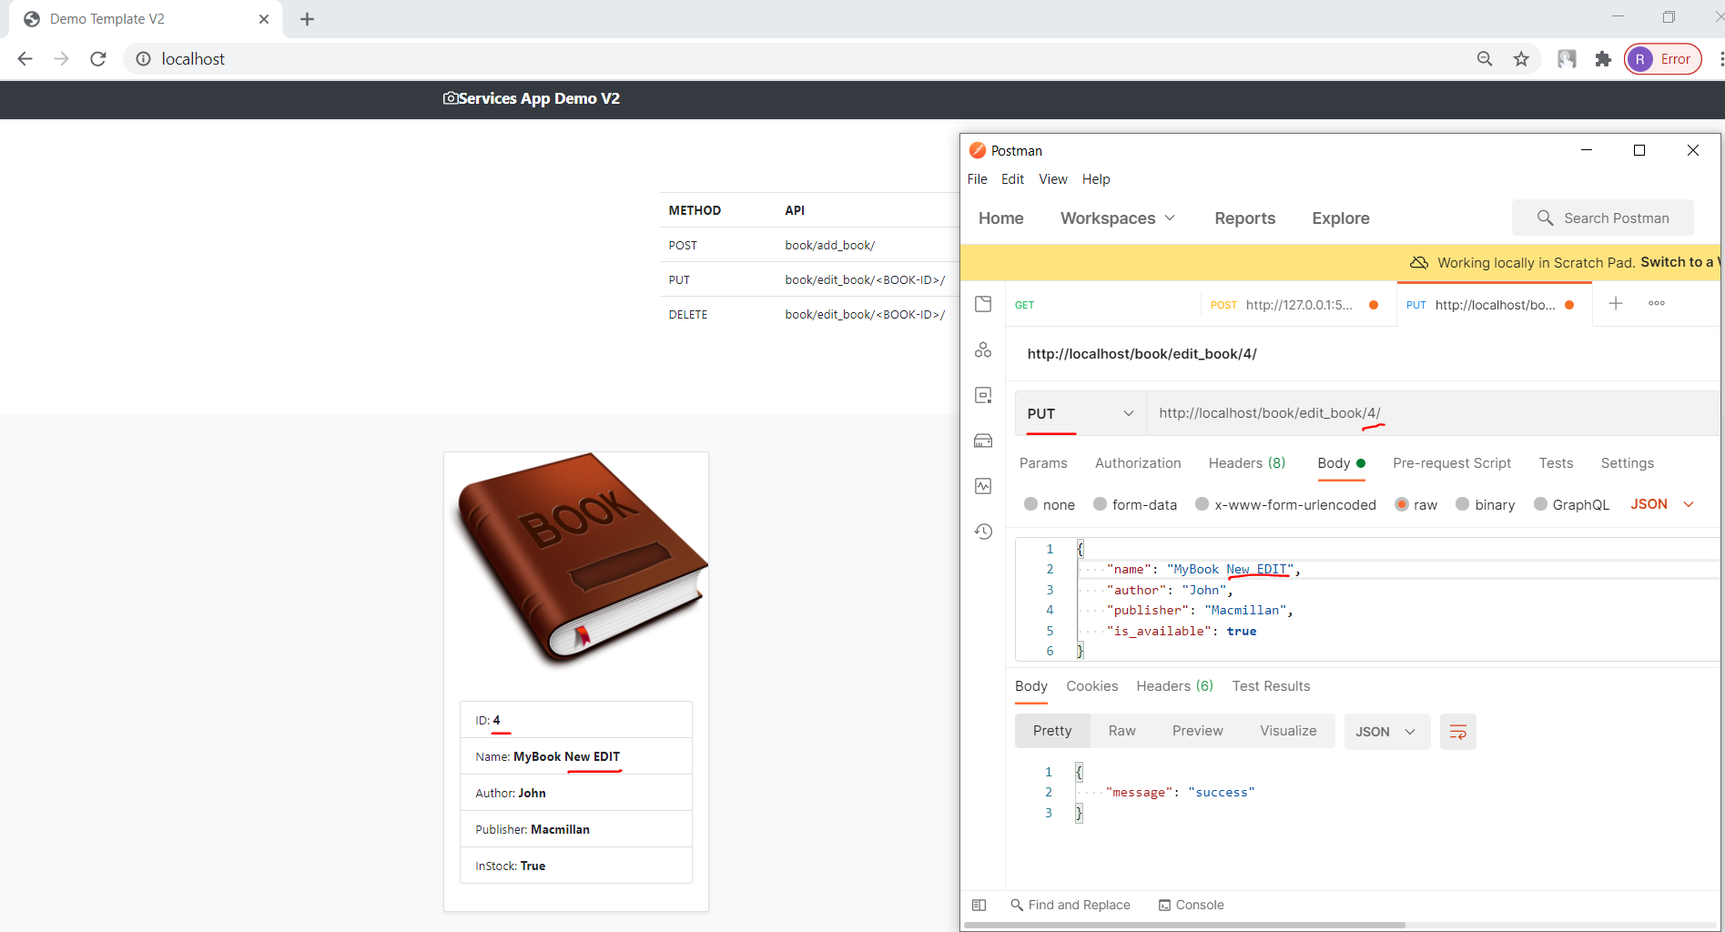

**3: Delete:**

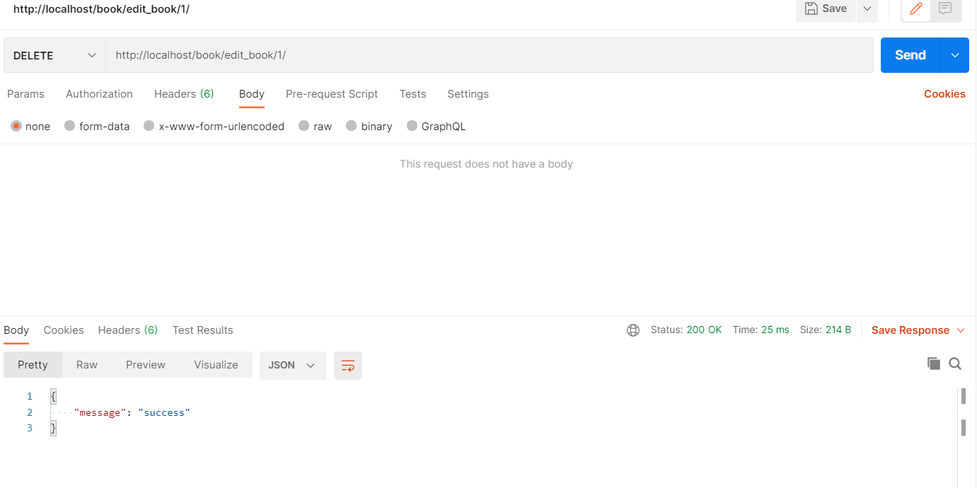

**4: GET (**Default method on UI home page**):**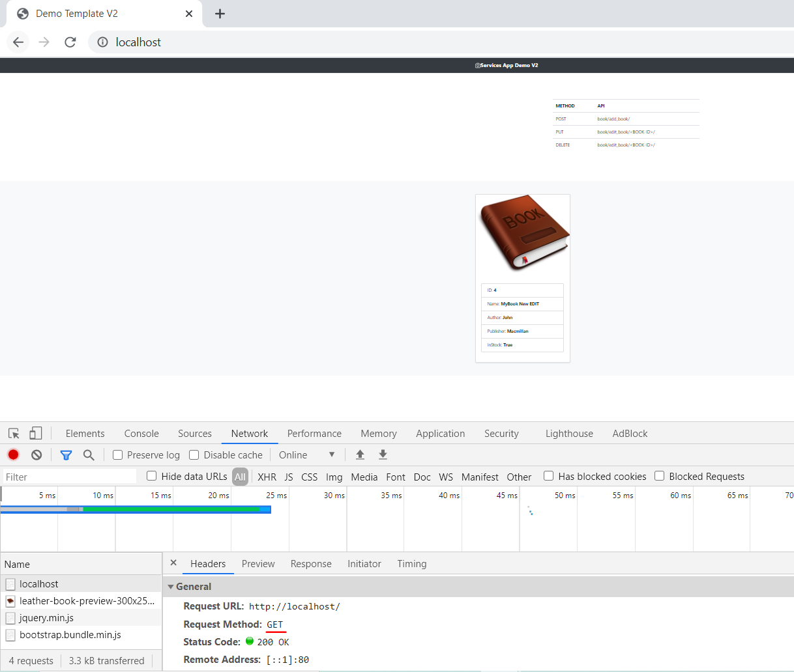

**Nginx**

**1: Nginx as LoadBalancer:**

upstream services_manager {

    server backend_v1:5000;

    server backend_v2:5001;

}

server {

    listen 80;

    location / {

        proxy_pass http://services_manager;

        proxy_set_header X-Forwarded-For $proxy_add_x_forwarded_for;

        proxy_set_header Host $host;

        proxy_redirect off;

    }

}

* ***Default Waterfall Model***:
  + 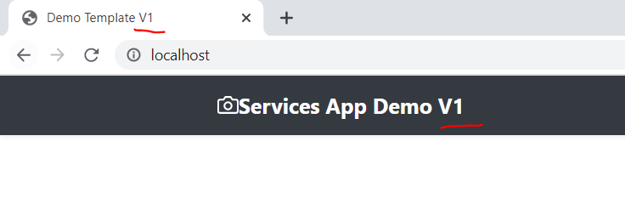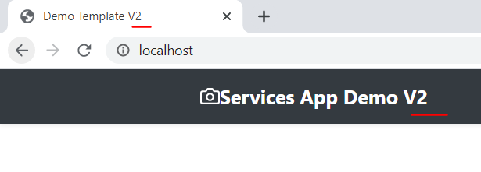

**2: Nginx as API-GateWay:**

upstream add_book {

    server backend_v1:5000;

}

upstream edit_book {

    server backend_v2:5001;

}

# LoadBalancer

upstream services_manager {

    server backend_v1:5000;

    server backend_v2:5001;

}

server {

    listen 80;

    location / {

        proxy_pass http://services_manager;

        proxy_set_header X-Forwarded-For $proxy_add_x_forwarded_for;

        proxy_set_header Host $host;

        proxy_redirect off;

    }

    # Add Book TO DB

    location /book/add_book/ {

        proxy_pass http://add_book;

    }

    # Edit & Delete book from DB

    location /book/edit_book/ {

        proxy_pass http://edit_book;

    }

}

**ADD Record (POST):**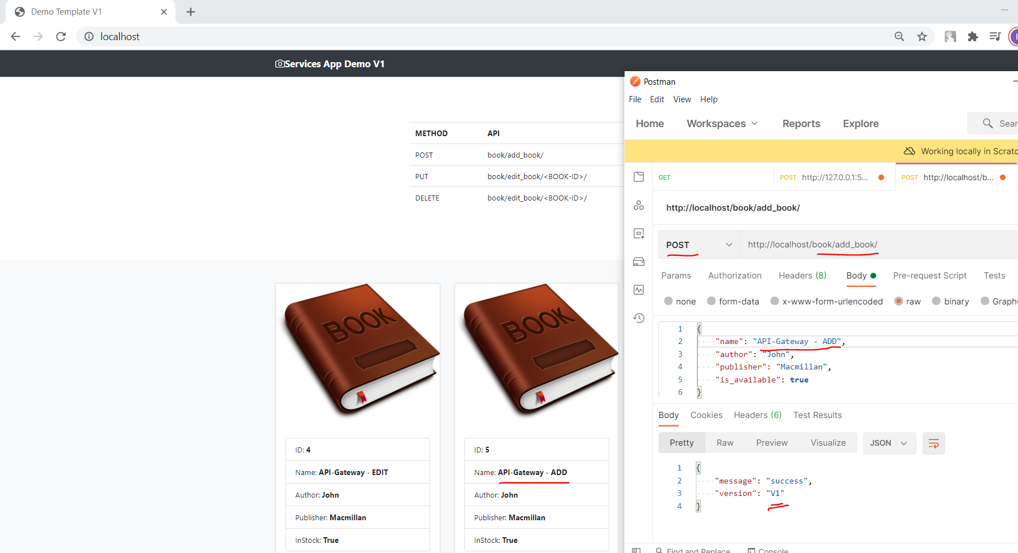

**EDIT Record (PUT):**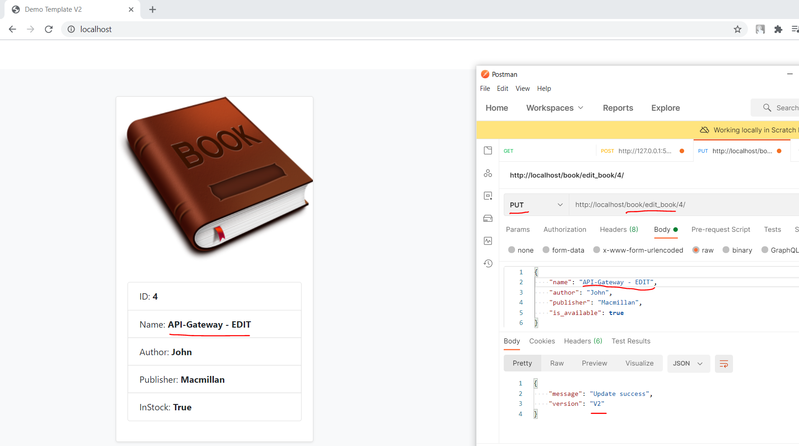

**3: Nginx as Webserver:**

upstream services_manager {

    server backend:5000;

}

server {

    listen 80;

    location / {

        proxy_pass http://services_manager;

        proxy_set_header X-Forwarded-For $proxy_add_x_forwarded_for;

        proxy_set_header Host $host;

        proxy_redirect off;

    }

}

***Single Instance***

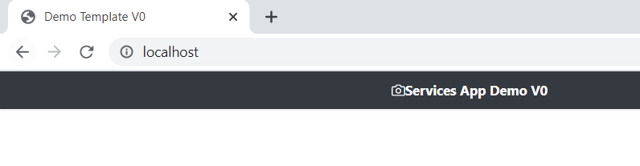

**Kubernetes**

***1: Create Application and Database pods in K8s cluster***

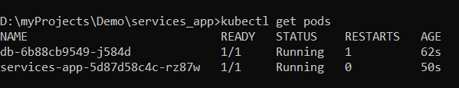

***2: Get Running Service for Application and Database***

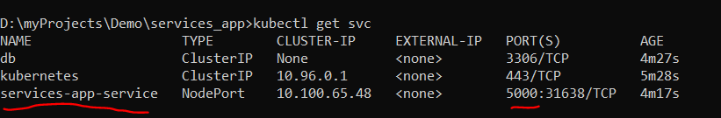

***3: Access Application inside K8s Cluster***

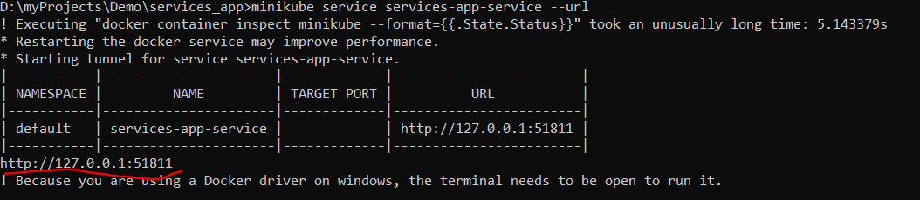

***Demo:***

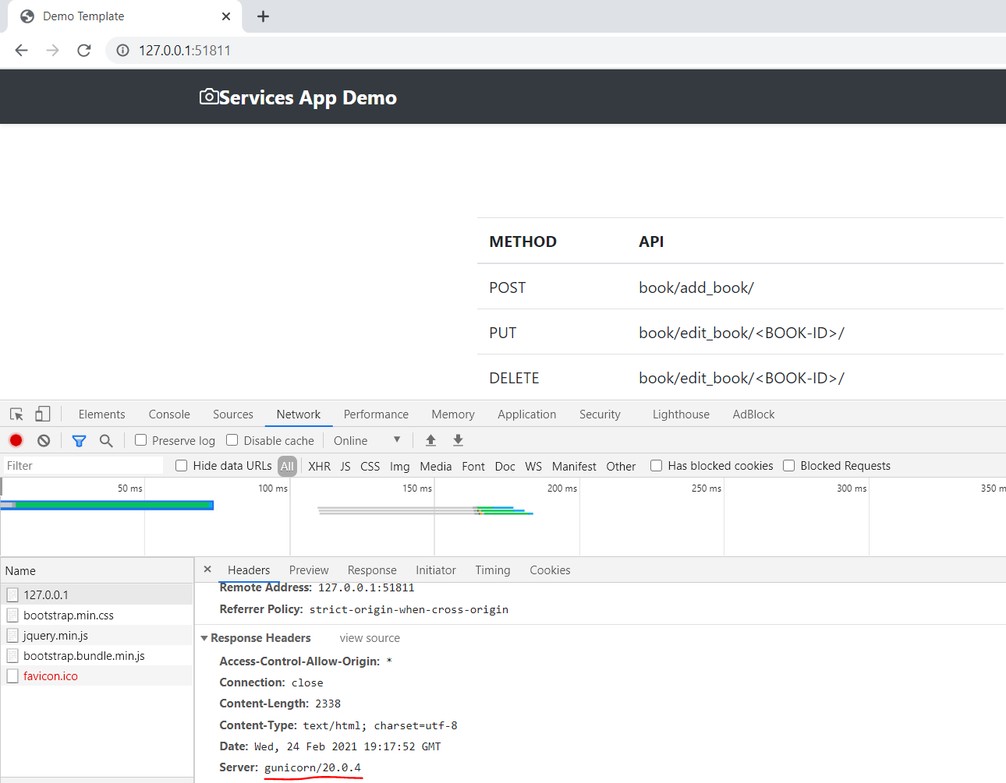

***4: Ingress controller (NOT WORKING):***

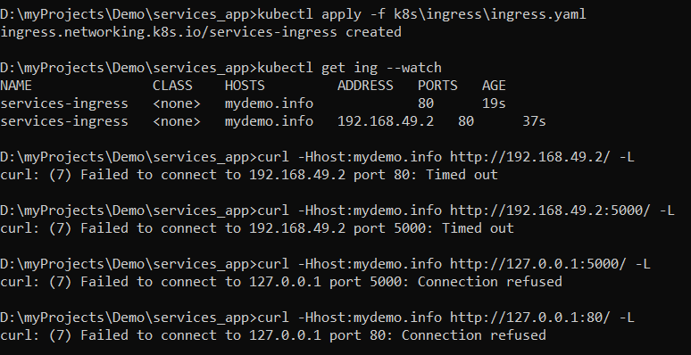

**Istio(Service Mesh):**

***1: Istio Pods and Service:***

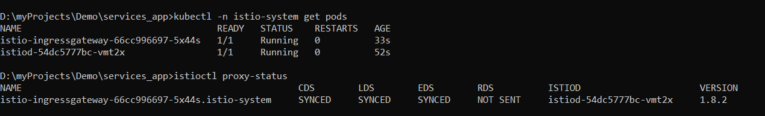

***2: Inject Istio side car (Envoy) to Application and DB pods.***

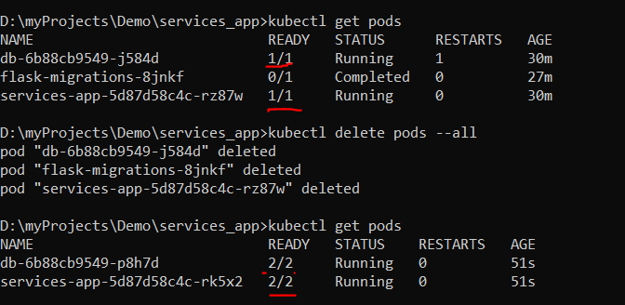

***3: Access Application inside K8s Cluster via Istio-envoy:***

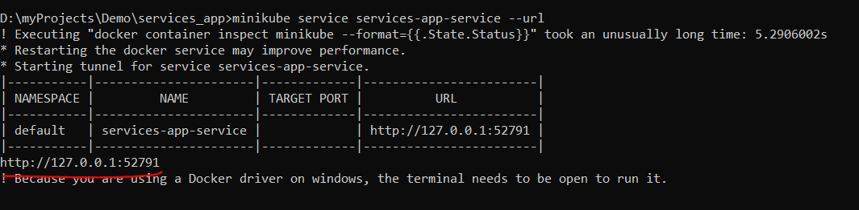

***Demo:***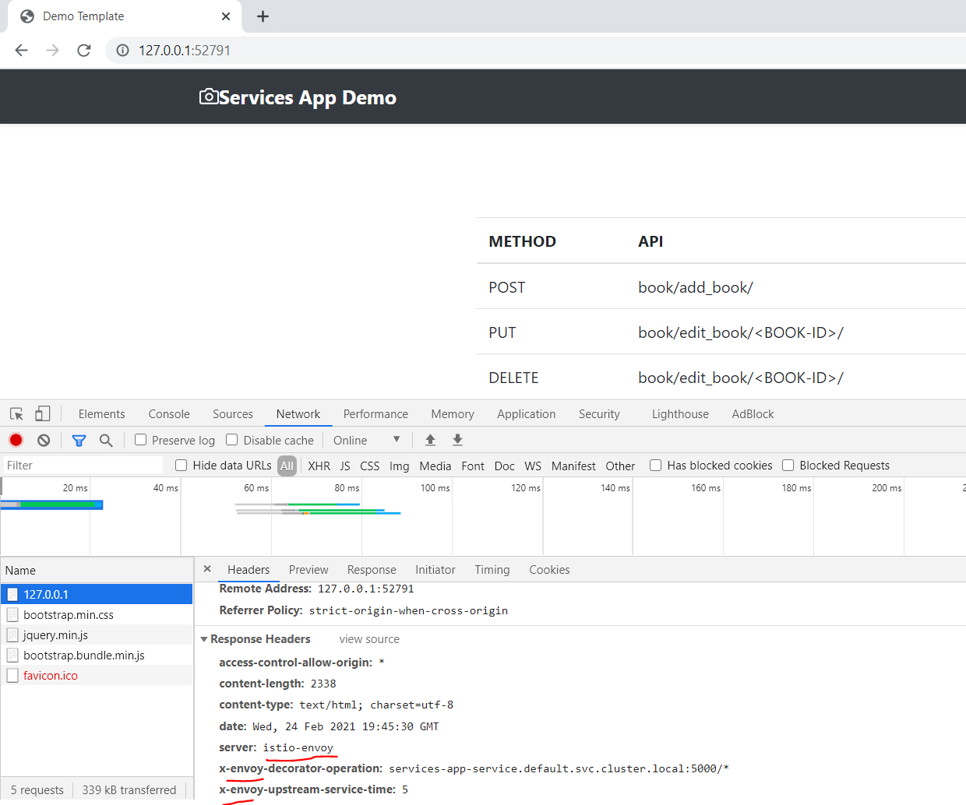

***4: Istio Gateway & VirtualService(NOT WORKING):***

