 

**Product Dissection for Facebook**

**Company Overview:**

Facebook is now known as Meta Platform is a leading American technology conglomerate. Initially founded as Facebook, the company has evolved significantly since its inception, expanding its portfolio to include various social media, virtual reality, and communication platforms. It was founded in February 4, 2004.

**Product Dissection and Real-World Problems Solved by Facebook:**

• **Description:** A social networking platform allowing users to connect with friends, family, and businesses.

• **Features:** News Feed, Friends List, Groups, Pages, Events, Marketplace, Messenger integration, and Stories.

• **Real-World Problems Solved:**

* **Connecting People:** Enables users to stay connected with friends and family regardless of geographic location.
* **Community Building:** Allows for the formation of interest-based groups and communities, fostering a sense of belonging and support.
* **Information Sharing:** Provides a platform for sharing news, events, and updates, which can be crucial during emergencies or for spreading awareness on social issues.

**Case Study: Real-World Problems and Facebook's Innovative Solutions**

Instagram, a leading social media platform, has not only revolutionised the way we share and consume content but has also addressed significant real-world challenges through its innovative features. By identifying user needs and leveraging technology, Instagram has positioned itself as a solution-driven platform that fosters connections, encourages self-expression, and enhances digital interactions.

**Problem 1: Disconnect in Digital Relationships**

#### 1. ****Problem: Natural Disasters and Crisis Response****

* **Situation:** During natural disasters, timely information dissemination and communication are crucial for saving lives and coordinating relief efforts.
* **Solution:** **Facebook's Crisis Response**
  + **Crisis Response Hub:** Facebook introduced a centralized hub where users can find and share information during crises.
  + **Safety Check:** Allows users in the affected area to mark themselves as safe, notifying their friends and family.
  + **Community Help:** Enables users to offer or request help, such as shelter, food, and transportation.
  + **Local Alerts:** Governments and emergency response agencies can send targeted alerts to users in the affected area.

**Impact:**

* + **Rapid Information Sharing:** Enhances the speed and accuracy of information dissemination during emergencies.
  + **Community Support:** Facilitates community-driven assistance and resource sharing.
  + **Reassurance:** Provides a quick way for people to check on the safety of loved ones.

#### Problem 2: ****Small Business Growth and Digital Marketing****

• **Situation:** Small businesses often struggle with limited budgets for marketing and reaching potential customers.

• **Solution:** **Facebook for Business Tools**

* **Targeted Advertising:** Facebook Ads allow businesses to target specific demographics, interests, and behaviors, maximizing the impact of their marketing spend.
* **Facebook Pages:** Businesses can create dedicated pages to interact with customers, post updates, and showcase products/services.
* **Facebook Shops:** A feature that allows businesses to set up online storefronts directly on Facebook and Instagram.
* **Insights and Analytics:** Provides businesses with detailed metrics on ad performance, page interactions, and audience demographics.

**Impact:**

* **Increased Reach:** Helps small businesses reach a larger and more targeted audience.
* **Cost-Effective Marketing:** Offers affordable advertising solutions with high ROI.
* **Enhanced Customer Engagement:** Facilitates direct interaction with customers, improving loyalty and customer service.

.

#### Problem 3: ****Misinformation and Fake News****

* **Situation:** The rapid spread of misinformation and fake news on social media platforms can have serious societal impacts.
* **Solution:** **Facebook's Efforts to Combat Misinformation**
  + **Third-Party Fact-Checking:** Partnering with independent fact-checkers to review and rate the accuracy of content.
  + **Content Warnings:** Flagging and labeling content that has been identified as false or misleading.
  + **Downranking False Information:** Reducing the distribution of content that has been rated false by fact-checkers.
  + **User Education:** Promoting media literacy and providing tips to help users identify false information.

**Impact:**

* + **Reduced Spread of Misinformation:** Limits the reach of false information on the platform.
  + **Informed Users:** Educates users on how to critically evaluate the information they encounter.
  + **Trust and Credibility:** Enhances the overall credibility of content shared on Facebook.

#### Problem 4: ****Social Isolation and Mental Health****

* **Situation:** Increasing social isolation and mental health issues, particularly during events like the COVID-19 pandemic.
* **Solution:** **Facebook’s Mental Health Initiatives**
  + **Groups and Communities:** Facilitating support groups and communities where users can connect and share experiences.
  + **Mental Health Resources:** Providing access to mental health resources and helplines through partnerships with organizations.
  + **Well-Being Features:** Introducing tools like "Quiet Mode" to help users manage their time on the platform and reduce stress.

**Impact:**

* + **Support Networks:** Helps users find and connect with supportive communities.
  + **Resource Accessibility:** Makes mental health resources more accessible to those in need.
  + **Healthy Platform Use:** Encourages healthier social media habits, promoting better mental well-being.

#### ****Problem 5: Education and Remote Learning****

* **Situation:** The need for effective remote learning solutions, especially highlighted during the COVID-19 pandemic.
* **Solution:** **Facebook’s Educational Initiatives**
  + **Facebook for Education:** Offering tools and resources for educators and students to facilitate online learning.
  + **Workplace from Facebook:** A communication tool used by educational institutions to collaborate and manage remote teaching.
  + **Live Streaming and Video Calls:** Facilitating virtual classrooms and educational webinars through Facebook Live and Messenger Rooms.

**Impact:**

* + **Continuity of Education:** Ensures that learning can continue remotely during disruptions.
  + **Interactive Learning:** Provides interactive tools that enhance the remote learning experience.
  + **Community Building:** Enables educators and students to maintain a sense of community and connection.

### Conclusion

Facebook (Meta Platforms, Inc.) has developed innovative solutions to address a variety of real-world problems. From crisis response and small business support to combating misinformation and enhancing mental health, Facebook’s initiatives demonstrate its commitment to leveraging technology for social good. By continuously evolving its platforms and tools, Facebook aims to meet the changing needs of its users and contribute positively to society.

**Top Features of Facebook:**

#### 1. ****User Profiles****

Facebook allows users to create detailed personal profiles with elements such as usernames, full names, bios, profile pictures, cover photos, and personal information like hometown, education, and work history. This creates a personalized online presence reflecting each user's identity.

#### 2. ****News Feed****

The News Feed displays a curated stream of updates from friends, pages, and groups. It uses an algorithm to prioritize content based on user interactions and preferences, ensuring users see relevant and engaging posts. Sponsored content also appears in the feed.

#### 3. ****Friends and Connections****

Users can send and accept friend requests to connect with others. Additionally, users can follow public figures and pages without being friends, expanding their network and staying updated on interesting content.

#### 4. ****Groups****

Groups provide a space for users to join communities based on shared interests. Groups can be public, closed, or secret, and offer features like group chats, events, polls, and file sharing for interaction and community building.

#### 5. ****Pages****

Facebook Pages are public profiles for businesses, brands, celebrities, and organizations to connect with their audience. Pages include tools for likes, comments, shares, reviews, and provide insights and analytics for performance tracking.

#### 6. ****Marketplace****

The Marketplace is a platform for buying and selling items locally, featuring various categories like vehicles, rentals, and services. Users can list items, browse listings, and communicate via Messenger. Safety features include user profiles and ratings.

#### 

**Schema Description:**

The schema for Facebook involves multiple entities that represent different aspects of the platform. These entities include Users, Posts, Comments, Reactions, Friends, Groups, Pages, Events, and more. Each entity has specific attributes that describe its properties and relationships with other entities.

#### User Entity:

Users are at the core of Facebook. The user entity contains information about each user:

* **User ID (Primary Key):** A unique identifier for each user.
* **Username:** The chosen username for the user's account.
* **Email:** The user's email address for account-related communication.
* **Full Name:** The user's full name as displayed on their profile.
* **Bio:** A brief description that users can use to express themselves.
* **Profile Picture:** A URL to the user's profile picture.
* **Cover Photo:** A URL to the user's cover photo.
* **Registration Date:** The date when the user joined Facebook.
* **Hometown:** The user's hometown.
* **Education:** Information about the user's educational background.
* **Work History:** Information about the user's work history.

#### Post Entity:

Posts are central to content sharing on Facebook. The post entity contains information about each post made by users:

* **Post ID (Primary Key):** A unique identifier for each post.
* **User ID (Foreign Key):** The unique identifier of the user who created the post.
* **Content:** The text content of the post.
* **Image URL:** A URL to any images associated with the post.
* **Video URL:** A URL to any videos associated with the post.
* **Timestamp:** The date and time when the post was created.
* **Privacy Setting:** The privacy level of the post (e.g., public, friends only).

#### Comment Entity:

Comments allow users to respond to posts. The comment entity contains information about each comment:

* **Comment ID (Primary Key):** A unique identifier for each comment.
* **Post ID (Foreign Key):** The unique identifier of the post being commented on.
* **User ID (Foreign Key):** The unique identifier of the user who made the comment.
* **Content:** The text content of the comment.
* **Timestamp:** The date and time when the comment was made.

#### Reaction Entity:

Reactions allow users to express their feelings about posts. The reaction entity contains information about each reaction:

* **Reaction ID (Primary Key):** A unique identifier for each reaction.
* **Post ID (Foreign Key):** The unique identifier of the post being reacted to.
* **User ID (Foreign Key):** The unique identifier of the user who made the reaction.
* **Type:** The type of reaction (e.g., like, love, haha, wow, sad, angry).
* **Timestamp:** The date and time when the reaction was made.

#### Friend Entity:

The friend entity represents the relationships between users:

* **UserID1 (Composite Key):** The unique identifier of the first user in the friendship.
* **UserID2 (Composite Key):** The unique identifier of the second user in the friendship.
* **Friendship Status:** The status of the friendship (e.g., pending, accepted, blocked).
* **Timestamp:** The date and time when the friendship was established.

#### Group Entity:

Groups allow users to join communities based on shared interests. The group entity contains information about each group:

* **Group ID (Primary Key):** A unique identifier for each group.
* **Name:** The name of the group.
* **Description:** A brief description of the group.
* **Privacy Setting:** The privacy level of the group (e.g., public, closed, secret).
* **Creation Date:** The date when the group was created.

#### Page Entity:

Pages represent businesses, brands, celebrities, and organizations. The page entity contains information about each page:

* **Page ID (Primary Key):** A unique identifier for each page.
* **Name:** The name of the page.
* **Description:** A brief description of the page.
* **Category:** The category of the page (e.g., business, entertainment).
* **Creation Date:** The date when the page was created.

#### Event Entity:

Events allow users to create and participate in events. The event entity contains information about each event:

* **Event ID (Primary Key):** A unique identifier for each event.
* **Name:** The name of the event.
* **Description:** A brief description of the event.
* **Location:** The location of the event.
* **Start Time:** The start time of the event.
* **End Time:** The end time of the event.
* **Privacy Setting:** The privacy level of the event (e.g., public, private).
* **Creator ID (Foreign Key):** The unique identifier of the user who created the event.

**Relationships are:**

• **Users and Posts:** A one-to-many relationship where a user can create multiple posts.

• **Posts and Comments:** A one-to-many relationship where a post can have multiple comments.

• **Posts and Reactions:** A one-to-many relationship where a post can have multiple reactions.

• **Users and Friends:** A many-to-many relationship where a user can have multiple friends, and friendships are bidirectional.

• **Users and Groups:** A many-to-many relationship where a user can join multiple groups, and each group can have multiple members.

• **Users and Pages:** A many-to-many relationship where a user can follow multiple pages, and each page can have multiple followers.

• **Users and Events:** A many-to-many relationship where a user can participate in multiple events, and each event can have multiple participants.

**ER Diagram:**

Let's construct an ER diagram that vividly portrays the relationships and attributes of the entities within the Facebook schema. This ER diagram will serve as a visual representation, shedding light on the pivotal components of Facebook's data model. By employing this diagram, we'll gain a clearer grasp of the intricate interactions and connections that define the platform's dynamics.

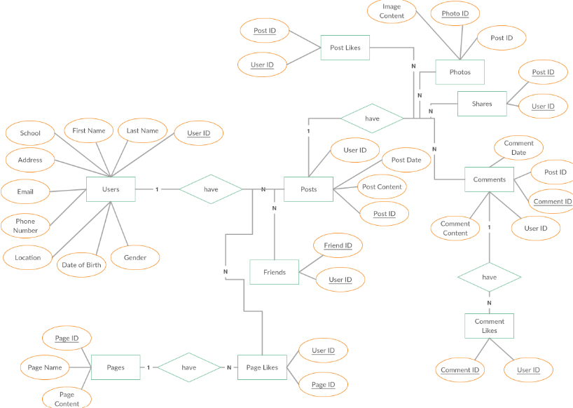

### Conclusion

In this case study, we delved into the design of Facebook's schema and Entity-Relationship diagram. Facebook has revolutionized the way people connect, share content, and engage with various forms of media. The platform's intricate data model, consisting of entities like users, posts, comments, reactions, friends, groups, pages, and events, forms the foundation for its seamless functionality. By understanding this schema, we gain insight into how Facebook effectively manages the complexities of user interactions and content sharing, contributing to its widespread popularity and continued growth in the world of social media. This comprehensive framework enables Facebook to facilitate robust user engagement, dynamic content dissemination, and a rich social experience, solidifying its position as a leading social networking service.