**Kadapala Rakesh Reddy -M22AI608-Assignment-1 (Fractal - 3)-** [**Algorithms for Big Data**](https://classroom.google.com/c/NjA4OTM0MDA5MDk5)

**Q>Create a Hadoop multi-node cluster using either Virtual Machines or Docker.**

**Permissions Required for windows to install Docker.**

Start🡪 Control Panel🡪Programs🡪Programs and Features🡪Turn on Windows features on or off🡪

**Enable the Following:**

* windows subsystem for Linux
* 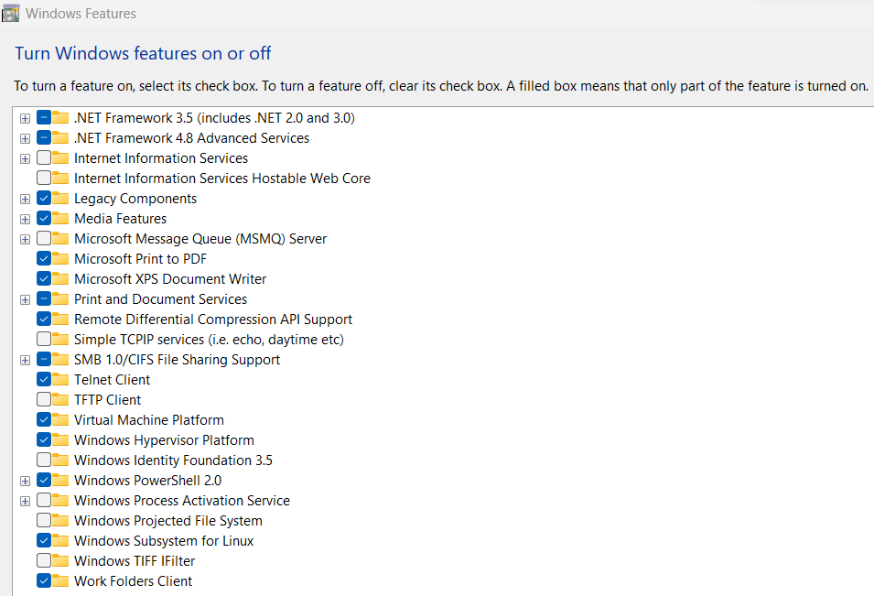Windows Hypervisor Platform

Restart the System.

Docker Installation Link 64bit: <https://docs.docker.com/desktop/install/windows-install/>

Download the Dataset from Classroom: <https://drive.google.com/file/d/1Ja6fD9ico9emdX8YNBioqOK1fD4L8g97/view?usp=sharing>

Extract the ZIP File

Open the folder –go to specific files –in file manger path ----remove path and write Powershell

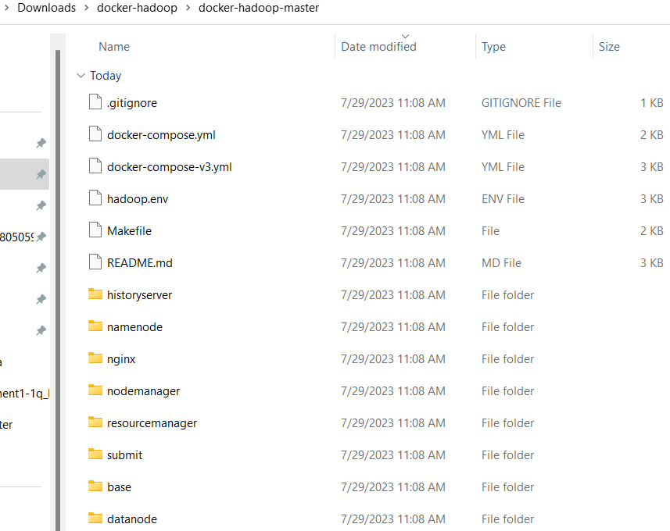

**Docker-compose.yml contains 5 Data nodes:**

version: "3"

services:

namenode:

image: bde2020/hadoop-namenode:2.0.0-hadoop3.2.1-java8

container_name: namenode

restart: always

ports:

- 9870:9870

- 9000:9000

volumes:

- hadoop_namenode:/hadoop/dfs/name

environment:

- CLUSTER_NAME=test

env_file:

- ./hadoop.env

datanode01:

image: bde2020/hadoop-datanode:2.0.0-hadoop3.2.1-java8

container_name: datanode01

restart: always

volumes:

- hadoop_datanode01:/hadoop/dfs/data01

environment:

SERVICE_PRECONDITION: "namenode:9870"

env_file:

- ./hadoop.env

datanode02:

image: bde2020/hadoop-datanode:2.0.0-hadoop3.2.1-java8

container_name: datanode02

restart: always

volumes:

- hadoop_datanode02:/hadoop/dfs/data02

environment:

SERVICE_PRECONDITION: "namenode:9870"

env_file:

- ./hadoop.env

datanode03:

image: bde2020/hadoop-datanode:2.0.0-hadoop3.2.1-java8

container_name: datanode03

restart: always

volumes:

- hadoop_datanode03:/hadoop/dfs/data03

environment:

SERVICE_PRECONDITION: "namenode:9870"

env_file:

- ./hadoop.env

datanode04:

image: bde2020/hadoop-datanode:2.0.0-hadoop3.2.1-java8

container_name: datanode04

restart: always

volumes:

- hadoop_datanode04:/hadoop/dfs/data04

environment:

SERVICE_PRECONDITION: "namenode:9870"

env_file:

- ./hadoop.env

datanode05:

image: bde2020/hadoop-datanode:2.0.0-hadoop3.2.1-java8

container_name: datanode05

restart: always

volumes:

- hadoop_datanode05:/hadoop/dfs/data05

environment:

SERVICE_PRECONDITION: "namenode:9870"

env_file:

- ./hadoop.env

resourcemanager:

image: bde2020/hadoop-resourcemanager:2.0.0-hadoop3.2.1-java8

container_name: resourcemanager

restart: always

environment:

SERVICE_PRECONDITION: "namenode:9000 namenode:9870 datanode:9864"

env_file:

- ./hadoop.env

nodemanager1:

image: bde2020/hadoop-nodemanager:2.0.0-hadoop3.2.1-java8

container_name: nodemanager

restart: always

environment:

SERVICE_PRECONDITION: "namenode:9000 namenode:9870 datanode:9864 resourcemanager:8088"

env_file:

- ./hadoop.env

historyserver:

image: bde2020/hadoop-historyserver:2.0.0-hadoop3.2.1-java8

container_name: historyserver

restart: always

environment:

SERVICE_PRECONDITION: "namenode:9000 namenode:9870 datanode:9864 resourcemanager:8088"

volumes:

- hadoop_historyserver:/hadoop/yarn/timeline

env_file:

- ./hadoop.env

volumes:

hadoop_namenode:

hadoop_datanode01:

hadoop_datanode02:

hadoop_datanode03:

hadoop_datanode04:

hadoop_datanode05:

hadoop_historyserver:

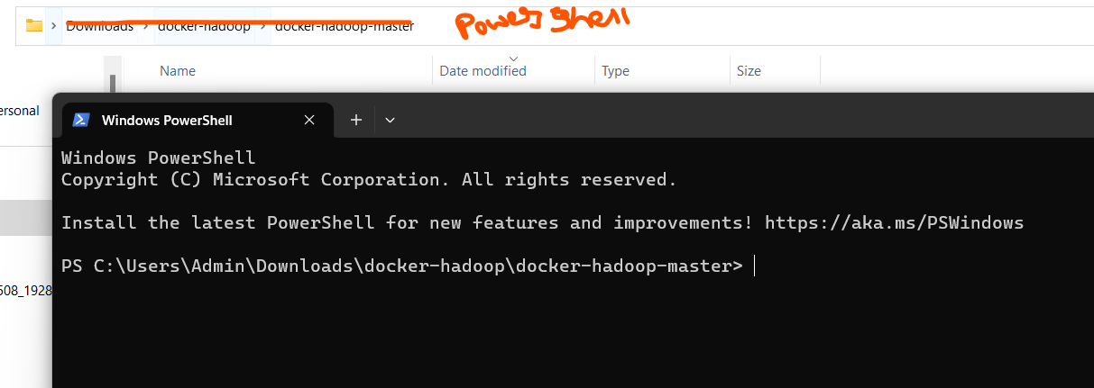

In Command Prompt type:

* Docker compose up -d
* ls

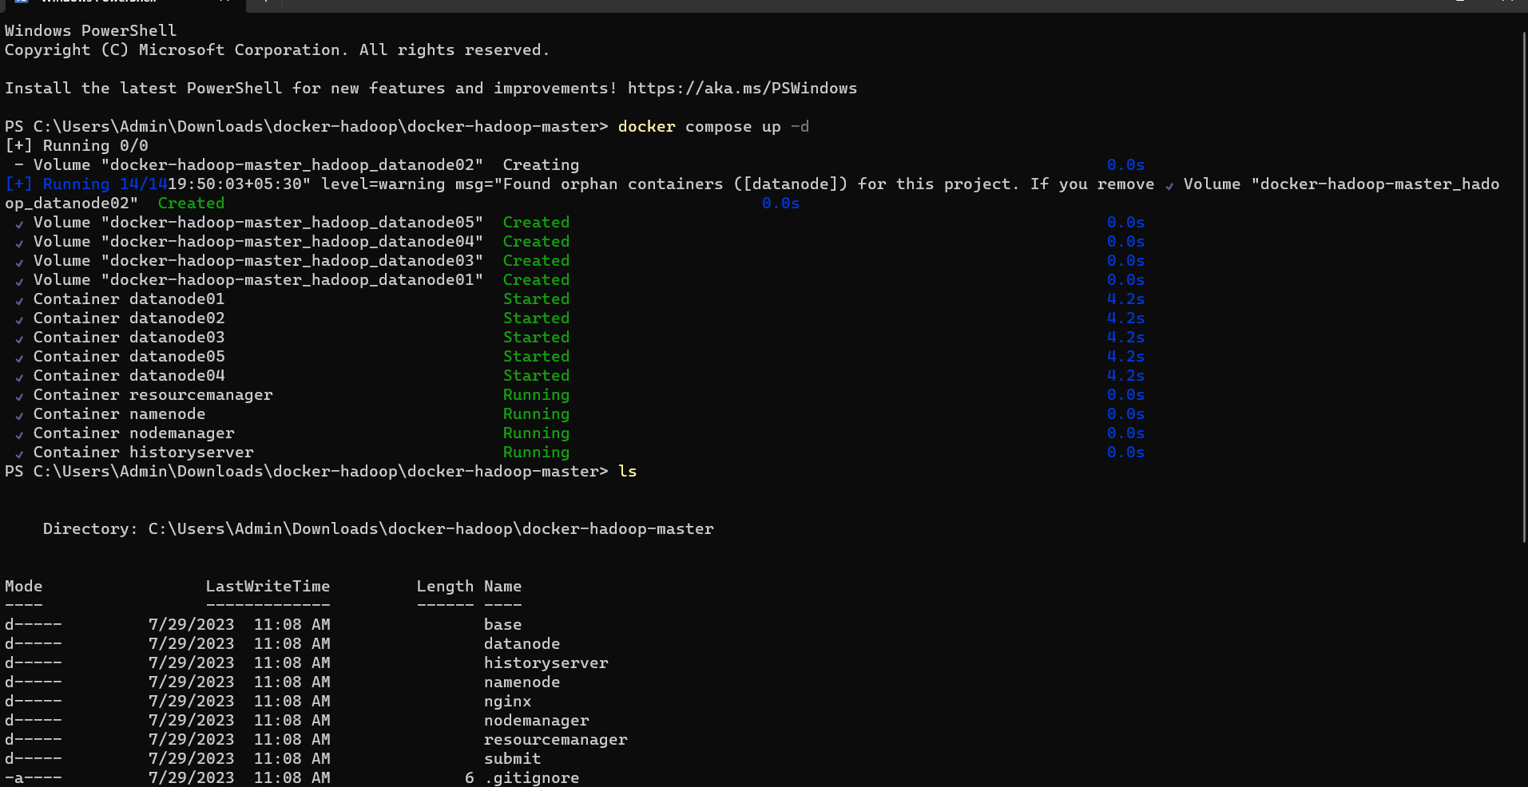

* docker-compose ps
* ls

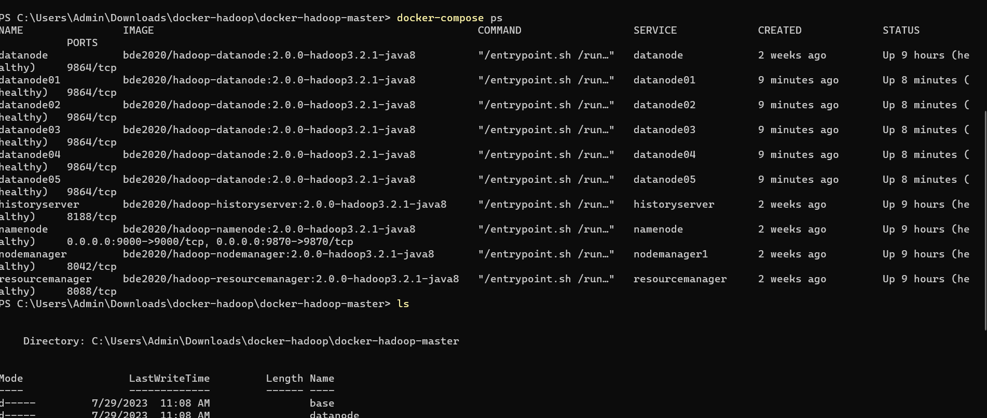

* docker network list
* docker network inspect docker-hadoop-master_default

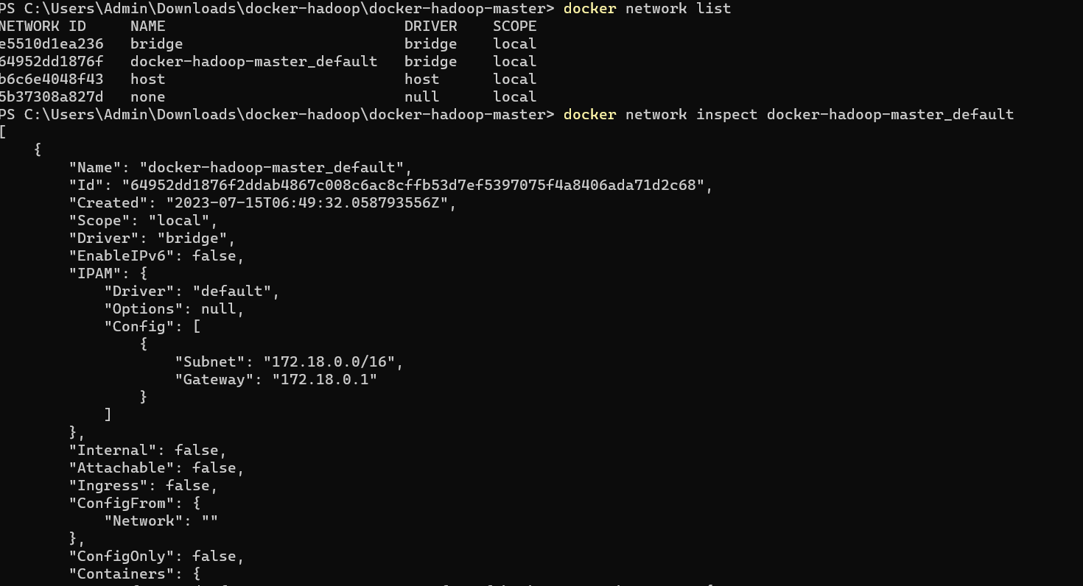

* docker exec -it namenode /bin/bash
* ls



SERVICE_PRECONDITION: "namenode:9870"

Open the URL to check nodes are running or not:

<http://localhost:9870/dfshealth.html#tab-overview>

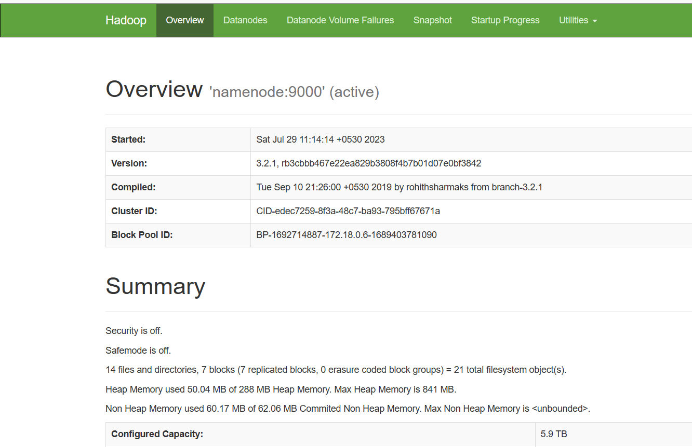

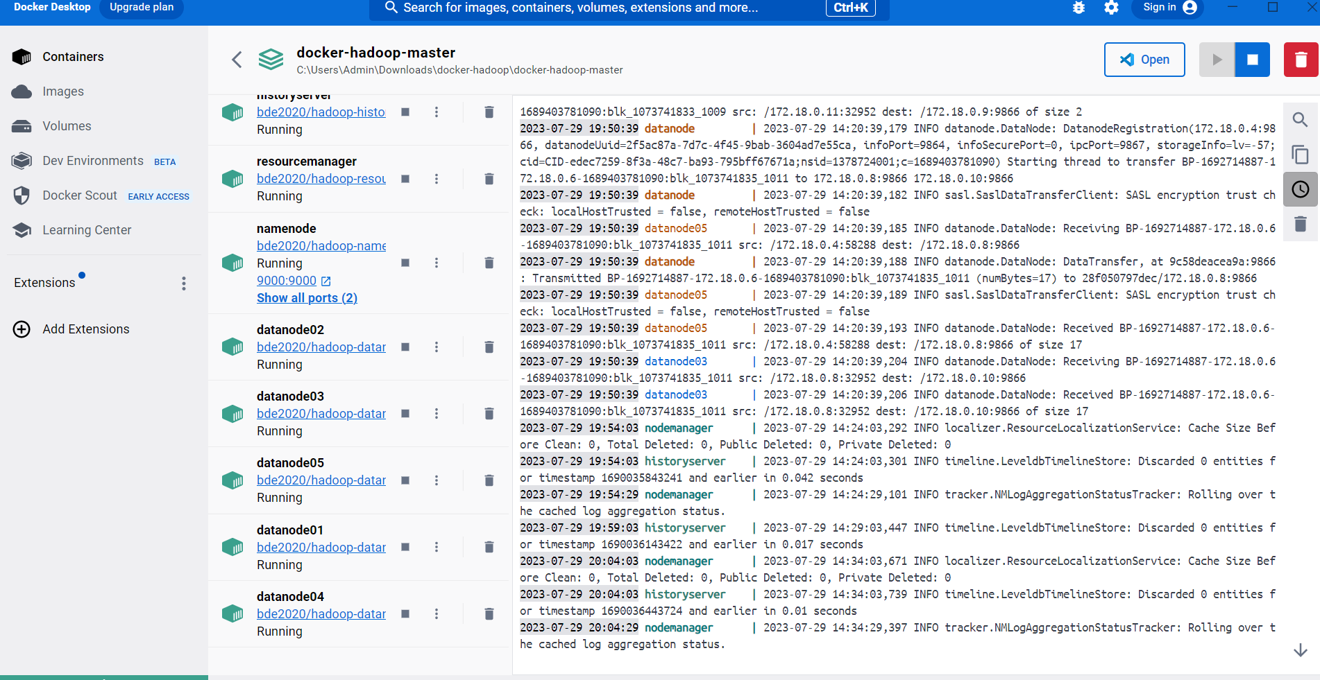Open Docker and Check

