SIMATS ENGINEERING
ASSESSMENT TOOL 2

COURSE NAME: Database Management Systems COURSE CODE: CSA0504

COURSE OUTCOME COVERED

CO2: Apply the relational model, relational algebra, SQL query structures, and views to solve database querying and data manipulation problems. (BL3, BL6)

Activity Tool : Scenario-Based Task (Medium) Assessment Tool Weightage: 20%

QUESTIONS
Q.N  o | Question | Bloom's Level
1 | A university stores student and course data in a single table. Analyze the structure and identify normalization issues, then redesign it up to 3NF | . BL4 – Analyze
2 | A company database contains employee and department details. Design appropriate SQL queries to retrieve employees working in multiple departments and justify your approach | . BL6 – Create
3 | Given a relation with multiple functional dependencies, determine the candidate keys and check whether the relation satisfies BCNF. If not, decompose it. | BL5 – Evaluate
4 | A banking system requires secure data access. Design views and constraints to ensure data security and integrity for different types of users. | BL6 – Create
5 | A sales database contains redundant data leading to anomalies. Analyze the schema and apply normalization up to 3NF or BCNF to eliminate redundancy. | BL4 – Analyze
6 | Given a dataset of customers and orders, write SQL queries using joins and subqueries to retrieve meaningful information such as frequent customers. | BL3 – Apply
7 | A relation contains multi-valued dependencies. Analyze the structure and decompose it into 4NF, explaining the reasoning. | BL4 – Analyze

8 | A database designer used improper constraints, leading to inconsistent data. Evaluate the schema and suggest appropriate integrity constraints. | BL5 – Evaluate
9 | For a given relational schema, analyze the presence of join dependencies and decompose it into 5NF to remove redundancy. | BL6 – Create
10 | A system uses inefficient SQL queries for data retrieval. Analyze the queries and optimize them using joins, indexing concepts, or query restructuring. | BL5 – Evaluate

Code of Conduct:

I A.Rakesh(192525388)(Name / Reg No) certify that this submission is my original work and that I have adhered to the guidelines specified for this assessment. I understand that any violation of academic integrity rules will result in disciplinary action.

Signature of the student:
A.Rakesh
RUBRICS FOR CALCULATION:

Criteria | Level 4 (Exemplary) | Level 3 (Proficient) | Level 2 (Developing) | Level 1 (Beginning)
Understandin g of Scenario | Demonstrates clear and complete understanding of the scenario  and context | Shows good understanding with minor gaps | Partial understanding  ; misses key aspects | Misinterprets or fails to understand the scenario
Identification of Key Issues | Accurately identifies all relevant issues  and factors involved | Identifies most key issues with minor omissions | Identifies limited issues; some  irrelevant points | Unable to identify key issues
Application of Concepts | Applies appropriate concepts effectively to  address the scenario | Applies concepts with minor errors | Limited or partially correct application | Unable to apply relevant concepts
Decision Making | Makes well-reasoned,  logical decisions with strong  rationale | Makes reasonable decisions with some  justification | Makes weak decisions with limited justification | No clear decisions made or rationale  provided
Clarity of Response | Response is clear, structured, and  logically presented | Generally clear with minor issues | Somewhat unclear or poorly structured | Disorganized and difficult to understand

Q1. A university stores student and course data in a single table. Analyze the structure and identify normalization issues, then redesign it up to 3NF.
(BL4 – Analyze) Unnormalized Table (UNF)
Student_ID | Student_Name | Course_ID | Course_Name | Faculty | Faculty_Phone
101 | Rahul | C101 | DBMS | Ramesh | 9876543210
101 | Rahul | C102 | Java | Suresh | 9876543211
102 | Priya | C101 | DBMS | Ramesh | 9876543210
Problems

- Data redundancy.

- Update anomaly.

- Insertion anomaly.

- Deletion anomaly.

1NF

Separate repeating groups.

Student

Student_ID | Student_Name
101 | Rahul
102 | Priya

Course

Course_ID | Course_Name | Faculty
C101 | DBMS | Ramesh
C102 | Java | Suresh
Enrollment

Student_ID | Course_ID
101 | C101
101 | C102
102 | C101

2NF

Remove partial dependency.

Faculty

Faculty_ID | Faculty_Name | Phone
F101 | Ramesh | 9876543210
F102 | Suresh | 9876543211

Course

Course_ID | Course_Name | Faculty_ID
C101 | DBMS | F101
C102 | Java | F102
3NF

Final Tables

Student (Student_ID, Student_Name) Faculty (Faculty_ID, Faculty_Name, Phone)
Course (Course_ID, Course_Name, Faculty_ID) Enrollment (Student_ID, Course_ID)

Justification
Normalization removes redundancy and eliminates update, insertion, and deletion anomalies. 3NF improves consistency and maintains data integrity.

Q2. A company database contains employee and department details. Design SQL queries to retrieve employees working in multiple departments and justify your approach.
(BL6 – Create) Tables Employee
Emp_ID | Emp_Name
Department

Dept_ID | Dept_Name

Employee_Department

Emp_ID | Dept_ID

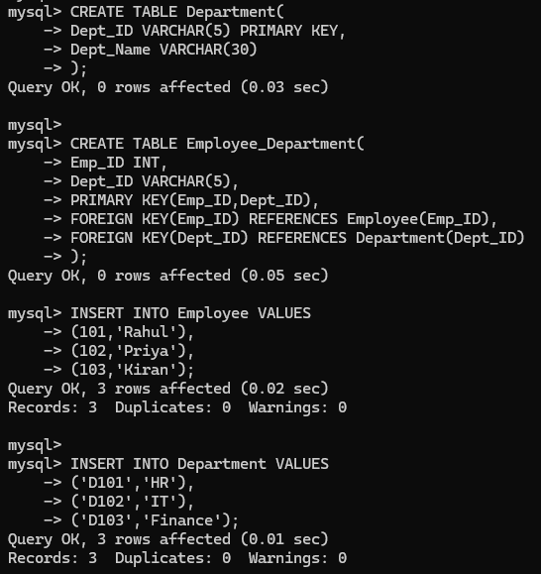

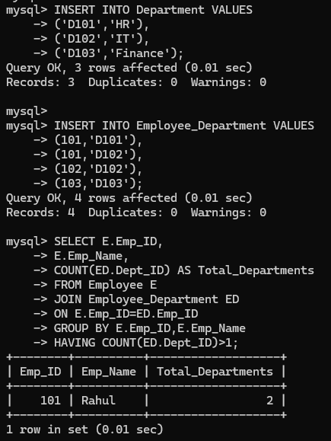

Justification
A JOIN combines employee and department information, while GROUP BY and HAVING identify employees assigned to more than one department efficiently.

Q3. Given a relation with multiple functional dependencies, determine the candidate keys and check BCNF. If not, decompose it.
(BL5 – Evaluate) Relation
R(Student_ID, Course_ID, Faculty)

FDs

(Student_ID, Course_ID) → Faculty Faculty → Course_ID
Candidate Key

(Student_ID, Course_ID)

BCNF Check

Faculty → Course_ID

Faculty is not a candidate key. Hence,
Relation is NOT in BCNF. BCNF Decomposition R1(Faculty,Course_ID) R2(Student_ID,Faculty)
CREATE TABLE FacultyCourse( Faculty VARCHAR(30), Course_ID VARCHAR(5), PRIMARY KEY(Faculty)
);

CREATE TABLE StudentFaculty( Student_ID INT,
Faculty VARCHAR(30),
PRIMARY KEY(Student_ID,Faculty)
);

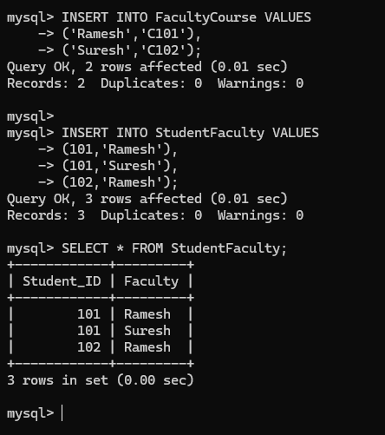

Justification
BCNF removes dependencies where the determinant is not a candidate key, reducing redundancy and preventing update anomalies.

Q4. A banking system requires secure data access. Design views and constraints to ensure data security and integrity.

Create Tables

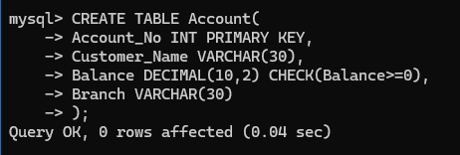

Insert Data
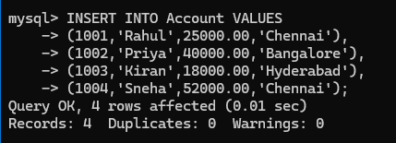

View and constraints used
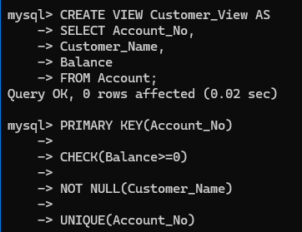

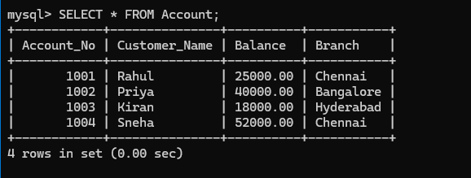

Justification
The view restricts users to only the required information, hiding sensitive columns such as Branch. The constraints (PRIMARY KEY, NOT NULL, and CHECK) ensure data integrity by preventing duplicate records, null values, and invalid account balances.

Q5. A sales database contains redundant data leading to anomalies. Analyze the schema and apply normalization up to 3NF or BCNF.
(BL4 – Analyze) Unnormalized Relation
Sales(Order_ID, Customer_Name, Customer_Address, Product_ID, Product_Name, Quantity)
Problems

- Redundant customer data.

- Product details repeated.

- Update anomalies.

3NF Tables

Customer, Product , Orders
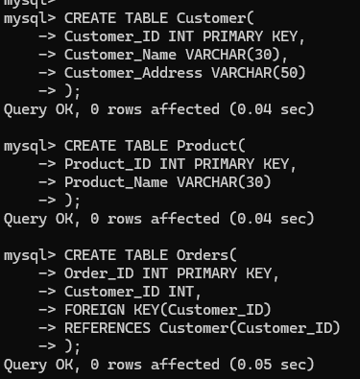

Insert data

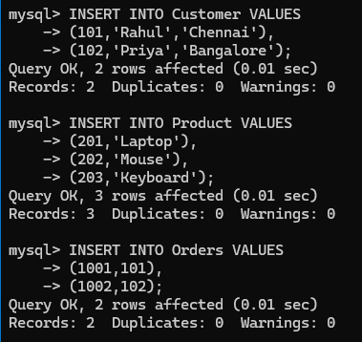

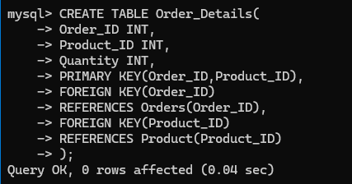
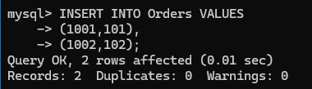

OUTPUT
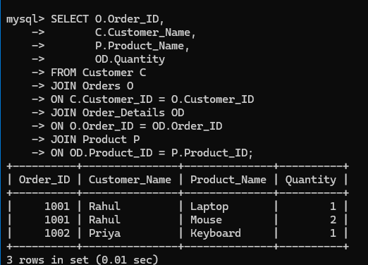

Justification
The sales database is normalized into separate Customer, Product, Orders, and Order_Details tables to eliminate redundancy and remove update, insertion, and deletion anomalies. The original sales information can be reconstructed efficiently using JOIN operations while maintaining data integrity.

Q6. A dataset of customers and orders. Write SQL queries using joins and subqueries to retrieve meaningful information such as frequent customers.

Create Tables customer, orders
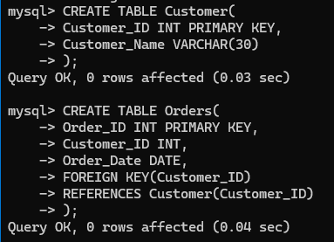

Insert data
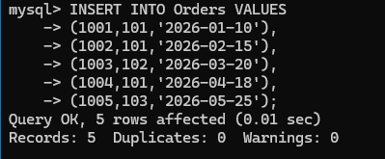

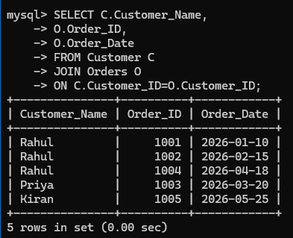
Join Query

Output
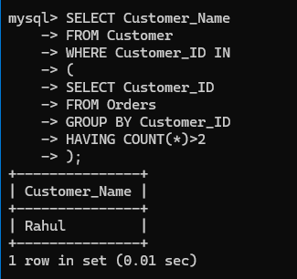

Justification
JOIN combines customer and order details, while the subquery identifies customers who have placed more than two orders. This efficiently retrieves meaningful business information.

Q7. A relation contains multivalued dependencies. Analyze the structure and decompose it into 4NF.
(BL4 – Analyze) Relation
- Student(
- Student_ID,
- Hobby,
- Language

Sample Data

Student_ID | Hobby | Language
101 | Cricket | English
101 | Music | English
101 | Cricket | Hindi
101 | Music | Hindi

Multivalued Dependencies Student_ID →→ Hobby Student_ID →→ Language

The hobbies and languages are independent of each other, causing redundancy.

4NF Decomposition

Student Hobby , Student language

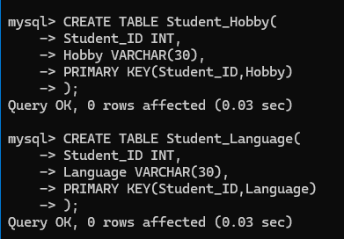

Insert data
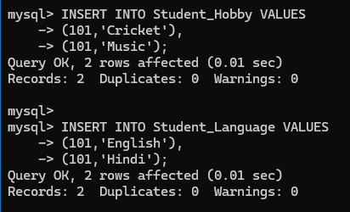

Output
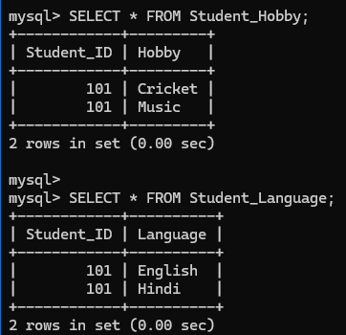

Justification
4NF removes multivalued dependencies by separating independent attributes into different relations. This eliminates redundancy and prevents unnecessary duplication of data.

Q8. A database designer used improper constraints leading to inconsistent data. Evaluate the schema and suggest appropriate integrity constraints.
(BL5 – Evaluate) Create Table
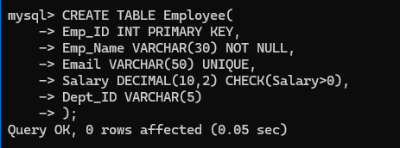

Insert Valid Data
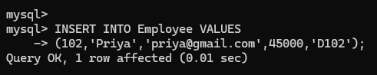

Display of the table
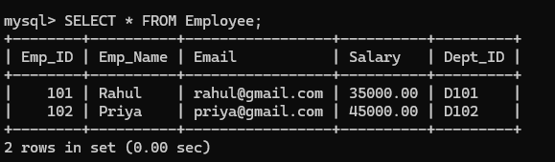

Test Constraint

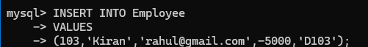

OUTPUT:

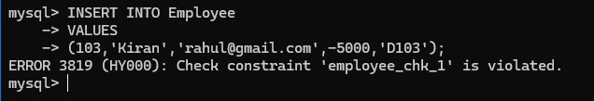

Integrity Constraints Used

- PRIMARY KEY → Prevents duplicate employee IDs.

- NOT NULL → Employee name cannot be empty.

- UNIQUE → Prevents duplicate email addresses.

- CHECK → Ensures salary is greater than zero.

Justification
Integrity constraints maintain data accuracy and consistency by preventing invalid or duplicate entries. They improve database reliability and reduce the chances of inconsistent data.

Q9. For a given relational schema, analyze the presence of join dependencies and decompose it into 5NF to remove redundancy.
(BL6 – Create)

Given Relation

- Supply(
- Supplier_ID,
- Product_ID,
- Project_ID
- )
Sample Data

Supplier_ID | Product_ID | Project_ID
S1 | P1 | J1
S1 | P2 | J1
S2 | P1 | J2

Join Dependency

The relation contains a Join Dependency because suppliers, products, and projects can be stored independently and later joined.
Decomposition into 5NF

Create tables – Supplier product , supplier project , product project
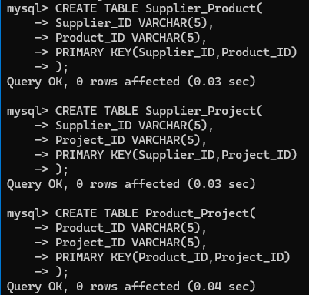

Insert data
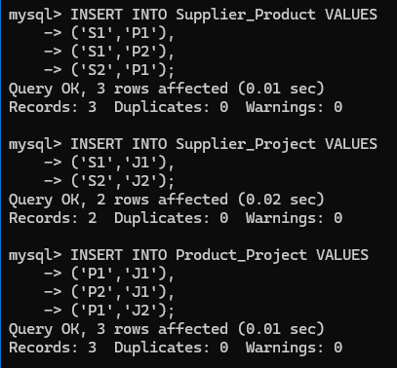

Display tables
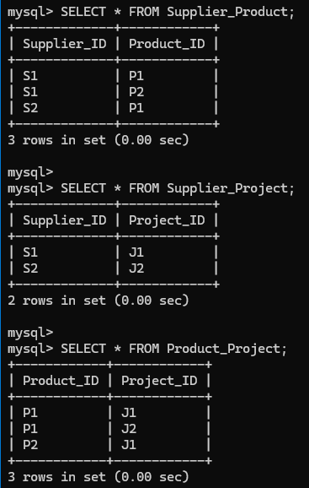

OUTPUT
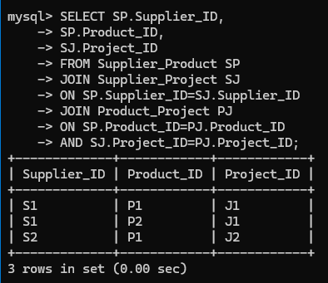

Justification
5NF removes redundancy caused by join dependencies by decomposing the relation into smaller relations. The original relation can be reconstructed using JOIN operations without losing information.

Q10. A system uses inefficient SQL queries for data retrieval. Analyze the queries and optimize them using joins, indexing concepts, or query restructuring.
(BL5 – Evaluate) Create Tables Student, department
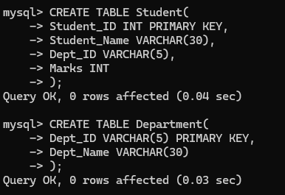

Insert Data
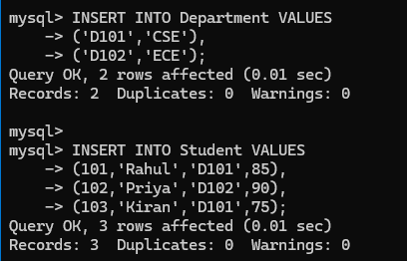

Display of tables
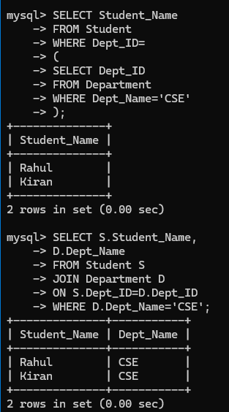

Creating index

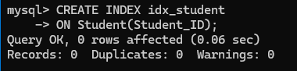

OUT[UT
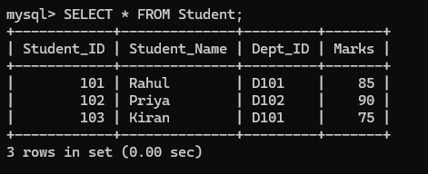

Performance Comparison

Before Optimization | After Optimization
Subquery | JOIN
No Index | Index Created
Slower | Faster
Repeated Search | Optimized Search

Justification
Replacing subqueries with JOINs improves execution efficiency when retrieving related data. Creating indexes on frequently searched columns speeds up query execution, making the database more scalable and efficient.

