ANALYSISOFLANDSLIDEREACTIVATIONUSINGSATELLITEDATA: **­­**HIMACHALPRADESH,INDIA

Name to be filled

1 School of Engineering, Indian Institute of Technology Mandi, India (*sharadgupta27@gmail.com)

KEYWORDS: Temporal Change detection, Reactivated Landslide, Kotrupi (HP), Google Earth, Geomorphological

Analysis, Remote Sensing

ABSTRACT:

Landslides pose a significant threat to the mountainous regions of Himachal Pradesh, India, affecting lives, infrastructure, and ecosystems. Understanding the factors contributing to landslide reactivation is crucial for effective hazard mitigation and risk management in this region. This research paper explores the application of satellite data for analysing landslide reactivation events in Himachal Pradesh. By employing remote sensing techniques and data analysis methodologies, this study aims to identify precursory indicators and assess the factors influencing landslide reactivation in the context of the Himalayan landscape. Through case studies and comparative analysis, the potential of satellite data in monitoring and predicting landslide reactivation is highlighted, which can improve early warning systems and inform proactive mitigation strategies tailored to the unique challenges of Himachal Pradesh.

1.INTRODUCTION

**1.1 Background**

Himachal Pradesh, nestled in the western Himalayas, is prone to various natural hazards, including landslides, due to its rugged terrain, steep slopes, and intense rainfall during the monsoon season. Landslides in this region pose a significant risk to human settlements, transportation networks, and agricultural land, necessitating effective measures for hazard assessment and management.

**1.2 Objectives**

This research paper aims to investigate the role of satellite data in analyzing landslide reactivation events in Himachal Pradesh. Specific objectives include:

* Identifying precursory indicators of landslide reactivation using satellite imagery.
* Assessing the influence of environmental factors, such as rainfall and slope characteristics, on landslide reactivation.
* Examining the effectiveness of satellite data in monitoring and predicting landslide reactivation in the Himalayan context.
* Providing insights for the development of early warning systems and proactive mitigation strategies tailored to Himachal Pradesh.

**1.3 Scope of the Study**

The study focuses on analyzing landslide reactivation events in Himachal Pradesh using satellite data, with an emphasis on remote sensing techniques and data analysis methodologies suitable for the Himalayan terrain. Case studies from different regions within Himachal Pradesh will be examined to demonstrate the applicability and effectiveness of satellite-based monitoring in landslide hazard assessment and mitigation.

**2. Literature Review**

**2.1 Landslide Reactivation: Causes and Mechanisms** Landslide reactivation in Himachal Pradesh can be triggered by various factors, including intense rainfall, snowmelt, seismic activity, and human-induced changes such as deforestation and road construction. The complex geological and geomorphological characteristics of the region contribute to the occurrence of landslides, making it essential to understand the mechanisms driving landslide reactivation.

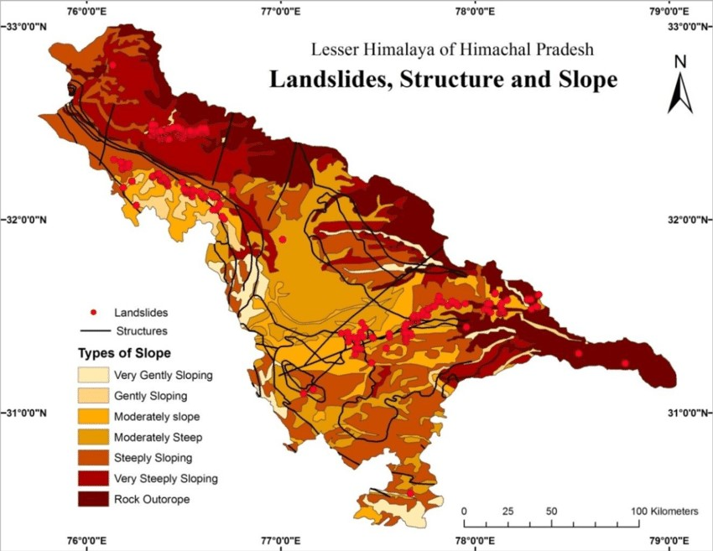

**2.2 Remote Sensing and Satellite Data in Landslide Monitoring** Remote sensing technologies, particularly satellite imagery, offer valuable tools for landslide monitoring and analysis in Himachal Pradesh. Satellite data provide synoptic views of large areas, allowing for the identification of landslide features, monitoring of land surface changes, and assessment of terrain stability over time. Advanced remote sensing techniques, such as interferometric synthetic aperture radar (InSAR) and LiDAR, enable high-resolution mapping of terrain deformation and surface displacements associated with landslide reactivation.

**2.3 Previous Studies on Landslide Reactivation Using Satellite Data** Several studies have demonstrated the utility of satellite data in detecting and analyzing landslide reactivation events in mountainous regions, including Himachal Pradesh. These studies have utilized multi-temporal satellite imagery, change detection algorithms, and machine learning approaches to identify precursory indicators and assess the factors contributing to landslide reactivation. However, the unique challenges of the Himalayan landscape, such as rugged terrain and dense vegetation cover, present specific considerations for landslide monitoring using satellite data.

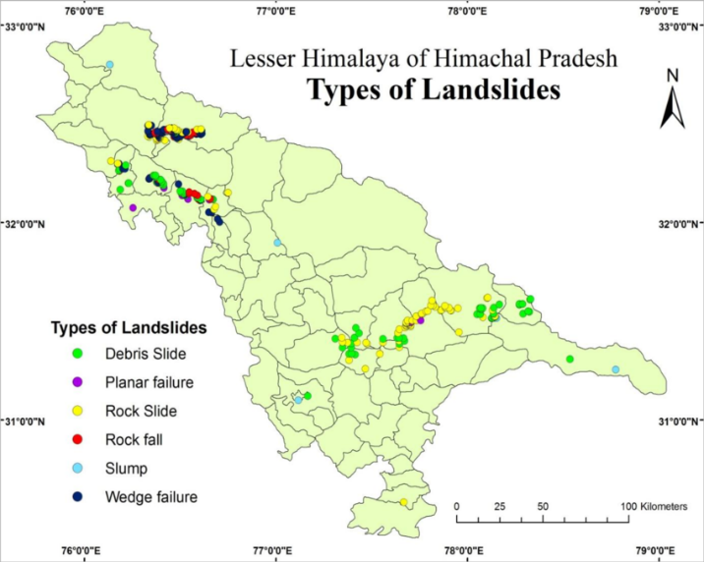

**3. Methodology**

**3.1 Data Collection** Satellite imagery from various sensors, including optical, radar, and LiDAR, will be acquired for selected study areas in Himachal Pradesh. Multi-temporal datasets covering different seasons and years will be collected to capture seasonal variations and long-term trends in landslide activity.



**3.2 Pre-processing of Satellite Data** Pre-processing steps, such as image correction, registration, and orthorectification, will be performed to ensure the accuracy and consistency of the satellite datasets. Radiometric and geometric corrections will be applied to mitigate sensor-specific distortions and improve data quality, particularly in rugged terrain and high-relief areas.

**3.3 Identification of Landslide Reactivation Events** Change detection techniques will be employed to identify areas of significant land surface changes indicative of landslide reactivation in Himachal Pradesh. Image enhancement, classification, and segmentation algorithms will be used to detect alterations in terrain morphology, land cover, and surface properties associated with landslide activity.

**3.4 Analysis Techniques**



**3.4.1 Change Detection Methods** Change detection algorithms, including pixel-based and object-based approaches, will be applied to satellite imagery to detect and quantify land surface changes over time in Himachal Pradesh. Thresholding, clustering, and machine learning techniques will be used to distinguish between natural and anthropogenic changes and identify landslide reactivation events.

**3.4.2 Multi-temporal Analysis** Multi-temporal analysis of satellite data will be conducted to track temporal variations in landslide-prone areas and assess the temporal relationship between environmental factors and landslide reactivation events in Himachal Pradesh. Time-series analysis, trend detection, and anomaly detection methods will be employed to identify patterns and trends in landslide activity.



**3.4.3 Machine Learning Approaches** Machine learning algorithms, such as random forests, support vector machines (SVM), and convolutional neural networks (CNN), will be applied to satellite data for landslide susceptibility mapping and prediction in Himachal Pradesh. Supervised and unsupervised learning techniques will be used to classify landslide-prone areas and develop predictive models for landslide reactivation.

**4. Case Studies**

**4.1 Case Study 1: Landslide Reactivation in [Location]** Satellite data from [satellite sensor] will be analyzed to investigate landslide reactivation events in a selected location in Himachal Pradesh. Pre- and post-event imagery will be compared to identify changes in terrain morphology, land cover, and surface properties associated with landslide activity.



**4.2 Case Study 2: Landslide Reactivation in [Location]** Landslide reactivation events in another selected location in Himachal Pradesh will be analyzed using satellite data from [satellite sensor]. Multi-temporal datasets will be processed to detect land surface changes indicative of landslide activity and assess the influence of environmental factors on landslide reactivation.



**5. Results and Discussion**

**5.1 Identification of Precursory Indicators** The analysis of satellite data will enable the identification of precursory indicators of landslide reactivation in Himachal Pradesh, including changes in terrain morphology, land cover, and surface displacement patterns. Temporal analysis will reveal seasonal variations and trends in landslide activity, highlighting potential triggers of landslide reactivation.

**5.2 Factors Influencing Landslide Reactivation** Environmental factors influencing landslide reactivation, such as rainfall intensity, slope gradient, land use changes, and geological conditions, will be assessed using satellite data and geospatial analysis techniques. The integration of satellite-derived information with environmental datasets will facilitate the identification of factors contributing to landslide susceptibility and reactivation in the Himalayan context.

**5.3 Comparison of Case Studies** The results of case studies will be compared to assess the effectiveness of satellite data in monitoring and predicting landslide reactivation events in Himachal Pradesh. Variations in terrain characteristics, land cover types, and environmental conditions will be considered to evaluate the applicability of satellite-based approaches across different regions of the state.

**5.4 Limitations and Challenges** Limitations and challenges associated with the use of satellite data for landslide monitoring and analysis in Himachal Pradesh will be discussed, including data availability, spatial and temporal resolution, cloud cover, and image coherence.

**6. Implications for Hazard Mitigation and Risk Management**

**6.1 Early Warning Systems** The findings of this study will contribute to the development of early warning systems for landslide reactivation in Himachal Pradesh by providing insights into precursory indicators and environmental triggers. Satellite-based monitoring can enhance the timeliness and accuracy of landslide hazard assessments, enabling proactive measures to mitigate risks and minimize potential impacts on vulnerable communities.

**6.2 Proactive Mitigation Strategies** Proactive mitigation strategies, such as land use planning, slope stabilization, and infrastructure protection, can be informed by satellite-derived information on landslide susceptibility and reactivation in Himachal Pradesh. The integration of satellite data with geospatial analysis tools and decision support systems will facilitate the prioritization of mitigation efforts and allocation of resources in landslide-prone areas.

**6.3 Policy Recommendations** Policy recommendations for enhancing landslide hazard management and risk reduction in Himachal Pradesh will be formulated based on the research findings. The integration of satellite-based monitoring into state-level disaster management frameworks will be advocated to strengthen resilience and preparedness against landslide events.

**7. Conclusion** The analysis of landslide reactivation using satellite data offers valuable insights into the dynamics of slope instability and environmental change in Himachal Pradesh. By leveraging remote sensing techniques and data analysis methodologies, this study contributes to the understanding of landslide processes and the development of effective hazard mitigation and risk management strategies tailored to the unique challenges of the Himalayan region.

**8. Future Directions and Recommendations**

**8.1 Integration of Satellite Data with Ground-based Monitoring** Future research should focus on integrating satellite data with ground-based monitoring networks in Himachal Pradesh to enhance the accuracy and reliability of landslide detection and prediction. Synergistic approaches combining satellite remote sensing with in-situ measurements and geophysical monitoring techniques will improve our ability to monitor and forecast landslide reactivation events in the region.

**8.2 Advancements in Remote Sensing Technologies** Advancements in remote sensing technologies, such as the development of new satellite sensors and platforms, offer opportunities for improving landslide monitoring capabilities in Himachal Pradesh. High-resolution imagery, advanced radar systems, and emerging technologies such as UAVs can provide detailed insights into landslide dynamics and processes in the Himalayan context.

**8.3 Long-term Monitoring and Prediction Models** Long-term monitoring and prediction models for landslide reactivation should be developed based on satellite-derived information and environmental data specific to Himachal Pradesh. Time-series analysis and statistical modelling techniques can be employed to identify trends, patterns, and potential triggers of landslide activity, enabling the implementation of proactive measures to mitigate risks and safeguard vulnerable areas in the region.

**Summary: Analysis of Landslide Reactivation Using Satellite Data in Himachal Pradesh**

Landslides represent a significant hazard in the mountainous terrain of Himachal Pradesh, India, posing threats to lives, infrastructure, and the environment. This paper delves into the utilization of satellite data for understanding landslide reactivation events in this region, employing advanced remote sensing techniques and data analysis methodologies.

The study aims to identify precursory indicators and assess the factors influencing landslide reactivation, offering valuable insights for hazard mitigation and risk management. Through case studies and comparative analysis, the effectiveness of satellite data in monitoring and predicting landslide reactivation is underscored, with implications for the development of early warning systems and proactive mitigation strategies tailored to the unique challenges of Himachal Pradesh.

The research highlights the importance of integrating satellite-based monitoring into state-level disaster management frameworks, advocating for policy recommendations to strengthen resilience and preparedness against landslide events. Future directions include the integration of satellite data with ground-based monitoring networks and advancements in remote sensing technologies for improved landslide monitoring and prediction in the Himalayan region.

Overall, this study contributes to the understanding of landslide dynamics and processes in Himachal Pradesh, offering a roadmap for enhancing landslide hazard management and risk reduction efforts in the face of increasing vulnerabilities associated with mountainous environments.

Top of Form

.