Poultry Diseases Diagnostics Models using Deep Learning

In this project as per your request we have trained different pre-trained algorithms such as MobileNetV2, VGG16 and InceptionV2 as transfer learning algorithm to predict poultry disease. We have trained all algorithms using same dataset given by you and then each algorithm performance is evaluated in terms of accuracy, precision, recall, FSCORE and confusion matrix.

To implement this project we have designed following modules

1. Upload Poultry Dataset: using this module will upload dataset to application and then plot graph on various skin diseases found in dataset
2. Pre-process Dataset: using this module will shuffle and normalize image pixel values
3. Train & Test Split: using this module will split dataset into train and test where application using 80% dataset for training and 220% for testing
4. Run InceptionV3 Algorithm: 80% training data will be input to InceptionV3 algorithm to train a model and this model will be applied on 20% test data to calculate prediction accuracy
5. Run MobileNetV2 Algorithm: 80% training data will be input to MobileNetV2 algorithm to train a model and this model will be applied on 20% test data to calculate prediction accuracy
6. Run VGG16 Algorithm: 80% training data will be input to VGG16 algorithm to train a model and this model will be applied on 20% test data to calculate prediction accuracy
7. Comparison Graph: will plot comparison graph between all algorithms
8. Predict Cancer from Test Image: will input test image and then algorithm will predict skin cancer type

SCREEN SHOTS

To run project double click on run.bat file to get below screen

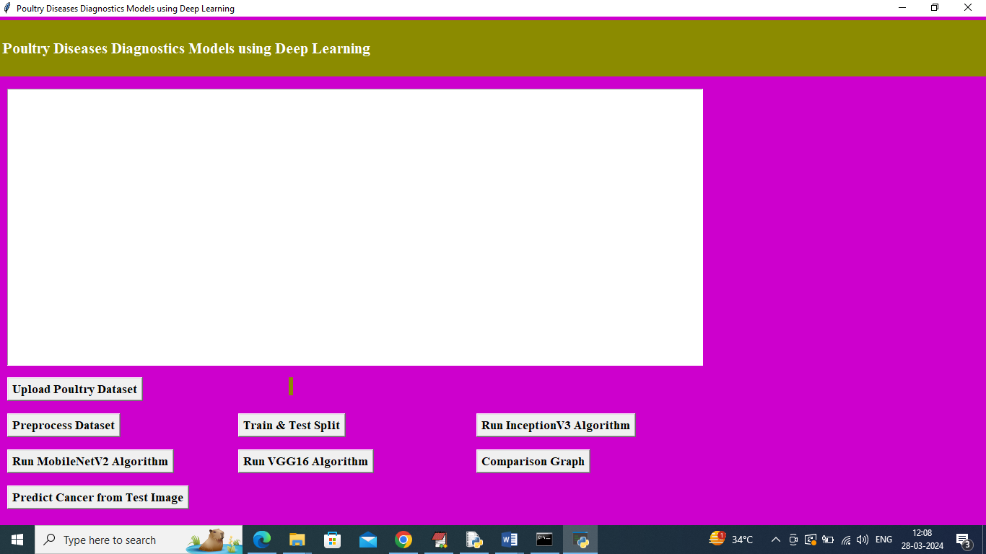

In above screen click on ‘Upload Poultry Dataset’ button to upload dataset and get below page

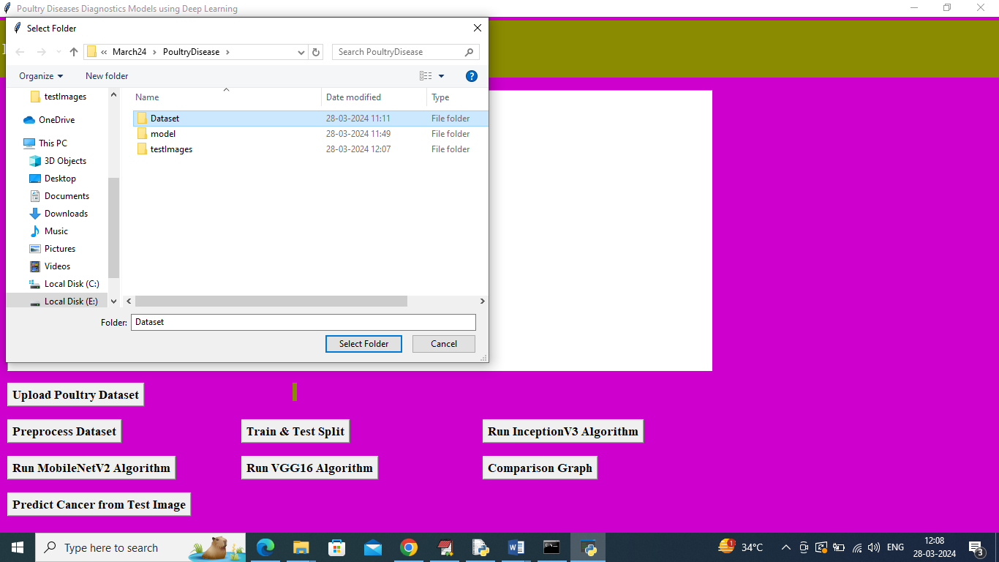

In above screen selecting and uploading ‘Dataset’ folder and then click on ‘Select Folder’ button to load dataset and get below page

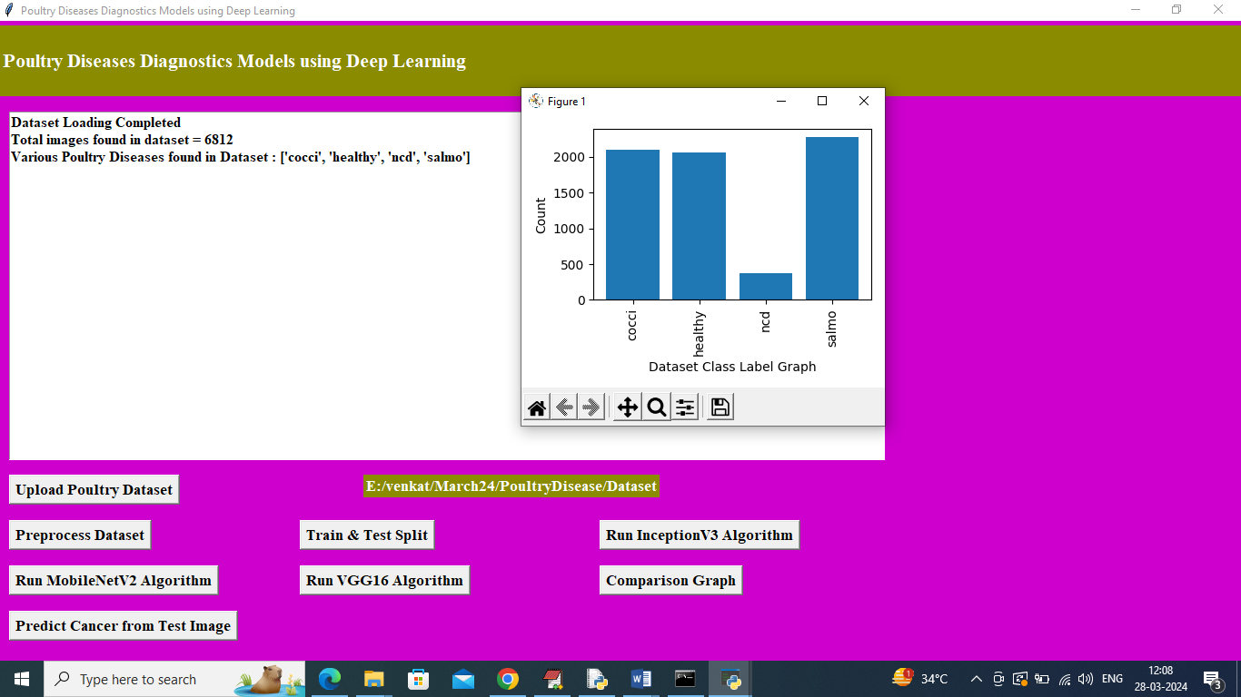

In above screen dataset loaded and can see total images found in dataset along with different class labels and in graph x-axis represents poultry disease type and y-axis represents number of images found in that label and now click on ‘Pre-process Dataset’ button to shuffle and normalize images and get below output

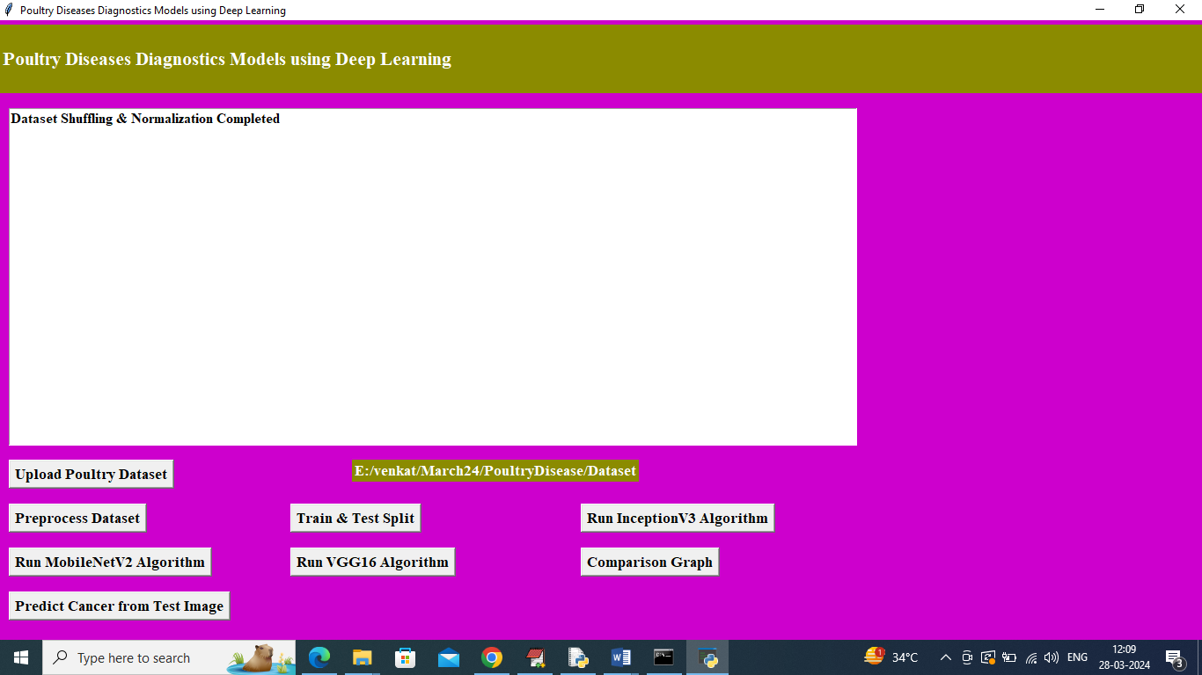

In above screen dataset processing completed and now click on ‘Train & Test Split’ button to split dataset and get below page

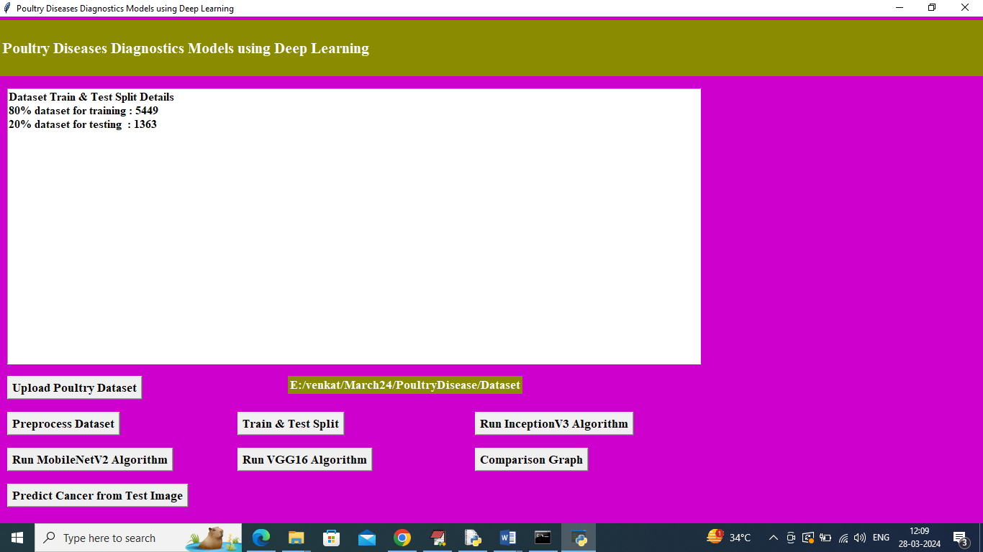

In above screen can see training and testing images size and now click on ‘Run InceptionV3 Algorithm’ button to train InceptionV3 and get below output

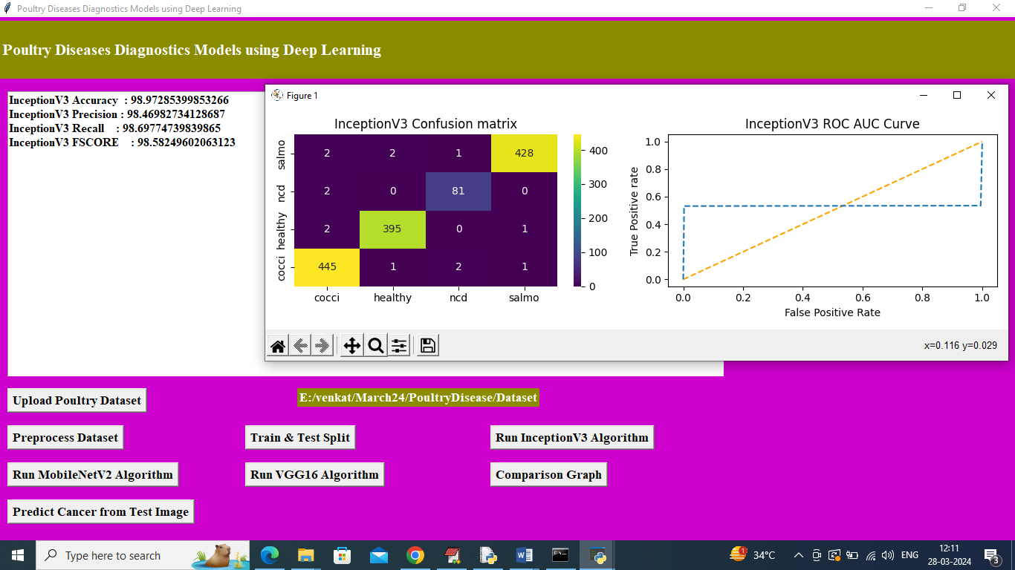

In above screen training InceptionV3 algorithm completed and then it got 98.97% accuracy and can see other metrics like precision, recall and etc. in confusion matrix graph x-axis represents Predicted Labels and y-axis represents True labels and then different color boxes in diagnol represents correct prediction count and all remaining blue boxes represents incorrect prediction count which are very few. In ROC graph x-axis represents False Positive Rate and y-axis represents True Positive Rate and if blue lines comes below orange line then all predictions are incorrect or false and if goes above orange line then all predictions are correct or true. In above screen can see only few predictions are incorrect. Now click on ‘Run MobileNetV2 Algorithm’ button to get below output

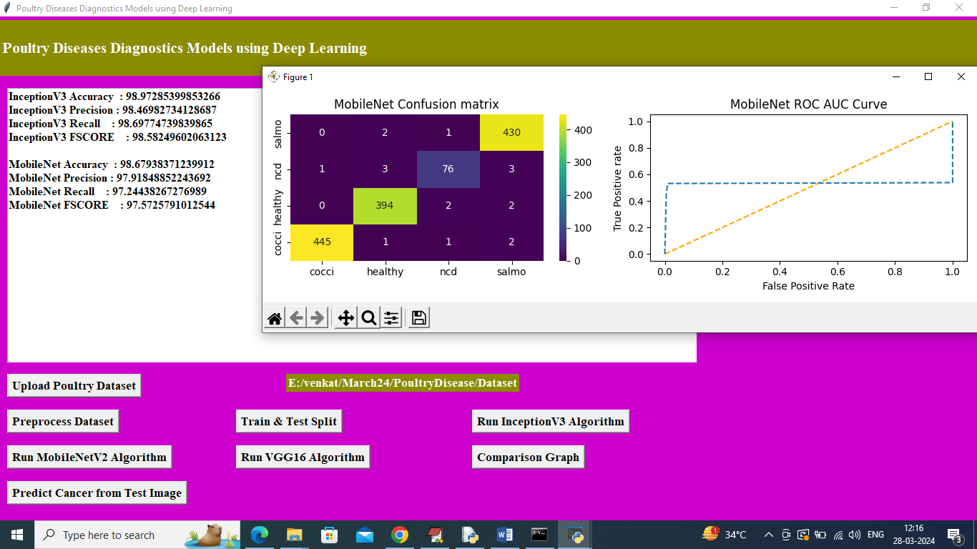

In above screen MobileNetV2 algorithm got 98.67% accuracy and can see other metrics also and now click on ‘Run VGG16 Algorithm’ button to get below output

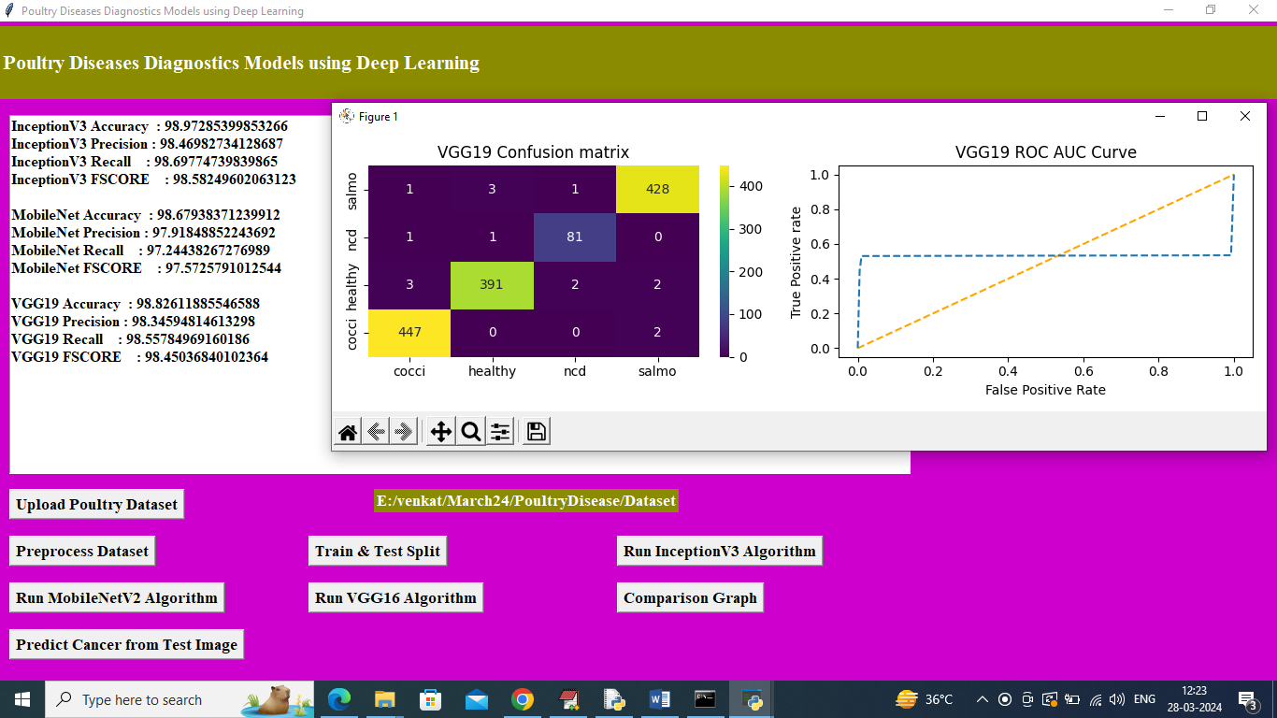

In above screen VGG16 got 98.82% accuracy and can see other metrics also and now click on ‘Comparison Graph’ button to get below graph

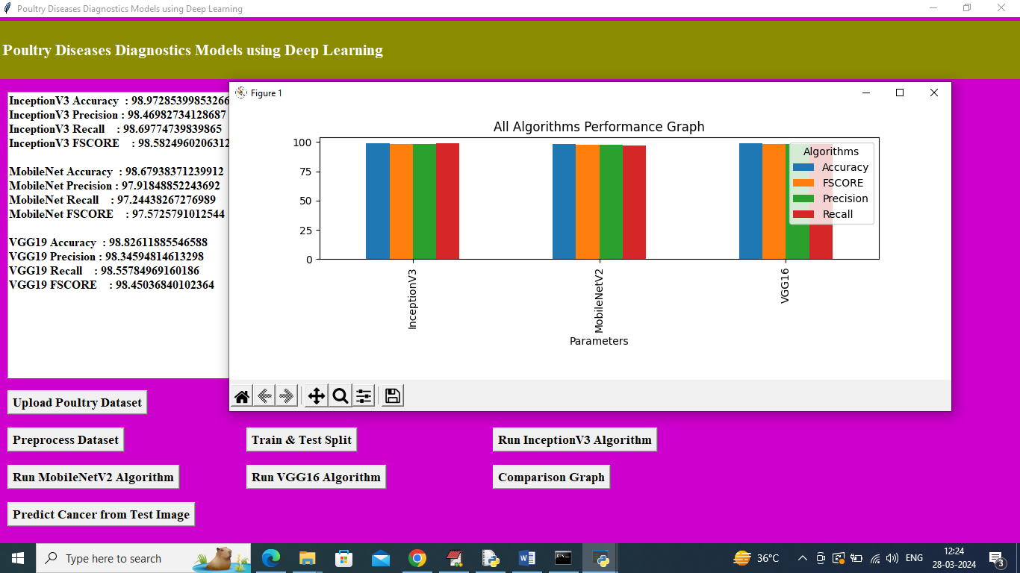

In above graph x-axis represents algorithm names and y-axis represents accuracy and other metrics in different color bars and in all algorithms InceptionV3 got high performance and in all algorithms can see InceptionV3 got high accuray. Now click on ‘Predict Poultry Disease from Test Image’ button to upload test image and detect poultry disease type

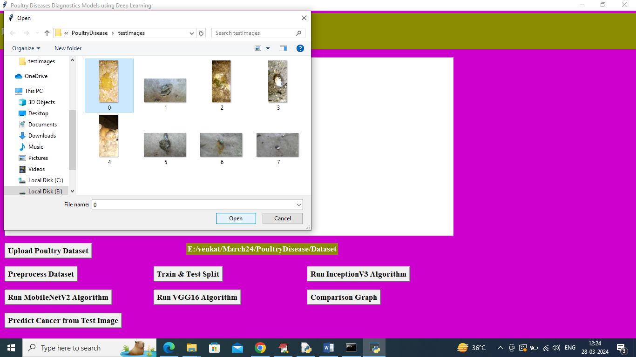

In above screen selecting and uploading 0.jpg file and then click on ‘Open’ button to get below predicted output

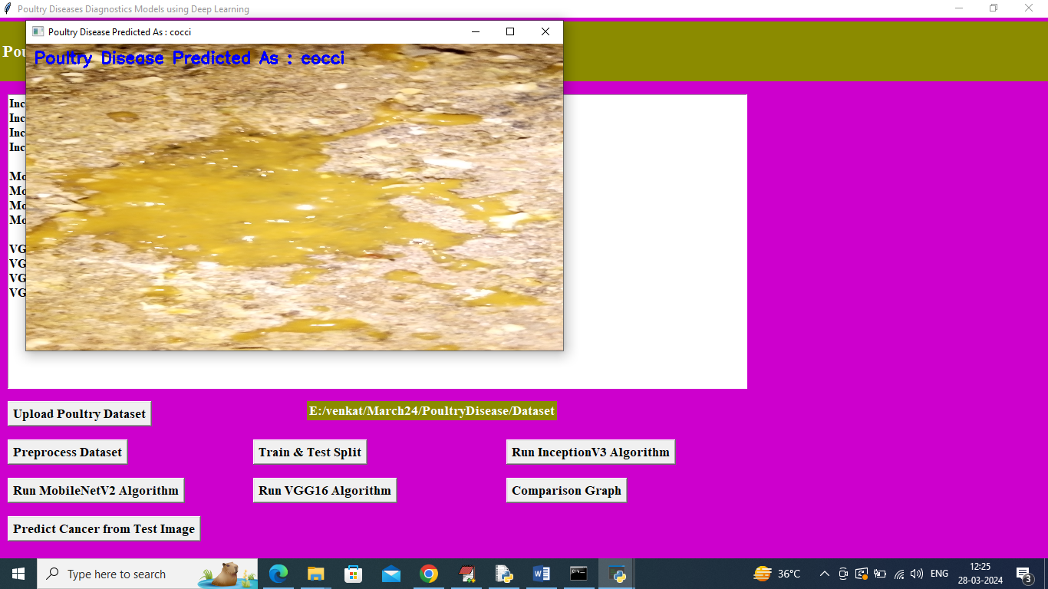

In above screen image in title bar or blue color text can see disease predicted as ‘cocci’. Similarly upload and test other images

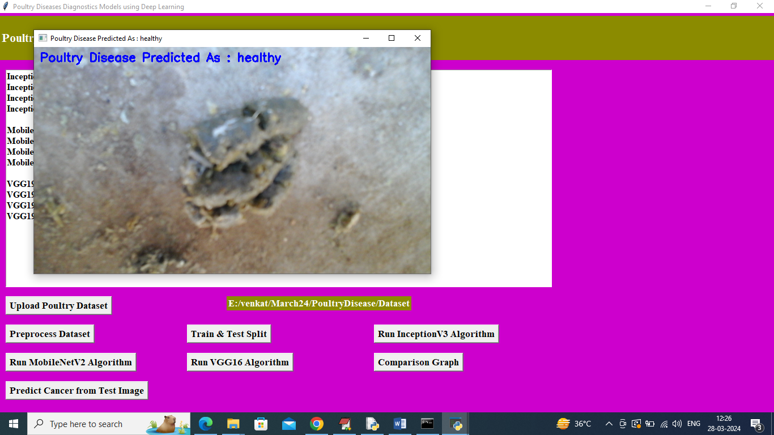

In above screen healthy is predicted

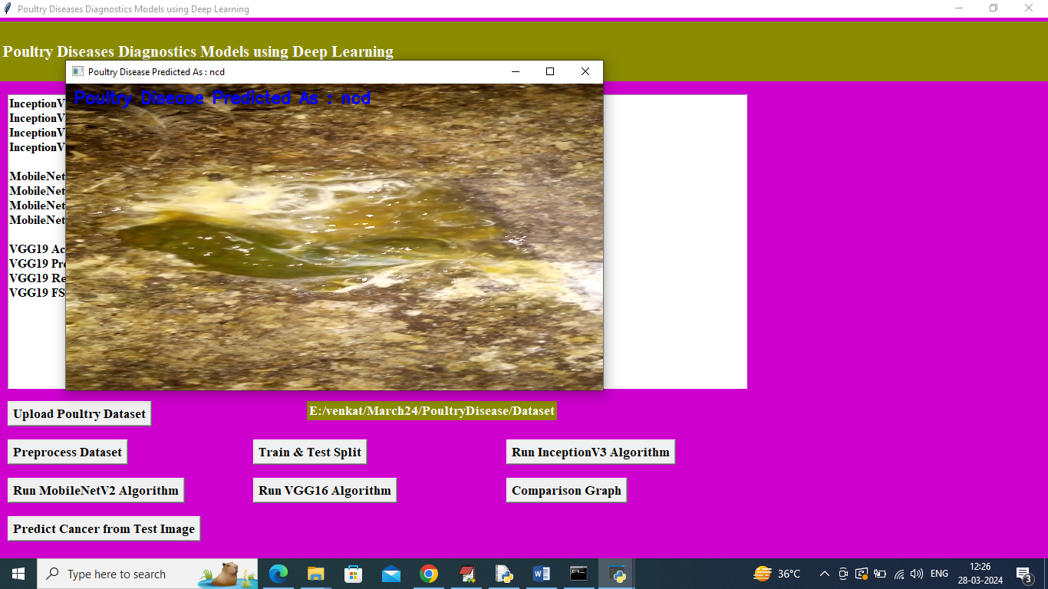

In above screen ncd is predicted

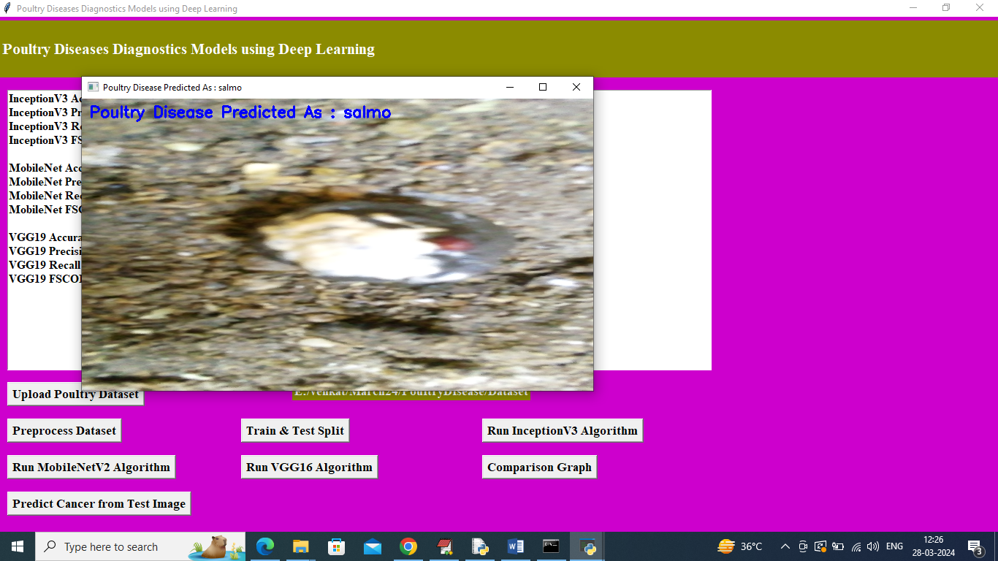

In above screen salmo is predicted.

So by using above screens you can predict poultry diseases