Intent Classification with Rasa NLU and SpaCy.

* + A Library for intent recognition and entity extraction based on SpaCy and Sklearn

NLP = NLU+

* NLP = understand, process ,interpret everyday human language
* NLU = unstructured inputs and convert them into a structured form that a machine can understand and act upon.

Step 1: Load The Library

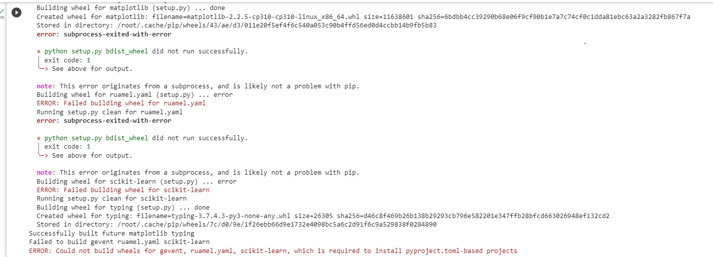

Library is deprecated and outdated providing wheel error this error indicates a hint about updating the python version but my python version is adapted to latest , also same error occurs when its run on python3.8.2 and 3.9. So program is not executable and need further assistance in solving the error.