*Reddit_Chatbot*

**Chatbot based on Transformer NMT Model**

nmt-chatbot is the implementation of chatbot using Google Transformer Model. Main purpose of this project is to make a chatbot, but it is fully compatible with Neural Machine Translation and still can be used for sentence translations between two languages.

Step 1: Clone the chatbot into google collab

!git clone https://github.com/Ar9av/transformer-nmt-chatbot.git

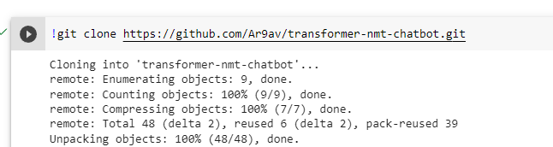

STEP 2: change the directory to cloned repository to access and install programs and run

%cd transformer-nmt-chatbot/

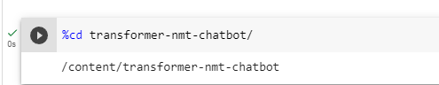

Step3: Loading the config.yml, This is a configuration file for a machine learning model. It specifies the hyperparameters and settings for the model, such as the number of layers, target vocabulary size, model dimensions, dropout rate, and batch size. It also includes settings for training, such as the number of epochs and checkpoints, as well as options for testing and evaluation.

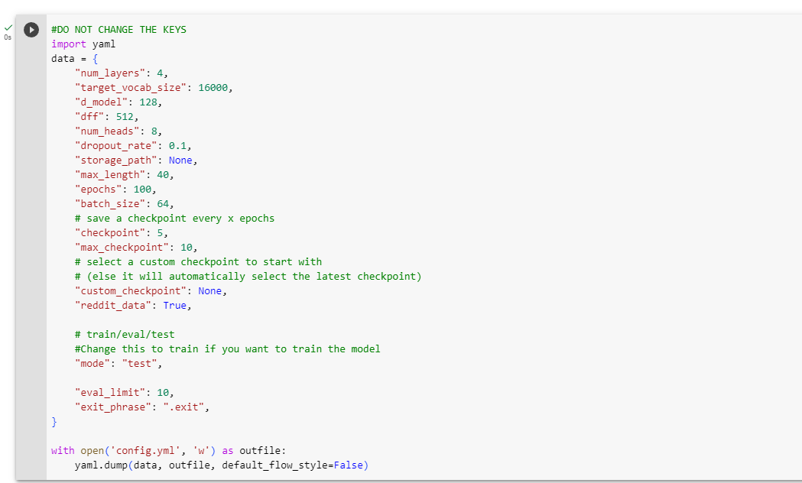

Step4: This is a configuration file for a web scraping program that will scrape the top posts from the subreddits "r/AMA" and "r/explainlikeim5" on the website "https://old.reddit.com/". The program will scrape 200 pages of each subreddit and sort the posts by "top" for "all" time. 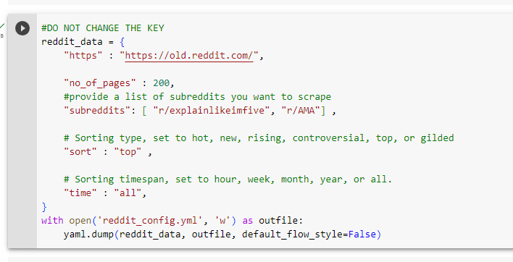

Step5: This is a list of Python packages and their corresponding versions that are required for a particular project or application. These packages can be installed using a package manager like pip to ensure that the project has all the necessary dependencies.

!pip install -r requirements.txt

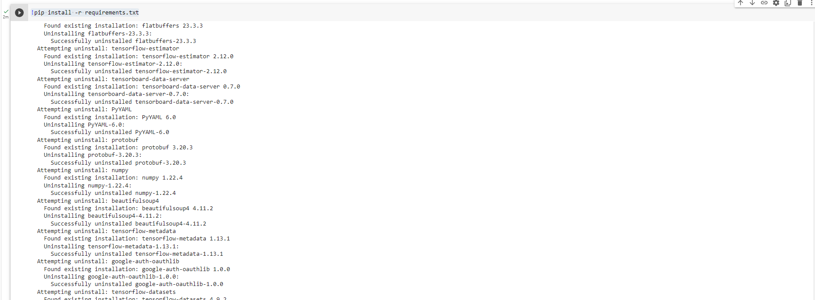

Step6: Running python main.py to execute the program.

But since due to deprecated libraries and dependencies unable to load the the chatbot which is an internal error.

