An NLP-based Chatbot to Facilitate RE Activities:

An Experience Paper on Human Resources Application

1)What is the paper about?

A comprehensive proposal which theorises creating a chatbot resource to reduce distractions or reduce time, navigating through many software’s and other application by far increases time consumption in most case the level of productivity per workload will be quantized. Generally, this chatbot facilitates with companies’ workspace application and forms a bridge between other existing applications in which the companies operate upon and here they propose this chatbot to make sure that employees work with single main system to prevent employees navigating through other applications since the chatbot resources are interfaced on the main workspace, this is a prototype its construction is for a human resources application and provide a use for requirements engineering activities it applies not just for employees to clients also. Let us dive deep into the technical understanding of the above concept Here the chatbot acts as an interface and provides access with the various applications which includes the client’s application.

2). What are the authors doing that is new?

The structure of the paper is differentiated on the architecture, requirements, parameters, natural language, API etc. On top of that various language models along different machine learning labels are implemented here to tarin and test data Such as both supervised and Unsupervised algorithm , to determine compatibility accuracy of each models and also to pick the accurate model also compared to other works this a traditional way of writing a blue-print to any existing chatbot project this model approach of developing a chatbot adaptation can witnessed in several paper ,but the idea of implementing this for Human Resources , Finance , Project Management is also not new. Whether new or not, what matters Is how the program is built upon, here they have implemented an NLP pipeline called Term Frequency - Inverse Document Frequency (TF-IDF) which helps in determining the value of a word in a sentence lets us dive deep into it during the use case.

3)Did it work? why or why not?

Here the aim was to find results with the rule based and model-based algorithms that they created and used respectively. Model based algorithms, below are the results from using model-based classifier

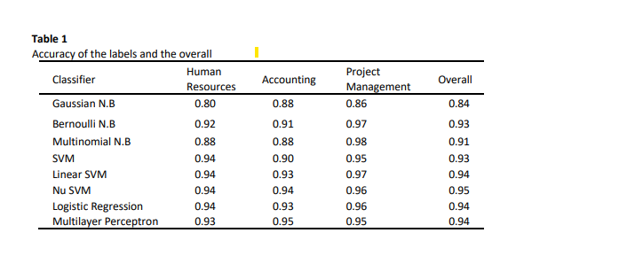

Observation: we can identify that Nu SVM vector has more accuracy compared to other classifiers. Furthermore, use of NLP and Techniques for text processing can seen such as POS (Part of speech Tagging) NER (Named Entity Recognition), Stemming Method has been used. With help of a built-in text processer called scikit-learn they have labelled Term Frequency - Inverse Document Frequency (TF-IDF) which act as an estimator for text pre processing

4.Why is this good or bad?

Most of the chatbot software have deep understanding of nlp and Machine learning models so I would concur this as a great start but down the line if we want create a state-of -the-art chatbots, I think the data here is inconclusive and need more pressing research to it.

5) Technical Specification?

The programming language used here is python, for text processing they have used NLP, which includes NLP library as NLTK and Spacy. For Machine Learning related scikit learning and Pandas are used BOTSTAR for BOT delivery and hosting it on other websites, one of BOTSTARS features is that it is CMS (Content Management System), has customization for mimicking human behaviour, backend relates to JAVASCRIPT, DOCKER, and NGINX for as web server in which is HOSTED on AWS deployment server.

6)Conclusion

In conclusion, they introduce an NLP-based chatbot solution to the fatigue caused by multiple platforms in business environments. Companies use multiple platforms to run their operations which may not be excelled by their employees and customers. they propose integrating a chatbot integrated to the Super App of the company. The chatbot is currently integrated to the human resources application. They also provide an RE related use case as part of our on-going work.

Future Work is yet to be done. Which aims to train and test more dataset and integrate this to existing domain platforms.