Rakesh

Rakeshnandakumar2005@gmail.com

WIREFRAMES

CB011234

Abstract

This Document consist of all the wireframes of all the 7 pages in both Pc and Mobile view

# Home

# Turtle categories

# 

# Hikkaduwa Turtle Hatchery

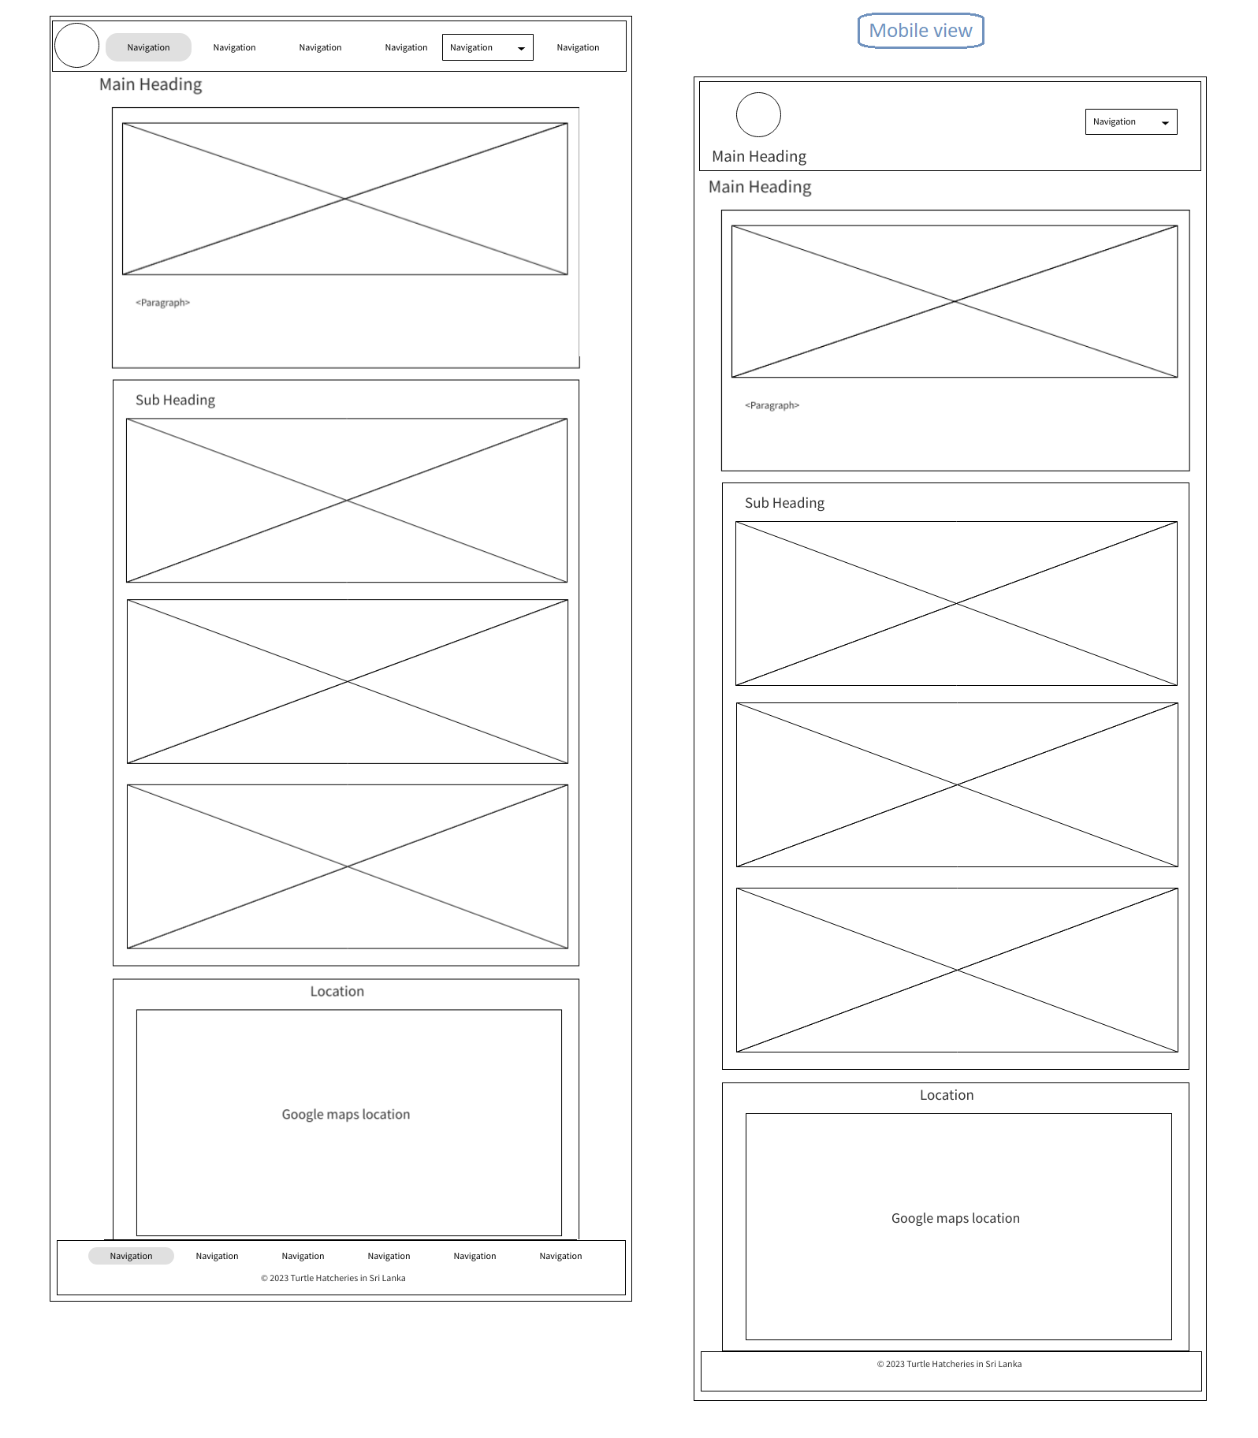

# Threats to Turtles

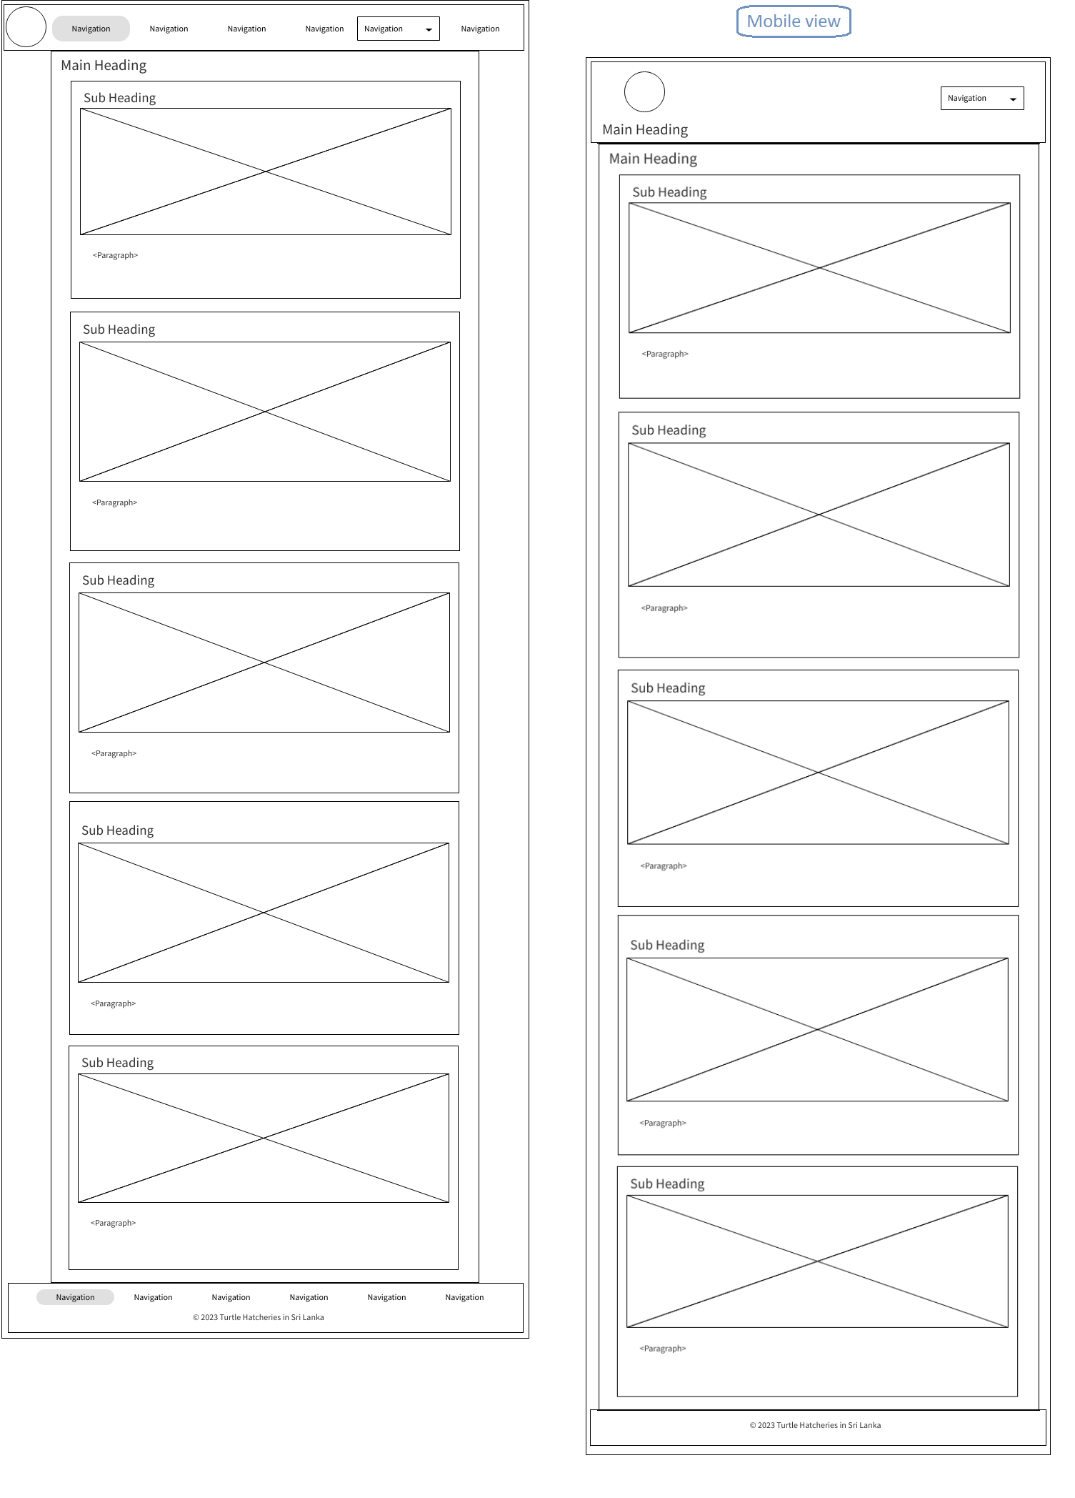

# Kosgoda Turtle Hatcheries

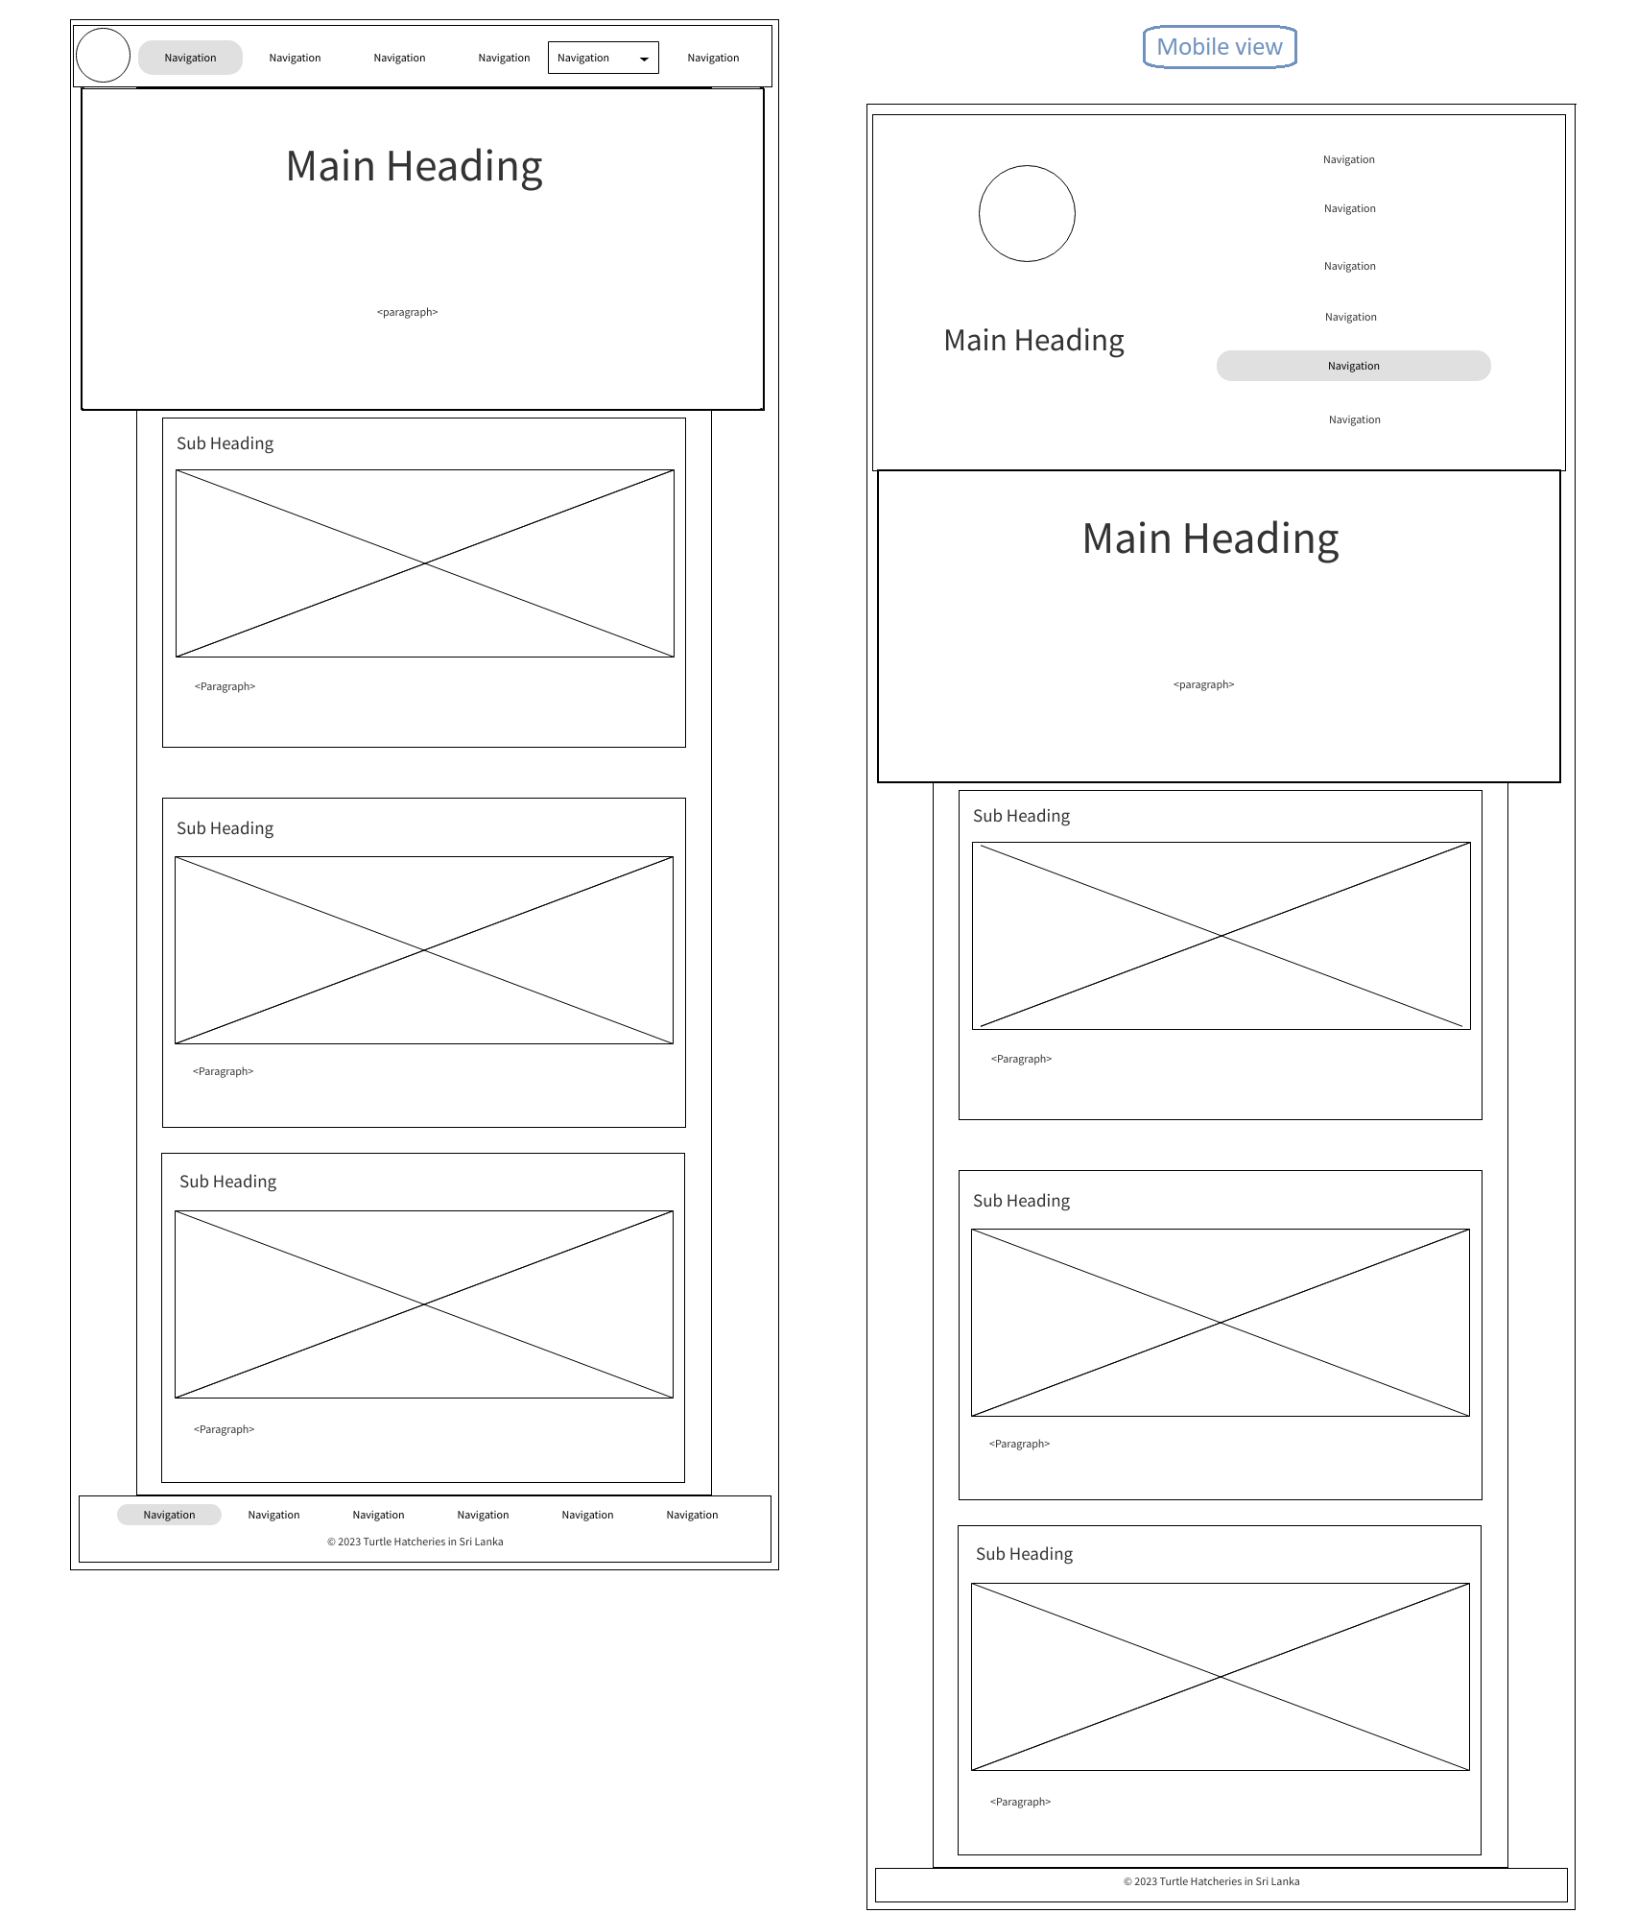

# Bentota Turtle Hatcheries

# 

# Purchase and Donate

