DETAILED DESIGN

Project Code: | POS-01
Project Name: | Pizza Ordering System

Revision History

Version | Date of | Description of Change | Reason for | Affected | Approved By
(x.yy) | Revision |  | Change | Sections
1.0 | 16/04/2013 | Initial Draft
1.1 | 10/05/2013 | Revision
2.10 | Aug 2013 | Revision
2.20 | Sept 2013 | Revision | Mapping with
 |  |  | CPC
2.3 | Dec 2013 | Revision | Mapping with
 |  |  | UCF

Affected Groups

Development Engineering

Quality Assurance

XYZ Automation Ltd

List of Reference Documents

Name | Version No.
1.RS_POS | 2.20
2.FS_POS | 2.20
3.
4.

Prepared by/Date Reviewed by/Date Approved by/Date
Detailed Design ^{POS-01/DD-2.20}

 |  |  |  |  | Table of Contents
TABLE OF CONTENTS ............................................................................................................................... |  |  |  |  |  |  | 2
1. | INTRODUCTION ................................................................................................................................... |  |  |  |  |  | 3
 | 1.1 |  | Background ................................................................................................................................. |  |  |  | 3
 | 1.2 |  | Purpose ....................................................................................................................................... |  |  |  | 3
 | 1.3 |  | Scope ............................................................................................................................................... |  |  |  | 3
2. | GLOBAL DATA STRUCTURES AND SHARED DATA FUNCTIONS |  |  |  |  |  | ................................................. 4
3. | HIGH LEVEL DESIGN........................................................................................................................... |  |  |  |  |  | 5
 | 3.1 |  | Use Case Diagrams ......................................................................................................................... |  |  |  | 5
 | 3.1.1 Use Case Diagram for Administrator ............................................................................................ |  |  |  |  |  | 5
 | 3.1.2 Use Case Diagram for Customer .................................................................................................. |  |  |  |  |  | 5
 | 3.3 |  | Class Diagram ................................................................................................................................. |  |  |  | 9
 | 3.4 |  | Sequence Diagram .......................................................................................................................... |  |  |  | 9
 | 3.5 |  | Packages / Interface / Classes ...................................................................................................... |  |  |  | 10
4. | CRITICAL FUNCTIONS AND FOCUS FOR TESTING ...................................................................... |  |  |  |  |  | 16
5. | LIMITATIONS ...................................................................................................................................... |  |  |  |  |  | 16
6. | APPENDIX ........................................................................................................................................... |  |  |  |  |  | 17
 | 1 | Table: POS_TBL_User_Profile ......................................................................................................... |  |  |  |  | 17
 | 2 | Table: POS_TBL_User_Credentials ................................................................................................. |  |  |  |  | 17
 | 3 | Table: POS_TBL_PizzaStore ........................................................................................................... |  |  |  |  | 17
 | 4 Table: POS_TBL_Food .................................................................................................................... |  |  |  |  |  | 18
 | 5 | Table: POS_TBL_Order ................................................................................................................... |  |  |  |  | 18
 | 6 | Table: POS_TBL_Cart ...................................................................................................................... |  |  |  |  | 18
 | 7 | Table: POS_TBL_CreditCard ........................................................................................................... |  |  |  |  | 19
 | Database Sequences........................................................................................................................... |  |  |  |  |  | 19

TP_DTLDS – Version 2.1 Page 2 of 19
Detailed Design ^{POS-01/DD-2.20}

1. Introduction

1.1 Background

XYZ Automation Ltd focuses on automating various systems that have been working manually since years.

1.2 Purpose

XYZ Automation Ltd recently planned to automate “ Pizza Ordering System” - a Web application intended to be used by user for ordering of pizza.

1.3 Scope

The scope of the Pizza Ordering System (POS) will be to provide the functionality as described in Functional Requirements document. The system will be developed on a Windows XP/Windows 7 machine using Java/J2EE technology and Oracle database.

TP_DTLDS – Version 2.1 Page 3 of 19
Detailed Design ^{POS-01/DD-2.20}

2. Global Data Structures and Shared Data Functions

This section describes the structure of 7 tables to be used for the implementation of requirements as stated in the specification.
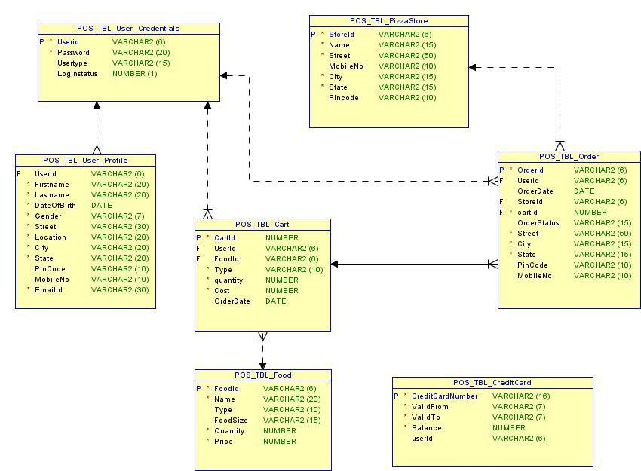

TP_DTLDS – Version 2.1 Page 4 of 19
Detailed Design ^{POS-01/DD-2.20}

3. High Level Design

This section describes the high level design diagrams Use case diagram with Use Case definition, Sequence Diagram and Class Diagram which provides a visual representation of the requirements , logical flow and their class representations.

3.1 Use Case Diagrams

The requirements of a system can be represented using a use case model in the Use Case Diagram. The use case diagrams for the actors of this case study are given as below.

3.1.1 Use Case Diagram for Administrator
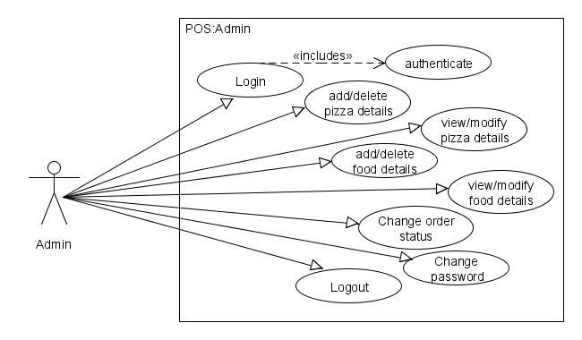

3.1.2 Use Case Diagram for Customer
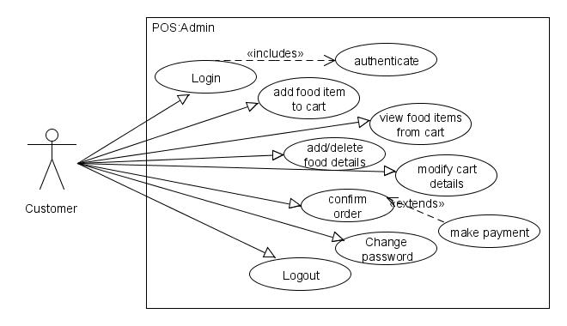

TP_DTLDS – Version 2.1 Page 5 of 19

Detailed Design

3.2 Use case Definition

POS-01/DD-2.20

Generally, In a design document, Use case definitions should be written for all the Requirements of the system. Below shown is an example for Use Case Definition.

3.2.1 Add Food Item Details
Admin performing add food item fuctionality
USE CASE # | AD-005
Goal | The admin should be able to add food items details
Preconditions | Admin should be successfully logged in.
Success End Condition | Food item details are added successfully and a FoodID is
 | auto-generated.
Failed End Condition | Not able to add a food item and a proper message is shown.
Primary, Secondary | Primary: Administrator
Actors
Trigger | Admin Initiative
DESCRIPTION | Step | Action
 | 1 | Click on ‘Add Food Item’ link.
 | 2 | Enter valid Food Item details
 | 3 | Click on ‘Add FoodItem’ button
 | Step | Branching Action
 | 1 | Enter invalid/incomplete item details
 | 2 | Click on ‘Add FoodItem’ button
Related Information/Use
cases
Priority | P1
Performance | 1sec (excluding user input)
Frequency | 2 / week
Assumptions | All Pizza Stores will have the same food items.

TP_DTLDS – Version 2.1 Page 6 of 19

Detailed Design ^{POS-01/DD-2.20}

3.2.2 Modify Food Item Details

Administrators performing modify food item functionality
USE CASE # | AD-008
Goal | The admin should be able to modify food items details
Preconditions | Food Items are present in the database.
Success End Condition | Food Items details modified successfully. A proper message
 | is shown.
Failed End Condition | Unable to modify Food Item details
Primary, Secondary | Primary-Administrator
Actors
Trigger | Admin Initiative
5DESCRIPTION | Step |  | Action
 | 1 |  | Click on ‘Edit Food Item Details’ link
 | 2 |  | Enter FoodID. Click on Submit. Food details are
 |  |  | shown.
 | 3 |  | Enter new Food Item details.
 | 4 |  | Click on ‘Modify FoodItem’ button.
 | 5 |  | On the Confirmation box, Select OK.
 | Step |  | Branching Action
 | 1 |  | Enter invalid FoodID. Click on Submit.
 | 2 |  | Select Cancle on confirmation.
Related Information/Use
cases
Priority | P2
Performance | 1sec (excluding user interaction)
Frequency | 1 / week
Assumptions | The updation affects all pizza stores.

TP_DTLDS – Version 2.1 Page 7 of 19
Detailed Design ^{POS-01/DD-2.20}

3.2.3 Confirm Order and Make Payment

Customer performing Order Confirmation and Make payment functionality
USE CASE # | CU-004
Goal | The user should be able to confirm order by making payment
Preconditions | Food Items should be available in shopping cart.
Success End Condition | OrderID should be auto-generated and shipment details
 | should be entered in the database.
Failed End Condition | No order generated. Shipment details also not stored in the
 | database.
Primary, Secondary | Primary-Customer
Actors
Trigger | User Initiative.
DESCRIPTION | Step |  | Action
 | 1 |  | Click on ‘Confirm Order’ button on the shopping cart
 | 1 |  | page.
 | 2 |  | Enter the shipment details.
 | 3 |  | Click on ‘Make Payment’ button.
 | 4 |  | Enter Credit Card details. Click on Pay.
 | Step |  | Branching Action
 | 1 |  | Enter incomplete shipment details
 | 2 |  | Or, Enter invalid Credit Card details
 | 3 |  | Or, Purchase worth more than Credit Balance.
Related Information/Use
cases
Priority | P1
Performance | 2 sec
Frequency | 30/day per Customer
Assumptions | Credit Card details of the customer must be available in the
 | database.

TP_DTLDS – Version 2.1 Page 8 of 19
Detailed Design ^{POS-01/DD-2.20}

3.3 Class Diagram

The class diagram is a very basic concept in object-oriented world. Class diagrams demonstrate a model, describing what attributes and behavior it has rather than describing the methods for accomplishing operations. Class diagrams are very useful in representing relationships between classes and interfaces. The below example is for a Web Application using JSP/Servlet.

<to be designed by the participant…………>

3.4 Sequence Diagram

A graphical representation of a module’s function invoking functions of other modules in order to achieve a task (specific user requirement) is called a sequence diagram. A sequence diagram for the authentication process is given below for reference. The below example is for a Web Application using servlets/jsp.

3.4.1 View Food details

Admin performing view food details
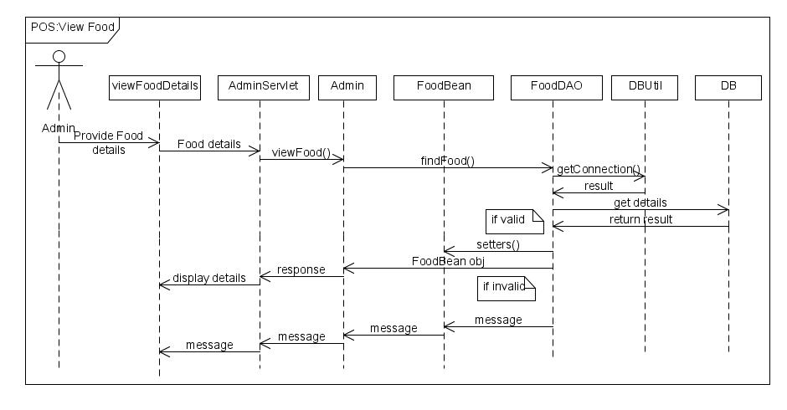

TP_DTLDS – Version 2.1 Page 9 of 19
Detailed Design ^{POS-01/DD-2.20}

3.5 Packages / Interface / Classes

This section provides a brief outlook on the packaging hierarchy along with the respective classes to be used for the implementation.

The 4 packages mentioned below are for both standalone and Web Application.
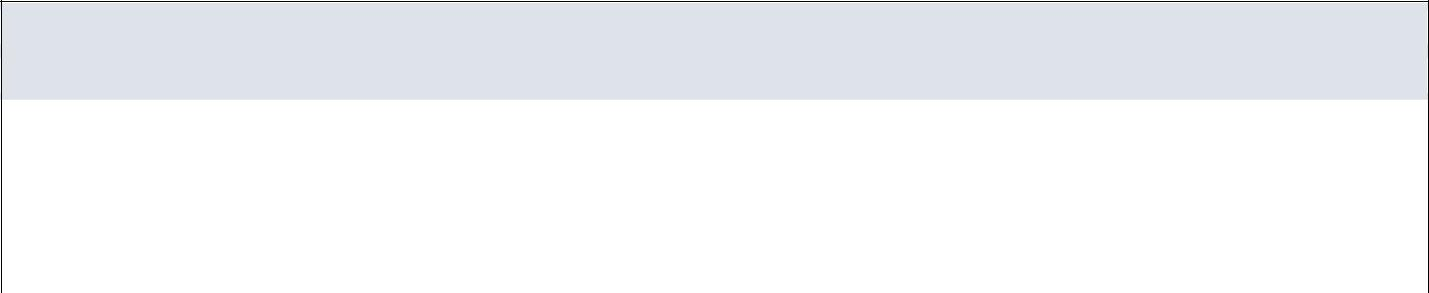

Packages

Package Description

com.xxx.pos.service This package contains all the Service Classes

com.xxx.pos.bean This package contains all the bean Classes

com.xxx.pos.dao This package contains all the DAO functionality classes

com.xxx.pos.util This package contains all the generic functionality classes

This package is used only for a standalone application.

com.xxx.pos.ui This package contains all the UI related classes [ For Core Java ]

The package for the controller class should be used as below based on the type of application
 | com.xxx.pos.listener |  | listener - core java
 |  | or
 | com.xxx.pos.servlet |  | servlet - Web Applications
 |  | or
 | com.xxx.pos.action |  | action - Struts
 |  | or
 | com.xxx.pos.controller |  | controller - Spring
 | Package com.xxx.pos.bean
 |  | Class Name |  | Attributes |  |  | Data Type
 |  |  |  | userID |  |  | String
 |  |  |  | firstName |  |  | String
 |  |  |  | lastName |  |  | String
 |  |  |  | dateOfBirth |  |  | Date
 |  |  |  | gender |  |  | String
 |  |  |  | street |  |  | String
 |  | ProfileBean |  | location |  |  | String
 |  |  |  | city |  |  | String
 |  |  |  | state |  |  | String
 |  |  |  | pincode |  |  | String
 |  |  |  | mobileNo |  |  | String
 |  |  |  | emailID |  |  | String
 |  |  |  | password |  |  | String
 | TP_DTLDS – Version 2.1 |  |  |  |  |  | Page 10 of 19

 | CredentialsBean | password |  | String
 | CredentialsBean | userType |  | String
 |  | loginStatus |  | int
 |  | storeID |  | String
 |  | name |  | String
 |  | street |  | String
 | StoreBean | mobileNo |  | String
 |  | city |  | String
 |  | state |  | String
 |  | pincode |  | String
 |  | foodID |  | String
 |  | name |  | String
 | FoodBean | type |  | String
 | FoodBean | foodSize |  | String
 |  | quantity |  | int
 |  | price |  | double
 |  | orderID |  | String
 |  | userID |  | String
 |  | orderDate |  | Date
 |  | storeID |  | String
 |  | cartID |  | int
 | OrderBean | totalPrice |  | double
 | OrderBean | orderStatus |  | String
 |  | street |  | String
 |  | city |  | String
 |  | state |  | String
 |  | pincode |  | String
 |  | mobileNo |  | String
 |  | cartID |  | int
 |  | userID |  | String
 |  | foodID |  | String
 | CartBean | type |  | String
 |  | quantity |  | int
 |  | cost |  | double
 |  | orderDate |  | Date
TP_DTLDS – Version 2.1 |  |  |  | Page 11 of 19

Detailed Design ^{POS-01/DD-2.20}

Package com.xxx.pos.service


Interface Summary

 |  | Interface |  |  | Description
 |  | Administrator |  |  | Entity class for Admin dealing with the admin process functionalities
 |  |  |  |  | Methods
 |  |  |  |  |  | String addStore(StoreBean storebean)
 |  |  |  |  |  | Return value must be either: "SUCCESS", "FAIL", “ERROR”
 |  |  |  |  |  | boolean modifyStore(StoreBean storebean)
 |  |  |  |  |  | Int removeStore(ArrayList<String> storeId)
 |  |  |  |  |  | StoreBean viewStore(String storeId)
 |  |  |  |  |  | ArrayList <StoreBean> viewAllStore()
 |  |  |  |  |  | String addFood(FoodBean foodbean)
 |  |  |  |  |  | Return value must be either: "SUCCESS", "FAIL", “ERROR”
 |  |  |  |  |  | boolean modifyFood(FoodBean foodbean)
 |  |  |  |  |  | boolean removeFood(String storeId, String foodId)
 |  |  |  |  |  | FoodBean viewFood(String foodId)
 |  |  |  |  |  | ArrayList<FoodBean> viewAllFood(String storeId)
 |  |  |  |  |  | String changeOrderStatus(String orderId)
 |  |  |  |  |  | Return value must be either: "SUCCESS", "FAIL"
 | Customer |  |  |  | Entity class of Customer for dealing with the Customer process functionalities
 |  |  |  |  | Methods
 |  |  |  |  |  | int addToCart(CartBean cartBean)
 |  |  |  |  |  | boolean modifyCart(CartBean cartBean)
 |  |  |  |  |  | String confirmOrder(OrderBean orderBean, ArrayList<CartBean> cartbean)
 |  |  |  |  |  | String cancelOrder(String orderId)
 |  |  |  |  |  | ArrayList<StoreBean> viewStore(String city)
 |  |  |  |  |  | ArrayList<CartBean> viewCart(String userid)
 |  |  |  |  |  | ArrayList <OrderBean> viewOrder()

TP_DTLDS – Version 2.1 Page 12 of 19
Detailed Design ^{POS-01/DD-2.20}

Package com.xxx.pos.dao

Find below the suggestive approach for CRUD operations [method naming & signature] for the DAO classes. Create the necessary DAO Interface/classes .
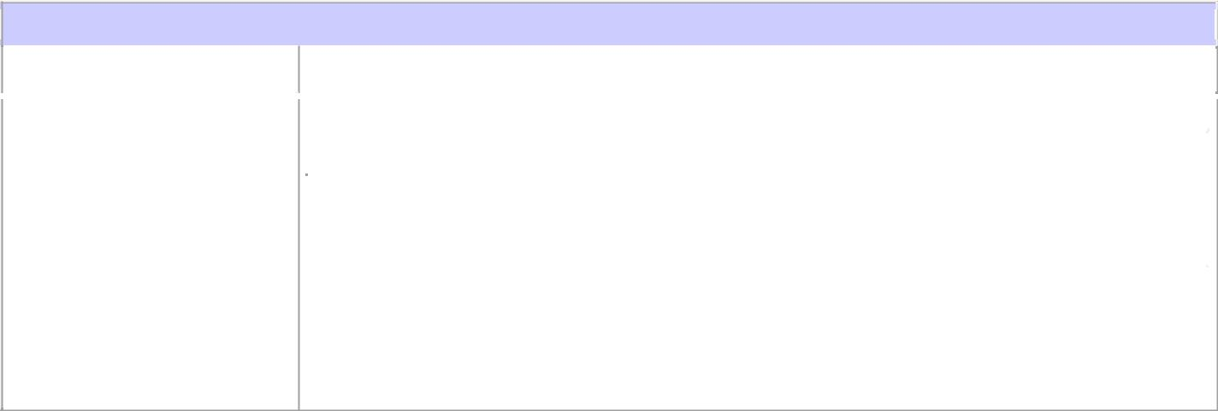

Interface/class Summary

Interface |  | Description
xyzDAO |  | DAO interface to deal with operations related to the specific table.
 |  | Method Summary
 |  | String createXYZ(BeanObject)
 |  | int deleteXYZ(ArrayList<String> )
 |  | boolean updateXYZ(BeanObject)
 |  | BeanObject findByID(String)
 |  | ArrayList<BeanObject> findAll()

- If required, additional find methods can be created.

Package com.xxx.pos.util


Interface/class Summary
 |  | Interface |  |  |  | Description
 |  | Authentication |  |  |  | This interface is responsible for performing the Authentication and Authorization process.
 |  |  |  |  |  |  | Methods
 |  |  |  |  |  |  | boolean authenticate(CredentialsBean credentialsBean)
 |  |  |  |  |  |  | String authorize(String userId)
 |  |  |  |  |  |  | boolean changeLoginStatus(CredentialsBean credentialsBean, int loginStatus)
 |  | DBUtil |  |  |  | This interface is responsible for the Database connection establishment.
 |  |  |  |  |  |  | Methods
 |  |  |  |  |  |  | static Connection getDBConnection(String driverType)
 |  | User |  |  |  | Interface for handling different types of users
 |  |  |  |  |  |  | Methods
 |  |  |  |  |  |  | String login(CredentialsBean credentialsBean)
 |  |  |  |  |  |  | Return value must be either: "A", "C", "FAIL", “INVALID”
 |  |  |  |  |  |  | A->Admin, C->Customer
 |  |  |  |  |  |  | Wrong username/password should return INVALID.
 |  |  |  |  |  |  | boolean logout(String userId)
 |  |  |  |  |  |  | String changePassword(CredentialsBean credentialsBean, String newPassword)
 |  |  |  |  |  |  | Return value must be either: "SUCCESS", "FAIL", “INVALID”
 |  |  |  |  |  |  | String register(ProfileBean profileBean)
 |  |  |  |  |  |  | Return value must be either: <userId of lenght 6>, "FAIL"
 |  |  |  |  |  |  | Note: userId-> first 2 letter of first name followed by 4 digit auto generated number
 |  | TP_DTLDS – Version 2.1 |  |  |  |  |  |  | Page 13 of 19

Detailed Design ^{POS-01/DD-2.20}
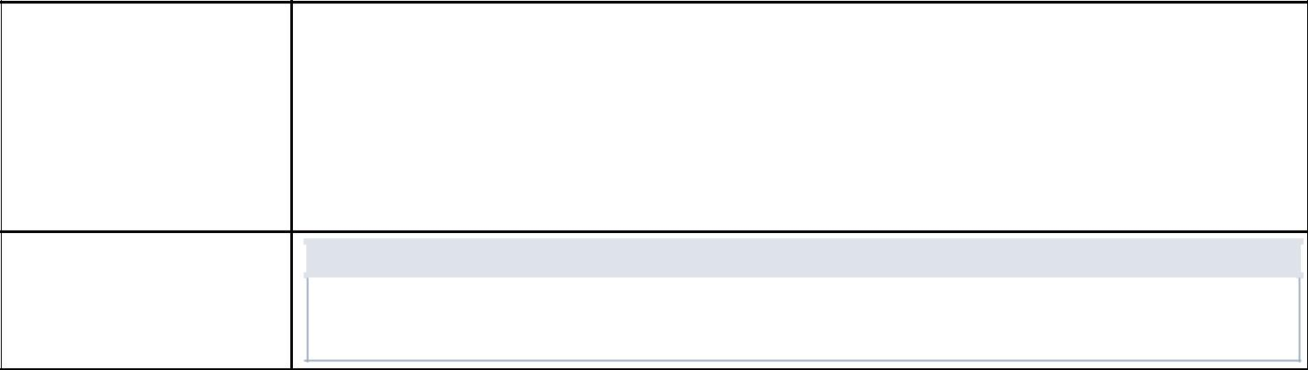

Interface for handling payment related information
Payment

String creditCardNumber, validFrom, validTo
int balance

Methods

boolean findByCardNumber(String userid, String cardnumber)

String process(Payment payment)

3.6 UI Templates

3.6.1 UI Principle

The UI [ Presentation Layer ] should be designed with the below mentioned principles which helps easy interaction by the user to the application.

3.6.2 UI controls and Usage Principle
Provides the information on UI Controls, which type of control should be used when and where.

UI Type | Controls | Description
Direct Entry | Text Box, Text Area | Any input that cannot be predicted and needs the
 |  | user to key in. e.g. Name, Street, contact no etc.
Static Selection | Option Button, Check Box, | Should be used where the input can be
 | Drop Down | predefined.
 |  | e.g. gender, month [ Jan – Dec ] etc. If number of
 |  | items is more, drop down is preferred.
Dynamic Selection | Drop Down | The items for the drop down should be retrieved
 |  | from a stored data. e.g. Displaying BranchId in a
 |  | drop down from branch table.
Automation | Label | Data that are calculative or an output of a
 | Text Field [Read Only] | function. e.g. : Displaying system date, showing
 |  | total amount etc.
Decision Control | Button | Operations like submit, save, clear should be
 |  | executed only upon clicking respective buttons.

TP_DTLDS – Version 2.1 Page 14 of 19
Detailed Design ^{POS-01/DD-2.20}

3.6.3 UI Template

This section contains the design template for the website home page [Fig. 1] that will be displayed at the time of opening this web application and Actor specific home page [Fig. 2].

<logo> | < Project Title >

About Us Contact Us
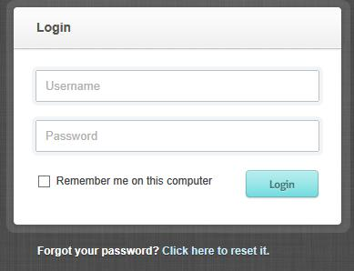

< General Info >

Copyright © 2013 Xxx Technologies. All rights reserved

Fig. 1 - Main Page [ First Page to open ]

<logo> |  |  |  |  | < Project Title >
< Logged in Name > |  |  |  |  | Home | Logout
<Navigation Links>
<Navigation Links>
 |  |  |  |  | < Page based on the navigation link selected>
<Navigation Links> |  |  |  |  | < Page based on the navigation link selected>
<Navigation Links>
<Navigation Links>
<Navigation Links>
 |  |  |  | Copyright © 2013 Xxx Technologies. All rights reserved
 |  |  |  | Fig. 2 - Home Page for Actor
 | TP_DTLDS – Version 2.1 |  |  | Page 15 of 19

Detailed Design ^{POS-01/DD-2.20}

 | <logo> |  |  |  | < Project Title >
 | < Logged in Name > |  |  |  |  |  |  | Home |  |  |  | Logout
 | < Title for the View Screen >
 | <Col Head> |  | <Col Head> | <Col Head> | <Col Head> | <Col Head> | <Col Head>
 |  |  |  |  |  |  |  |  | Edit |  |  | Delete
 |  |  |  |  |  |  |  |  | Edit |  |  | Delete
 |  |  |  |  |  |  |  |  | Edit |  |  | Delete
 |  |  |  |  |  |  |  |  | Edit |  |  | Delete
 |  |  |  |  |  |  |  |  | Edit |  |  | Delete
 |  |  |  |  |  |  |  |  | Edit |  |  | Delete
 |  |  |  |  |  |  |  |  | Edit |  |  | Delete

Copyright © 2013 Xxx Technologies. All rights reserved

Fig. 3 – View Screen with Edit and Delete Functionality

4. Critical Functions and Focus for Testing

Authorization & Authentication are the critical functions need to be implemented before performing the tasks.

- Limitations

  - The scope of the application is limited to only one country.

  - Users should be registered or logged in for performing Order related operations.

  - Customer’s credit card details have to be already entered in the database.

  - The number of administrators is limited to 2.

TP_DTLDS – Version 2.1 Page 16 of 19
Detailed Design ^{POS-01/DD-2.20}

6. APPENDIX

1 Table: POS_TBL_User_Profile

This table contains User specific details entered during User Registration.

Field Name | Data Type | Description
Userid | VARCHAR2(6) | Auto-Generated, Primary Key*
Firstname | VARCHAR2(20) | Not Null
Lastname | VARCHAR2(20) | Not Null
DateOfBirth | DATE | Not Null
Gender | VARCHAR2(7) | Not Null
Street | VARCHAR2(30) | Not Null
Location | VARCHAR2(20) | Not Null
City | VARCHAR2(20) | Not Null
State | VARCHAR2(20) | Not Null
PinCode | VARCHAR2(10)
MobileNo | VARCHAR2(10) | Exact 10 digit only
EmailId | VARCHAR2(30) | Not Null
* First 2 letters of First Name followed by 4 digits auto generated number

2 Table: POS_TBL_User_Credentials

This table contains Authentication Information for Administrator and Customer

 | Field Name |  | Data Type |  |  | Description
 | Userid | VARCHAR2(6) |  |  |  | Primary Key
 | Password | VARCHAR2(20) |  |  |  | Not Null
 | Usertype | VARCHAR2(15) |  |  |  | Either ['A','C']
 | Loginstatus | NUMBER(1) |  |  |  | Either[1 ,0]
3 Table: POS_TBL_PizzaStore
 | This table contains Pizza Store information added by the Admin.
 | Field Name |  | Data Type |  |  | Description
 | StoreId |  | VARCHAR2(6) |  |  | Primary Key, Auto Generated*
 | Name |  | VARCHAR2(15) |  |  | Not Null
 | Street |  | VARCHAR2(50) |  |  | Not Null
 | MobileNo |  | VARCHAR2(10) |  |  | Must be 10-digit exactly
 | City |  | VARCHAR2(15) |  |  | Not Null
 | State |  | VARCHAR2(15) |  |  | Not Null
 | Pincode |  | VARCHAR2(10)

* First 2 letters of Store name followed by 4 digits auto generated number

TP_DTLDS – Version 2.1 Page 17 of 19
 | This table contains Food Item details as defined below.
 | Field Name | Data Type | Description
 | FoodId | VARCHAR(6) | Primary Key, Auto
 |  |  | Generated**
 | Name | VARCHAR(20) | Not Null
 | Type | VARCHAR2(10) | Either [Veg | Non-Veg]
 | FoodSize | VARCHAR2(15) | Either [Small | Medium | Large]
 | Quantity | NUMBER | Not Null
 | Price | NUMBER | Not Null
** First 2 letters of Food name followed by 4 digits auto generated number

5 Table: POS_TBL_Order

This table contains Order details provided by the customer.
 | Field Name | Data Type | Description
 | OrderId | VARCHAR2(6) | Primary Key
 | Userid | VARCHAR2(6) | FK
 | OrderDate | DATE | Sysdate
 | StoreId | VARCHAR2(6) | FK
 | TotalPrice | NUMBER | Not Null, >0
 | OrderStatus | VARCHAR(15) | Confirmed, Delivered,
 |  |  | Pending, Cancelled
 | cartId | NUMBER
 | Street | VARCHAR(50) | Not Null
 | City | VARCHAR(15) | Not Null
 | State | VARCHAR(15) | Not Null
 | PinCode | VARCHAR(10)
 | MobileNo | VARCHAR(10)
6 Table: POS_TBL_Cart
 | This table contains cart details added by the customer.
 | Field Name | Data Type | Description
 | CartId | NUMBER
 | UserId | VARCHAR2(6) | FK
 | FoodId | VARCHAR2(6) | FK
 | Type | VARCHAR2(10) | Not Null [Veg | Non Veg]
 | quantity | NUMBER | Not Null, >0
 | Cost | NUMBER | Not Null
 | OrderDate | Date
TP_DTLDS – Version 2.1 |  |  | Page 18 of 19

Detailed Design ^{POS-01/DD-2.20}

7 Table: POS_TBL_CreditCard

This table contains CreditCard details of the user for ticket reservation.

 | Field Name | Data Type |  | Description
 | CreditCardNumber | VARCHAR2(16) |  | Primary Key
 | ValidFrom | VARCHAR2(7) |  | Not Null
 | ValidTo | VARCHAR2(7) |  | Not Null
 | Balance | NUMBER |  | Not Null
 | userId | VARCHAR2(6)
Database Sequences
 | Sequence Name | Purpose |  | Start With
 | pos_seq_userid | User ID |  | 1000
 | pos_seq_storeId | Store ID |  | 1000
 | pos_seq_foodId | Food ID |  | 1000
 | pos_seq_orderId | Order ID |  | 1000
 | pos_seq_cartId | Cart ID |  | 1000

TP_DTLDS – Version 2.1 Page 19 of 19

