**REPORT**

BINARY CODED GENETIC ALGORITHM

SUBMITTED BY

**RAKESH KIRAN**

**204103325**

**PROBLEM DEFINITION**

To develop a generalized computer program for a binary-coded GA with Roulette-wheel reproduction scheme, two point crossover and bit-wise mutation to optimize the following objective function.

Minimize $f\left(x1 , x2\right) = x_{1}+ x_{2}-2x_{1}^{2}- x_{2}^{2}+ x_{1}x_{2} ;$

in the range of

$$0.0≤ x_{1}, x_{2}≤0.5$$

* **PARAMETERS USED :**

1. N - Population size ( from user )
2. Pc - Crossover probability ( from user)
3. Pm - Mutation probability ( from user)
4. n - Number of variables , 2
5. nb - Number of bits for each variable , 20
6. Xmax - Maximum value of x , 0.5
7. Xmin - Minimum value of x , 0.0
8. Gn_max - Maximum number of generations , 70
9. Objective function -- $\frac{1}{( 1+ f\left(x_{1},x_{2}\right) )}$

$$f\left(x_{1}, x_{2}\right) ≠ -1$$

This is to change the given minimization problem to maximization problem because GA works well for maximization problem

* **RESULTS OBTAINED**

1. avg_fit - array average fitness value of mating pool in each generation.
2. max_fit - array maximum fitness value of mating pool in each generation.
3. min_fit - array minimum fitness value of mating pool in each generation.
4. sol - The binary strings of solution after Gn_max generations.
5. max_x – The values of x (x1,x2) which gives the maximum fitness value in each generation , from which the optimal solution of the problem is obtained.

* **CALCULATION FOR NUMBER OF BITS CHOSEN:**

Length of sub-string = nb = log2( )

e - smallest possible division = 10-5

nb = 18.9 .

Therefore choosing number of bits of each variable = nb = 20.

* **PLOTS MADE WITH FOLLOWING PARAMETERS**
* N – Population size = 1000
* Pc - Crossover probability = 0.9
* Pm - Mutation probability = 0.1
* Gn_max – Max. No. of generation = 70
* **PLOTS INCLUDED**

1. Average fitness value vs number of generation
2. Maximum fitness value vs number of iteration
3. Minimum fitness value vs number of iteration
4. Optimum solution vs number of iterations

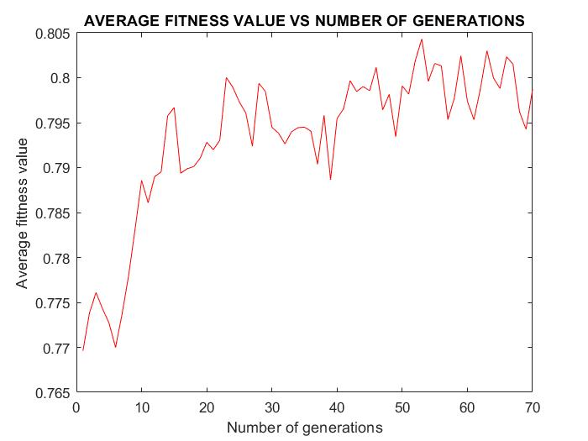

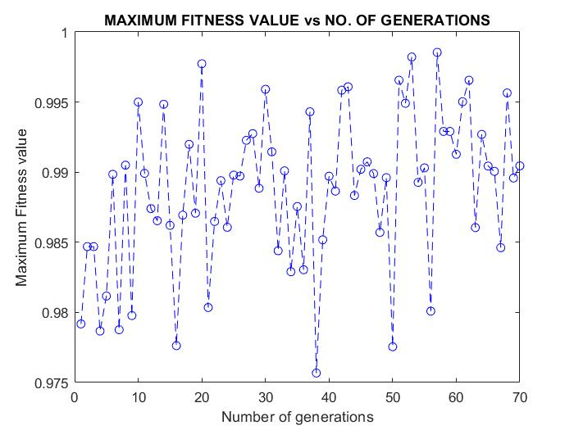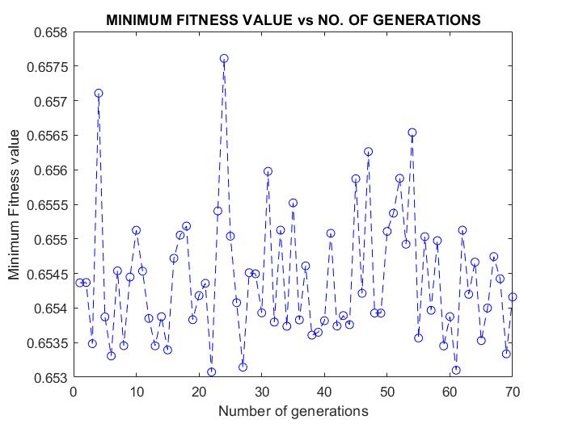

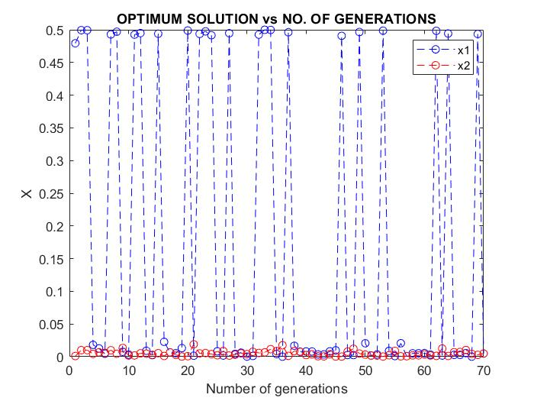

**RESULT**

* From the array “ max_x “ storing values of ( x1 , x2 ) after each generation having the maximum value of fitness. All the value were either nearly equal to ( 0.5 , 0 ) or ( 0 , 0 ). So we conclude these as the optimal solution of the given minimization problem obtained from the binary coded GA.
* Therefore the minimum value of function given in the problem is

$f\left(x_{1} , x_{2} \right)= f\left(0.5 , 0 \right)= f\left(0 , 0 \right)$ = 0

* The average fitness value increases from 0.77 at initial generations towards 0.81 as the number of generations increases.
* The minimum fitness value in each iteration varies between 0.653 and 0.66.
* The maximum fitness value in each iteration varies between 0.97 and 1.

**CONCLUSIONS**

* The average fitness value is increasing with increasing generations which implies that the algorithm is working fine.
* The optimal solution is converging towards optimal solutions (0,0) and (0.5,0) as both the solutions gives the minimum function value zero.
* The randomness in the plots obtained can be attributed probability involved in selection, crossover and mutation.
* It can be seen for same parameters if we increase the mutation probability the randomness in average fitness value increases many folds.
* And if we continue to more generations the average fitness value may decrease.
* With increasing the population size the accuracy of the optimum solutions obtained increases.
* It can be observed that the ranges of x1 and x2 values are very small 0.5 , therefore there is not much difference between the function fitness value obtained as a result the algorithm finds it difficult to differentiate between various solutions in the mating pool.
* It can be concluded that the solutions obtained is dependent on the parameters used like probabilities , population size , number of generations etc , so it is very important choose the appropriate parameters for a given problem.