NAT-INSTANCE SETUP

### METHOD - 1

1. AMI- Amazon-ami-nat-hvm (NAT-supported Ami)

* Should be in Public subnet
* Enable public ip (or should have a Elastic Ip attached)
* Security group with private subnet cidr restrictions

2. Disable src/des check to enable nat instance

3. Add nat instance under private route table Associations

### METHOD - 2

1. AMI- Amazon-ami-nat-hvm (NAT-supported Ami)

* Should be in Public subnet
* Enable public ip (or should have a Elastic Ip attached)
* Security group with private subnet cidr restrictions

2. SSH into the Instance/Userdata

Change/Adjust the private subnet based on your architect ip

* sysctl -w net.ipv4.ip_forward=1
* /sbin/iptables -t nat -A POSTROUTING -o eth0 -j MASQUERAD

(Or)

* vi /etc/sysctl.conf

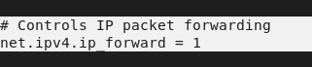

* sudo iptables -t nat -A POSTROUTING -o eth0 -s <Private_Ip_Cidr> -j MASQUERADE



* To verify

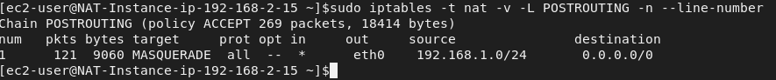

3. Disable src/des check to enable nat instance

4. Add nat instance under private route table Associations