CareNest HIMS
How to run the project on your laptop
Module 1 — Doctor ⇄ Nurse case flow · React + Node.js + MySQL
This guide takes you from a fresh Windows or macOS laptop to a working clinic system with demo data, in about 20 minutes. No prior coding experience is assumed — every command is given exactly as you type it.
Prepared 6 October 2026

Contents

(If the contents list looks empty, right-click it in Word and choose “Update Field”.)

1. What you are setting up
The project has three parts that run together on your laptop:
Part | Technology | What it does
Database | MySQL 8 | Stores clinics, staff, patients, visits, prescriptions, lab orders and accounts.
Backend (API) | Node.js + Express | Business rules, logins, the live nurse ⇄ doctor channel. Runs on port 4000.
Frontend (web app) | React + Vite + Tailwind | The screens doctors, nurses and patients use. Runs on port 5173.

Folder layout of the project:
HIMS/
├── server/ API, schema.sql, demo data
├── client/ React web app
├── docs/ This guide
├── dev.js Starts API + web app
└── package.json Shortcut commands

2. Install the prerequisites (one time)

2.1 Node.js (version 20 or newer)
- Go to https://nodejs.org and download the LTS installer (version 22 recommended).
- Run the installer and accept the defaults.
- Open a new terminal (Windows: “Command Prompt” or “PowerShell”; macOS: “Terminal”) and check:
node -v
npm -v
You should see v20.x or higher, and an npm version number.

2.2 MySQL Server 8
Windows: download “MySQL Installer for Windows” from https://dev.mysql.com/downloads/installer/. Choose “Server only”, keep port 3306, select “Use Strong Password Encryption”, and set a root password you will remember.
macOS: either download the DMG from https://dev.mysql.com/downloads/mysql/ or, with Homebrew:
brew install mysql
brew services start mysql
mysql_secure_installation # set the root password
Check that MySQL is running:
mysql -u root -p -e "SELECT VERSION();"
Enter your root password. You should see a version like 8.0.x. MariaDB 10.6+ also works.
Tip: Optionally install MySQL Workbench to browse the tables visually. It is not required.

2.3 Git and a code editor (recommended)
- Git: https://git-scm.com/downloads — used to download the project.
- Visual Studio Code: https://code.visualstudio.com — to read or change the code.

3. Get the code
In your terminal, go to the folder where you keep projects and run:
git clone https://github.com/rakeshkumar-369/HIMS.git
cd HIMS
This downloads the main branch.
If the code you want is still on a separate branch (not yet merged into main), open the repository on GitHub, click the branch selector to see its name, and switch to it:
git checkout <branch-name>
No Git? On GitHub, open the repository, switch to the branch above, click “Code → Download ZIP”, unzip it, and open a terminal inside the unzipped HIMS folder.

4. Install the project packages
From inside the HIMS folder:
npm run setup
Downloads all libraries for the server and the client. Takes 1–3 minutes the first time.

5. Connect the project to MySQL
- Copy the example settings file:
Windows: copy server\.env.example server\.env
macOS: cp server/.env.example server/.env
- Open server/.env in VS Code or Notepad and fill in your values:
Setting | Example | Meaning
PORT | 4000 | Port of the API. Leave as is.
JWT_SECRET | (filled by npm run secret) | Secret that signs logins. Leave it empty here — the next step fills it.
CLIENT_ORIGIN | http://localhost:5173 | Address of the web app. Leave as is.
ALLOW_SELF_SIGNUP | false | Keep false: doctor accounts are created by your team in the admin console.
DB_HOST | 127.0.0.1 | Where MySQL runs (your own laptop).
DB_PORT | 3306 | MySQL port.
DB_USER | root | MySQL user name.
DB_PASSWORD | (your password) | The root password you set while installing MySQL.
DB_NAME | carenest_hims | Database name. It is created automatically.

- Create a strong random secret for signing logins (one time):
npm run secret
Writes a 96-character random JWT_SECRET into server/.env. Without it, everyone is signed out whenever the server restarts.
- Create the database, tables and demo data:
npm run db:reset
Creates the database, applies server/db/schema.sql and loads a year of realistic demo data (2 clinics, ~3,000 patients, ~5,300 visits).
Important: db:reset deletes and recreates all tables. Use it for demos only. For real clinic use, run it once (or run “npm run db:setup” for empty tables) and never again — see section 9 for backups.

6. Start the application
npm run dev
Starts the API (green [api] lines) and the web app (purple [web] lines). Keep this window open; press Ctrl + C to stop.
Now open http://localhost:5173 in Chrome, Edge or Safari.

6.1 Demo logins
Who | Login | Password
Platform admin (your team) | admin@carenest.app | Admin@123
Doctor (owns both clinics) | doctor@demo.com | Demo@123
Nurse — Sunrise Family Clinic | nurse@demo.com | Demo@123
Nurse — Green Valley Health Centre | nurse2@demo.com | Demo@123
Patient portal | Case ID 100200300 | Mobile 9000000001

The login page also has one-click “Try the demo” buttons. The patient portal is reached from “I’m a patient — open my case sheet”.
Note: Today’s demo queue is created for the date on which you ran “npm run db:reset”. On a later day, run it again to get a fresh queue.

6.2 Open it on the doctor’s phone (same Wi-Fi)
- Stop the app (Ctrl + C) and start it in LAN mode:
npm run dev:lan
- The [web] lines show a “Network” address such as http://192.168.1.20:5173. Open that address on the phone.
- Allow Node.js through the Windows / macOS firewall if asked.

6.3 Use it like an app on phones and tablets
The whole system is designed for phones too. At the bottom of the screen there is a menu: Today · Patients · ＋ New case (the big round button) · Consult · More. “More” opens every other screen (Insights, Accounts, Clinics, Settings), light/dark mode and Sign out.
- Consult room on a phone: switch between “Patient & history” and “Consultation”. Tap “Start consultation”, fill in the notes, and tap “Complete” at the bottom.
- Visit history on a phone: tap any date to open that visit full-screen; use the arrows for the previous/next visit and “← All visits” to go back.
Install as an app (works best with the production build, section 8):
- Android (Chrome / Edge): open the address, sign in, tap More → “Install the app”.
- iPhone / iPad (Safari): open the address, tap the Share button, then “Add to Home Screen”.
CareNest then opens full-screen from its own icon. Patient information is never saved on the phone — it always comes fresh from the clinic server.

7. A two-minute tour
Try the complete flow with two browser windows side by side — one signed in as the nurse, one as the doctor (use a private/incognito window for the second login).
- Nurse → New case. Enter name, gender and age, tap complaints and known conditions, type vitals (abnormal values turn red), then “Register & add to queue” (or Ctrl + Enter). A unique 9-digit Case ID is generated.
- Nurse → Today. The patient appears in the queue. When the patient walks in, tap “Display to doctor”.
- Doctor → Consult room. The case appears instantly with vitals, complaints and history. Record observations, diagnosis, lab tests (tap chips), medicines (frequent ones auto-fill dose and duration; “Repeat last” copies the previous prescription), advice, next visit and fee. The yellow private note is for the doctor only.
- Doctor → Complete & send out. The nurse’s Today screen moves the patient to “Seen & ready to hand over”.
- Nurse → Print. Prints the A4 case sheet with the clinic letterhead, or tap “PDF” to save it as a file. The private note never appears on it.
- No nurse today? The doctor can register patients and use “Call in” / “Call next” directly.
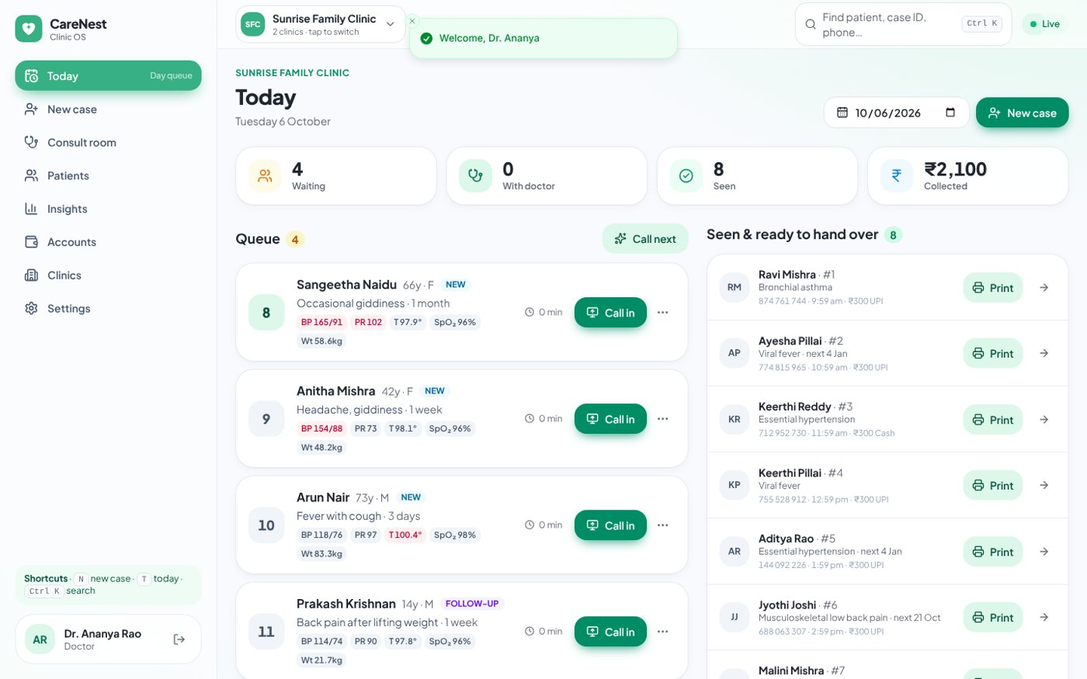
Today — the live day queue
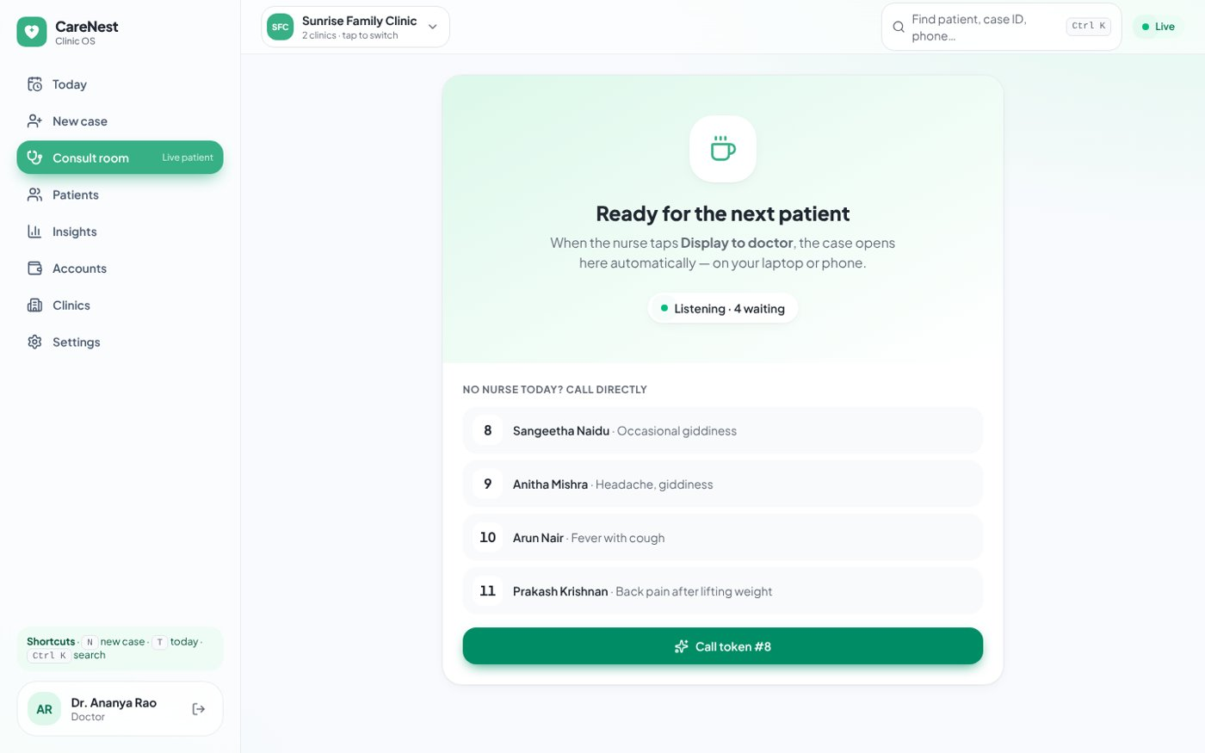
Consult room — waiting for the nurse to display the next case (the case opens here automatically)
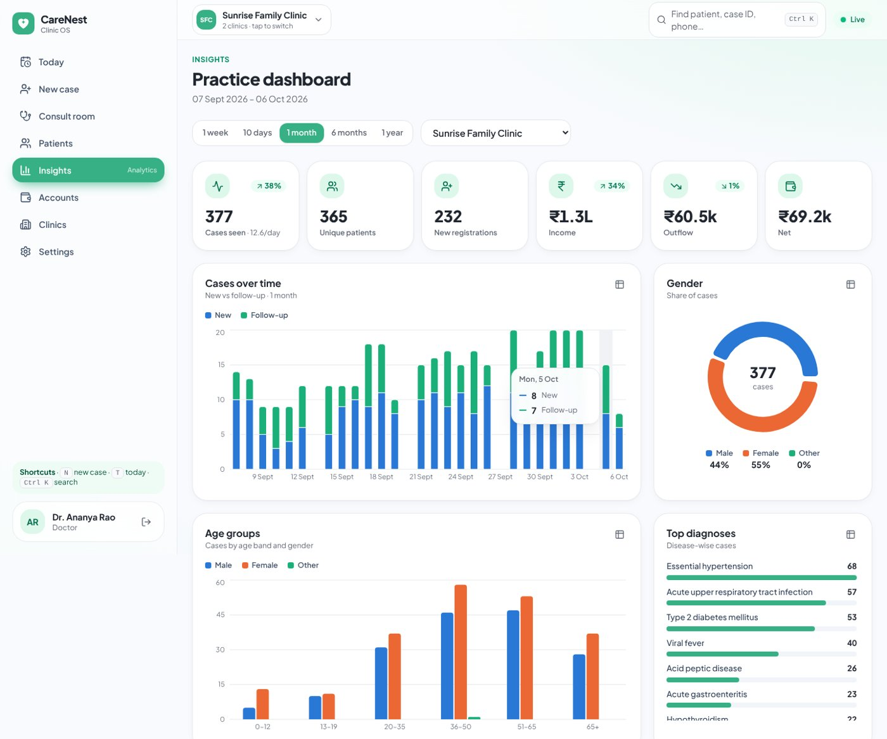
Insights dashboard
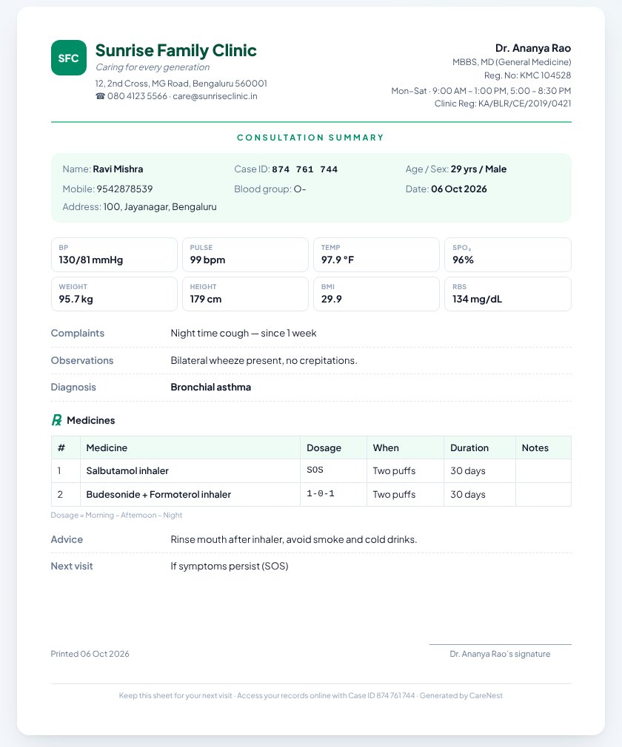
A4 consultation summary handed to the patient

7.1 Other screens
- Patients: search by name, Case ID or mobile; open the case file with visit history and BP/weight trends; “Add to today’s queue” for follow-ups; print the complete record.
- Insights: choose 1 week, 10 days, 1 month, 6 months or 1 year, per clinic or all clinics. Every chart has a table view (grid icon).
- Accounts: consultation fees are added automatically; record rent, salaries, supplies and other income in two taps.
- Clinics: add clinics (unique names), edit letterhead details and fee, add nurses/doctors, and pick a colour theme per clinic.
- Case ID across clinics: a patient registered at one of your clinics can be found at your other clinics by typing their 9-digit Case ID in the search (Ctrl + K). Their full history comes along.
- Download PDF: every case sheet has a “PDF” button that saves a real A4 PDF file — on laptops and phones. In the patient portal, “Download full case sheet” saves the complete record as a PDF.
- Dark mode: tap the sun/moon icon in the top bar (Light → Dark → Same as device), or choose it in Settings. Printed sheets and PDFs always stay white.
- Visit history: on the case file every visit is one line (newest first, grouped by year). Click any date — or use the ↑ / ↓ keys — to see that entire visit: vitals, complaints, diagnosis, medicines, tests, advice and next visit. In the consult room, click any previous visit to open the same history browser; “Repeat Rx” copies that prescription.
- Shortcuts: N = new case, T = today, Ctrl + K = find patient.

7.2 Platform admin console (for your team)
Sign in as admin@carenest.app. The admin console is where you set up doctors — doctors no longer sign themselves up.
- New doctor: enter the profile (name, email, mobile, qualification, registration no., specialisation), address, how many clinics the doctor may own, and optionally create the clinics right away.
- Password: a strong temporary password is generated (you can type your own). Share it privately. At first sign-in the doctor must set their own password.
- Doctors list: search, open a doctor to edit details, raise the clinic limit, add a clinic, reset the password, unlock after failed attempts, or deactivate the account (signs them out everywhere).
- Security log: every sign-in, failed attempt, password change, case file opened and admin action, with time and IP address.
Replace the demo admin: before real use, create your own admin with “npm run admin:create -- --email you@yourcompany.com --name "Your Name" --password "AStrongPass2026"”, then start from an empty database (npm run db:setup).

8. Running it for daily use
For everyday use at the clinic, run the optimised production build — one window, one address:
npm run build
npm start
Then open http://localhost:4000 (or http://<laptop-IP>:4000 from other devices on the same Wi-Fi).
To start for real instead of the demo: run “npm run db:setup” (empty tables), create your admin with “npm run admin:create”, sign in as admin and create the doctor accounts.
Security: for use over the internet, always run behind HTTPS (for example nginx with a free Let’s Encrypt certificate), set NODE_ENV=production and TRUST_PROXY=1 in server/.env, and read docs/SECURITY-AUDIT.md — it includes the go-live checklist.

9. Backing up your data
All data lives in the MySQL database. Take a backup at the end of each day:
mysqldump -u root -p carenest_hims > carenest-backup-2026-10-06.sql
Keep copies on a USB drive or cloud folder.
To restore a backup:
mysql -u root -p carenest_hims < carenest-backup-2026-10-06.sql

10. Troubleshooting
What you see | Fix
“Database is not reachable — is MySQL running?” | Start MySQL (Windows: Services → MySQL80 → Start; macOS: brew services start mysql) and check DB_HOST/DB_PORT in server/.env.
“Access denied for user 'root'” | DB_PASSWORD in server/.env does not match your MySQL password.
“Cannot reach the server. Is the backend running?” | The API is not running. Run “npm run dev” from the HIMS folder and look for errors in the [api] lines.
“EADDRINUSE: address already in use :::4000” (or 5173) | Another copy is already running. Close other terminals, or change PORT in server/.env.
Today’s queue is empty in the demo | The demo day is the day you seeded. Run “npm run db:reset” again.
“npm is not recognized” | Node.js is not installed or the terminal was opened before installing. Reinstall Node.js and open a new terminal.
Doctor’s screen does not update live | Check the “Live” pill in the top bar. If it says Offline, refresh the page; make sure both devices use the same address.
Phone cannot open the Network address | Use “npm run dev:lan”, keep both devices on the same Wi-Fi and allow Node.js in the firewall.
“Account temporarily locked” | Five wrong passwords lock an account for 15 minutes. Wait, or an admin can press Unlock on the doctor’s page.
Asked to “Set your own password” | Normal at first sign-in with a password given by the admin or a doctor. Choose a new one with letters and numbers (8+ characters).
Signed out after restarting the server | Run “npm run secret” once so the login secret is saved in server/.env.
Server says “JWT_SECRET must be set” and stops | You are in production mode without a secret. Run “npm run secret”.

11. Useful commands
Command | What it does
npm run setup | Install all packages (server + client).
npm run dev | Start API + web app for development (http://localhost:5173).
npm run dev:lan | Same, and reachable from phones on your Wi-Fi.
npm run db:setup | Create the database and empty tables.
npm run db:reset | Recreate tables and load demo data (erases existing data).
npm run secret | Generate a strong login secret in server/.env.
npm run admin:create -- --email … --password … | Create or reset a platform admin account.
npm run lint | Check the code for problems (server + client).
npm run build | Create the optimised web app.
npm start | Serve the built app + API on http://localhost:4000.

