* **Install Power BI Desktop and share the final screenshot of the report view page which appears when power desktop starts.**

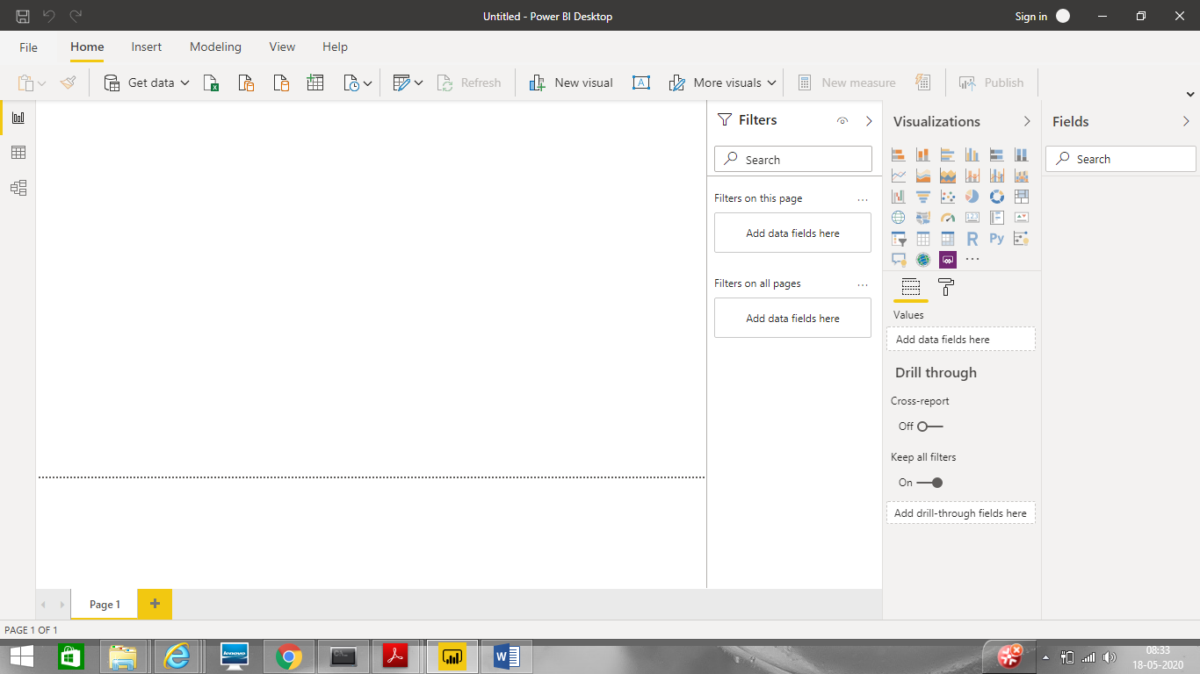

* Prepare a document and with the following screenshot

1. Report View



1. Data View

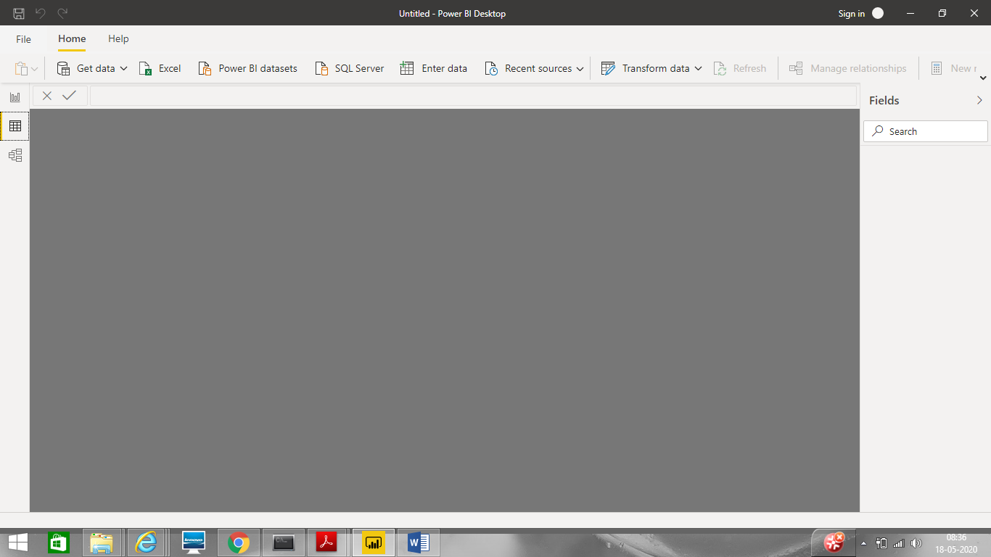

1. Model View

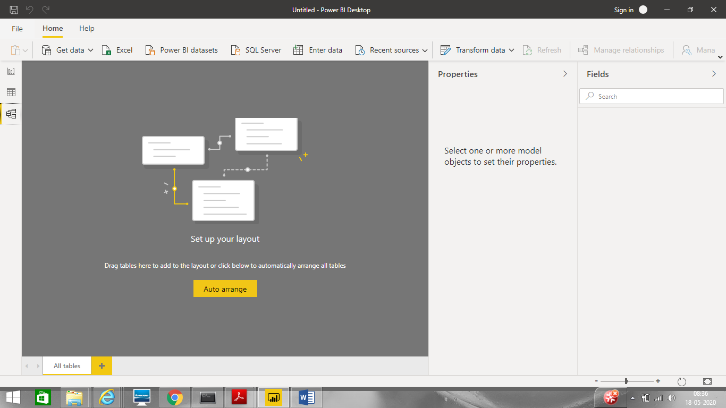

1. Power Query Editor

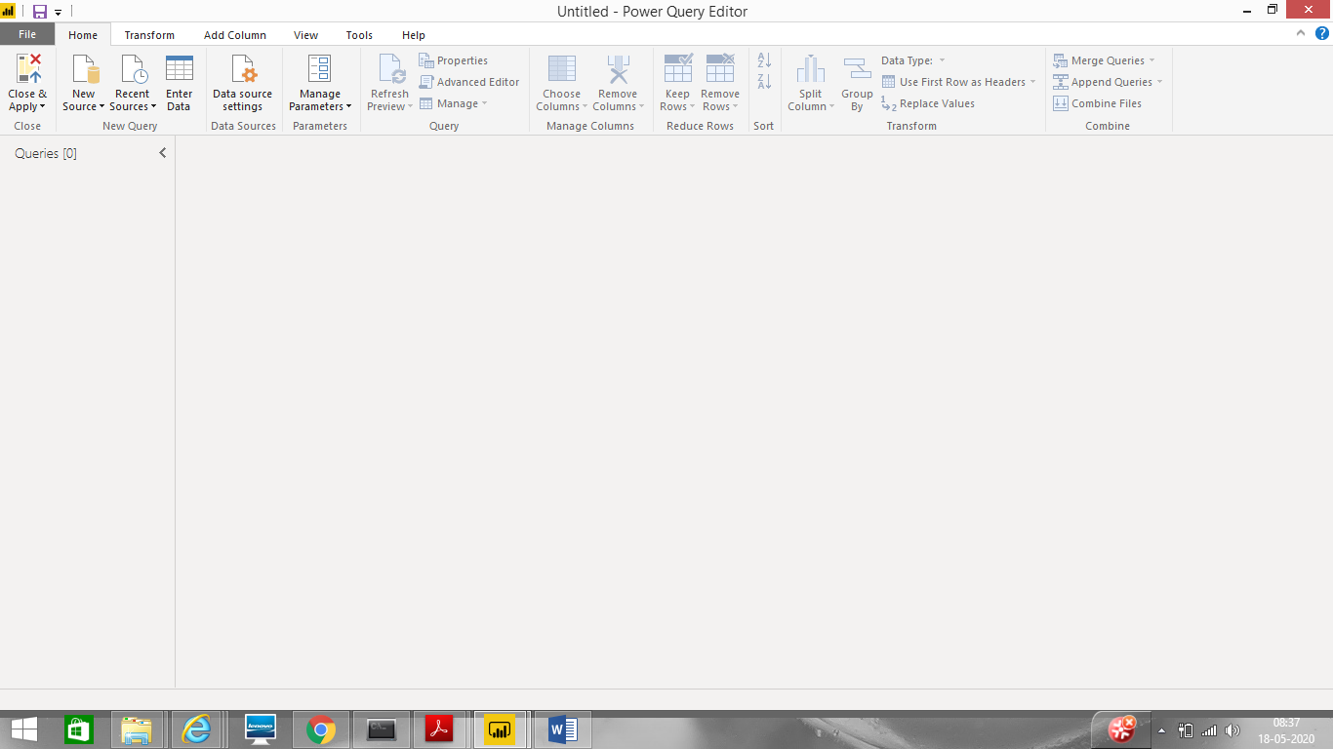

1. Advance Editor

* Prepare a document with details of the following along with their price

1. Power BI Desktop
2. Power BI Pro - $9.99 Monthly price per user
3. Power BI Premium - $4,995 Monthly price per dedicated cloud compute and storage resource with an annual subscription