Flyrock Distance Prediction using MOO + PSO + Hybrid ANN

In this project as per your instruction we have MOO optimization algorithm from python PYMOO library to optimize features and then applied PSO + SVM algorithm to select relevant features and this selected features will get trained with ANN algorithm to predict Flyrock distance.

All process applied on your given dataset and then ANN algorithm performance is evaluated in terms of Mean Square Error (MSE) and R2square. MSE refers to difference between true values and predicted values so the lower the difference the better is the algorithm. R2square refers as accuracy of the algorithm the higher the R2square the better is the algorithm.

In below screen we are showing code for all steps

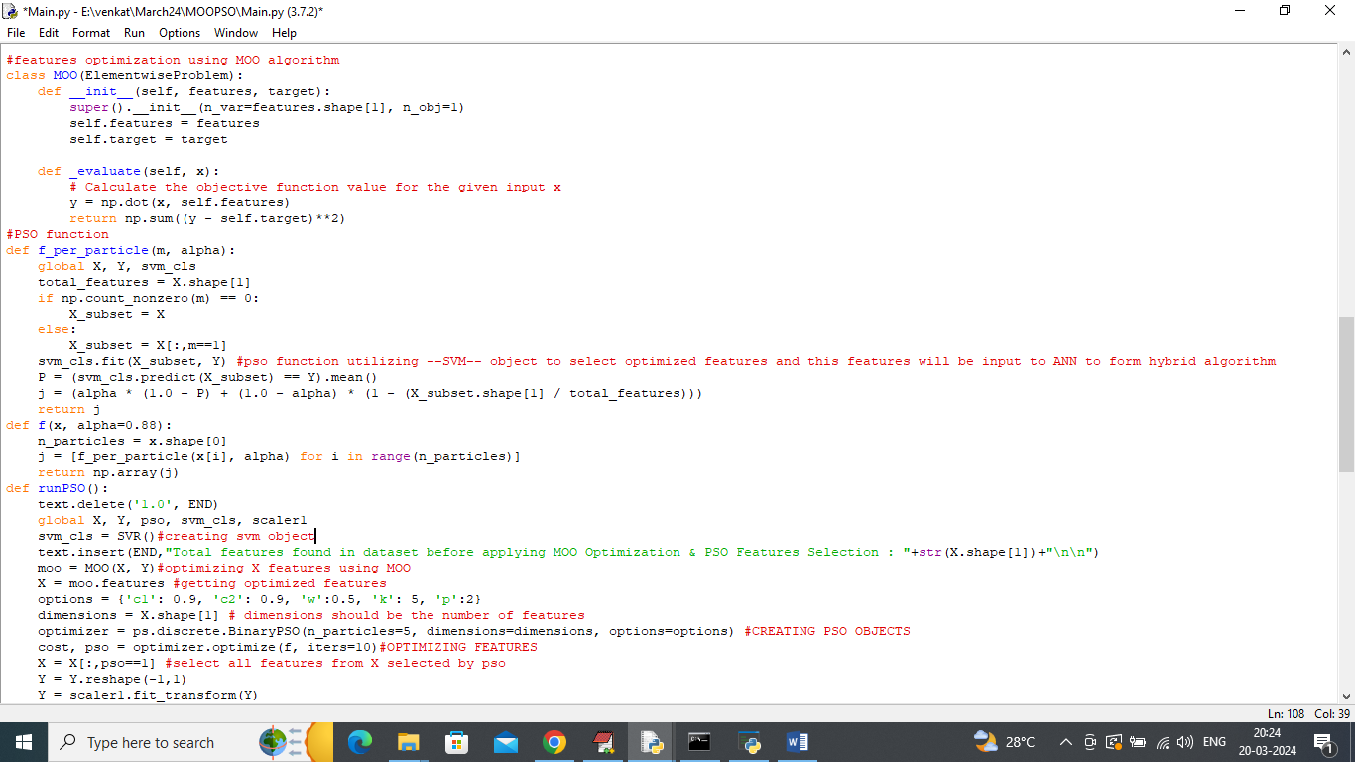

In above screen read red colour comments to know about MOO + PSO and SVM implementation and the features selected by all 3 algorithm will be input to ANN algorithm to form a Hybrid ANN algorithm.

To implement this project we have designed following modules

1. Upload Flyrock Dataset: using this module will upload dataset to application
2. Preprocess Dataset: using this module will remove missing values and then clean and normalize dataset values
3. MOO Optimization & PSO + SVM Features Selection: using this module will apply MOO + PSO + SVM to optimize and select relevant features
4. Run Hybrid ANN Using PSO + SVM Features: optimize PSO + SVM selected features will be input to ANN algorithm to train a model and this model will be applied on test data to calculate MSE and R2square values.

SCREEN SHOTS

To run project double click on run.bat file to get below screen

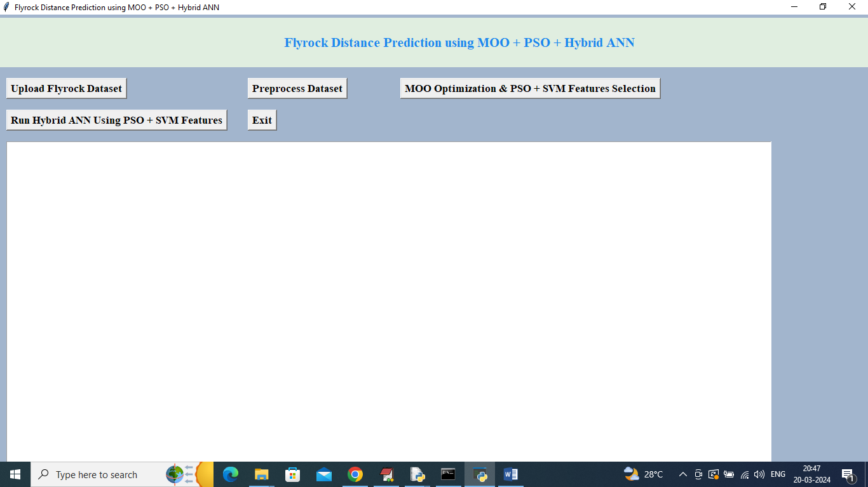

In above screen click on ‘Upload Flyrock Dataset’ button to upload dataset and get below page

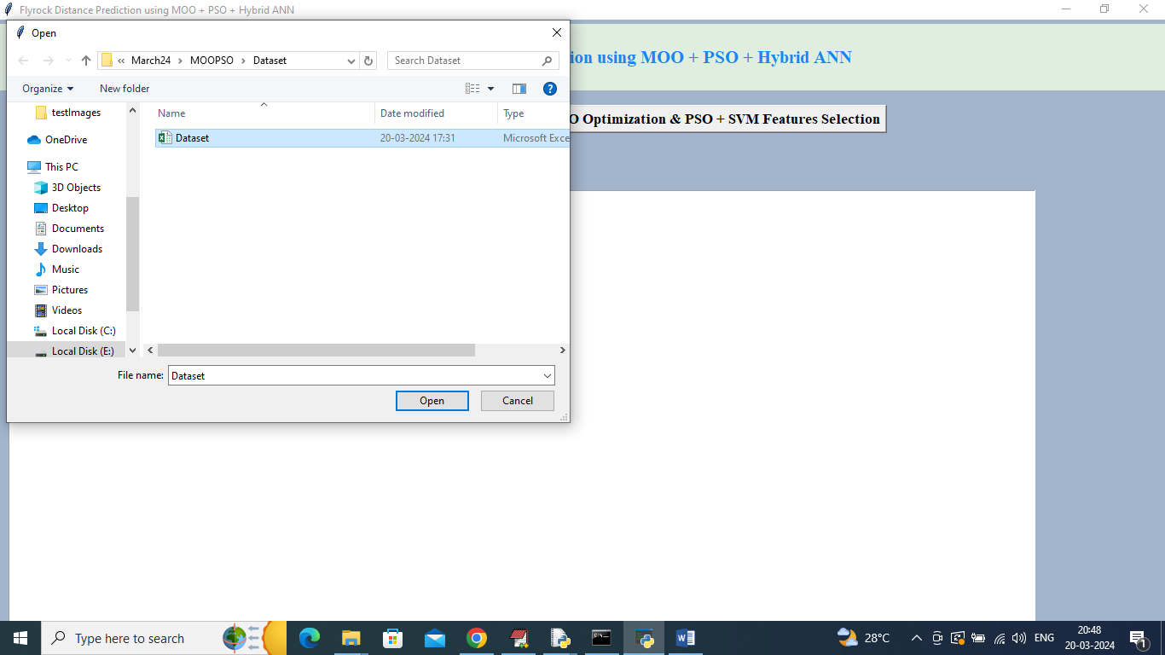

In above screen selecting and uploading dataset file and then click on ‘Open’ button to load dataset and get below page

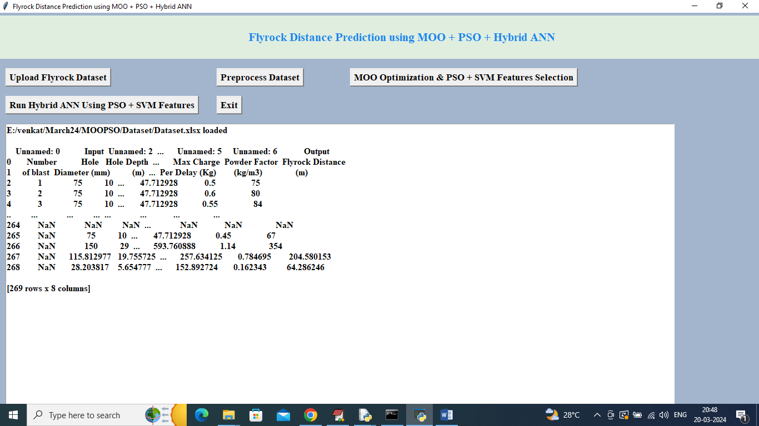

In above screen dataset loaded and displaying few values from dataset and in above values we can see dataset contains so MANY NAN missing values so click on ‘Pre-process Dataset’ button to handle missing values and then clean and normalize dataset values and get below page

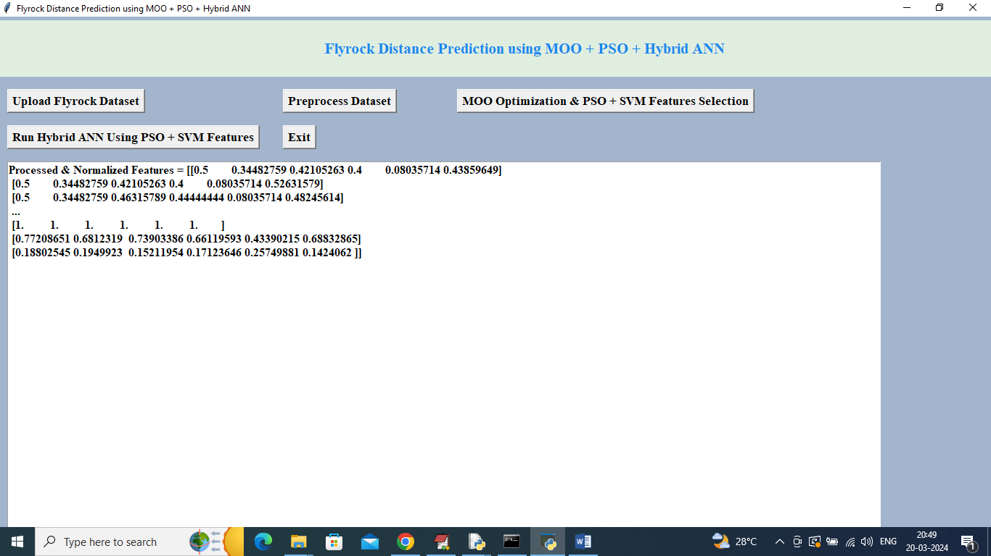

In above screen all dataset values are cleaned and normalized and now click on ‘MOO Optimization & PSO + SVM Features Selection’ button to optimize and select relevant features and get below page

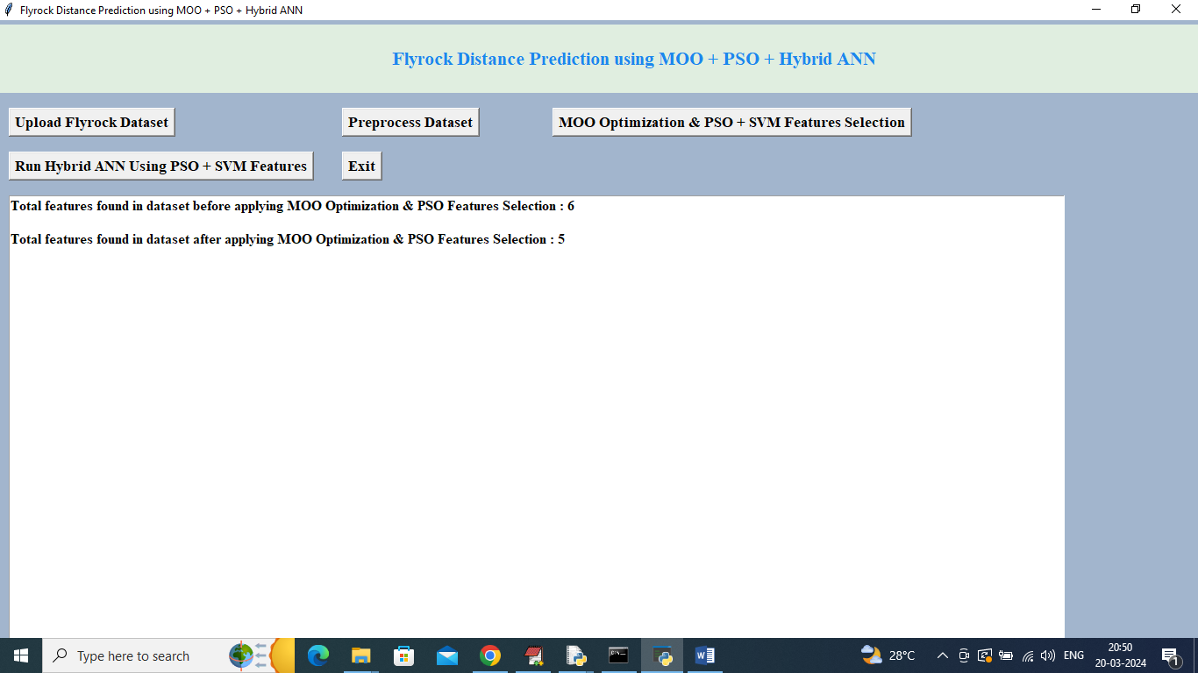

In above screen before applying MOO + PSO + SVM dataset were having 6 features and after optimizing and selecting relevant features then we got 5 as the selected features and now click on ‘Run Hybrid ANN Using PSO + SVM Features’ button to train ANN on selected features to form HYBRID ANN and get below output

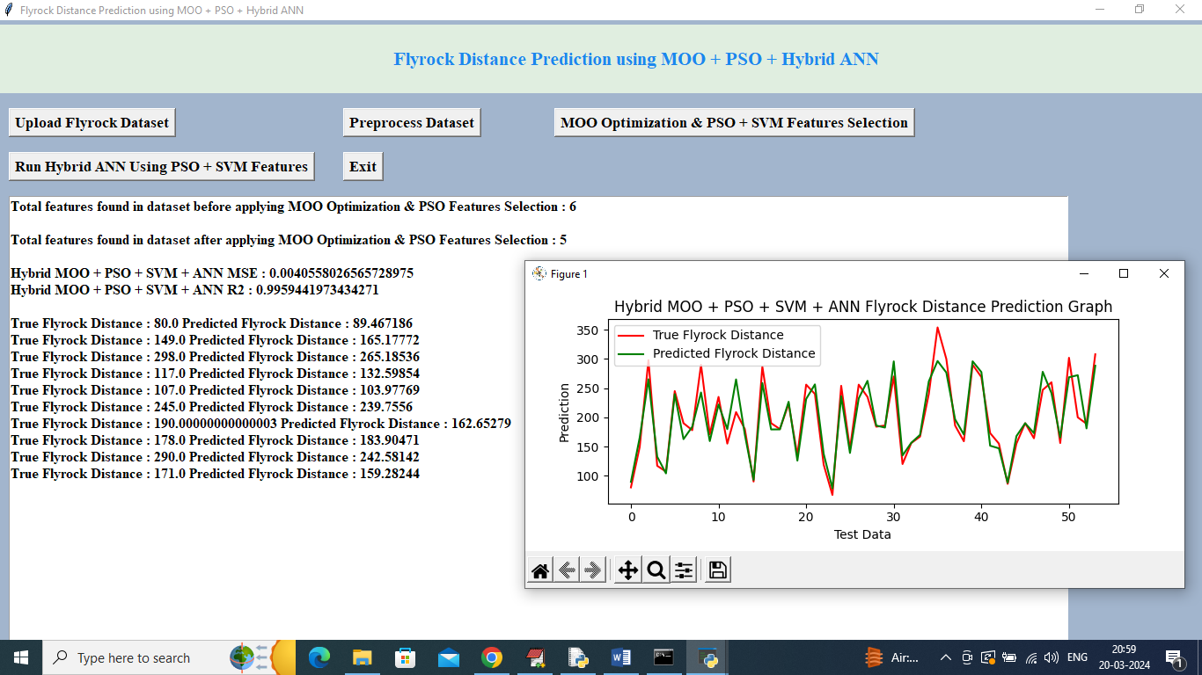

In above screen can see Hybrid ANN got MSE as 0.004 and R2square as 0.99 and then in next lines can see True Flyrock distance value and PREDICTED fly rock distance values and can see both values are very close. In above graph x-axis represents TEST data number and y-axis represents Flyrock distance and then red line represents original true values and green line represents Hybrid ANN predicted values and can see both lines are fully overlapping so we can say hybrid ANN is accurate in prediction

Note: some time PSO may select all 6 features or 0 features and to avoid this problem run all buttons from starting again so PSO will select relevant features