5. Create a SQL database to consolidate 2 different HR sources or Csv files. Use that as Universal directory to generate Unique username, email, proxy address.using powershell instead of using sql database.  
  
  
Solution:-

1. We need to create a csv file1 with some attributes (e.g: employeeid,samaccountname,firstname,lastname,username,email,password,...etc)
2. We need to have csv file 2 with some attributes are you can add more attributes but it should be matched with csv file 1 attribute list.(e.g: employeeid,samaccountname,firstname,lastname,username,email,password,...etc)
3. Now we will merge these 2 csv files and get third csv file with unique names populated with csvfile1 and csv file2.

Here is the code to merge 2 csv files:-

1. While writing this script i just used basic commands you are able to understand the code easily by seeing the script.
2. $file1 = Import-Csv -Path "downloads\NewUsersFinal.csv" -Delimiter ";" // this is 1st csv file
3. $file2 = Import-Csv -Path "C:\Users\Administrator\Documents\BulkUsersForSql.csv" -Delimiter "," // this is 2nd csv file
4. $combinedData = $file1 + $file2 // here iam just combing or adding two files
5. $combinedData | Export-Csv -Path "C:\PowerShell\MergedDirectory.csv" -NoTypeInformation  
   // here iam getting 3rd csv file after adding 2 csv files
6. Write-Host "Combined data has been written to C:\PowerShell\MergedDirectory.csv"
7. $csvFile2 = Import-Csv "C:\PowerShell\MergedDirectory.csv"
8. $csvFile2 | ogv //here iam checking the merged csv file iam etting output perfectly or not

OUTPUT:-  
  
  
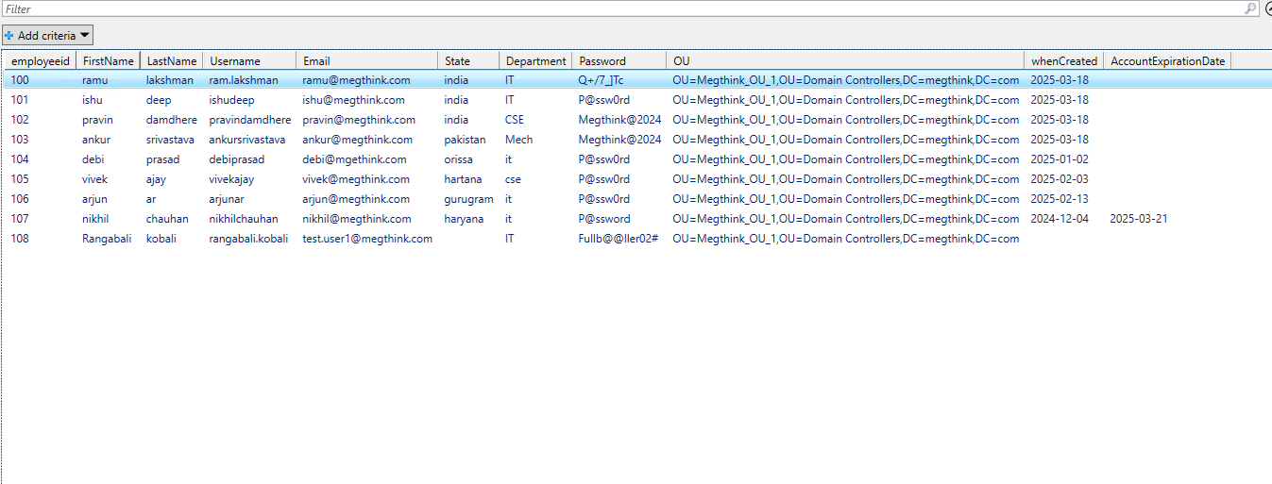

**UML Diagrams:-**

