create database miniprojects;

use miniprojects;

|  |  |
| --- | --- |
| 1 | hadoop fs -cp <file:///home/cloudera/Desktop/AgentPerformance.csv>/tmp/**data** |

|  |  |
| --- | --- |
| 1 | hadoop fs –cp <file:///home/cloudera/Desktop/AgentLogingReport.csv>/tmp/**data** |

# create table agent_performance

1.) and 2.) ----------

|  |  |
| --- | --- |
| 1  2  3  4  5  6  7  8  9 10 11 12 13 14 | **create** **table** agent_performance  (  sl_no int,  date string,  agent_name string,  total_chats int,  avg_resp_time array<int>,  avg_resol_time array<int>,  avg_rating double,  total_feedback int  )  row format delimited  fields terminated **by** ','  collection items terminated **by** ':' tblproperties("skip.header.line.count"="1"); |

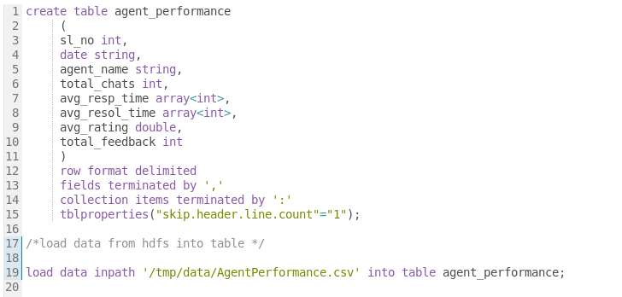

# load data from hdfs into table

|  |  |
| --- | --- |
| 1 | **load** **data** inpath '/tmp/data/AgentPerformance.csv' **into** **table** agent_performance; |

# create agent_login_report

|  |  |
| --- | --- |
| 1  2  3  4  5  6  7  8  9 10 11 12 13 | **create** **table** agent_login_report  (  sl_no int,  agent_name string,  date string,  login_time array<int>,  logout_time array<int>,  duration array<int>  )  row format delimited  fields terminated **by** ','  collection items terminated **by** ':'  tblproperties("skip.header.line.count"="1"); |

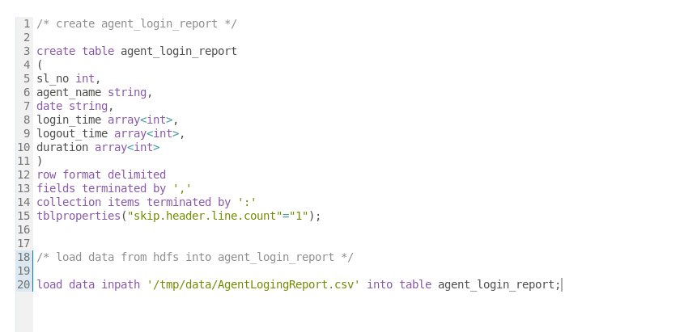

# load data from hdfs into agent_login_report

|  |  |
| --- | --- |
| 1 | **load** **data** inpath '/tmp/data/AgentLogingReport.csv' **into** **table** agent_login_report; |

3.) --------

|  |  |
| --- | --- |
| 1 | **select** **distinct**(agent_name) **from** agent_performance; |



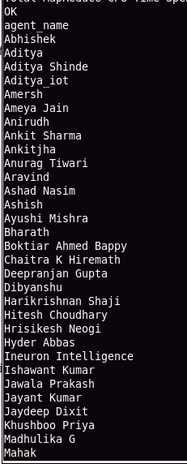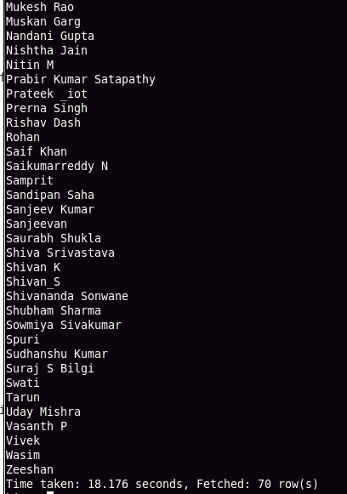

4.) ------

# since each agent has 30 average ratings(data is for the month of july), the query finds avg for all of them for each agent.

|  |  |
| --- | --- |
| 1 2 3 | **select** agent_name, round(**avg**(avg_rating))  from agent_performance  group **by** agent_name; |

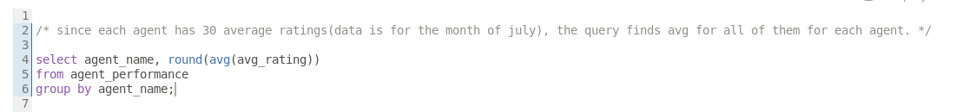

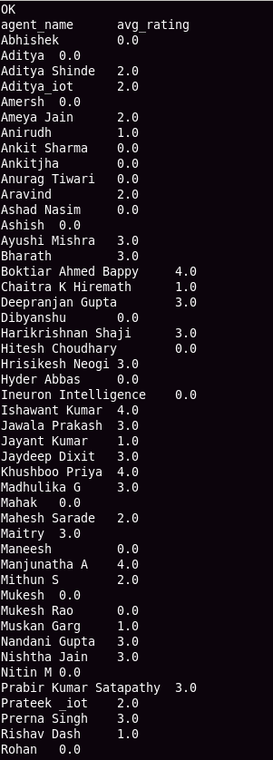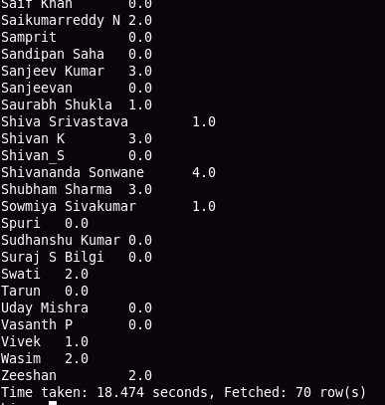

5.)--------

# query is executed on agent_login_report table

# Since an agent was logged in multiple times in a day. we have to count the distinct days for each agent

|  |  |
| --- | --- |
| 1 2 3 | **select** agent_name, **count**(**distinct**(date)) **as** working_days  from agent_login_report  group **by** agent_name; |

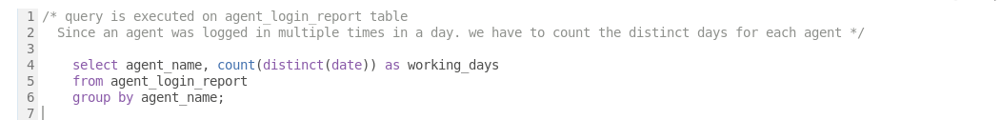

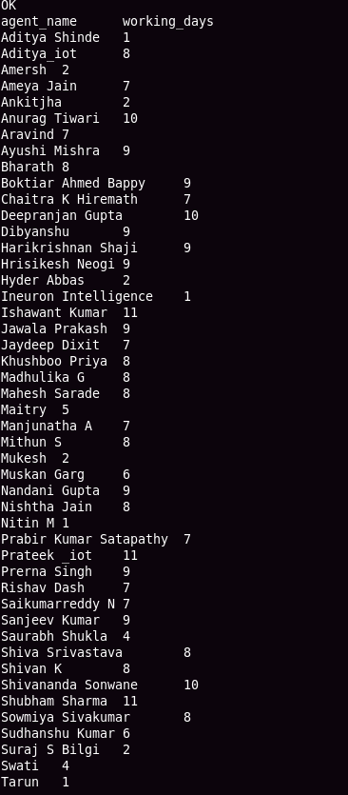

6.)------

# total_chats field conveys that count that agent had chats with customer to resolve queries on daliy basis. So we can consider this column to query

|  |  |
| --- | --- |
| 1 2 3 | **select** agent_name, **sum**(total_chats) **as** queries_taken  from agent_performance  group **by** agent_name; |

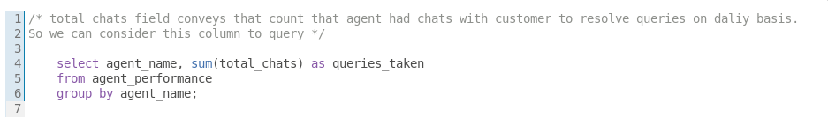

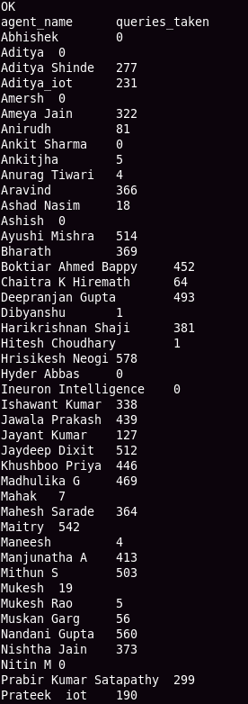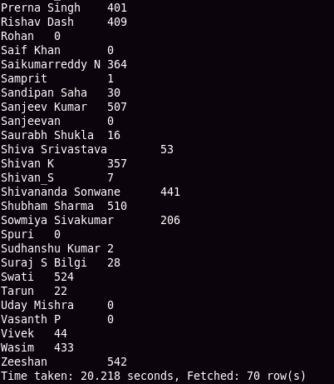

7.) ------

|  |  |
| --- | --- |
| 1 2 3 | **select** agent_name, **sum**(total_feedback) **as** total_feedbacks  from agent_performance  group **by** agent_name; |

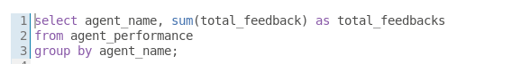

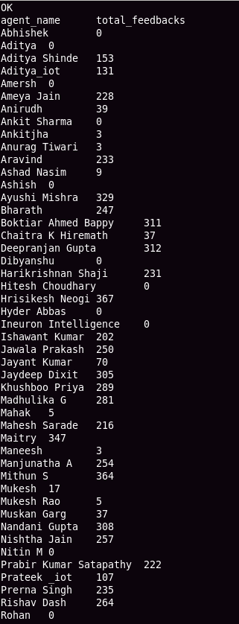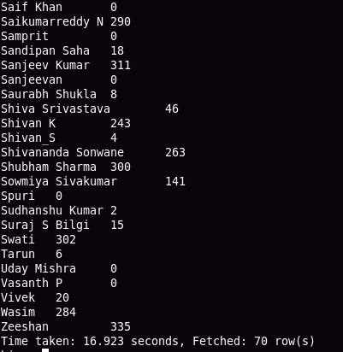

8.) -------

# since agent has ratings everyday. First avg all the ratings for each agent and find those who has ratings >=35 and <=4.

|  |  |
| --- | --- |
| 1 2 3 4 | **select** agent_name, round(**avg**(avg_rating)) **as** avg_rating  from agent_performance  group **by** agent_name  having round(**avg**(avg_rating)) >= **3**.**5** **and** round(**avg**(avg_rating)) <=**4**; |

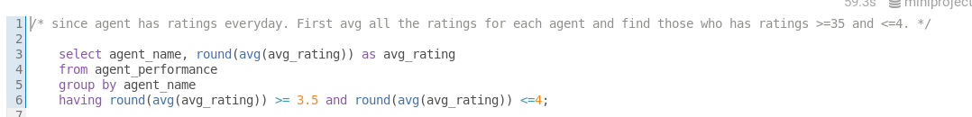

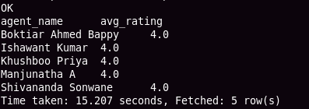

9.) ---------

# considering rating as average rating for whole month for each agent

|  |  |
| --- | --- |
| 1 2 3 4 | **select** agent_name, round(**avg**(avg_rating)) **as** avg_rating  from agent_performance  group **by** agent_name  having round(**avg**(avg_rating)) < **3**.**5**; |

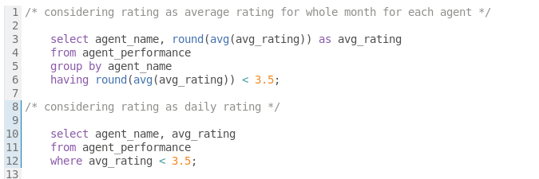

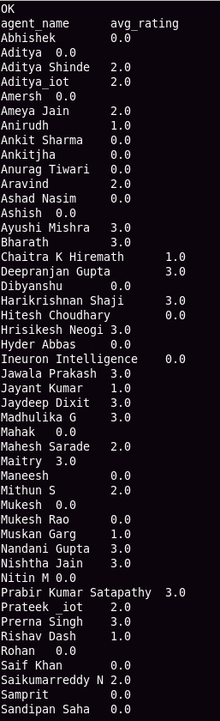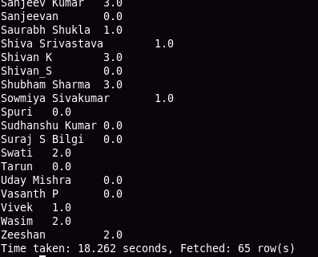

# considering rating as daily rating

|  |  |
| --- | --- |
| 1 2 3 | **select** agent_name, avg_rating  from agent_performance  where avg_rating < **3**.**5**; |

10.) -------

# considering rating as daily rating

|  |  |
| --- | --- |
| 1 2 3 | **select** agent_name, avg_rating  from agent_performance  where avg_rating > **4**.**5**; |

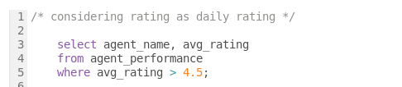

11.)

# take average ratings for each agent and round it to two decimal values. then fetch those are having avg > 4.5

|  |  |
| --- | --- |
| 1 2 3 4 | **select** agent_name, round(**avg**(total_feedback)) **as** avg_feedback  from agent_performance  group **by** agent_name  having round(**avg**(total_feedback)) > **4**.**5**; |

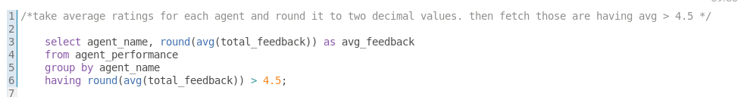

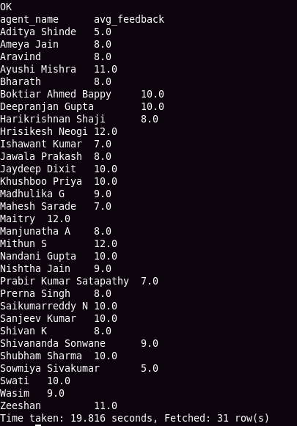

12.) -------

# first calclate the sum of daily response time for each agent. Then find the weekly average.

|  |
| --- |
| **with** agent_daily_resp_time_table **as**  (  select from_unixtime(unix_timestamp(date , 'MM/dd/yyyy'), 'yyyy-MM-dd') **as** date, agent_name,  sum(avg_resp_time[**0**] * **3600** + avg_resp_time[**1**] * **60** + avg_resp_time[**2**]) **as** total_daily_resp_time  from agent_performance  group **by** date,agent_name  ),   weekly_avg_table **as**  (  select weekofyear(date) **as** week_of_year,agent_name,round(**avg**(total_daily_resp_time)) **as** weekly_avg_resp_time_in_sec **from** agent_daily_resp_time_table  group **by** weekofyear(date),agent_name  )  select agent_name,  sum(**case** **when** week_of_year = **26** **then** weekly_avg_resp_time_in_sec **else** **0** **end**) **as** week_1,  sum(**case** **when** week_of_year = **27** **then** weekly_avg_resp_time_in_sec **else** **0** **end**) **as** week_2,  sum(**case** **when** week_of_year = **28** **then** weekly_avg_resp_time_in_sec **else** **0** **end**) **as** week_3,  sum(**case** **when** week_of_year = **29** **then** weekly_avg_resp_time_in_sec **else** **0** **end**) **as** week_4,  sum(**case** **when** week_of_year = **30** **then** weekly_avg_resp_time_in_sec **else** **0** **end**) **as** week_5  from weekly_avg_table  group **by** agent_name; |

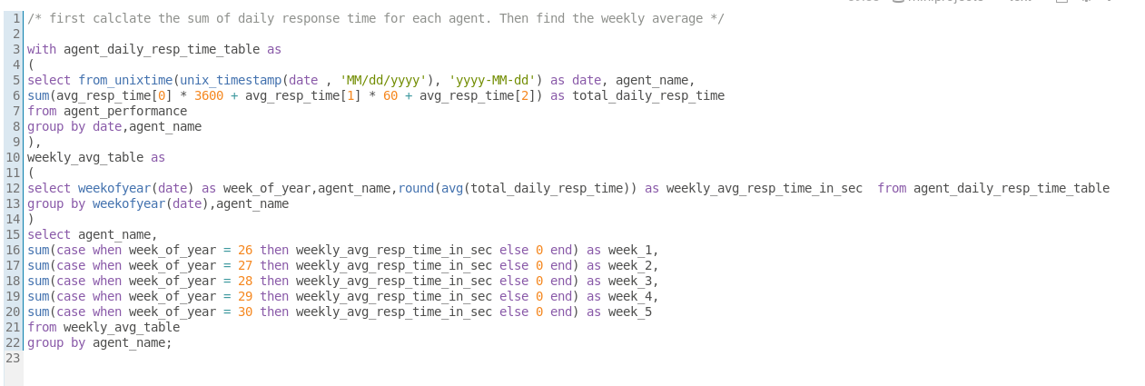

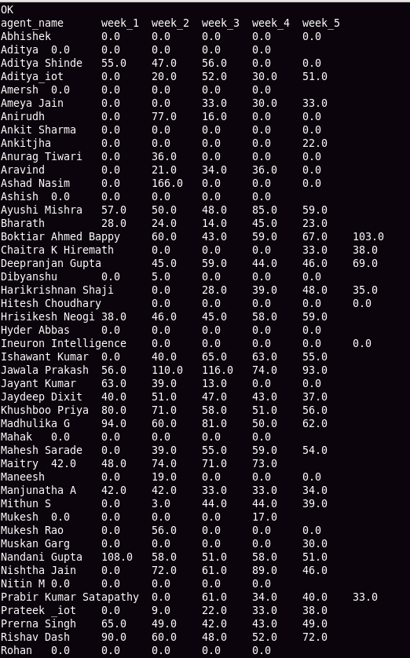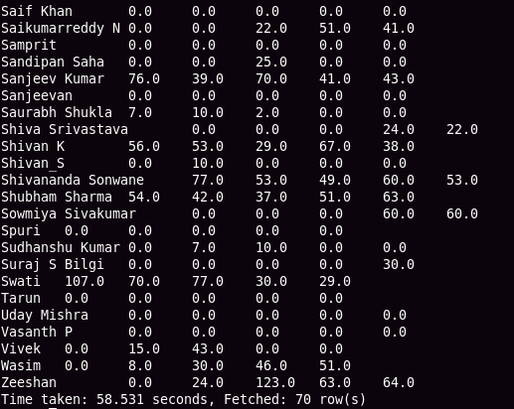

13.) --------

# first calclate the sum of daily resolution time for each agent. Then find the weekly average

|  |
| --- |
| **with** agent_daily_resol_time_table **as**  (  select from_unixtime(unix_timestamp(date , 'MM/dd/yyyy'), 'yyyy-MM-dd') **as** date, agent_name,  sum(avg_resol_time[**0**] * **3600** + avg_resol_time[**1**] * **60** + avg_resol_time[**2**]) **as** total_daily_resol_time  from agent_performance  group **by** date,agent_name  ),  weekly_avg_table **as**  (  select weekofyear(date) **as** week_of_year,agent_name,round(**avg**(total_daily_resol_time)) **as** weekly_avg_resol_time_in_sec **from** agent_daily_resol_time_table  group **by** weekofyear(date),agent_name  )  select agent_name,  sum(**case** **when** week_of_year = **26** **then** weekly_avg_resol_time_in_sec **else** **0 end**) **as** week_1,  sum(**case** **when** week_of_year = **27** **then** weekly_avg_resol_time_in_sec **else** **0** **end**) **as** week_2,  sum(**case** **when** week_of_year = **28** **then** weekly_avg_resol_time_in_sec **else** **0** **end**) **as** week_3,  sum(**case** **when** week_of_year = **29** **then** weekly_avg_resol_time_in_sec **else** **0** **end**) **as** week_4,  sum(**case** **when** week_of_year = **30** **then** weekly_avg_resol_time_in_sec **else** **0** **end**) **as** week_5  from weekly_avg_table  group **by** agent_name; |

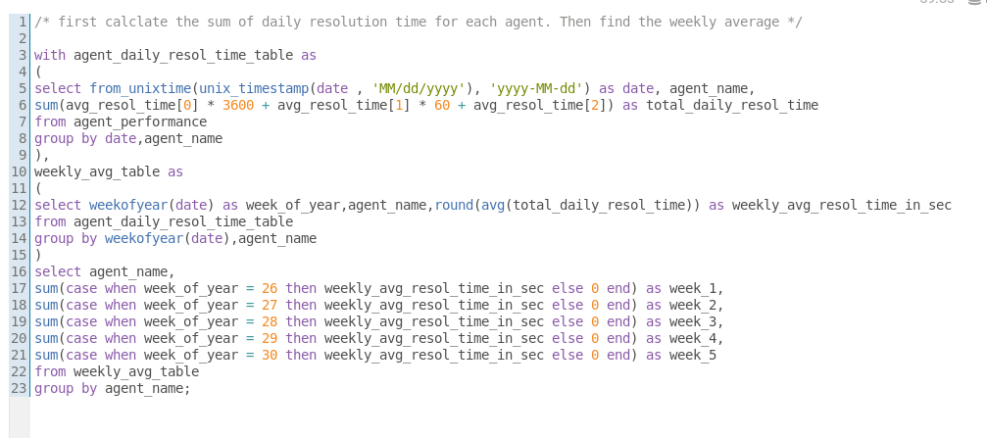

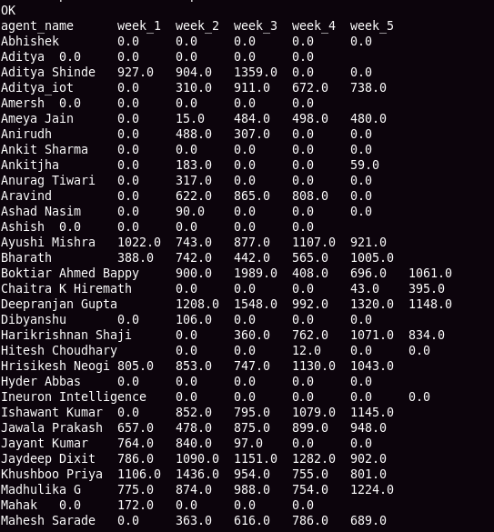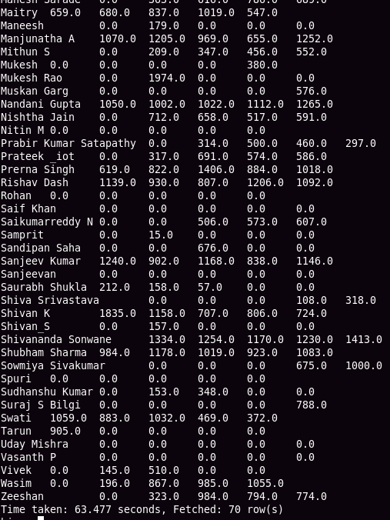

14.) --------

|  |  |
| --- | --- |
| 1 2 3 | **select** **count**(total_chats) **as** count_of_chats_with_feedback  from agent_performance  where total_feedback != **0**; |

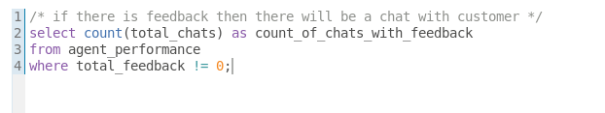

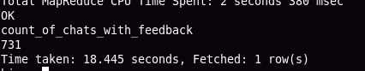

15.)---------

change_date_udf.py

-----------------

|  |
| --- |
| **import** **sys**   for line **in** sys.stdin:    line = line.strip("**\n\r**")   date, agent_name, duration = line.split("**\t**")   date = date.replace("-","/")   date = date.replace("Jul/22","07/2022")    hour,minutes,sec = duration.split(":")    duration = str(round((float(hour) + float(minutes)/**60**  +float(sec)/**3600**),**2**))    result = "**\t**".join([date,agent_name,duration])    **print**(result) |

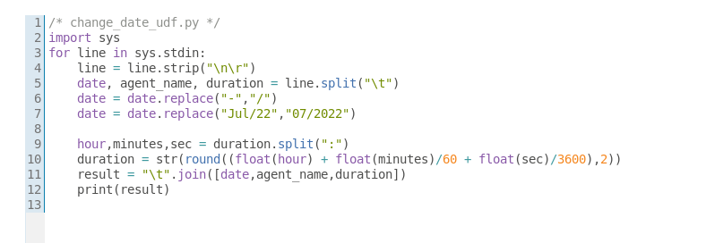

# add .py file to hive

add files /home/cloudera/Desktop/change_date_udf.py

# find daily working hours. Then find weekly average . Duration is in hours .

|  |
| --- |
| **with** cte **as**  (  select **transform** (date,agent_name,duration)  using 'python change_date_udf.py' **as** (date string, agent_name string, duration double)  from agent_login_report  ),  daily_working_hrs_table **as**  (  select from_unixtime(unix_timestamp(date , 'dd/MM/yyyy'), 'yyyy-MM-dd') **as** date, agent_name,  round(**sum**(duration)) **as** duration **from** cte  group **by** from_unixtime(unix_timestamp(date , 'dd/MM/yyyy'), 'yyyy-MM-dd') , agent_name  ),  weekly_working_hrs_table **as**  (  select weekofyear(date) **as** week_of_year, agent_name,  round(**sum**(duration)/**4**) **as** weekly_avg **from** daily_working_hrs_table  group **by** weekofyear(date) , agent_name  )  select agent_name,  sum(**case** **when** week_of_year = **26** **then** weekly_avg **else** **0** **end**) **as** week_1,  sum(**case** **when** week_of_year = **27** **then** weekly_avg **else** **0** **end**) **as** week_2,  sum(**case** **when** week_of_year = **28** **then** weekly_avg **else** **0** **end**) **as** week_3,  sum(**case** **when** week_of_year = **29** **then** weekly_avg **else** **0** **end**) **as** week_4,  sum(**case** **when** week_of_year = **30** **then** weekly_avg **else** **0** **end**) **as** week_5  from weekly_working_hrs_table  group **by** agent_name; |

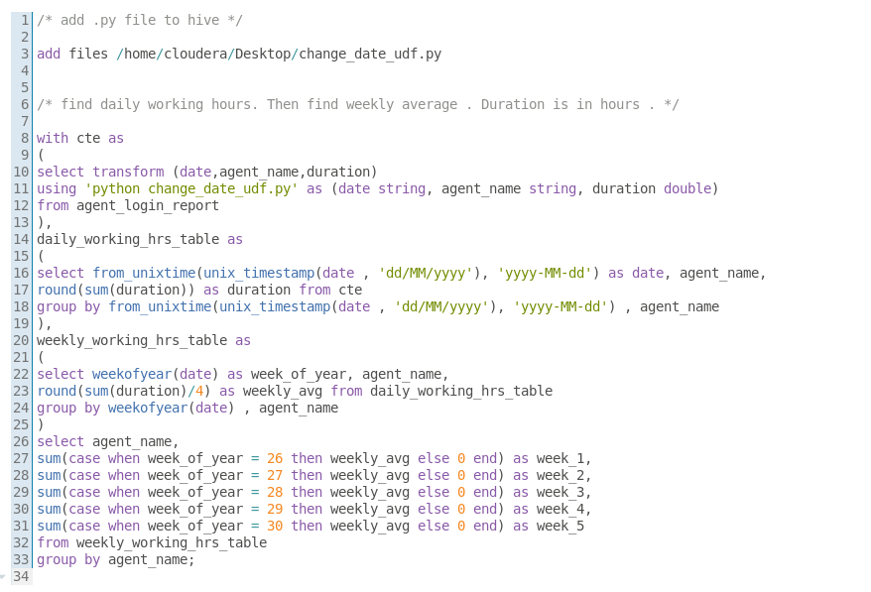

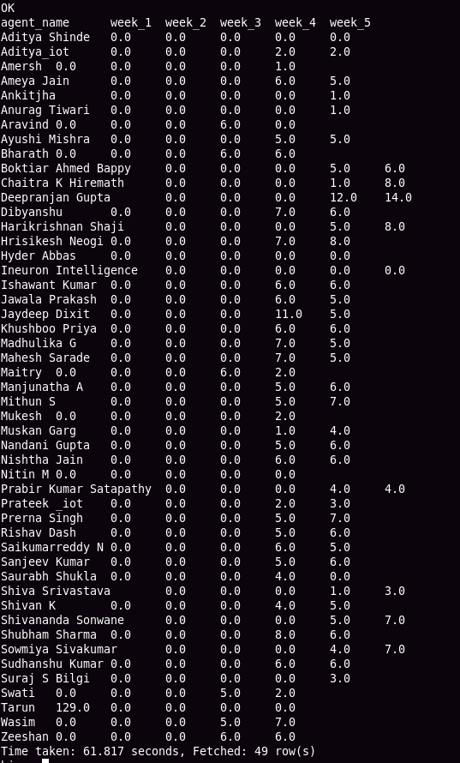

16) -------

a) INNER JOIN

****************

# create a table to store the left joined data

|  |
| --- |
| **create** **table** inner_join_data  row format delimited  fields terminated **by** ','  lines terminated **by** '\n'  stored **as** textfile  as  select  'a.sl_no' **as** a_sl_no,  'a.date' **as** a_date,  'a.agent_name' **as** a_agent_name,  'a.total_chats' **as** a_total_chats,  'a.avg_resp_time' **as** a_avg_resp_time,  'a.avg_resol_time' **as** a_avg_resol_time,  'a.avg_rating' **as** a_avg_rating,  'a.total_feedback' **as** a_total_feedback,  'b.sl_no' **as** b_sl_no,  'b.agent_name' **as** b_agent_name,  'b.date' **as** b_date,  'b.login_time' **as** b_login_time,  'b.logout_time' **as** b_logout_time,  'b.duration' **as** b_duration; |

#insert into that table after join operation

|  |  |
| --- | --- |
| 1 2 3 4 | **insert** **into** inner_join_data  select * **from** agent_performance a  inner **join** agent_login_report b  on a.agent_name = b.agent_name; |

# find the location of table

|  |  |
| --- | --- |
| 1 | **describe** formatted inner_join_data; |

hdfs://quickstart.cloudera:8020/user/hive/warehouse/miniprojects.db/inner_join_data

# using below line of code move data from hdfs to local

hadoop fs -cat hdfs://quickstart.cloudera:**8020**/**user**/hive/warehouse/miniprojects.db/inner_join_data/* > ~/Desktop/csv_files/inner_join_data.csv

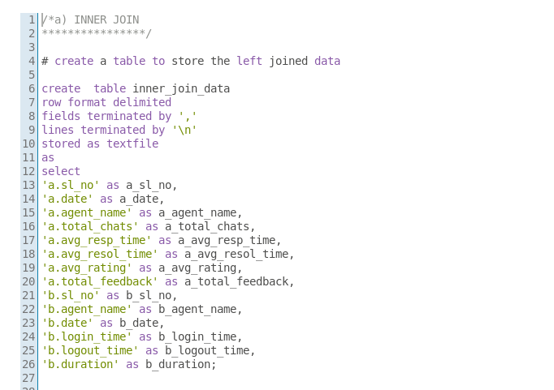

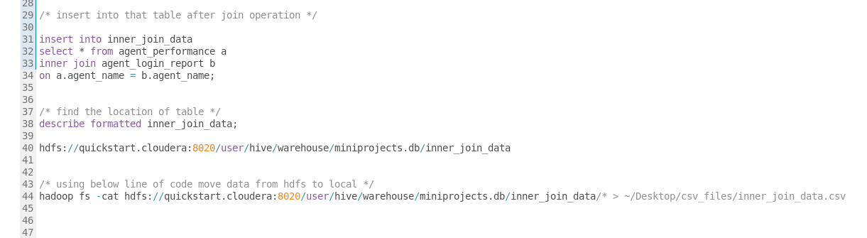

LEFT JOIN

**********

# we have already a temporary table to store the joined data. Just rename it for our use.

|  |  |
| --- | --- |
| 1 | **alter** **table** inner_join_data **rename** **to** left_join_data; |

# insert data into table after left join operation.

|  |  |
| --- | --- |
| 1 2 3 4 | **insert** **into** left_join_data  select * **from** agent_performance a  left **join** agent_login_report b  on a.agent_name = b.agent_name; |

# move data from hdfs to local

hadoop fs -cat hdfs://quickstart.cloudera:8020/user/hive/warehouse/miniprojects.db/left_join_data/* > ~/Desktop/csv_files/left_join_data.csv

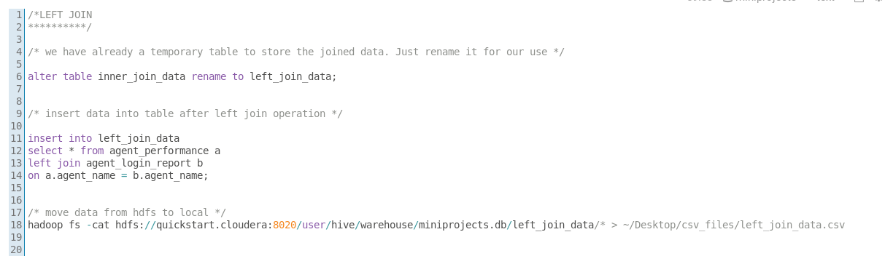

RIGHT JOIN

**********

# we have already a temporary table to store the joined data. Just rename it for our use.

|  |  |
| --- | --- |
| 1 | **alter** **table** left_join_data **rename** **to** right_join_data; |

# insert data into table after right join operation.

|  |  |
| --- | --- |
| 1 2 3 4 | **insert** **into** right_join_data  select * **from** agent_performance a  right **join** agent_login_report b  on a.agent_name = b.agent_name; |

# move data from hdfs to local

hadoop fs -cat hdfs://quickstart.cloudera:8020/user/hive/warehouse/miniprojects.db/right_join_data/* > ~/Desktop/csv_files/right_join_data.csv

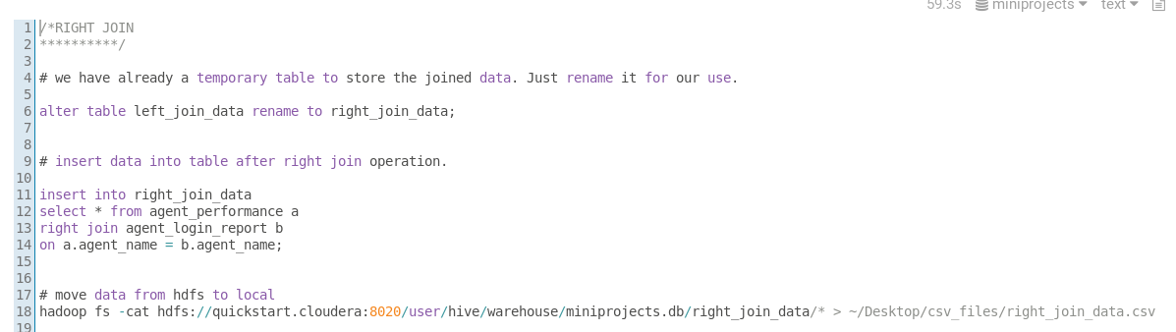

FULL JOIN

**********

# we have already a temporary table to store the joined data. Just rename it for our use.

|  |  |
| --- | --- |
| 1 | **alter** **table** right_join_data **rename** **to** full_join_data; |

# insert data into table after full join operation.

|  |  |
| --- | --- |
| 1 2 3 4 | **insert** **into** full_join_data  select * **from** agent_performance a  full **join** agent_login_report b  on a.agent_name = b.agent_name; |

# move data from hdfs to local

hadoop fs -cat hdfs://quickstart.cloudera:8020/user/hive/warehouse/miniprojects.db/full_join_data/* > ~/Desktop/csv_files/full_join_data.csv

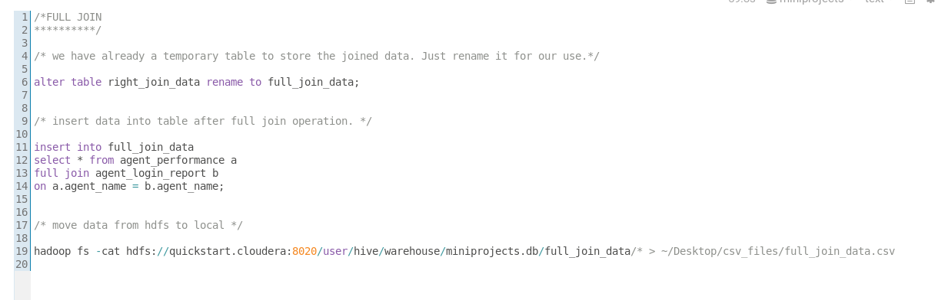

17) --------

# for partitioning we use dynamic partitioning .set this property for dynamic partitioning

|  |  |
| --- | --- |
| 1 | **set** hive.**exec**.**dynamic**.partition.**mode**=nonstrict; |

# create a table to store the partitioned data

|  |  |
| --- | --- |
| 1  2  3  4  5  6  7  8  9 10 11 | **create** **table** agent_performance_dynamic_part  (  sl_no int,  date string,  total_chats int,  avg_resp_time string,  avg_resol_time string,  avg_rating double,  total_feedback int  )  partitioned **by** (agent_name string); |

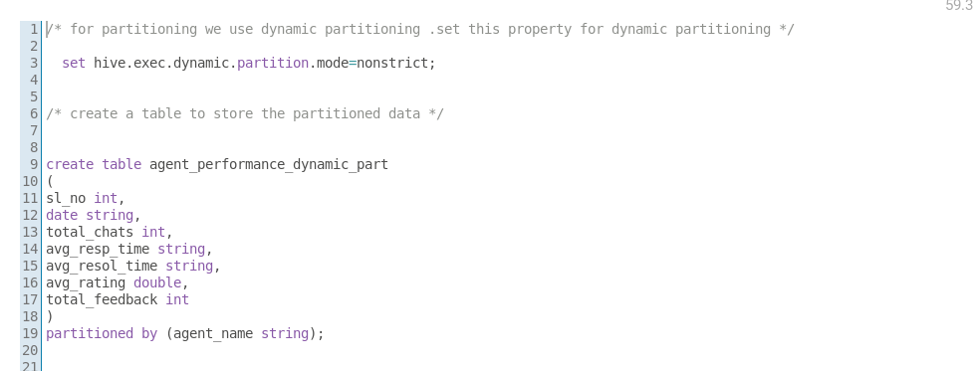

# since we have many agents. partition data based on agent_name

# ------> Note: The partition column/s should be used at last in select statement <--------

|  |
| --- |
| **insert** overwrite **table** agent_performance_dynamic_part partition(agent_name)  select sl_no, date,total_chats, avg_resp_time, avg_resol_time, avg_resol_time, avg_rating total_feedback, agent_name  from agent_performance; |

# you can check the partitions in hdfs

hadoop fs -ls /user/hive/warehouse/miniprojects.db/agent_performance_dynamic_part/*

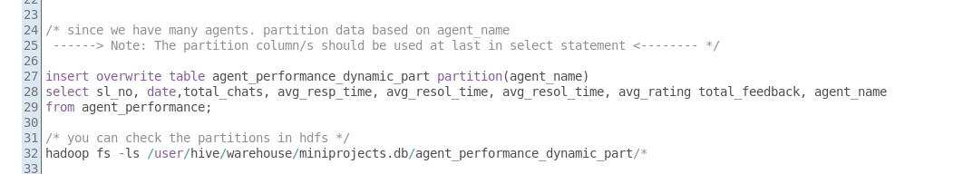

Bucketing

*********

# first set bucketing to true

|  |  |
| --- | --- |
| 1 | **set** hive.enforce.bucketing=**true**; |

|  |  |
| --- | --- |
| 1  2  3  4  5  6  7  8  9 10 11 12 13 14 | **create** **table** bucket_agent_performance  (  sl_no int,  agent_name string,  date string,  total_chats int,  avg_resp_time string,  avg_resol_time string,  avg_rating double,  total_feedback int  )  clustered **by** (agent_name)  sorted **by** (sl_no)  into **4** buckets; |

# create buckets

|  |  |
| --- | --- |
| 1 | **insert** overwrite **table** bucket_agent_performance **select** * **from** agent_performance_dynamic_part; |

# you can check the buckets in the hdfs

hadoop fs -ls /user/hive/warehouse/miniprojects.db/bucket_agent_performance/*

