create database miniprojects;

use miniprojects;

hadoop fs -cp file:///home/cloudera/Desktop/AgentPerformance.csv /tmp/data

hadoop fs -cp file:///home/cloudera/Desktop/AgentLogingReport.csv /tmp/data

# create table agent_performance

1.) and 2.) ----------

create table agent_performance

(

sl_no int,

date string,

agent_name string,

total_chats int,

avg_resp_time array<int>,

avg_resol_time array<int>,

avg_rating double,

total_feedback int

)

row format delimited

fields terminated by ','

collection items terminated by ':'

tblproperties("skip.header.line.count"="1");

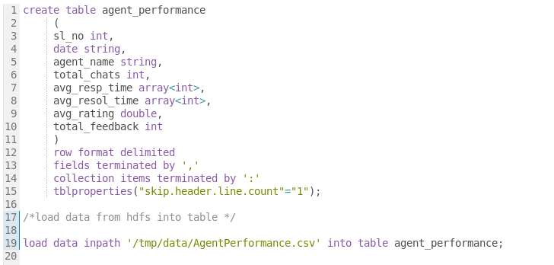

# load data from hdfs into table

load data inpath '/tmp/data/AgentPerformance.csv' into table agent_performance;

# create agent_login_report

create table agent_login_report

(

sl_no int,

agent_name string,

date string,

login_time array<int>,

logout_time array<int>,

duration array<int>

)

row format delimited

fields terminated by ','

collection items terminated by ':'

tblproperties("skip.header.line.count"="1");

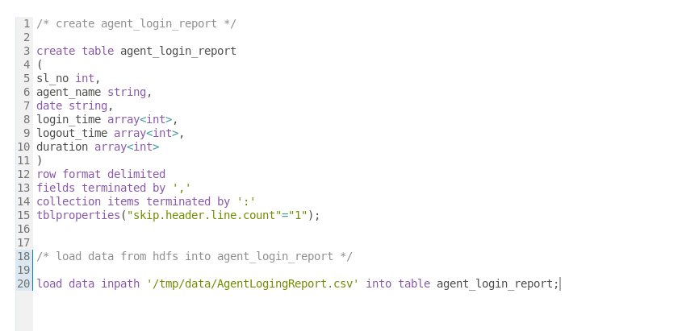

# load data from hdfs into agent_login_report

load data inpath '/tmp/data/AgentLogingReport.csv' into table agent_login_report;

3.) --------

select distinct(agent_name) from agent_performance;



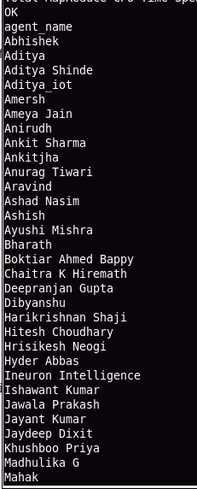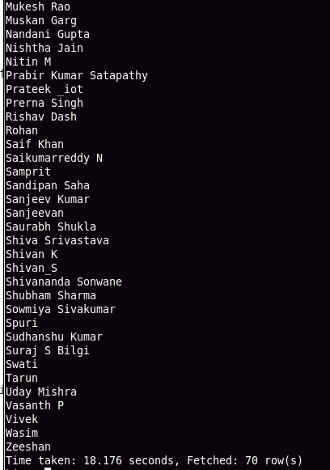

4.) ------

# since each agent has 30 average ratings(data is for the month of july), the query finds avg for all of them for each agent.

select agent_name, round(avg(avg_rating))

from agent_performance

group by agent_name;

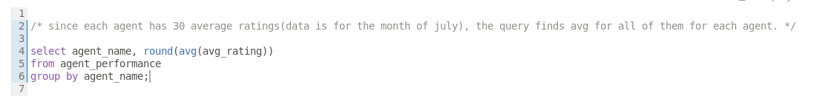

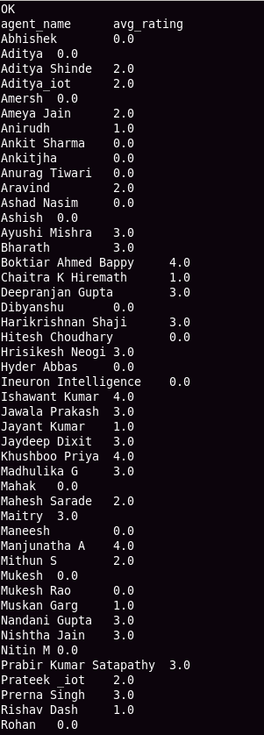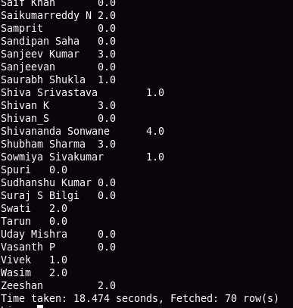

5.)--------

# query is executed on agent_login_report table

# Since an agent was logged in multiple times in a day. we have to count the distinct days for each agent

select agent_name, count(distinct(date)) as working_days

from agent_login_report

group by agent_name;

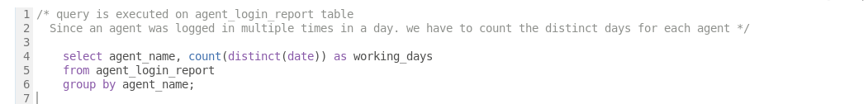

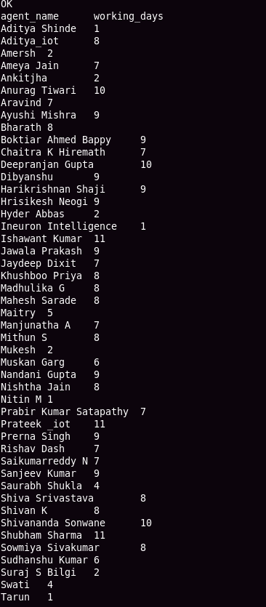

6.)------

# total_chats field conveys that count that agent had chats with customer to resolve queries on daliy basis. So we can consider this column to query

select agent_name, sum(total_chats) as queries_taken

from agent_performance

group by agent_name;

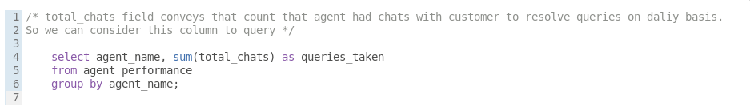

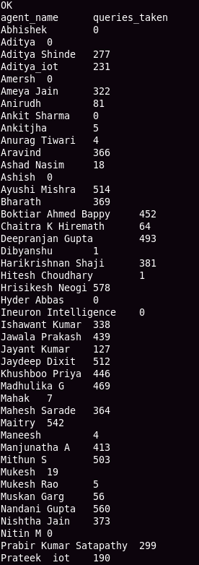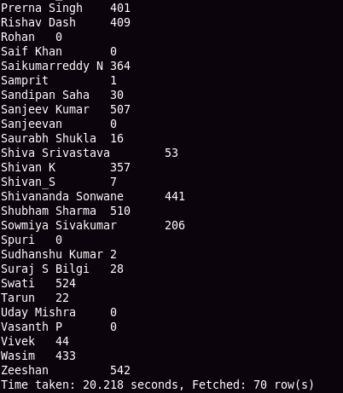

7.) ------

select agent_name, sum(total_feedback) as total_feedbacks

from agent_performance

group by agent_name;

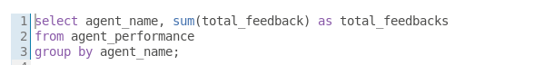

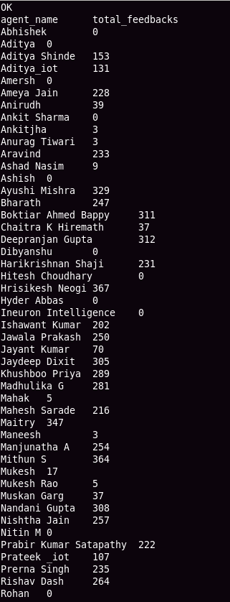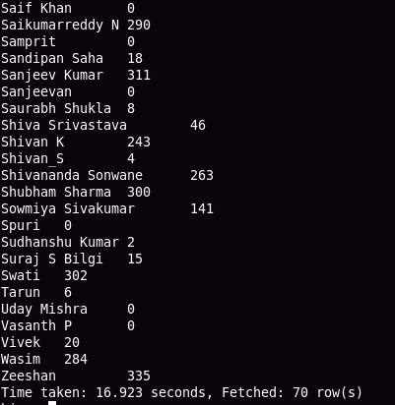

8.) -------

# since agent has ratings everyday. First avg all the ratings for each agent and find those who has ratings >=35 and <=4.

select agent_name, round(avg(avg_rating)) as avg_rating

from agent_performance

group by agent_name

having round(avg(avg_rating)) >= 3.5 and round(avg(avg_rating)) <=4;

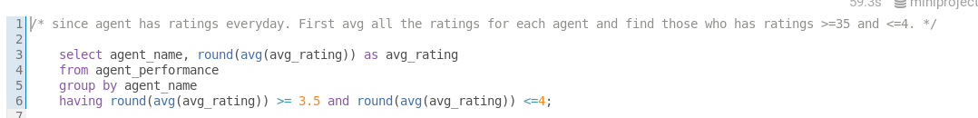

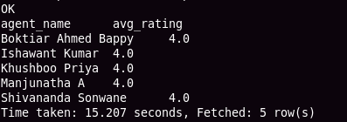

9.) ---------

# considering rating as average rating for whole month for each agent

select agent_name, round(avg(avg_rating)) as avg_rating

from agent_performance

group by agent_name

having round(avg(avg_rating)) < 3.5;

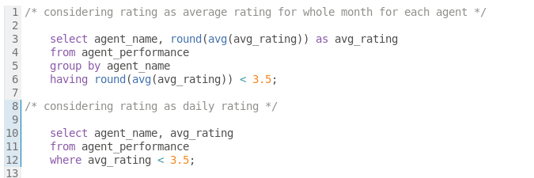

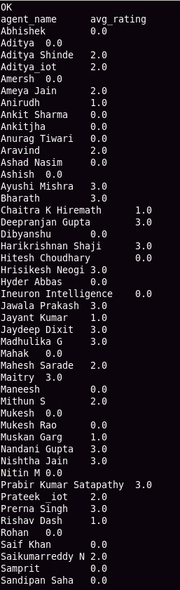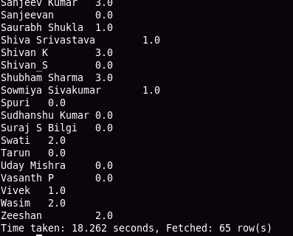

# considering rating as daily rating

select agent_name, avg_rating

from agent_performance

where avg_rating < 3.5;

10.) -------

# considering rating as daily rating

select agent_name, avg_rating

from agent_performance

where avg_rating > 4.5;

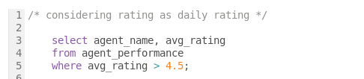

11.)

# take average ratings for each agent and round it to two decimal values. then fetch those are having avg > 4.5

select agent_name, round(avg(total_feedback)) as avg_feedback

from agent_performance

group by agent_name

having round(avg(total_feedback)) > 4.5;

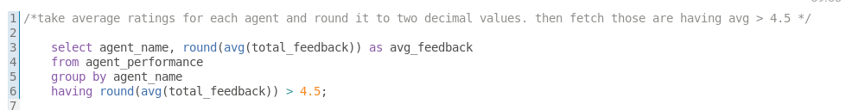

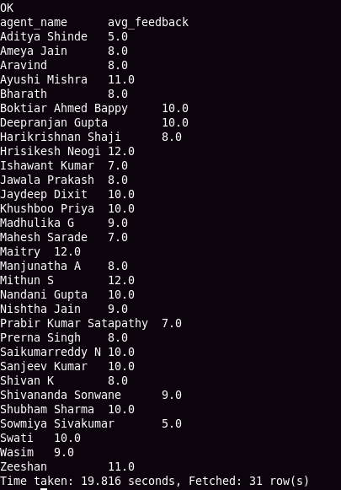

12.) -------

# first calclate the sum of daily response time for each agent. Then find the weekly average.

with agent_daily_resp_time_table as

(

select from_unixtime(unix_timestamp(date , 'MM/dd/yyyy'), 'yyyy-MM-dd') as date, agent_name,

sum(avg_resp_time[0] * 3600 + avg_resp_time[1] * 60 + avg_resp_time[2]) as total_daily_resp_time

from agent_performance

group by date,agent_name

),

weekly_avg_table as

(

select weekofyear(date) as week_of_year,agent_name,round(avg(total_daily_resp_time)) as weekly_avg_resp_time_in_sec from agent_daily_resp_time_table

group by weekofyear(date),agent_name

)

select agent_name,

sum(case when week_of_year = 26 then weekly_avg_resp_time_in_sec else 0 end) as week_1,

sum(case when week_of_year = 27 then weekly_avg_resp_time_in_sec else 0 end) as week_2,

sum(case when week_of_year = 28 then weekly_avg_resp_time_in_sec else 0 end) as week_3,

sum(case when week_of_year = 29 then weekly_avg_resp_time_in_sec else 0 end) as week_4,

sum(case when week_of_year = 30 then weekly_avg_resp_time_in_sec else 0 end) as week_5

from weekly_avg_table

group by agent_name;

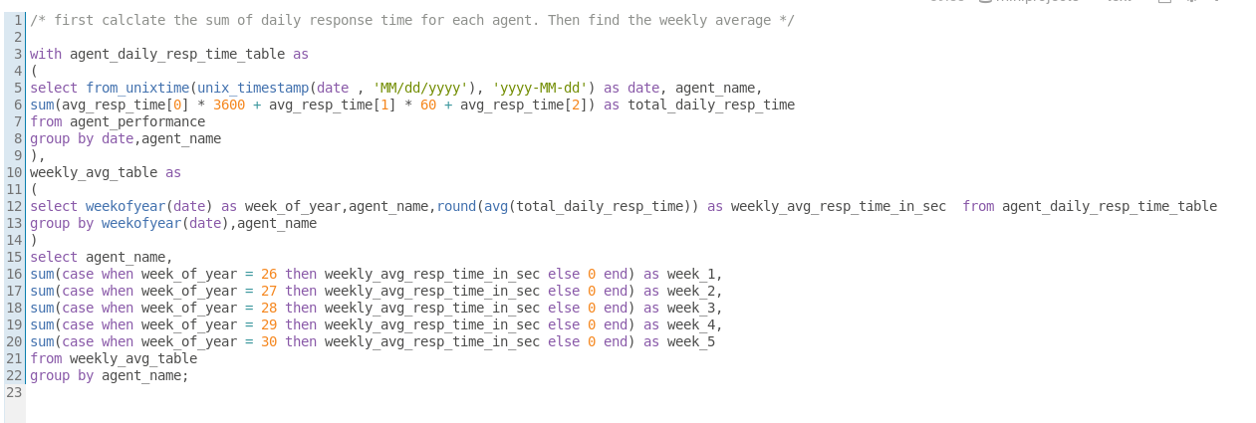

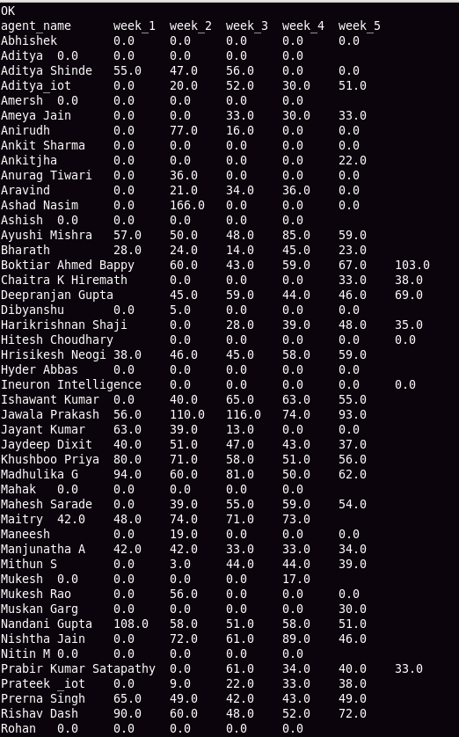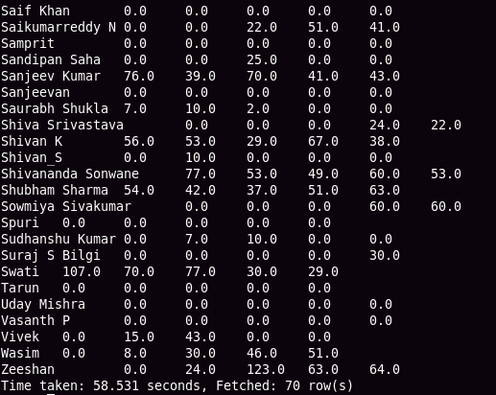

13.) --------

# first calclate the sum of daily resolution time for each agent. Then find the weekly average

with agent_daily_resol_time_table as

(

select from_unixtime(unix_timestamp(date , 'MM/dd/yyyy'), 'yyyy-MM-dd') as date, agent_name,

sum(avg_resol_time[0] * 3600 + avg_resol_time[1] * 60 + avg_resol_time[2]) as total_daily_resol_time

from agent_performance

group by date,agent_name

),

weekly_avg_table as

(

select weekofyear(date) as week_of_year,agent_name,round(avg(total_daily_resol_time)) as weekly_avg_resol_time_in_sec from agent_daily_resol_time_table

group by weekofyear(date),agent_name

)

select agent_name,

sum(case when week_of_year = 26 then weekly_avg_resol_time_in_sec else 0 end) as week_1,

sum(case when week_of_year = 27 then weekly_avg_resol_time_in_sec else 0 end) as week_2,

sum(case when week_of_year = 28 then weekly_avg_resol_time_in_sec else 0 end) as week_3,

sum(case when week_of_year = 29 then weekly_avg_resol_time_in_sec else 0 end) as week_4,

sum(case when week_of_year = 30 then weekly_avg_resol_time_in_sec else 0 end) as week_5

from weekly_avg_table

group by agent_name;

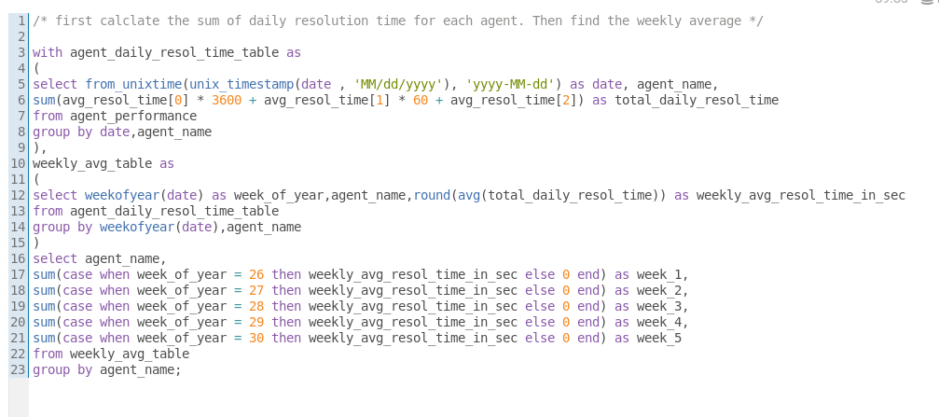

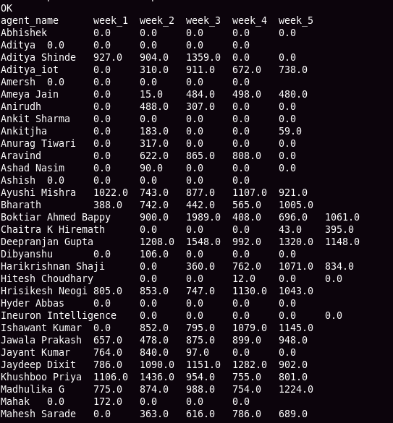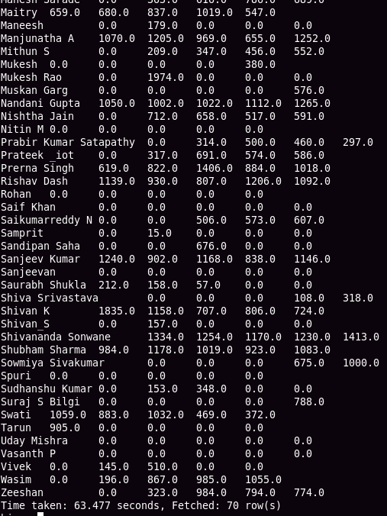

14.) --------

select count(total_chats) as count_of_chats_with_feedback

from agent_performance

where total_feedback != 0;

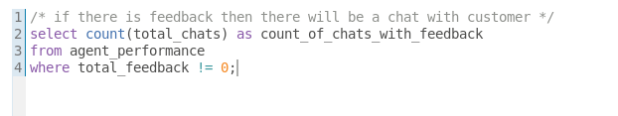

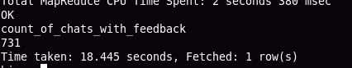

15.)---------

change_date_udf.py

-----------------

import sys

for line in sys.stdin:

line = line.strip("\n\r")

date, agent_name, duration = line.split("\t")

date = date.replace("-","/")

date = date.replace("Jul/22","07/2022")

hour,minutes,sec = duration.split(":")

duration = str(round((float(hour) + float(minutes)/60 + float(sec)/3600),2))

result = "\t".join([date,agent_name,duration])

print(result)

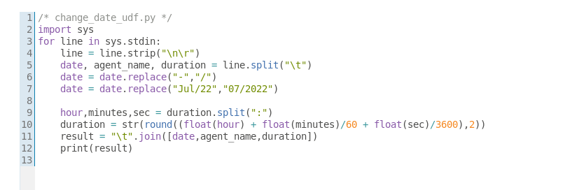

# add .py file to hive

add files /home/cloudera/Desktop/change_date_udf.py

# find daily working hours. Then find weekly average . Duration is in hours .

with cte as

(

select transform (date,agent_name,duration)

using 'python change_date_udf.py' as (date string, agent_name string, duration double)

from agent_login_report

),

daily_working_hrs_table as

(

select from_unixtime(unix_timestamp(date , 'dd/MM/yyyy'), 'yyyy-MM-dd') as date, agent_name,

round(sum(duration)) as duration from cte

group by from_unixtime(unix_timestamp(date , 'dd/MM/yyyy'), 'yyyy-MM-dd') , agent_name

),

weekly_working_hrs_table as

(

select weekofyear(date) as week_of_year, agent_name,

round(sum(duration)/4) as weekly_avg from daily_working_hrs_table

group by weekofyear(date) , agent_name

)

select agent_name,

sum(case when week_of_year = 26 then weekly_avg else 0 end) as week_1,

sum(case when week_of_year = 27 then weekly_avg else 0 end) as week_2,

sum(case when week_of_year = 28 then weekly_avg else 0 end) as week_3,

sum(case when week_of_year = 29 then weekly_avg else 0 end) as week_4,

sum(case when week_of_year = 30 then weekly_avg else 0 end) as week_5

from weekly_working_hrs_table

group by agent_name;

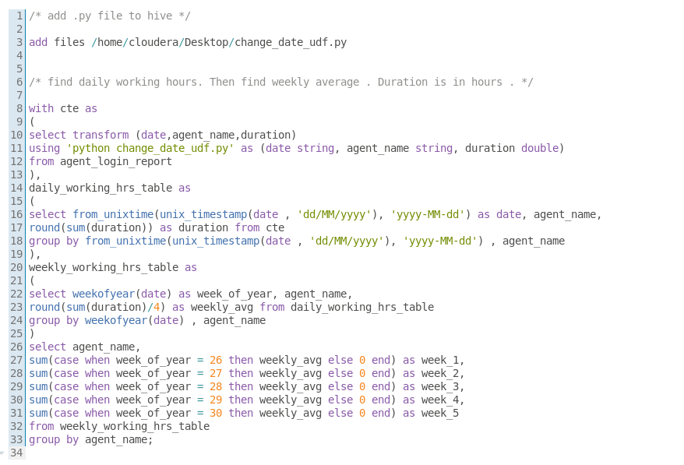

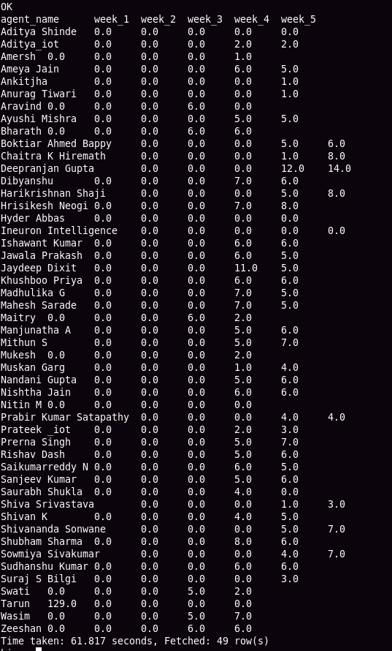

16) -------

a) INNER JOIN

****************

# create a table to store the left joined data

create table inner_join_data

row format delimited

fields terminated by ','

lines terminated by '\n'

stored as textfile

as

select

'a.sl_no' as a_sl_no,

'a.date' as a_date,

'a.agent_name' as a_agent_name,

'a.total_chats' as a_total_chats,

'a.avg_resp_time' as a_avg_resp_time,

'a.avg_resol_time' as a_avg_resol_time,

'a.avg_rating' as a_avg_rating,

'a.total_feedback' as a_total_feedback,

'b.sl_no' as b_sl_no,

'b.agent_name' as b_agent_name,

'b.date' as b_date,

'b.login_time' as b_login_time,

'b.logout_time' as b_logout_time,

'b.duration' as b_duration;

#insert into that table after join operation

insert into inner_join_data

select * from agent_performance a

inner join agent_login_report b

on a.agent_name = b.agent_name;

# find the location of table

describe formatted inner_join_data;

hdfs://quickstart.cloudera:8020/user/hive/warehouse/miniprojects.db/inner_join_data

# using below line of code move data from hdfs to local

hadoop fs -cat hdfs://quickstart.cloudera:8020/user/hive/warehouse/miniprojects.db/inner_join_data/* > ~/Desktop/csv_files/inner_join_data.csv

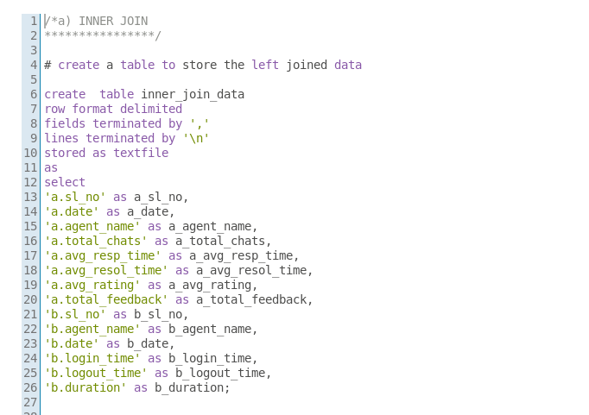

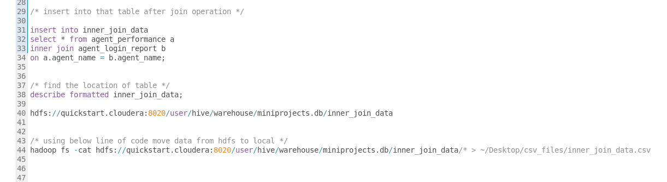

LEFT JOIN

**********

# we have already a temporary table to store the joined data. Just rename it for our use.

alter table inner_join_data rename to left_join_data;

# insert data into table after left join operation.

insert into left_join_data

select * from agent_performance a

left join agent_login_report b

on a.agent_name = b.agent_name;

# move data from hdfs to local

hadoop fs -cat hdfs://quickstart.cloudera:8020/user/hive/warehouse/miniprojects.db/left_join_data/* > ~/Desktop/csv_files/left_join_data.csv

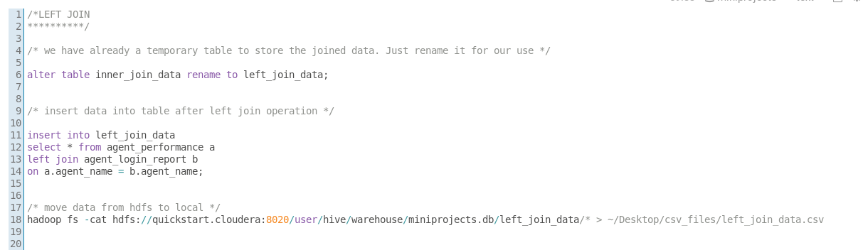

RIGHT JOIN

**********

# we have already a temporary table to store the joined data. Just rename it for our use.

alter table left_join_data rename to right_join_data;

# insert data into table after right join operation.

insert into right_join_data

select * from agent_performance a

right join agent_login_report b

on a.agent_name = b.agent_name;

# move data from hdfs to local

hadoop fs -cat hdfs://quickstart.cloudera:8020/user/hive/warehouse/miniprojects.db/right_join_data/* > ~/Desktop/csv_files/right_join_data.csv

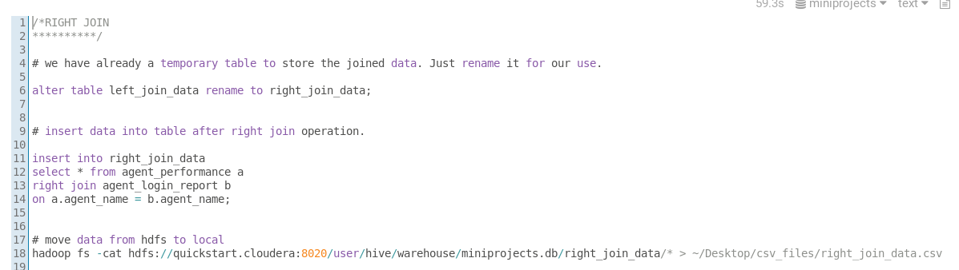

FULL JOIN

**********

# we have already a temporary table to store the joined data. Just rename it for our use.

alter table right_join_data rename to full_join_data;

# insert data into table after full join operation.

insert into full_join_data

select * from agent_performance a

full join agent_login_report b

on a.agent_name = b.agent_name;

# move data from hdfs to local

hadoop fs -cat hdfs://quickstart.cloudera:8020/user/hive/warehouse/miniprojects.db/full_join_data/* > ~/Desktop/csv_files/full_join_data.csv

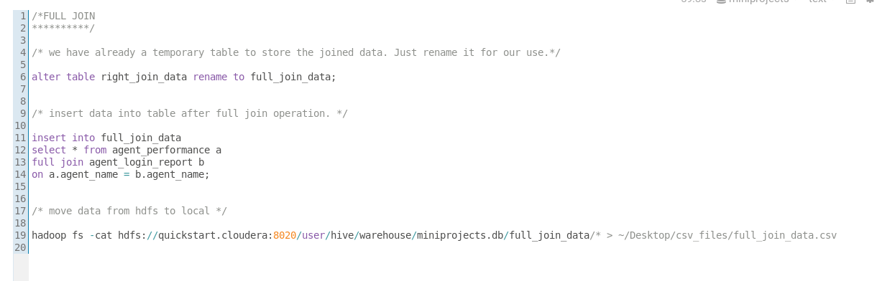

17) --------

# for partitioning we use dynamic partitioning .set this property for dynamic partitioning

set hive.exec.dynamic.partition.mode=nonstrict;

# create a table to store the partitioned data

create table agent_performance_dynamic_part

(

sl_no int,

date string,

total_chats int,

avg_resp_time string,

avg_resol_time string,

avg_rating double,

total_feedback int

)

partitioned by (agent_name string);

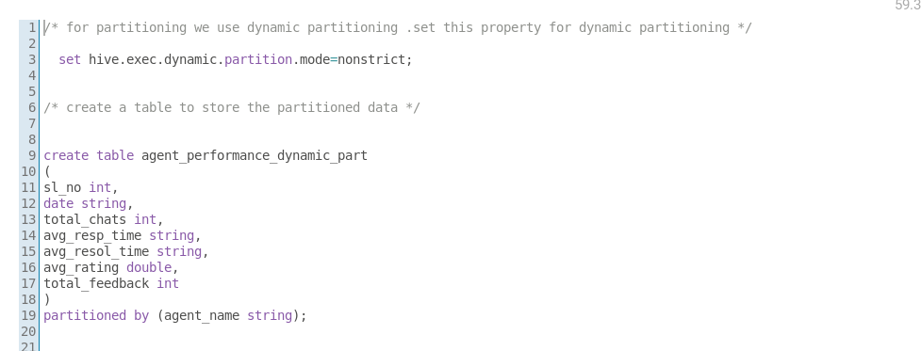

# since we have many agents. partition data based on agent_name

# ------> Note: The partition column/s should be used at last in select statement <--------

insert overwrite table agent_performance_dynamic_part partition(agent_name) select sl_no, date,total_chats, avg_resp_time, avg_resol_time, avg_resol_time, avg_rating total_feedback, agent_name

from agent_performance;

# you can check the partitions in hdfs

hadoop fs -ls /user/hive/warehouse/miniprojects.db/agent_performance_dynamic_part/*

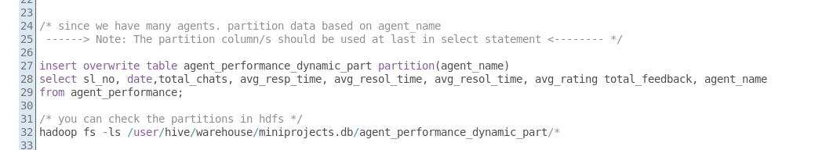

Bucketing

*********

# first set bucketing to true

set hive.enforce.bucketing=true;

create table bucket_agent_performance

(

sl_no int,

agent_name string,

date string,

total_chats int,

avg_resp_time string,

avg_resol_time string,

avg_rating double,

total_feedback int

)

clustered by (agent_name)

sorted by (sl_no)

into 4 buckets;

# create buckets

insert overwrite table bucket_agent_performance select * from agent_performance_dynamic_part;

# you can check the buckets in the hdfs

hadoop fs -ls /user/hive/warehouse/miniprojects.db/bucket_agent_performance/*

