**Objective:**

The assignment is meant for you to apply learnings of the module on Hive on a real-life dataset. One of the major objectives of this assignment is gaining familiarity with how an analysis works in Hive and how you can gain insights from large datasets.

**Problem statement:**

New York City is a thriving metropolis and just like most other cities of similar size, one of the biggest problems its residents face is parking. The classic combination of a huge number of cars and a cramped geography is the exact recipe that leads to a large number of parking tickets.

* **first create an external csv table which points to the data**

|  |  |
| --- | --- |
| 1  2  3  4  5  6  7  8  9 10 11 12 13 14 15 16 17 18 19 20 21 22 23 24 25 26 27 28 29 30 31 32 33 34 35 36 37 38 39 40 41 42 43 44 45 46 47 48 49 | **create** **external** **table** park_vio_ext_csv ( SUMMONS_NUMBER int, PLATE_ID string, REGISTRATION_STATE string, PLATE_TYPE string, ISSUE_DATE string, VIOLATION_CODE int, VEHICLE_BODY_TYPE string, VEHICLE_MAKE string, ISSUING_AGENCY string, STREET_CODE_1 int, STREET_CODE_2 int, STREET_CODE_3 int, VEHICLE_EXPIRATION_DATE int, VIOLATION_LOCATION string, VIOLATION_PRECINCT int, ISSUER_PRECINCT int, ISSUER_CODE int, ISSUER_COMMAND string, ISSUER_SQUAD string, VIOLATION_TIME string, TIME_FIRST_OBSERVED string, VIOLATION_COUNTRY string, VIOLATION_INFRONT_OF_OR_OPPOSITE string, HOUSE_NUMBER string, STREET_NAME string, INTERSECTING_STREET string, DATE_FIRST_OBSERVED int, LAW_SECTION int, SUB_DIVISION string, VIOLATION_LEGAL_CODE string, DAYS_PARKING_IN_EFFECT string, FROM_HOURS_IN_EFFECT string, TO_HOURS_IN_EFFECT string, VEHICLE_COLOR string, UNREGISTERED_VEHICLE string, VEHICLE_YEAR int, METER_NUMBER string, FEET_FROM_CURB int, VIOLATION_POST_CODE string, VIOLATION_DESCRIPTION string, NO_STANDING_OR_STOPPING_VIOLATION string, HYDRANT_VIOLATION string, DOUBLE_PARKING_VIOLATION string ) row format delimited fields terminated **by** ',' tblproperties("skip.header.line.count"="1"); |

* **Load data into park_vio_ext_csv table**

|  |  |
| --- | --- |
| 1 | **load** **data** **local** inpath 'file:///home/cloudera/Desktop/csv_files/Parking_Violations_Issued_-_Fiscal_Year_2017.csv' **into** **table** parking_vio_ext_csv; |

* **ORC is the optimized file format used in Hive for better analysis.**
* **So, create an external orc table to load the csv data into it.**
* **And also perform partitioning and bucketing on top of it.**

|  |  |
| --- | --- |
| 1  2  3  4  5  6  7  8  9 10 11 12 13 14 15 16 17 18 19 20 21 22 23 24 25 26 27 28 29 30 31 32 33 34 35 36 37 38 39 40 41 42 43 44 45 46 47 48 49 50 | **create** **external** **table** park_vio_ext_orc ( SUMMONS_NUMBER int, PLATE_ID string, REGISTRATION_STATE string, PLATE_TYPE string, ISSUE_DATE string, VIOLATION_CODE int, VEHICLE_BODY_TYPE string, VEHICLE_MAKE string, ISSUING_AGENCY string, STREET_CODE_1 int, STREET_CODE_2 int, STREET_CODE_3 int, VEHICLE_EXPIRATION_DATE int, VIOLATION_LOCATION string, VIOLATION_PRECINCT int, ISSUER_PRECINCT int, ISSUER_CODE int, ISSUER_COMMAND string, ISSUER_SQUAD string, VIOLATION_TIME string, TIME_FIRST_OBSERVED string, VIOLATION_INFRONT_OF_OR_OPPOSITE string, HOUSE_NUMBER string, STREET_NAME string, INTERSECTING_STREET string, DATE_FIRST_OBSERVED int, LAW_SECTION int, SUB_DIVISION string, VIOLATION_LEGAL_CODE string, DAYS_PARKING_IN_EFFECT string, FROM_HOURS_IN_EFFECT string, TO_HOURS_IN_EFFECT string, VEHICLE_COLOR string, UNREGISTERED_VEHICLE string, VEHICLE_YEAR int, METER_NUMBER string, FEET_FROM_CURB int, VIOLATION_POST_CODE string, VIOLATION_DESCRIPTION string, NO_STANDING_OR_STOPPING_VIOLATION string, HYDRANT_VIOLATION string, DOUBLE_PARKING_VIOLATION string ) partitioned **by** (violation_country string) clustered **by** (violation_code) sorted **by** (violation_code) into **5** buckets stored **as** orc; |

* **set some hive properties for dynamic_partition and bucketing**

|  |  |
| --- | --- |
| 1 2 3 | **set** hive.**exec**.**dynamic**.partition=**true**; set hive.**exec**.**dynamic**.partition.**mode**=nonstrict; set hive.enforce.bucketing=**true**; |

* **overwrite the orc table with csv table**
* **Filter the data of year 2017.**

|  |  |
| --- | --- |
| 1  2  3  4  5  6  7  8  9 10 11 12 13 14 15 16 17 18 19 20 21 22 23 24 25 26 27 28 29 30 31 32 33 34 35 36 37 38 39 40 41 42 43 44 45 46 47 | **insert** **into** park_vio_ext_orc partition(violation_country)  select  SUMMONS_NUMBER, PLATE_ID , REGISTRATION_STATE, PLATE_TYPE, ISSUE_DATE , VIOLATION_CODE, VEHICLE_BODY_TYPE, VEHICLE_MAKE, ISSUING_AGENCY, STREET_CODE_1, STREET_CODE_2 , STREET_CODE_3, VEHICLE_EXPIRATION_DATE, VIOLATION_LOCATION, VIOLATION_PRECINCT, ISSUER_PRECINCT, ISSUER_CODE, ISSUER_COMMAND, ISSUER_SQUAD, VIOLATION_TIME, TIME_FIRST_OBSERVED, VIOLATION_INFRONT_OF_OR_OPPOSITE, HOUSE_NUMBER, STREET_NAME, INTERSECTING_STREET, DATE_FIRST_OBSERVED, LAW_SECTION, SUB_DIVISION, VIOLATION_LEGAL_CODE, DAYS_PARKING_IN_EFFECT, FROM_HOURS_IN_EFFECT, TO_HOURS_IN_EFFECT, VEHICLE_COLOR, UNREGISTERED_VEHICLE, VEHICLE_YEAR, METER_NUMBER, FEET_FROM_CURB, VIOLATION_POST_CODE, VIOLATION_DESCRIPTION, NO_STANDING_OR_STOPPING_VIOLATION, HYDRANT_VIOLATION, DOUBLE_PARKING_VIOLATION, VIOLATION_COUNTRY from park_vio_ext_csv where issue_date **like** '%2017'; |

**Part-I: Examine the data**

**1.)**

|  |  |
| --- | --- |
| 1 2 3 | /* total tickets */  select **count**(*) **as** total_tickets **from** park_viol_ext_orc; |

**2.)**

|  |  |
| --- | --- |
| 1 2 | /* unique registration states */ select **count**(**distinct**(registration_state)) **as** number_of_states **from** park_vio_ext_orc; |

**3.)**

|  |  |
| --- | --- |
| 1 2 3 4 | /* parking tickets don’t have addresses on them */  select **count**(*) **as** tickets_not_having_address **from** park_viol_ext_orc where street_code_1 = **0** **or** street_code_2 = **0** **or** street_code_3 = **0**; |

**Part-II: Aggregation tasks**

**1.)**

* **frequency of violation codes - find the top 5**

|  |  |
| --- | --- |
| 1 2 3 4 5 6  7 | /* group the data by violation code to find the frequency of each code */  select violation_code , **count**(*) **as** frequency **from** park_vio_ext_orc group **by** violation_code sort **by** frequency **desc** **limit** **5**; |

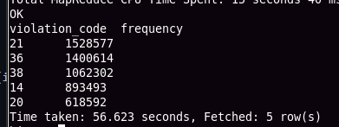

**2.)**

**a.**

* **Frequencies of vehicle body top 5**

|  |  |
| --- | --- |
| 1 2 3 4 5 6 7 | /* group the data by vehicle body to find the frequency */  select vehicle_body_type, **count**(*) **as** ticket_count from park_vio_ext_orc group **by** vehicle_body_type sort **by** ticket_count **desc** **limit** **5**; |

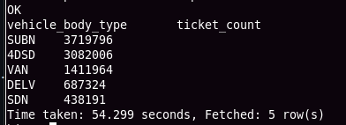

**b.**

* **Frequencies of vehicle make top 5**

|  |  |
| --- | --- |
| 1 2 3 4 5 6 7 | /* group the data by vehicle body to find the frequency */  select vehicle_make, **count**(*) **as** ticket_count from park_vio_ext_orc group **by** vehicle_make sort **by** ticket_count **desc** **limit** **5**; |

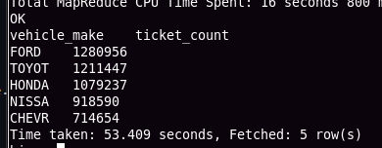

**3.)**

**a.**

* **Frequencies of Violation precincts**

|  |  |
| --- | --- |
| 1 2 3 4 5 6 7 | /* group the data by violation precinct and find frequencies of each */  select violation_precinct, **count**(*) **as** frequency from park_vio_ext_orc group **by** violation_precinct sort **by** frequency **desc** **limit** **5**; |

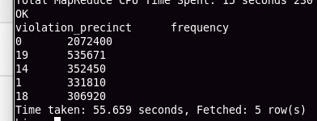

**b.**

* **Frequencies of issuer precincts**

|  |  |
| --- | --- |
| 1 2 3 4 5 6 7 | /* group by issuer precinct and find the frequencies of each */  select issuer_precinct, **count**(*) **as** frequency from park_vio_ext_orc group **by** issuer_precinct sort **by** frequency **desc** **limit** **5**; |

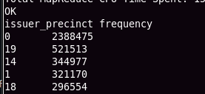

**4.)**

* **Find the violation code frequency across 3 precincts which have issued the most number of tickets**

|  |  |
| --- | --- |
| 1 2 3 4 5 6 7 | /* find the top 3 issuer_precinct */  select issuer_precinct,**count**(*) **as** frequency from park_vio_ext_orc group **by** issuer_precinct sort **by** frequency **desc** **limit** **3**; |

|  |  |
| --- | --- |
| 1  2  3  4  5  6  7  8  9 10 | /* from the above queryissuer_precincts are 0, 19,14. Based on the result perform group by violation_code */  select violation_code, sum(**case** **when** issuer_precinct = **0** **then** **1** **else** **0** **end**) **as** issuer_0, sum(**case** **when** issuer_precinct = **19** **then** **1** **else** **0** **end**) **as** issuer_19, sum(**case** **when** issuer_precinct = **14** **then** **1** **else** **0** **end**) **as** issuer_14 from park_vio_ext_orc a where a.issuer_precinct **in** (**0**,**19**,**14**) group **by** violation_code; |

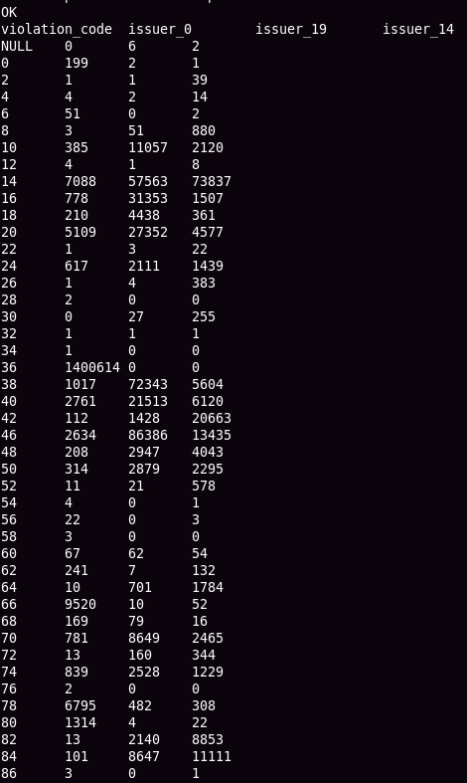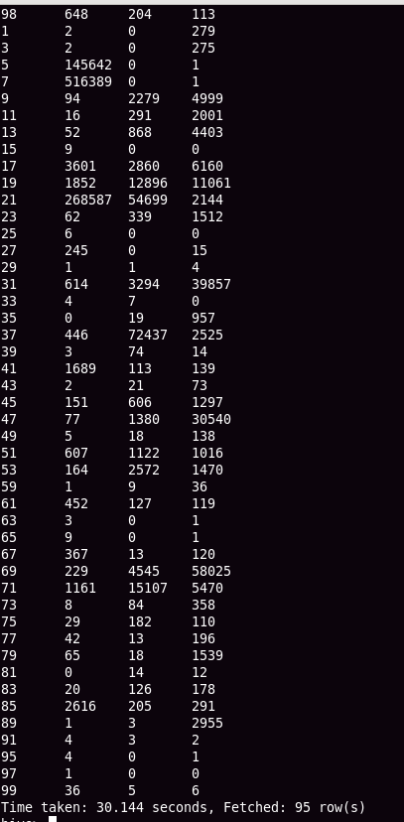

**5.)**

* **Divide time based on AM and PM**
* **Find the frequencies for them.**

|  |  |
| --- | --- |
| 1  2  3  4  5  6  7  8  9 10 11 12 13 14 15 16 17 18 19 20 21 22 23 24 25 26 27 28 29 | /*  1.) filter data where violation_time has A or P at the end. 2.) And consider the data where hour in violation_time is from 1 - 12 3.) Append the date time and convert them into unix_timestamp. 4.) Now perform group by on violation_code which results the count of each violation_code in AM and PM  */  with data_2017 **as** ( select registration_state, issue_date, violation_code, violation_precinct,  issuer_precinct, violation_time, violation_country from park_vio_ext_orc  where (violation_time **like** '%P' **or** violation_time **like** '%A') **and**  (**cast**(**substring**(violation_time,**1**,**2**) **as** int) > **0** **and**  cast(**substring**(violation_time,**1**,**2**) **as** int) <=**12**) ), change_time **as** ( select registration_state,issue_date, violation_code, violation_precinct, issuer_precinct,  concat(**substring**(violation_time,**1**,**2**),':',**substring**(violation_time,**3**,**2**),':00 ',**substring**(violation_time,**5**,**1**),'M') **as** violation_time, violation_country **from** data_2017 ) select violation_code, sum(**case** **when** violation_time **like** '%AM' **then** **1** **else** **0** **end**) **as** AM, sum(**case** **when** violation_time **like** '%PM' **then** **1** **else** **0** **end**) **as** PM from change_date group **by** violation_code; |

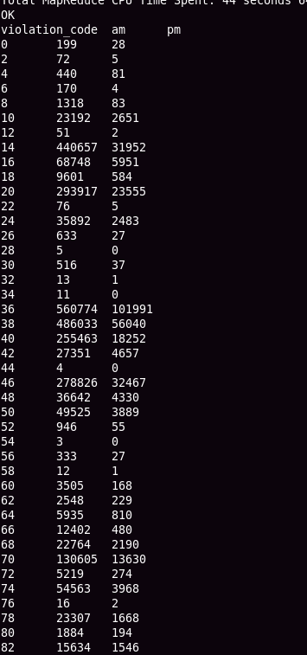

**6.)**

* **create external table to store only required fileds from main data after applying all the filtering.**

|  |  |
| --- | --- |
| 1  2  3  4  5  6  7  8  9 10 | **create** **external** **table** filtered_data_orc  ( registration_state string, date_time string, violation_code int, violation_precinct int, issuer_precinct int, violation_country string ) stored **as** orc; |

* **The below code is written with the help of common table expressions.**
* **1.) filter the data**
* **2.) convert the date in string format to unix_timestamp and time to hh:mm:ss format**
* **3.) combine the time and date and convert both to unix_time**
* **4.) insert the final modified data into filtered_data_orc table**

|  |
| --- |
| **with** data_2017 **as** ( select registration_state, issue_date, violation_code, violation_precinct, issuer_precinct, violation_time, violation_country from park_vio_ext_orc  where (violation_time **like** '%P' **or** violation_time **like** '%A') **and**  (**cast**(**substring**(violation_time,**1**,**2**) **as** int) > **0** **and** **cast**(**substring**(violation_time,**1**,**2**) **as** int) <=**12**) ), change_date **as** ( select registration_state, from_unixtime(unix_timestamp(issue_date,'MM/dd/yyyy'),'yyyy-MM-dd') **as** date, violation_code, violation_precinct, issuer_precinct,  concat(**substring**(violation_time,**1**,**2**),':',**substring**(violation_time,**3**,**2**),':00 ',**substring**(violation_time,**5**,**1**),'M') **as** violation_time,  violation_country  from data_2017 ),  combine_date_time **as** ( select registration_state, from_unixtime(unix_timestamp(concat(date,violation_time),'yyyy-MM-ddhh:mm:ss a'),'yyyy-MM-dd hh:mm:ss a') **as** date_time, violation_code, violation_precinct, i ssuer_precinct,violation_country  from change_date ) from combine_date_time  insert overwrite **table** filtered_data_orc **select** *; |

* **Now from the filtered_data_orc table group the hours into six groups.**
* **Find the frequency of each violation_code in that particular interval group**

|  |
| --- |
| **with** time_groups **as** ( select violation_code , sum(**case** **when** (date_time **like** '%AM' **and** hour(date_time) **in** (**12**,**1**,**2**,**3**)) **then** **1** **else** **0** **end**) **as** **12**_AM_to_4_AM, sum(**case** **when** (date_time **like** '%AM' **and** hour(date_time) **in** (**4**,**5**,**6**,**7**)) **then** **1** **else** **0** **end**) **as** **4**_AM_to_8_AM, sum(**case** **when** (date_time **like** '%AM' **and** hour(date_time) **in** (**8**,**9**,**10**,**11**)) **then** **1** **else** **0** **end**) **as** **8**_AM_to_12_PM, sum(**case** **when** (date_time **like** '%PM' **and** hour(date_time) **in** (**12**,**1**,**2**,**3**)) **then** **1** **else** **0** **end**) **as** **12**_PM_to_4_PM, sum(**case** **when** (date_time **like** '%PM' **and** hour(date_time) **in** (**4**,**5**,**6**,**7**)) **then** **1** **else** **0** **end**) **as** **4**_PM_to_8_PM, sum(**case** **when** (date_time **like** '%PM' **and** hour(date_time) **in** (**8**,**9**,**10**,**11**)) **then** **1** **else** **0** **end**) **as** **8**_PM_to_12_PM from filtered_data_orc group **by** violation_code ) select violation_code, **12**_AM_to_4_AM  from time_groups sort **by** **12**_AM_to_4_AM **desc** **limit** **3**; |

* **Similarly for all the time intervals**

|  |  |
| --- | --- |
| 1  2  3  4  5  6  7  8  9 10 11 12 13 14 15 16 17 18 19 20 21 22 23 24 25 26 27 28 29 30 | /* similarly for all other groups */  select violation_code, **4**_AM_to_8_AM  from time_groups sort **by** **4**_AM_to_8_AM **desc** **limit** **3**;   select violation_code, **8**_AM_to_12_PM  from time_groups sort **by** **8**_AM_to_12_PM **desc** **limit** **3**;   select violation_code, **12**_PM_to_4_PM  from time_groups sort **by** **12**_PM_to_4_PM **desc** **limit** **3**;   select violation_code, **4**_PM_to_8_PM  from time_groups sort **by** **4**_PM_to_8_PM **desc** **limit** **3**;   select violation_code, **8**_PM_to_12_PM from time_groups sort **by** **8**_PM_to_12_PM **desc** **limit** **3**; |

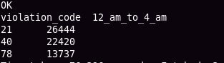

**7.)**

* **first find the 3 most commonly occurring violation codes**

|  |  |
| --- | --- |
| 1 2 3 4 5 | **select** violation_code, **count**(*) **as** frequency from filtered_data_orc group **by** violation_code sort **by** frequency **desc** **limit** **3;** |

* **So, the top 3 violation_codes are 21, 36, 38**
* **And the frequencies of these top 3 violation_code in all the intervals**

|  |
| --- |
| **select** violation_code, sum(**case** **when** (date_time **like** '%AM' **and** hour(date_time) **in** (**12**,**1**,**2**,**3**)) **then** **1** **else** **0** **end**) **as** **12**_AM_to_4_AM, sum(**case** **when** (date_time **like** '%AM' **and** hour(date_time) **in** (**4**,**5**,**6**,**7**)) **then** **1** **else** **0** **end**) **as** **4**_AM_to_8_AM, sum(**case** **when** (date_time **like** '%AM' **and** hour(date_time) **in** (**8**,**9**,**10**,**11**)) **then** **1** **else** **0** **end**) **as** **8**_AM_to_12_PM, sum(**case** **when** (date_time **like** '%PM' **and** hour(date_time) **in** (**12**,**1**,**2**,**3**)) **then** **1** **else** **0** **end**) **as** **12**_PM_to_4_PM, sum(**case** **when** (date_time **like** '%PM' **and** hour(date_time) **in** (**4**,**5**,**6**,**7**)) **then** **1** **else** **0** **end**) **as** **4**_PM_to_8_PM, sum(**case** **when** (date_time **like** '%PM' **and** hour(date_time) **in** (**8**,**9**,**10**,**11**)) **then** **1** **else** **0** **end**) **as** **8**_PM_to_12_PM from filtered_data_orc  where violation_code **in** (**21**,**36**,**38**) group **by** violation_code; |

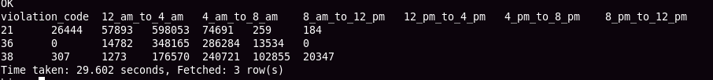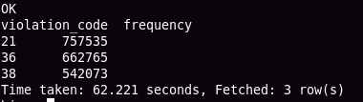

**8)**

**a.)**

* **frequency of tickets for each of the seasons**

|  |
| --- |
| **select** **sum**(**case** **when** **month**(date_time) **in** (**3**,**4**,**5**) **then** **1** **else** **0** **end**) **as** spring, sum(**case** **when** **month**(date_time) **in** (**6**,**7**,**8**) **then** **1** **else** **0** **end**) **as** summer, sum(**case** **when** **month**(date_time) **in** (**9**,**10**,**11**) **then** **1** **else** **0** **end**) **as** fall, sum(**case** **when** **month**(date_time) **in** (**12**,**1**,**2**) **then** **1** **else** **0** **end**) **as** winter from filtered_data_orc; |

**b.)**

* **3 most common violations in these seasons**

|  |
| --- |
| **with** cte **as** ( select violation_code, sum(**case** **when** **month**(date_time) **in** (**3**,**4**,**5**) **then** **1** **else** **0** **end**) **as** spring, sum(**case** **when** **month**(date_time) **in** (**6**,**7**,**8**) **then** **1** **else** **0** **end**) **as** summer, sum(**case** **when** **month**(date_time) **in** (**9**,**10**,**11**) **then** **1** **else** **0** **end**) **as** fall, sum(**case** **when** **month**(date_time) **in** (**12**,**1**,**2**) **then** **1** **else** **0** **end**) **as** winter from filtered_data_orc group **by** violation_code ) /* This selects for spring season */ select violation_code,spring from cte order **by** spring **desc** **limit** **3**; |

* **Similarly for all the seasons**

|  |  |
| --- | --- |
| 1  2  3  4  5  6  7  8  9 10 11 12 13 14 15 16 17 | /* similarly for all the seasons */  select violation_code,summer from cte order **by** summer **desc** **limit** **3**;  select violation_code,fall from cte order **by** fall **desc** **limit** **3**;   select violation_code,winter from cte order **by** winter **desc** **limit** **3**; |

