**Tribhuvan University**

**Faculty of Humanities and Social Sciences**

**AGRICULTURE PRODUCT MANAGEMENT SYSTEM**

**A PROJECT REPORT**

**Submitted to**

**Department of Computer Application**

**The Times International College**

***In partial fulfilment of the requirements for the***

***bachelor’s in computer application***

Submitted by

Name: **Rakesh Tamang**

Roll no:

Name**: Sagar Bahadur Magar**

Roll no:

Under the Supervision of

**Mr. Subhash Belbase**

# **Introduction**

APMS is a web based platform which helps farmer to improve their profitability. It enables farmers to sell their products through online without the middle-man directly to the consumer. This platform will try to eliminate the need of the middle-man between the seller and the buyer. In context of our country middle-man hurt both farmers and consumers middle-man take away profit that could otherwise go to farmers.

According to the data, 66% people of our country are directly engaged in farming and it contributes to 23.13% of the GDP of the country but farmers have limited access to market and new technologies. If we connect the farmers with the technology it will give them the opportunity to sell their product at a right time and right price without the need of the middle-man.

` There are three kinds of users for the proposed system.

* Administrators: Administrators are the one who has full privilege of the websites.
* Sellers: Sellers are the farmers and they can sell their products through online after the registration. After registration the farmer can login into the system by entering login id and password.
* Customer: Customers can buy products through online.

**Problem Statement**

The problem that usually arises in online auction is that of the buyers uncertainly towards the sellers and their products due to lack of physical evaluation of the products despite the increased numerous advantages of online auction there are problems that are still present, unlike in offline markets where buyers can physically evaluate the product quality and interact directly with the sellers, in online markets the buyers do not have such opportunity as the buyers only get to evaluate the product quality via the internet interface that cannot perfectly describe the product. The problem of product and the sellers uncertainly negatively affects the key success of the outcomes of the online auctions. The implementation of an online auction system that provides detailed seller and product description results in the increased certainly of the bidders towards the choice of the products and sellers that they make.

**Objectives**

1. Developing Agriculture management system to help to improve the profitability.
2. The farmers can sell their products through online and customer can buy directly.
3. To provide the wider market opportunity to the farmer so, that they can sell their product at right time.

**Methodology**

After analyzing all the available data models we found out that prototyping will be suitable for our project as we aim in achieving the best possible interface and interaction which will be ensured by the end user with frequent feedbacks with the help of prototyping even the errors are detected earlier working with this model helps to reduce the testing, debugging becomes earlier and end up with a reliable system.

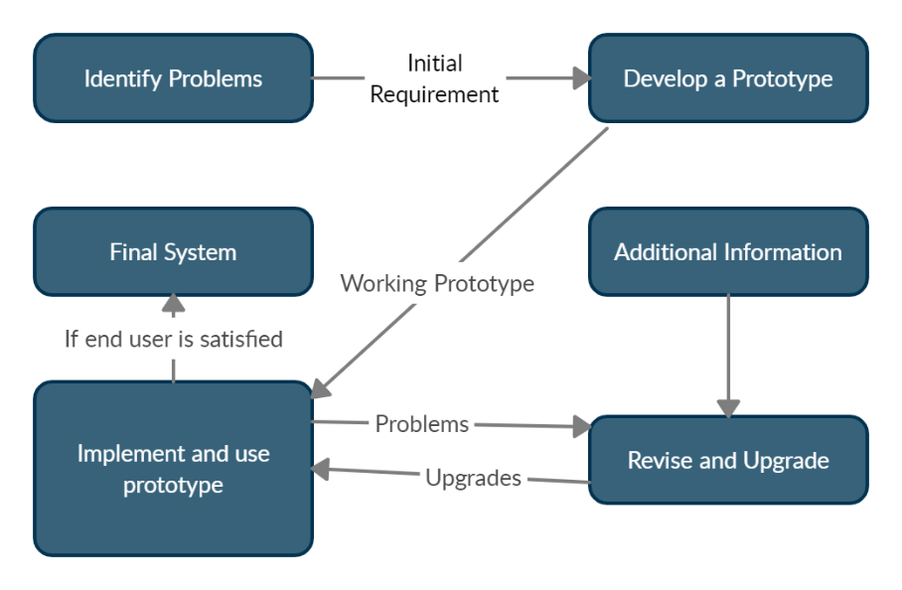

**Fig: Prototyping Model**

**Requirement Identification**

**Study of the existing system**

The first part of the project is an investigation of already existing online auction systems around the net. We considered three of the most famous auction web sites: eBay.com, asteinrete.com and onsale.com. All the three systems give the possibility to register, to login to the website and have a home page with a general description of the portal. They also offer a personal page, where each user can check the status of their auctions or of their offers. But the rating functionality not available on that portals. This existing system only allows to bid the products. But the main drawback is that there is no effective and particular method to prevent the users from giving false identity and hence the system fails in providing a secured environment.

**Requirement collection**

There are many requirements for the system. Requirements regarding how to build the system what type of features to be added, gathering information from existing system etc. The primary requirement collection was done with users of existing system and note down all the features and experience they will mostly prefer. The secondary collection was done through online research.

**System requirement**

**Hardware Requirements**

* Processor: AMD Ryzen 5 3500U @2.1 GHz
* Storage: 128 GB SSD
* Components: Keyboard, Mouse, 15-inch screen, Camera

**Software Requirements**

* OS: Windows 10 Home 2019
* Design Editor: Adobe Photoshop
* Code Editor: Visual Studio, Sublime Text 3
* Browser: Chrome, Firefox etc.
* Screenshots: Sniping tool
* Server: Xampp (Apache Server, Maria DB)

**Language Requirement**

* Front-end: HTML,CSS, JAVASCRIPT
* Back-end: PHP, MYSQL
* Framework: BOOTSTRAP, JQUERY

**Feasibility Study**

A Feasibility Study is an analysis that considers all of a projects relevent factors including economic, technical , legal and scheduling considerations to as certain the likelihood of completing the project successfully. It is measure of how beneficial development of system is to an organization. Information such as resource availability costestimation for software development benefits of the software to the organization aftwer it is developed and cost to be incurred on its maintenance are considered during feasibility study.

**Economic Feasibility:**

Economic feasibility typically involoves a cost/benefits analysis of the project, helping the organization to determine the viability cost and benefits associated with a project before financial resources are allocated. We have also conducted the study and our system doesn’t require huge amount money. Also no external manpower is required for its development and the system will be developed by two person. The prototype development cost will be also minimal. These overall all factor has made our project economically feasiable.

**Technical Feasibility:**

It focuses on the technical resources available. It helps to determine whether the technical resources meet capacity and whether the technical team is capable of converting the ideas into working systems. Technical Feasibility also involves the evaluation of the hardware, software and other technical requirements of the proposed system. We have required resources and manpower for developing our system. We have considered our system is technically feasible to develop .

**Operational Feasibility:**

Operational feasibility is mainly concerned with issues like whether the system will be used if it is developed and implemented. Whether there will be resistance from users that will effect the possible application benefits. It also determines how it will satisfy every requirement identified in its requirement analysis phase.

This system is small and needs small number of resources. Devices with minimum specification can meet hardware and software requirement. The proposed development fits with the objectives and environment, regarding the existing processes. Therefore this system is feasible in operation.

**High-Level Design**



**Fig (a) 0 level context diagram**

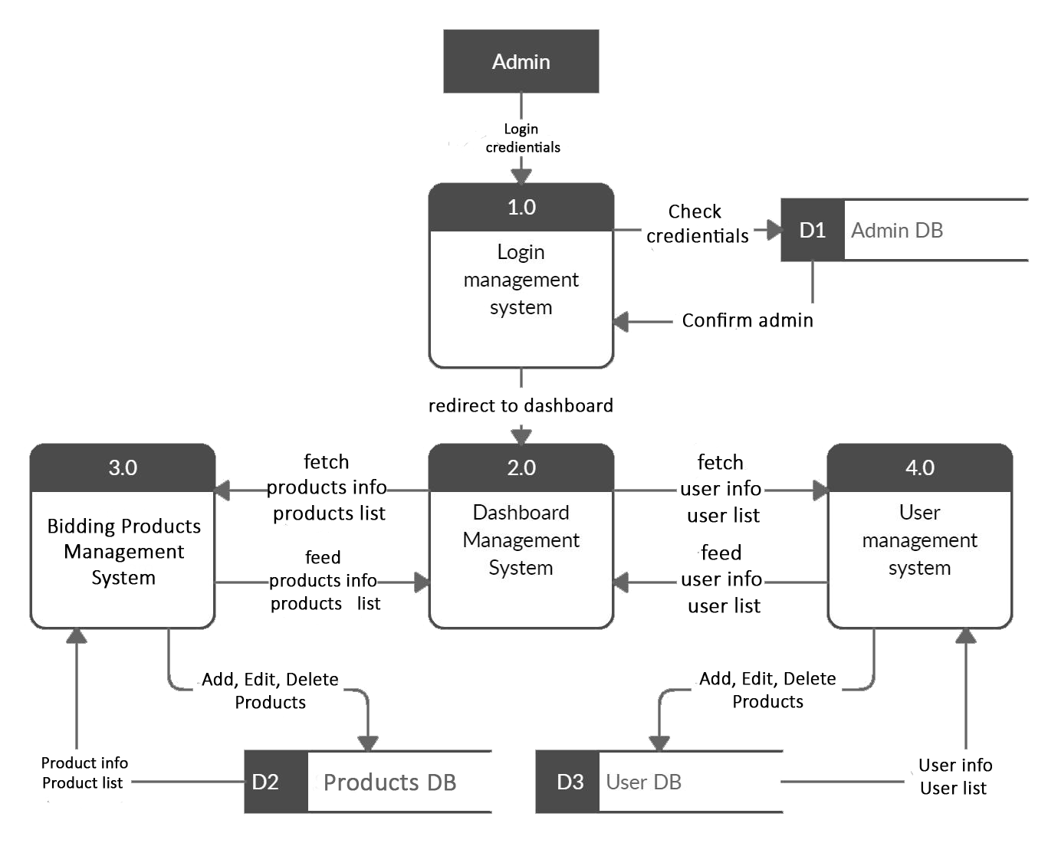

**Fig (b) context diagram of admin**

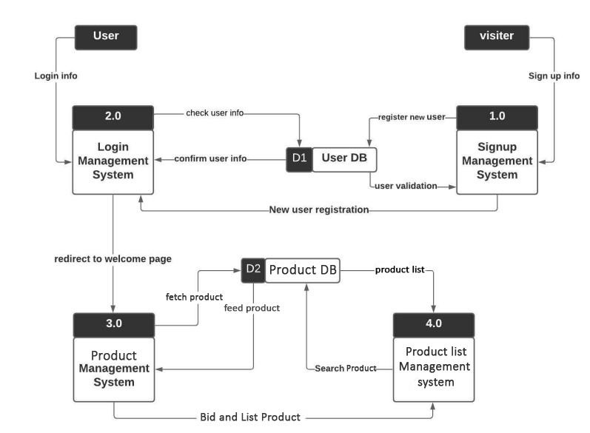

**Fig (c) context diagram of user**

**ER DIAGRAM**

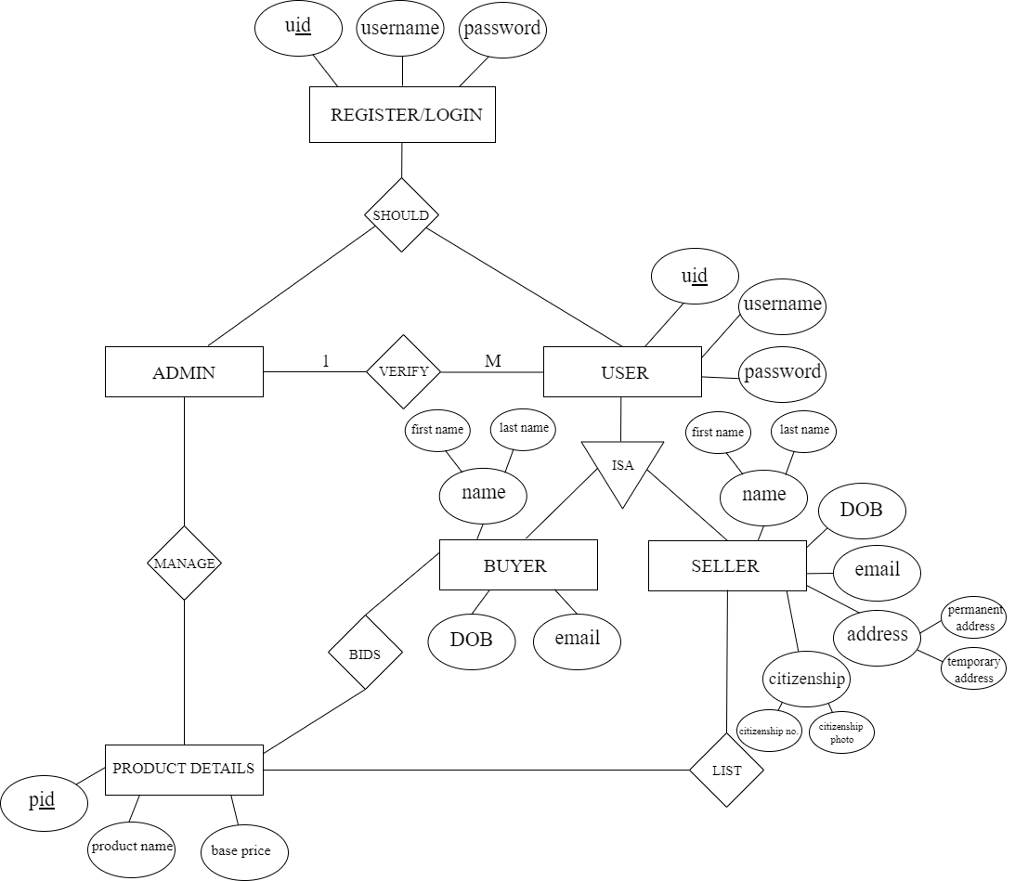

**USE CASE DIAGRAM**

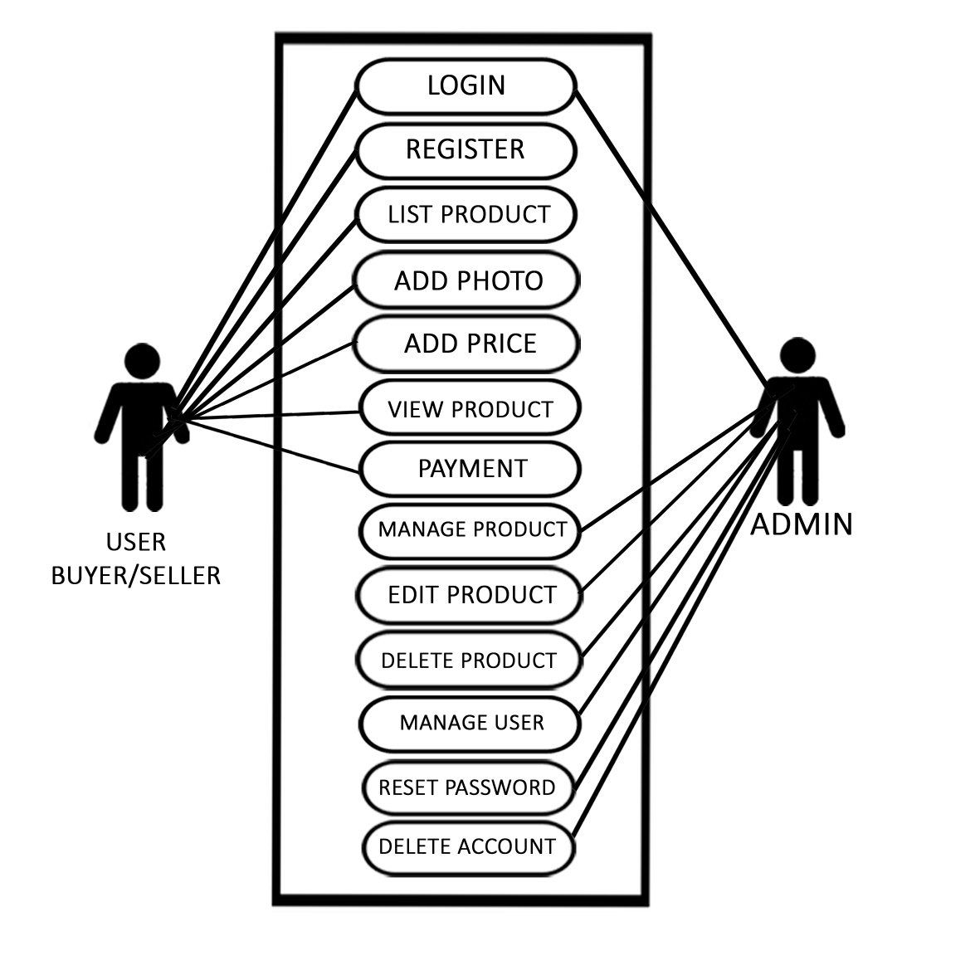

**Gantt Chart(2078/79)**

|  |  |  |  |  |  |  |  |  |  |  |  |  |  |  |  |  |  |  |  |
| --- | --- | --- | --- | --- | --- | --- | --- | --- | --- | --- | --- | --- | --- | --- | --- | --- | --- | --- | --- |
| **Weeks** | | | | | | | | | | | | | | | | | | | |
| Poush | | | | Magh | | | | Falgun | | | | Chaitra | | | | Baisakh | | | |
| **S.N** | Activity | 1 | 2 | 3 | 4 | 5 | 6 | 7 | 8 | 9 | 10 | 11 | 12 | 13 | 14 | 15 | 16 | 17 | 18 | 19 | 20 |
| 1 | Project Definition |  | | |  |  |  |  |  |  |  |  |  |  |  |  |  |  |  |  |  |
| 2 | Deliver Proposal |  | | |  |  |  |  |  |  |  |  |  |  |  |  |  |  |  |  |  |
| 3 | Proposal Defense |  |  |  |  |  |  |  |  |  |  |  |  |  |  |  |  |  |  |  |  |
| 4 | Documentation |  |  |  |  |  |  |  |  |  |  |  |  |  |  |  |  |  |  |  |  |
| 5 | Overview and Analysis |  |  |  |  |  |  |  |  |  |  |  |  |  |  |  |  |  |  |  |  |
| 5 | Designing |  |  |  |  |  |  |  |  |  |  |  |  |  |  |  |  |  |  |  |  |
| 7 | Coding |  |  |  |  |  |  |  |  |  |  |  |  |  |  |  |  |  |  |  |  |
| 8 | Implementation & Testing |  |  |  |  |  |  |  |  |  |  |  |  |  |  |  |  |  |  |  |  |
| 9 | Submission & Presentation |  |  |  |  |  |  |  |  |  |  |  |  |  |  |  |  |  |  |  |  |

# **Expected Outcome**

With this system, we hope our users will enjoy and like a new way of streaming music. This proposal suits our needs and will definitely fulfill user criteria. Our expected outcome is to achieve our goals.

* Clean and informative user interface with easy user experience.
* Secure user privacy and encrypted password system.
* Informative and accurate search results.
* Secure system that is invulnerable to XSS attack.
* Punctual documentations.