***ML-Predictive-Modeling-of-Multiple-Lung-Diseases-A-Machine-Learning-Approach***

***Abstract*—**COVID-19 is still shifting its forms and wreaking havoc by creating new variants as it spreads rapidly. Since its inception, early detection with precise result has been a major issue. Now, different detection methods are being coined among which deep learning models with medical imaging techniques that is using chest X-Ray images and CTScan images with consolidated datasets from different places is popular. Most of the researchers conducted their research based on the pre trained models. In this review paper, the most commonly used transfer learning models, fine tuning models and some other models are discussed along with its accuracy and effectiveness in detection of COVID-19. Lack of datasets and different approaches used to overcome these issues are also briefly discoursed.

***Keywords—*** *Covid-19, Convolutional Neural Network (CNN), Image processing, Chest x-ray (CXR), Datasets, Transfer Learning, Pre-trained Architecture*

# **I. INTRODUCTION**

November 17, 2019, a 55-year-old individual from Hubei province in China is known to be infected by Covid-19. Later in

March 2020, The World Health Organization (WHO) acknowledged transmission of Covid-19 as a global issue and declared it to be a pandemic [1]. Doctors and Scientists suspect that the Covid-19 originated from bats but are still trying to figure out the actual origination of Covid-19. Respiratory droplets of infectious patients that are produced through coughing, sneezing spreads the disease not only between humans but also from humans to animals. Mild to serious symptoms are seen in both human and animals including fever, cough, sore throat, diarrhea, fatigue, breathlessness etc. This situation quickly turned into chaos and people were forced to stay behind the closed doors since many countries imposed lockdown as an immediate way to control the rapid spread of disease [2]. The following graph depicts some of the most affected countries by covid-19.

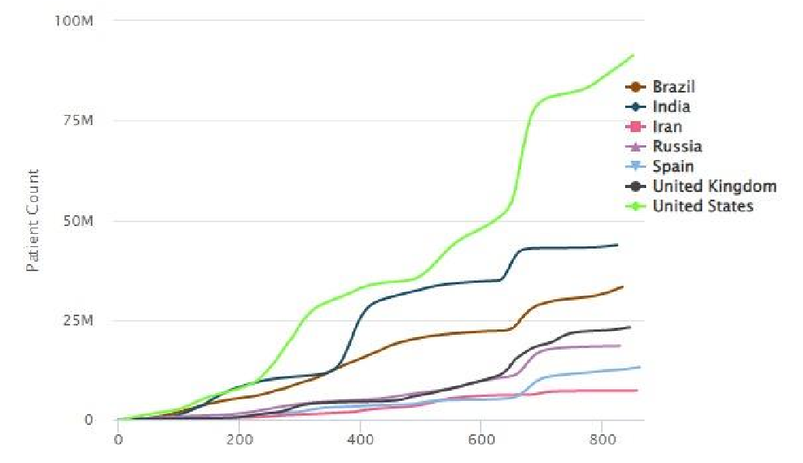 Figure 1 Top country with cumulative covid-19 cases [3]

Eventually, the skyrocketing Covid-19 cases each day and lack of efficient testing kits made the situation out of control. Today, Reverse Transcription Polymerase Chain Reaction known as RT-PCR is well known mechanisms for detecting Covid-19 [4]. Due to its tedious, time-consuming nature, painful and costly procedure, people started looking for the alternative approach of RT-PCR [5].

Through various tests and research, it was concluded that lungs were the most affected organ and there are several medical imaging techniques to detect lungs infection. Some of them include Chest X-ray (CXR), Computed Tomography (CT) [6]. Computer Vision, Artificial Intelligence, Deep Learning are some of the profound methods researchers have used for the uncovering Covid-19 from the infected person’s chest X-ray and CT. Because of recent advancement in Deep learning, it has been in use for some time and is being used for object tracking, facial recognition and so on. Medical Imaging is progressing steadily which demonstrates the real example of increased interest in using Deep Learning mechanism for Covid-19 discovery [6]– [14]. In traditional methods, features needed to be hand-picked but in Convolutional Neural Network (CNN) architecture, a model can be trained to pick up the best probable feature for the dataset in use [15].

In this paper, we will focus our review with deep learning architecture and parameters to evaluate different available Deep Learning models like CNN, ResNet-50, VGG-16, InstaCovNet19, Inception, along with the methods, the datasets used, metrics that are currently in use for comparison.

This section explains basic concepts of convolutional neural network, transfer learning, ResNet-18, VGG-16 and Inception model for covid-19 detection. So, it is necessary to be familiar with various types of deep learning models.

1. *Convolutional Neural Network* 
   1. type of artificial neural network known as a Convolutional Neural Network uses several perceptron to evaluate picture inputs and have learnable bases and weights for various image components that can be used to separate them from one another [16]. Moreover, it is a feed-forward neural network with multiple layers of neural networks built on top of one another. CNNs are also known as ConvNets which is constructed of three primary layers: a convolutional layer, a pooling layer and a fully connected layer. The reduction of ANN's parameter count is CNNs' most advantageous feature.
2. *Transfer Learning*

The storage of knowledge discovered while solving one problem and its subsequent application to other connected problems is the focus of the Machine Learning study area known as Transfer Learning. For instance, the skills used while learning to identify vehicles can be used when attempting to identify trucks. Essentially, attempt to use the knowledge gained from one assignment to enhance generalization in another. We transfer the learned weights from model "A" to model "B" in a network.

1. *VGG-16*

The VGG architecture was initially created for applications involving image recognition. In VGG, 16 and 19 weight layers are utilized with a 3*3 convolutional filter size. The VGG-16 has been trained on almost one million images. It can classify images into 1000 different categories. Similarly, in 2014, the network took first and second place in the ILSVR (ImageNet) competition [13], [17]. On the 14 million photos from 1000 different classes that make up the ImageNet dataset, this model achieves top-5 test accuracy of 92.7 percent.

1. *Inception V3* 
   1. deep learning model for categorizing images that is based on Convolutional Neural Networks is called Inception V3. The Inception V3 is a superior variety of the basic model Inception V1 which was introduced as GoogleNet in 2014. As the name suggests it was developed by Google. The inception V3 model has a total of 42 layers, which is a small increase over the inception V1 and V2 models. Nevertheless, the efficiency of the model is quite outstanding. As a result, numerous researchers employed this model for Covid-19 identification.

III. SUMMARY OF RESEARCH METHODS

Whenever we talk about the deep learning models and research there is always one constrains that always prevails i.e., enough publicly available training and testing data. For solving this problem, the superior way would be using Transfer Learning and fine-tuning techniques. Data augmentation techniques used to mirror the image, rotate the image to produce much more data sets from a single data set. The majority of the works and research are being done in the pre-trained datasets and models from ImageNet. Every year CCN architectures with transfer learning is being improved and are being used. This section specifies Transfer Learning and fine-tuning, CNN architectures along with some other methods used to detect COVID-19.

*A. Methodologies*

The majority of researchers utilize transfer learning the most since it includes a large number of freely available pre-trained modules. Every year ImageNet organizes a competition where researchers introduce different Transfer Learning and finetuning models and techniques. Although researchers use different architectures the methods used are same. Every year we can see difference in the CCN models which helps in transfer learning when datasets are small [18], [19]. A lot of deep learning architectures can be found as of now which users transfer learning method in ImageNet.

Table 1 Available Models in Keras Applicaton alongside pre-trained weights

[20]

|  |  |  |
| --- | --- | --- |
| **Model** | **Top-5 Accuracy** | **Parameter** |
| Xception | 94.5% | 22.9M |
| VGG16 | 90.1% | 138.4M |
| VGG19 | 90.0% | 143.7M |
| ResNet50 | 92.1% | 25.6M |
| ResNet50V2 | 93.0% | 25.6M |
| ResNet101 | 92.8% | 44.7M |
| ResNet101V2 | 93.8% | 44.7M |
| ResNet152 | 93.1% | 60.4M |
| ResNet152V2 | 94.2% | 60.4M |
| InceptionV3 | 93.7% | 23.9M |
| InceptionResNetV2 | 95.3% | 55.9M |
| MobileNet | 89.5% | 4.3M |
| MobileNetV2 | 90.1% | 3.5M |
| DenseNet121 | 92.3% | 8.1M |
| DenseNet169 | 93.2% | 14.3M |

Different variance can be seen where replacing the traditional fully connected layers. The global average pooling layer in CNN is created by averaging each feature map and putting the resultant vector directly into the soft max layer [21]. Result sets obtained before image augmentation and after image augmentation on different modules SqueezeNet [22], MobileNetV2, ResNet50 [23], InceptionV3 [19], VGG16, AlexNet50 [24] along with its accuracy precision and sensitivity [25], [26].

Fine-Tuning is another approach that is widely being used. The CNN, VGG16, VGG19, DenseNet201, Inception ResNet V2, Inception V3, Xception, Resnet50, and MobileNet V2 designs have their top layers fine-tuned [27]. Each pixel in the image has a membership degree to each window in the fuzzy color technique. The weights of each blurred window are averaged to get the final image.

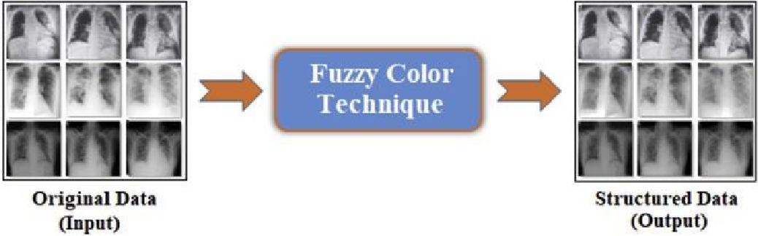

Figure 2 Sub-data sample of the original dataset obtained by the Fuzzy Color technique [28]

After creating first dataset from fuzzy color technique, by combining other datasets and original data other datasets were created [28].

With no data augmentations and a small dataset requirement, COVID-CAPS is a capsule network-based framework for detecting the presence of COVID infection from chest X-ray and CT scan images. To solve the lack of testing data images more weights were given to positive cases and less weights given to the negative cases [29].

InstaCovnet-19, a deep CNN (DCNN) used multiple pretrained modules stacked one above another to overcome the use of randomly initialized weights. Inception v3, MobileNetV2, ResNet101, NASNet and Xception were used along with two dense layers as integrated Stacking. Because of unique feature extraction technique, provided a better and improved

classification. Accuracy in the results were seen above 99% for InstaCovnet-19 [30].

CovidAID, which contained pre-trained CheXNet [31], and a 121-layer Dense Convolution Network (DenseNet) with as fully connected layer along its side. It used a sigmoid activation to produce the final output. While comparison with COVIDNet, CovidAID produced a significant better result in COVID detection using Chest X-ray images [32].

Use of LeakyRelu activation instead of relu activation function which were originally used to create a unique method than others although it used similar transfer learning techniques. It helped to solve the problem of dead neurons due to the use of relu neurons of zero slopes [33]. COVID-XNet, which consists of 5 convolutional layer, 4 max pooling layers, a GAP layer, and a softmax layer is Novel architecture which uses DSCNN to categorize CXR images for detecting Covid [34].

Fast COVID-19 Detector (FCOD) model uses depth wise separable convolution layers. Depth wise separable convolution uses less layers than the other basic architectures and decreases the computational complexity and computational time [35]. Research is not only limited to the COVID-19 detection but also to be able to differentiate between COVID-19 infection and Pneumonia infection which somehow display the analogous characteristics. Xpection and ResNet50V2 Network using partially feature extraction for better result accuracy [36].

# IV. DATASETS

The quantity of data has the biggest impact on how well any deep learning model performs. If dataset is too small, it may lead to model in overfitting. Since covid-19 is constantly changing, the publicly available datasets are inadequate. In this study, we examine different publicly available datasets used by previous researchers along with the number of images and classes. But no datasets contain those patients who got covid without any symptoms.

Table 2 Datasets used by previous researchers

|  |  |  |  |
| --- | --- | --- | --- |
| **Citation** | **No. of Image** | **Dataset Type** | **Classes** |
| [37] | 3047 | CXR | 3 |
| [38] | 388 | CXR | 2 |
| [39] | 1000 | Chest X-ray | 2 |
| [13] | 10040 | CXR | 3 |
| [32] |  | CXR | 3 |
| [33] | 6432 | CXR | 2 |
| [25] | 3141 | CT | 2 |
| [40] | 5155 | CXR | 3 |
| [19] | 1500 | CT | 4 |
| [18] | 1427 | CXR | 3 |
| [18] | 1442 | CXR | 3 |

# V. RESULT DISCUSSION

The majority of the researchers utilized a pre-trained model based on the idea of transfer learning, as can be inferred from Table 3. Among them, ResNet-50 model performs notably ideal. Unfortunately, model with a smaller number of images shows least accurate. Still only few numbers of datasets are publicly available for covid-19 detection. It is clear from the discussion above that using chest X-ray pictures to detect COVID-19 can be done accurately and quickly using the deep learning technique. Since patients with no covid-19 symptoms CXR datasets is still unavailable, it raises a question mark for existing models’ accuracy.

Table 3 Comparison of different covid-19 detection models

|  |  |  |  |  |  |
| --- | --- | --- | --- | --- | --- |
| **Met**  **hod** | **Model** | **Accura cy** | **Precision** | **F1-Score** | **Sensitiv ity** |
| [37] | InstaCovNet19 | 99.08 % | 99% | 99% |  |
| [38] | MobileNet and SVM | 98.62 % |  | 98.461% |  |
| [39] | CNN | 100 % | 100% | 100% |  |
| [13] | DLM | 96.43 % |  |  | 93.68% |
| [32] | CovidAID | 90.5 % |  |  | 100% |
| [33] | Xception | 97% | 99% | 95% | 93% |
| [33] | Inception V3 | 96% | 96% | 96% | 95% |
| [33] | ResNext | 93% | 94% | 95% | 97% |
| [34] | Covid-XNet | 94.43% | 93.76% | 93.14% | 92.53% |
| [42] | Inception V3 | 95.4% | 73.4% | 81.1% | 90.6% |
| [42] | ResNet 50 | 96.1% | 76.5% | 83.5% | 91.8% |
| [42] | ResNet 101 | 96.1% | 84.2% | 81.2% |  |
| [42] | Inception V2 | 94.2% | 67.7% | 74.8% | 83.5% |
| [42] | ResNet-152 | 93.9% | 74.8% | 69.8% | 78.3% |
| [40] | ResNet-50 | 99% | 99% | 99.8% | 99.8% |
| [43] | DarkCovidNe t | 98.08% | 98.03% | 96.51% | 95.13% |
| [23] | Stacked Ensemble | 84.73% | 79.13% | 85.45% | 92% |
| [19] | ResNet-50 | 96.5% | 96.04% | 96.5% | 97% |
| [19] | CoroNet | 93.5% | 93.63% | 91.77% | 90% |
| [19] | DenseNet | 96.4% | 96% | 96% | 96% |
| [19] | CNN | 91.21% | 90.47% | 90.5% | 90.52% |
| [19] | VGG | 95% | 95.5% | 92.7% | 90% |
| [29] | COVIDCAPS | 95.7% |  |  | 90% |
| [18] | CNN | 96.78% |  |  | 98.66% |
| [41] | VGG-19 | 90% | 83% | 91% | 100% |
| [41] | DenseNet201 | 90% | 83% | 91% | 100% |
| [41] | ResNetV2 | 70% | 100% | 57% | 40% |
| [41] | InceptionRes NetV2 | 80% | 100% | 75% | 60% |
| [35] | FCOD | 96% | 97% | 96% | 93% |

# VI. CONCLUSION

Despite the fact that COVID-19 vaccination has already begun, it is still in extant, and outbreaks still happen occasionally. The most common and effective way to detect the COVID-19 is regarded as RT-PCR but due to its high cost, painful procedure, and time-consuming nature to get result people tend to avoid the testing. Deep learning models can be used in conjunction with chest X-rays, CT scans, and other medical imaging techniques to detect COVID-19. Due to insufficient datasets different research used different techniques and invented different deep learning model. Among the different available modules, transfer learning was used by many and outshined other models. With each new model, there is increase in accuracy in coronavirus detection. To overcome the limited dataset publicly available many datasets were combined to form a custom dataset. There is still lack of datasets and research among the group who were infected and yet didn’t show major symptoms. This casts shadow on effectiveness of results provided by deep learning models. Images with consolidated datasets from different places is popular. It was found that most of the researchers conducted their research based on the pre trained models. In a nutshell, the most popular models such as Transfer Learning models and fine-tuning models were examined in this review study along with how accurate and successful they were at detecting COVID-19.

# REFERENCES

1. J. Bryner, “1st known case of coronavirus traced back to November in China,”

*https://www.livescience.com/first-case-coronavirusfound.html*, Mar. 14, 2020.

1. L. Zhou *et al.*, “One Hundred Days of Coronavirus Disease 2019 Prevention and Control in China,” *Clinical Infectious Diseases*, vol. 72, no. 2. Oxford University Press, pp. 332–339, Jan. 15, 2021. doi: 10.1093/cid/ciaa725.
2. Worldometer, “Coronavirus Worldwide Graphs,” *https://www.worldometers.info/coronavirus/worldwid e-graphs/#countries-cases*, Jul. 31, 2022.
3. N. Jawerth, “How is the COVID-19 Virus Detected using Real Time RT-PCR?,”

*https://www.iaea.org/newscenter/news/how-is-thecovid-19-virus-detected-using-real-time-rt-pcr*, Mar. 27, 2020.

1. S. Kliff, “Most Coronavirus Tests Cost About $100.

Why Did One Cost $2,315?,”

*https://www.nytimes.com/2020/06/16/upshot/coronavi rus-test-cost-varies-widely.html*, May 16, 2020.

1. A. Rehman, T. Saba, U. Tariq, and N. Ayesha, “Deep Learning-Based COVID-19 Detection Using CT and X-Ray Images: Current Analytics and Comparisons,” *IT Prof*, vol. 23, no. 3, pp. 63–68, May 2021, doi: 10.1109/MITP.2020.3036820.
2. G. Ciaparrone, F. Luque Sánchez, S. Tabik, L. Troiano, R. Tagliaferri, and F. Herrera, “Deep learning in video multi-object tracking: A survey,” *Neurocomputing*, vol.

381, pp. 61–88, Mar. 2020, doi:

10.1016/j.neucom.2019.11.023.

1. M. Asadi-Aghbolaghi *et al.*, “A Survey on Deep Learning Based Approaches for Action and Gesture

Recognition in Image Sequences,” in *2017 12th IEEE International Conference on Automatic Face & Gesture Recognition (FG 2017)*, May 2017, pp. 476– 483. doi: 10.1109/FG.2017.150.

1. I. Masi, Y. Wu, T. Hassner, and P. Natarajan, “Deep

Face Recognition: A Survey,” in *Proceedings - 31st Conference on Graphics, Patterns and Images, SIBGRAPI 2018*, Jan. 2019, pp. 471–478. doi: 10.1109/SIBGRAPI.2018.00067.

1. N. Subramanian, O. Elharrouss, S. Al-Maadeed, and A. Bouridane, “Image Steganography: A Review of the Recent Advances,” *IEEE Access*, vol. 9, pp. 23409– 23423, 2021, doi: 10.1109/ACCESS.2021.3053998.
2. N. Subramanian, I. Cheheb, O. Elharrouss, S. Al-

Maadeed, and A. Bouridane, “End-to-End Image Steganography Using Deep Convolutional Autoencoders,” *IEEE Access*, vol. 9, pp. 135585– 135593, 2021, doi: 10.1109/ACCESS.2021.3113953.

1. The Economist, “Coronavirus research is being published at a furious pace,”

*https://www.economist.com/graphicdetail/2020/03/20/coronavirus-research-is-beingpublished-at-a-furious-pace*, Mar. 20, 2020.

1. S. Chakraborty, B. Murali, and A. K. Mitra, “An Efficient Deep Learning Model to Detect COVID-19

Using Chest X-ray Images,” *Int J Environ Res Public*

*Health*, vol. 19, no. 4, Feb. 2022, doi:

10.3390/ijerph19042013.

1. Omar Elharrouss, Noor Almaadeed, and Somaya AlMaadeed, “An image steganography approach based on k-least significant bits (k-LSB),” *IEEE Xplore*, Jun. 2020.
2. A. Ulhaq, A. Khan, D. Gomes, and M. Paul,

“COMPUTER VISION FOR COVID-19 CONTROL: A SURVEY.”

1. S. Tammina, “Transfer learning using VGG-16 with Deep Convolutional Neural Network for Classifying

Images,” *International Journal of Scientific and Research Publications (IJSRP)*, vol. 9, no. 10, p. p9420, Oct. 2019, doi: 10.29322/ijsrp.9.10.2019.p9420.

1. T. Kaur and T. K. Gandhi, “Automated brain image classification based on VGG-16 and transfer learning.” [18] I. D. Apostolopoulos and T. A. Mpesiana, “Covid-19:

automatic detection from X-ray images utilizing transfer learning with convolutional neural networks,”

*Phys Eng Sci Med*, vol. 43, no. 2, pp. 635–640, Jun. 2020, doi: 10.1007/s13246-020-00865-4.

1. H. Kaheel, A. Hussein, and A. Chehab, “AI-Based Image Processing for COVID-19 Detection in Chest

CT Scan Images,” *Frontiers in Communications and*

*Networks*, vol. 2, Aug. 2021, doi:

10.3389/frcmn.2021.645040.

1. Keras, “Keras Applications,” *https://keras.io/api/applications/*, Aug. 31, 2022.
2. L. O. Hall, R. Paul, D. B. Goldgof, and G. M. Goldgof, “Finding COVID-19 from Chest X-rays using Deep Learning on a Small Dataset.” [Online]. Available: https://github.com/ieee8023/covid-chestxray-dataset [22] W. Ma and J. Lu, “An Equivalence of Fully Connected Layer and Convolutional Layer,” Dec. 2017, [Online]. Available: http://arxiv.org/abs/1712.01252
3. E. Jangam, A. A. D. Barreto, and C. S. R. Annavarapu, “Automatic detection of COVID-19 from chest CT scan and chest X-Rays images using deep learning, transfer learning and stacking,” *Applied Intelligence*, vol. 52, no. 2, pp. 2243–2259, Jan. 2022, doi: 10.1007/s10489-021-02393-4.
4. G. Maguolo and L. Nanni, “A critic evaluation of methods for COVID-19 automatic detection from X-

ray images,” *Information Fusion*, vol. 76, pp. 1–7, Dec. 2021, doi: 10.1016/j.inffus.2021.04.008.

1. N. S. Punn and S. Agarwal, “Automated diagnosis of COVID-19 with limited posteroanterior chest X-ray images using fine-tuned deep neural networks,” *Applied Intelligence*, vol. 51, no. 5, pp. 2689–2702, May 2021, doi: 10.1007/s10489-020-01900-3.
2. F. N. Iandola, S. Han, M. W. Moskewicz, K. Ashraf, W. J. Dally, and K. Keutzer, “SqueezeNet: AlexNetlevel accuracy with 50x fewer parameters and <0.5MB model size,” Feb. 2016, [Online]. Available:

http://arxiv.org/abs/1602.07360

1. C. Youness, A. Idri, K. el Asnaoui, and Y. Chawki,

“Automated Methods for Detection and Classification Pneumonia based on X-Ray Images Using Deep

Learning.” [Online]. Available:

https://www.researchgate.net/publication/340331870

1. M. Toğaçar, B. Ergen, and Z. Cömert, “COVID-19 detection using deep learning models to exploit Social Mimic Optimization and structured chest X-ray images using fuzzy color and stacking approaches,” *Comput*

*Biol Med*, vol. 121, Jun. 2020, doi:

10.1016/j.compbiomed.2020.103805.

1. P. Afshar, S. Heidarian, F. Naderkhani, A. Oikonomou,

K. N. Plataniotis, and A. Mohammadi, “COVIDCAPS: A capsule network-based framework for identification of COVID-19 cases from X-ray images,” *Pattern*